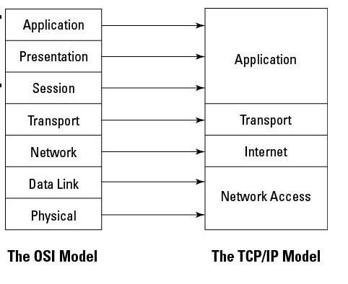
Topics

TCP/IP Model

Securing wired and wireless networks

Securing e-mail, Internet, Fax, and phone lines

Network attacks and countermeasures

In other words, Net+ or CCNA
The TCP/IP Model

TCP/IP Model

Developed by US DoD

Four layers

Application

Transport

Internet

Network Access (or Link)
Network Security

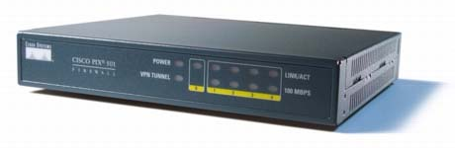
Firewalls

Hardware firewalls

Protect a whole network

Software firewalls

Typically protect only a single host

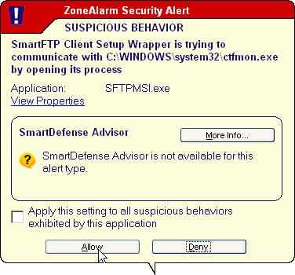
Dependent on OS

Images from www.scalenetwork.com and reneedasaro.com

Firewall Types

Packet filtering

Circuit-level gateway

Application-level gateway

Packet Filtering

Most basic and inexpensive firewall

Allows or denies traffic based on Access Control Lists (ACLs) using

TCP or UDP header

ICMP header

IP header

Traffic direction

Operate at OSI layers 3 or 4

Packet Filtering

Advantages

Inexpensive—can be implemented within a router

Fast and flexible

Transparent to users

Disadvantages

Examines only headers

No protection from IP or DNS spoofing

No support for strong user authentication

ACLs may be difficult to configure and maintain

Limited logging ability

Dynamic Packet Filtering

Dynamic modification of firewall rules

Context-based access control

Creates dynamic rules for sessions as they are established

Circuit-Level Gateway

Operates at OSI layer 5 (Session)

Maintains state information about established sessions

Once a session is established, a tunnel or virtual circuit is established

Packets flow freely through the tunnel without further inspection

Circuit-Level Gateway

Advantages

Speed

Support for many protocols

Easy maintenance

Disadvantages

Dependent on trustworthy users and hosts, since no further inspection of tunneled traffic is done

Limited logging

Stateful Packet Inspection

Developed by Check Point (link Ch 5a)

Gathers packets at layer 3

Analyzes those packets at higher layers, up to layer 7

Also includes context

Application-Layer Gateway

Operates at OSI Layer 7

The most secure

Operates as a proxy server—breaks the client-server connection

Advantages

Internal network is concealed from Internet

Can implement strong user authentication in applications

Disadvantages

Slow: every packet must be inspected up to layer 7

Must be tailored to specific applications

Can be difficult to maintain or update

Firewall Architectures

Screening Router

Dual-homed Gateway

Screened-host Gateway

Screened Subnet

Screening Router

Most basic firewall architecture

A router with ACLs sits between the trusted and untrusted networks

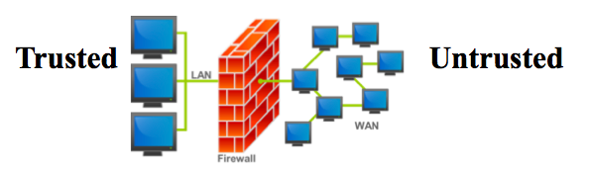
Images from Wikipedia & Iconspedia

Screening Router

Advantages

Transparent

Simple to use and inexpensive

Disadvantages

Limited logging

No user authentication

Difficult to conceal internal network structure

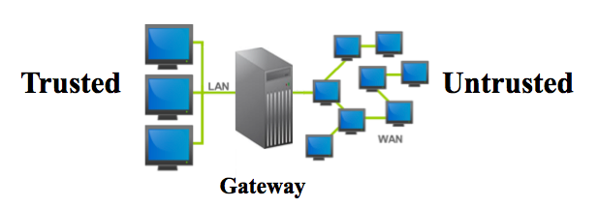
Dual-homed Gateway (or Bastion Host)

Gateway has two NICs

Acts as a proxy server, may require user authentication

Images from Wikipedia & Iconspedia

Advantages

Fail-safe: if it fails, it allows no access

Internal network structure is masked

Disadvantages

May inconvenience users by requiring authentication

Proxies may not be available for some services

May slow down network

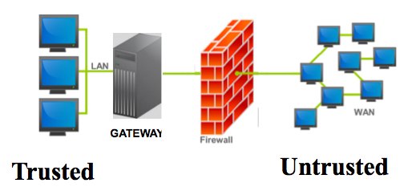
Screened-host Gateway

Gateway protected by screening router

Images from Wikipedia & Iconspedia

Advantages

Distributes security between two devices

Transparent outbound access

Restricted inbound access

Disadvantages

Less secure because screening router can bypass the bastion host for certain trusted services

Masking internal network structure is difficult

Multiple single points of failure

Screened-subnet

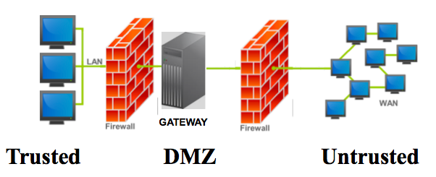
Most secure

Implements a DeMilitarized Zone (DMZ)

Advantages

Transparent to end-users

Flexible

Internal network structure can be masked

Defense in depth

Disadvantages

More expensive

More difficult to configure, maintain, and troubleshoot

Intrusion Detection and Prevention Systems (IDS, IPS, IDPS)

IPS or IDPS or Active IDS

Automatically blocks attacks in progress

Must be placed inline at a network boundary

Single point of failure and high-value target

Can deny access to legitimate users

May create a DoS if the IPS is attacked

Passive IDS

Detects attacks and alerts operator

Does not block attacks

Network-based and Host-based IDS

Network-based IDS

NIC sniffing in promiscuous mode on a monitor port

Host-based IDS

Requires agents on each monitored system

Agents write data to log files, and/or trigger alarms

Knowledge-based IDS (aka Signature-based)

Uses a database of attack signatures

Advantages

Low false-alarm rate

More standardized & easily understood than behavior-based IDS

Disadvantages

Signature database must be updated

New attacks may not be detected

Behavior-based IDS (aka Stastical Anomaly-based)

References a baseline of normal system activity

Deviations from normal activity trigger alarms

Advantage

Adapt to new attacks

Disadvantages

Higher false alarm rate

Inability to adapt to rapidly-changing legitimate usage patterns
Remote Access

Remote Access Security Methods

Restricted allowed addresses

Only certain IP addresses allowed in

Identifies node, not user

Can be spoofed

Caller ID

Can be spoofed

Callback

Requires RAS server to call back at known phone number

Can be defeated by call forwarding

Remote Access Protocols

RAS (Remote Access Server) uses PPP (Point-to-Point Protocol) to encapsulate packets

Three authentication protocols

PAP (Password Authentication Protocol) sends passwords in cleartext

CHAP (Challenge Handshake Protocol) sends a hash of challenge + shared secret

MS-CHAP and MS-CHAPv2 are Microsoft's versions

EAP (Extensible Authentication Protocol)

EAP Authentication

MD5-challenge

S/Key

Token, card

Digital certificates

More options

Commonly used on wireless networks

RADIUS (Remote Authentication Dial-In User Service)

Open source

Uses UDP

Provides authentication and accountability

Uses PAP or CHAP

Diameter

Improvement on RADIUS

Uses TCP

Supports IPSec or TLS

TACACS+ (Terminal Access Controller Access-Control System +)

Developed by Cisco

Replaces the older TACACS protocol

TCP 49

Supports many authentication methods

PAP, CHAP, MS-CHAP, EAP, Token cards, Kerberos, et.
VPNs (Virtual Private Networks)

VPN Tunnel

A secure tunnel connecting two endpoints via an insecure network, usually the Internet

Client-to-VPN Concentrator

Client-to-Firewall

Firewall-to-Firewall

Router-to-Router

VPN Protocols

PPTP (Point-to-Point Tunneling Protocol)

L2F (Layer 2 Forwarding)

L2TP (Layer 2 Tunneling Protocol)

IPSec (Internet Protocol Security)

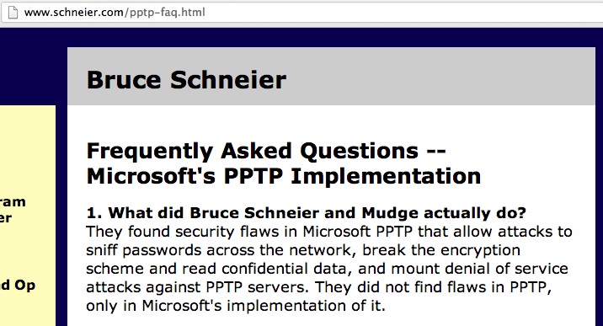
SSL (Secure Sockets Layer)

PPTP (Point-to-Point Tunneling Protocol)

Developed by Microsoft

Uses PPP authentication methods

PAP, CHAP, EAP

Broken (link Ch 5b)

L2F (Layer 2 Forwarding)

Developed by Cisco

Does not provide encryption, relies on a higher-level protocol to do that

L2TP (Layer 2 Tunneling Protocol)

Provides transport, not encryption

Commonly used with IPSec

Supports PPP authentication, RADIUS, TACACS, smart cards, and one-time passwords

IPSec (Internet Protocol Security)

Open standard

Most popular and robust VPN

Considered very secure

Transport mode: only data is encrypted

Tunnel mode: whole packet encrypted

AH (Authentication Header) provides integrity, authentication, and non-repudiation

Encapsulating Security Payload (ESP) provides confidentiality and limited authentication

SA (Security Association)

Each pair of hosts communicating in an IPSec session must establish a SA

SA is a one-way connection between two parties

Two SAs are required for two-way communication

Each SA supports only one protocol (SA or ESP)

An SA has three parameters that uniquely identify it

Security Parameter Index (SPI)

32-bit string in the AH or ESP header

Destination IP Address

Security Protocol ID

AH or ESP

Key Management in IPSec

Done with Internet Key Exchange (IKE), which uses three protocols

Internet Security Association and Key Management Protocol (ISAKMP)

Secure Key Exchange Mechanism (SKEME)

Oakley Key Exchange Protocol

SSL (Secure Sockets Layer)

Operates on upper layers of the OSI model (layers 5, 6, or 7)

References vary, but they all agree the textbook is wrong placing it at layer 4

SSL VPNs require no client software, other than a normal Web browser

User gets access to a single application, not the whole private network

Not all applications work over SSL VPNs
WLAN Security

Access Points (APs)

Omnidirectional

Most common type

Short antennas

Transmit and receive in all directions around a horizontal axis

Parabolic (dish antennas)

One direction

Sectorized and Yagi are other directional antennas

AP Modes

Root mode

Default for most APs

aka Infrastructure mode

Repeater mode

Doesn't connect directly to wired network

Extends range of a WLAN

Bridge mode

Connecting two wired LANS via a wireless link

Rare

WLAN Security

SSID (Service Set Identifier)

Name of the network, e.g. "CCSF Wireless"

Broadcast by AP in Beacon Frames

Included in frames in cleartext

WEP (Wired Equivalent Privacy)

Weak, broken, encryption method

Uses 40-bit or 104-bit key & 24-bit initialization vector

In common use but insecure

WPA (Wi-Fi Protected Access)

WPA uses TKIP (Temporal Key Integrity Protocol)

WPA & WPA2 support EAP extensions

EAP-TLS (Transport Layer Security)

EAP-TTLS (Tunnelled Transport Layer Security)

PEAP (Protected EAP)

WPA2 uses Counter Cipher Mode with Block Chaining Message Authentication Code Protocol or CCMP instead of TKIP

WPA Security

WPA and WPA-2 are both strong, unless the passphrase can be guessed

Wi-Fi Protected Setup (WPS), however, ruins it all by reducing WPA and WPA2 down to an 8-bit number with only 10,500 possible values which can be brute-forced
E-mail, Fax, & Phone Security

Email Security

SMTP (Simple Mail Transfer Protocol) servers send email

Usually without verifying the sender's address

This leads to Spam

Real-time Blackhole Lists

Block open relays and other sources of spam

Every organization must protect their email server from being used by spammers to keep off the blackhole lists

Risks from Spam

Missing important emails

Malware in attachments or links

Phishing and pharming scams

Web Security: HTTP & HTML

HTTP (Hypertext Transfer Protocol) is used to send Web pages

The pages are written in HTML (Hypertext Markup Language)

Attacks:

Script injection

Buffer overflow

Denial of Service

Fax Security

Messages may be mishandled at recipient station

Security practices:

Cover pages with proper routing & classification markings

Place fax machines in secure areas

Use secure phone lines

Encrypt fax data (link Ch 5n)

PBX, POTS, & VoIP Security

PBX (Private Branch Exchange) switches manage phone calls within a company

POTS (Plain Old Telephone Service)

VoIP (Voice over Internet Protocol)

Attacks

Personal use of company resources

Caller ID spoofing & hiding
Network Attacks and Countermeasures

Bluejacking & Bluesnarfing

Bluejacking

Sending spam bluetooth messages

Bluesnarfing

Stealing personal data, such as contacts, from a bluetooth-enabled phone

Phone serial numbers can be stolen this way and used to clone your phone

Smurf & Fraggle

Smurf attack

Sends pings to a broadcast address

Target is in source IP of pings

Target gets many ECHO REPLY packets

Fraggle attack

Sends UDP packets to port 7 (Echo) or 19 (Chargen)

Replies flood target, like the Smurf attack

Packet Floods

SYN Flood

Most effective

Burdens server waiting for SYN/ACK (half-open connections)

UDP Flood

ICMP Flood

Session Hijacking

Traditional method

Predicting SEQ numbers

Sending spoofed packets to replace packets in a session after login is complete

Modern method

Sniff authentication cookies

Access to Facebook, Gmail, etc.

Teardrop Attack

Length and Fragmentation Offset fields in IP packets

Intended to allow large packets to be fragmented & re-assembled

Malicious values in these packets cause fragments to overlap

Crashes vulnerable systems

Last modified 2-24-13

