Topics

Security governance, data classification, and risk management

Missions, goals, and objectives

Security policies, standards, guidelines, and procedures

Security management practices

Security education, training, and awareness
Information Security Governance Concepts and Principles

CIA Triad

Balancing these three things creates security

Confidentiality

Integrity

Availability

Other important concepts

Defense in depth

Avoiding single points of failure

Confidentiality

Prevents unauthorized use or disclosure of information

Privacy is confidentiality of personal data

Personally Identifiable Information (PII)

Name, Address, SSN, financial data, etc.

Integrity

Accuracy and completeness of data

Unauthorized users don't modify data

Authorized users don't make unauthorized modifications (insider threat)

Data isn't damaged in processing or transit

Availability

Authorized users can access systems and data as needed

Denial of Service attacks harm availability

Other threats to availability

Single points of failure

Inadequate capacity planning

Malfunctions

Fail-safe controls

Disasters

Defense in Depth

Multiple layers of defense

Security management principles

Data classification, personnel security policies and practices, security awareness programs

Security technologies

Firewalls, antivirus, IDS

Vendor solutions

Using different vendors on different layers

Data Classification


Assign value to information assets

Determines proper level of protection

Commercial data classification

Value

Age/useful life

Regulatory requirements

"Confidential", "Proprietary", "Internal Use Only"

Government Data Classification

Protect national interests or security

Comply with laws

Protect privacy

DoD

Unclassified, Sensitive but Unclassified, Confidential, Secret, and Top Secret

Access requires clearance and need-to-know

Wikileaks

Bradley Manning allegedly copied immense amounts of confidential data and gave it to Wikileaks

He was only a private

Need-to-know restrictions were not implemented to limit the data he could access

Image from bradleymanning.org

Unclassified

Lowest government data classification

Disclosure won't harm national security

May once have been classified, but has been declassified

May still be restricted by labels like

For Official Use Only

For Internal Use Only

Other Levels

SBU (Sensitive but Unclassified)

Disciplinary and medical records

Confidential

Could damage national security

Secret

Could seriously damage national security

Must be accounted for throughout its life cycle

Top Secret

Highest level, may require additional safeguards
Mission Statements, Goals, and Objectives

Mission Statement

Reason for an organization's existence

Also called philosophy or vision statement

CCSF's Mission Statement

Our primary mission is to provide programs and services leading to

Transfer to baccalaureate institutions;

Achievement of Associate Degrees in Arts and Sciences;

Acquisition of certificates and career skills needed for success in the workplace;

Basic Skills, including learning English as a Second Language and Transitional Studies.

Mission Statements

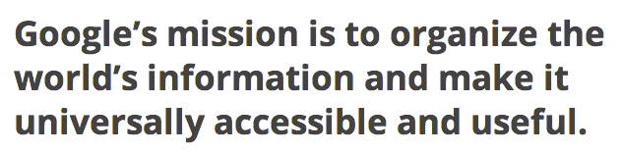
Goals and Objectives

An organization strives to accomplish goals

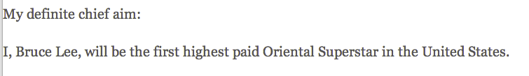
A milestone is a specific result that is expected and indicates progress towards goals

Bruce Lee

Goal and Milestone

Link Ch 6a

Policies, Standards, Guidelines, and Procedures

Policies, Standards, Guidelines, and Procedures

All work together to

Establish governance

Provide guidance and decision support

Help establish legal authority

Governance collectively represents the system of Policies, Standards, Guidelines, and Procedures that steer an organization's operation and decisions

Security Policy

Formal statement of rules

Four main types:

Senior management

Comes from management

Defines objectives, responsibilities, ethics, requirements, and controls

Regulatory

Advisory (most common type)

Informative

Standards, guidelines, and procedures support policy

Standards

Specific mandatory requirements

Define and support higher-level policies

Such as a standard encryption level of 3DES

May even specify exact brand, product, or protocol

Baseline identifies a consistent basis for security architecture

Guidelines and Procedures

Guidelines

Similar to standards

Recommendations, not compulsory

Procedures

Instructions on how to implement policies and meet the criteria defined in standards

Standard Operating Procedures

Information Security Governance Practices

Third-Party Governance

IT functions are often outsourced

Call-center

Application development

Outsourcing security

Access control

Maintenance hooks

Service-Level Agreements (SLAs)

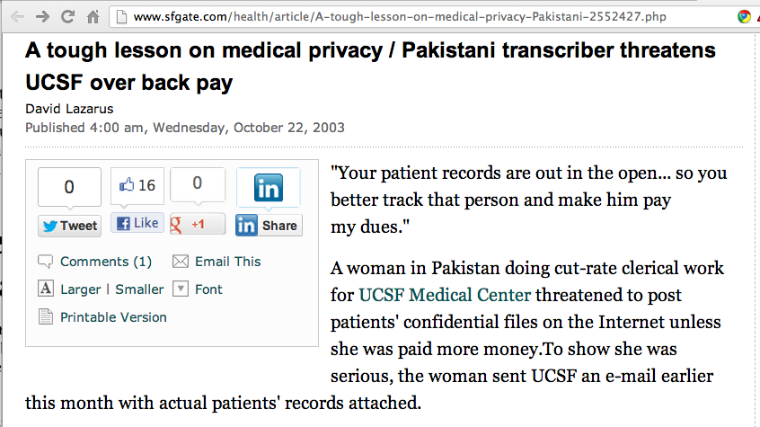
Link Ch 6b

Service-Level Agreements (SLAs)

Establish minimum performance standards

Internal SLAs – one part of an organization to another

Outsourcing SLAs specify what vendors must provide

99.999% uptime

Help desk response time

Identity Management

Account provisioning and de-provisioning

Access control

Directory services

Public Key Infrastructure

Case Study

Student directories and FERPA

Personnel Security Policies and Practices

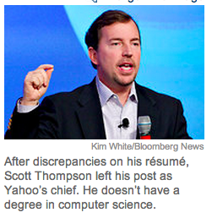
Background checks and security clearances

Reference checks

Verification of data in employment applications and resumes

Other records: court and law enforcement

Credit records

Drug testing

Special background investigation: FBI & INTERPOL records, field interviews, hiring a PI

Yahoo's CEO (2012)

Link Ch 6c

Employment Agreements

Non-Disclosure Agreement

Non-Compete Agreement

Not legal in California (link Ch 6d)

Acceptable Use Policies

Hiring and Termination Practices

Ensure fair and uniform treatment

Hiring

Background checks

Employment agreements

Indoctrination and orientation

Creating user accounts, assigning security badges

Termination

Surrender of keys, badges, parking permits

Exit interview

Security escort as employee leaves

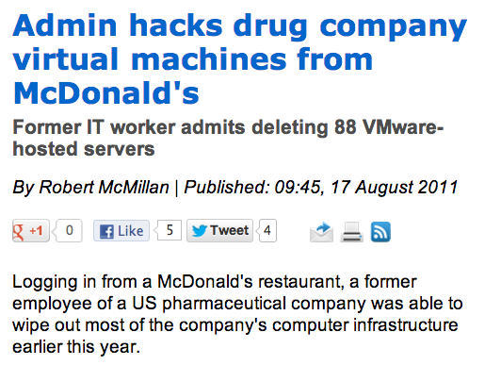
Collect all company materials: laptops, phones, etc.

Change locks and passwords, disable network accounts

Notify customers, partners, vendors, etc.

Link Ch 6e

Job Descriptions

Reduce confusion and ambiguity

Provide legal basis for employee's authority or actions

Demonstrate negligence

Security Roles and Responsibilities

Management

Creating a corporate information security policy

Leading by example

Rewarding compliance

Data Owner

Determining information classification levels

Policy for access

Maintaining inventories and accounting

Periodic review of classification levels; possible downgrade or destruction

Delegating day-to-day responsibility, but not accountability, to a data custodian

Data Custodian

Backups and recovery

Assigning directory and file permissions

Assigning new users to appropriate permission groups

Revoking user privileges

Maintaining classified documents in a vault or secure room

Users

Compliance with security requirements in policies, standards, and procedures

Exercising due care

Participating in training and awareness efforts

Reporting suspicious activity, violations, or problems

Separation of Duties

Ensures that no single individual has complete authority or control over a critical system or process

Reduces opportunity for waste, fraud, or abuse

Two-man control

Reduces dependency on individuals (avoiding single points of failure)

Job Rotation

Transferring key personnel to other positions or departments

Reduce opportunity for waste, fraud, and abuse

Reduce dependence on individuals

Promote professional growth

Reduce monotony and fatigue
Risk Management Concepts

Risk Management Terms

Quantitative Risk Assessment

Expressed in numbers, likle dollars per year

Qualitative Risk Assessment

Vague: "Low", "Medium", "High"

Risk Calculation

Safeguard selection criteria and objectives

Risk Management Terms

Threat

Something bad that might happen

Vulnerability

A weakness that could be exploited

Asset

Something valuable that should be protected

Three Elements of Risk Analysis

Asset Identification

Threat Analysis

Risk treatment

Risk Identification

Asset valuation

Supports quantitative and qualitative risk assessment, Business Impact Analysis (BIA), and security auditing

Facilitates cost-benefit analysis

Supports decisions re: safeguards

Can be used to determine insurance requirements, budgeting, and replacement costs

Helps demonstrate due care, limiting liability

Value of an Asset

Initial and maintenance costs

Organizational value

Value internal to the company

Public value

Cost to the organization if asset is compromised

Threat Analysis

Determine the actual threat

Identify possible consequences

Determine probable frequency

Assess the probability that a threat will actually materialize

Threats may be natural or man-made

Vulnerability Assessment

Measures weaknesses in a company

Vulnerability scanner help to test network defenses

Risk Analysis

Identify assets

Define specific threats

Calculate Annualized Loss Expectancy (ALE)

Select appropriate safeguards

SLE: Single Loss Expectancy

ARO: Annual Rate of Occurrence

ALE = SLE x ARO

Example

Threat: Laptops might be stolen

SLE: Replacing a stolen laptop costs $2000

ARO: Laptops have a 10% chance of being stolen each year

ALE = 10% x $2000 = $200 per year for each company laptop

Example

Threat: Laptops will become obsolete

SLE: Replacing an obsolete laptop costs $2000

ARO: Laptops are obsolete after three years, so they lose 33% of their value each year

ALE = 33% x $2000 = $660 per year for each company laptop

Qualititative Risk Analysis

No numbers, based on assumptions and guesswork

Cost-benefit analysis is not possible

Example: CCSF Emails

Threat: Hackers might dump CCSF emails on Wikileaks and embarrass us

Likelihood: Low

Damage done: Medium loss of prestige, but it's only a guess

Risk Treatment

Risk Reduction

Implementing controls, policies, and procedures to protect an asset

Risk transference

Outsource, or purchase insurance

Risk Avoidance

Stop doing the risky action altogether

Risk Acceptance

Do nothing: cure is worse than the disease

CCSF Examples

Employees might make personal copies on the copiers

Treatment: ACCEPT

Students might park in the faculty lots

Treatment:REDUCE with controls (campus police)

Employees might use social networks like Twitter, and say things management dislikes

Our ex-CTO wanted to AVOID this, but he was removed and now we ACCEPT it

Criteria to Select Safeguards

Cost-effectiveness

Is the loss prevented by the safeguard greater than the cost of the safeguard?

Legal liability

You may be required to implement controls

Operational impact

Safeguard may interfere with business

Technical factors

Safeguard may introduce new vulnerabilities

Security Education, Awareness, and Training

Critical Factors

Senior-level management support

Demonstrate that security supports business objectives

Demonstrate that security affects all individuals and jobs

Take into account audience's level of understanding

Action and follow-up

Awareness

Indoctrination and Orientation

Presentations

Printed materials

Formal Training

Classroom training

On-the-job training

Technical or vendor training

Apprenticeship or qualification programs

Education

Continuing education requirements

CPE credits to maintain a CISSP

Certificate programs

College certificates

Industry certificates like CCIE

Formal education or degrees

Companies often pay for employees to gain college degrees

Last modified 2-27-13

