Topics

Computer environments

Databases and data warehousing

Knowledge-based systems

Systems development life-cycle

Application security controls

Knowing your cyber-enemy
Computer environments

Distributed Applications

Use components on multiple networked computers

Examples

How many computers are being used to produce a Gmail page?

Consider a room full of workers all using a centralized database

Security in Distributed Systems

Software integrity

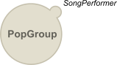
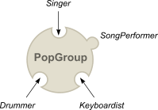
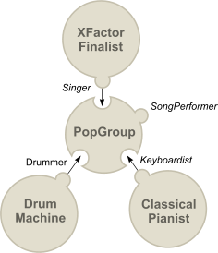
Complex with many systems & updates

Data integrity

Many copies of data on many systems

Access control

Authentication and access control needed

Difficult across large, diverse enterprise

Mobile devices rely on distributed systems

Agents

Agent: a software component that performs a particular service

Patch management

HIDs (Host-based Intrusion Detection)

Performance and capacity monitoring

Applet

A component downloaded and executed in a Web browser

Usually Java or ActiveX

Java runs in a "sandbox" to protect the underlying OS

ActiveX doesn't use a sandbox, but expects controls to signed

Many companies block ActiveX, but still use Java

Object-Oriented Environments

Alternative to distributed systems

Objects can be re-used

Building code is like using Lego toys

Images from davidpeterson.co.uk (Link Ch 7a)

Object-Oriented Terms

Class: Defines methods and variables in an object

Delegation: When object needs a method it doesn't have, it delegates the message to another object

Encapsulation: A package containing everything in an object, which can hide the contents

Inheritance: A new object inherits some characteristics from its class

Instance: A particular object that is a member of a class

Message: How objects communicate with each other

Method: Procedure (code) contained in an object
Databases and data warehousing

Databases

Stores and manipulates data

Examples: Access, MySQL, SQL Server, Oracle

Types:

Relational database

Hierarchical database

Object-oriented database

Database Example

Customers table

Customer ID#

Name

Address

Phone #

Transactions table

Customer #

Date

Item purchased

$Amount

Database Security

Granular access control

Can grant access to specific fields, records, etc.

View

Shows users only part of the database

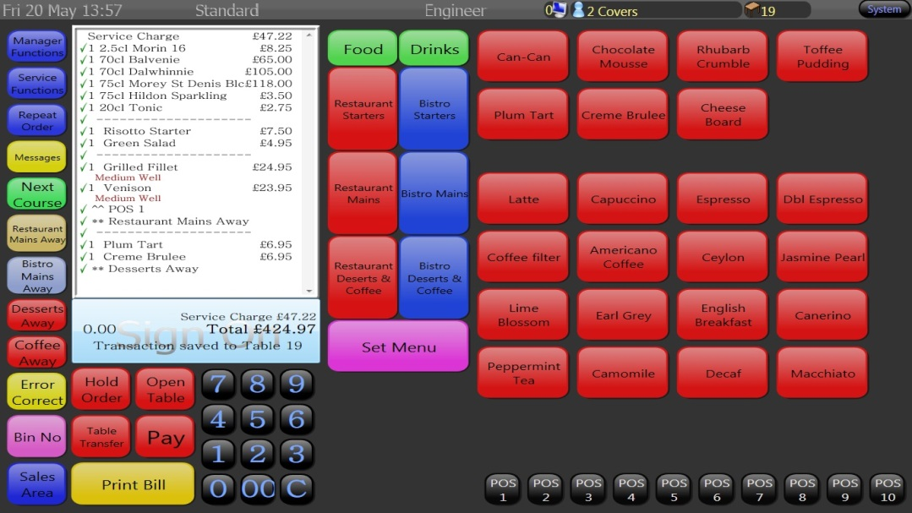
Aggregation

Combining low-sensitivity data items together to result in high-sensitivity data

Inference

Deducing high-sensitivity data from low-sensitivity data

Example View

From tevalis.com (Link Ch 7b)

Data Dictionaries

A database of databases

Contains the structure of all the tables in the database (its schema)

Data Warehouse

Special-purpose database used for decision support

Now called data mining or business intelligence

What-if planning

What if we oursourced IT?

What if we opened a new branch campus?

Demo link Ch 7c (requires Java)

Types of Databases

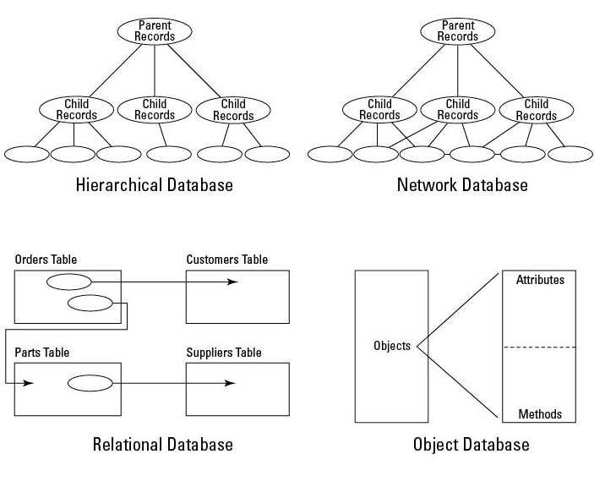

SQL Injection

Databases are often vulnerable to SQL injection

The best defense against this is stored procedures or parameterized queries

Data from the user is placed in a special structure which cannot be interpreted as active code

CNIT 123 SQL Injection Projects

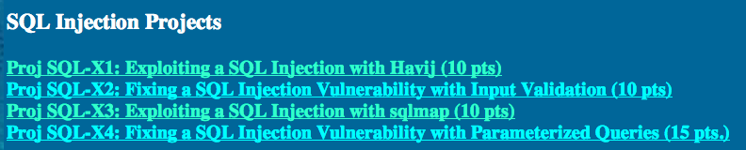

Database Transactions

Addition, alteration, or removal of data

SQL (Structured Query Language)

SELECT chooses records

UPDATE changes data

INSERT adds new records
Knowledge-based systems

aka Artificial Intelligence

Expert Systems

Build a database of past events in order to predict outcomes

Fuzzy logic

Combining many factors to predict an outcome

Produces a quantitative result from uncertainties

Certainty factors

Weighing each item of evidence as it contributes to the decision

Neural Networks

Mimic the biology of the brain

Must be trained with many experiences

Becomes more reliable with experience

Used to crack Captchas by DC 949 at LayerOne

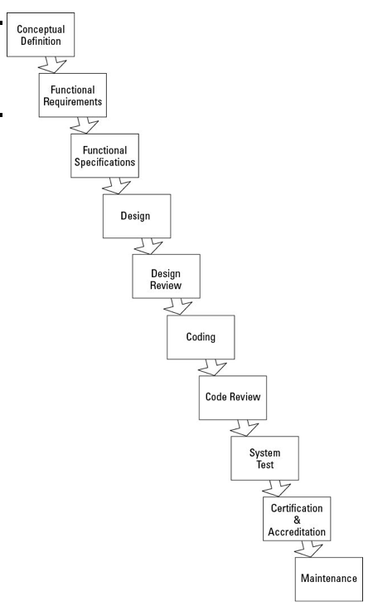
Link Ch 7d

Operating Systems

Ex: Linux, Mac OS X, Windows, iOS, Android

Kernel

Central component of an OS

Process management

Memory management

Interrupts

Hardware resource management

Device drivers

Utilities

User interface

OS Security Functions

Authentication

Access control

Process isolation

Network communication

Filesystem access
Systems development life-cycle

SDLC

Systems Development Life Cycle, or

Software Development Life Cycle

Waterfall model

Steps in SDLC

Conceptual definition

No details

Functional requirements

Required characteristics

Must include expected security requirements

Functional specifications

Engineering specifications

Design

Drawings, materials, and building instructions

Design review

Coding

Secure coding practices

Code review

Tools to identify vulnerabilities and errors

Unit test

Testing components separately

System test

Test entire assembled product

Certification and Accreditation

Certification declares the device fully functional

Accreditation means it is accepted for production

Maintenance

Change requests

Change management

Approval by review board

Configuration management

Documentation
OWASP Top Ten Web Application Vulnerabilities

A1 Injection

A2 Broken Authentication and Session Management

Logout, password handling, secret questions…

A3 Cross-Site Scripting (XSS)

A4 Insecure Direct Object References

A5 Security Misconfiguration

Missing patches, default passwords, etc.

A6 Sensitive Data Exposure

A7 Missing Function Level Access Control

Restricting each functions's permissions

A8 Cross-Site Request Forgery (CSRF)

A9 Using Known Vulnerable Components

A10 Unvalidated Redirects and Forwards

Target page in a redirect can be manipulated

Other Models

Warerfall model is very old

Newer ones include

RAD (Rapid Application Development)

Spiral

Scrum

Security Principles in Software Development

Security in the requirements

Consider security needs before starting design

Security in the design

Security in testing

Security in implementation

Ongoing security testing
Application security controls

Process isolation

One process can't read another process' memory

Hardware segmentation

Use different hardware for development and production

Least Privilege

Each person has only enough privilege to do his or her job

Accountability

Logs are kept of what everyone does

Defense in depth

Layers of defenses

Abstraction

Viewing an application from a high level, without worrying about internal details

Data hiding

Encapsulating data inside an object

System high mode

Highest security classification, e. g. Top Secret

Security kernel

Innermost ring: Ring 0 (Kernel mode)

Reference monitor

Enforces access controls

Supervisor and User modes

Administrator or root account is only for administration

Applications should run In User mode

Service-Level Agreements (SLAs)

Pledge to meet standards

Hours of availability

Average and peak concurrent users

Transaction throughput

Data storage capacity

Application response times

Service desk response times

Security incident response times

Escalation process during times of failure

How Many Nines

Downtime per year

99% 88 hours

99.9% 9 hours

99.99% 53 min.

99.999% 5 min.

Attack Methods

Malware

Virus

Attached to executable files

Worm

Spreads over networks without being attached to a file

Rootkit

Hides on the target system

Very difficult to detect & remove

Types of Rootkits

Hardware

Built into the chips during manufacture

Firmware

Such as router OS, NIC firmware, BIOS

Hypervisor

Converts the OS to a virtual machine

Kernel

May be difficult or impossible to find

UEFI boot for Windows 8 on ARM should detect them

Library

Hide in code library

Other Malware Types

Trojan

Lies about its purpose, like fake antivirus

Hoax

Scare users into unwise actions

Logic bomb

Triggered on a date or by some other event

Malicious applets

Easier with ActiveX than Java

Trap door

Within an application, triggered when certain features are used

Harmless ones are called Easter eggs

Hidden code

Code hidden inside another program

Alternation of authorized code

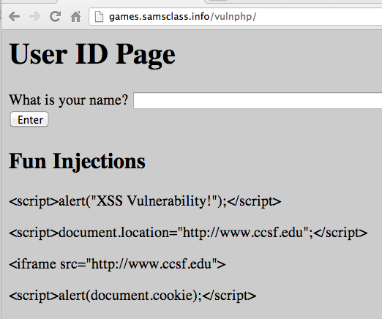
Can bypass User Account Control

Injection Attacks

SQL Injection

Executes code on a database

Frame injection (Cross-Frame Scripting)

In a browser

Action in one frame acts in a different frame

e.g. clicking "Win an iPad" makes a purchase at Amazon

Cross-Site Scripting (XSS)

Cross-Site Request Forgery

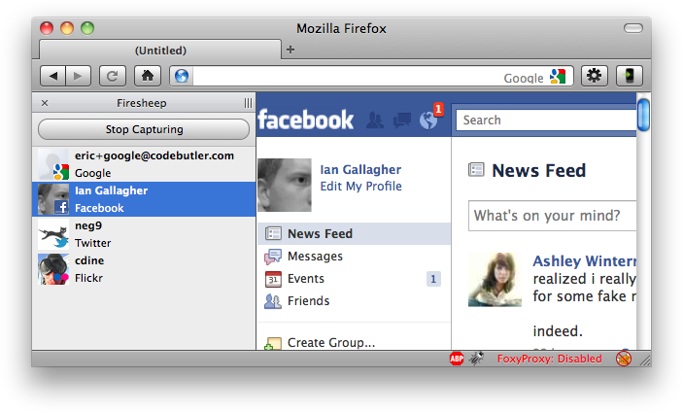
Steal cookies from a user's session

Replay them to hijack the session

Other Attacks

Privilege Escalation

Moving from user to administrator

Denial of Service (DoS)

Making system unavailable to users

Distributed Denial of Service (DDoS)

Attacking from many zombie computers

Dictionary Attack

Trying words in a dictionary to guess a password

Brute Force Attack

Trying every possible sequence of characters to guess a password

Spoofing

Impersonating another user, computer, or program

Spam

Unwanted email, may contain malware

Spam-blockers

Centralized appliances (like Barracuda)

Cloud services (like Postini)

Software on the email server or the workstation

Social Engineering

Phishing

Sending email with a "hook"

Pharming

Changing the hosts file to redirect Web requests later

Spear phishing

Carefully targeting users or groups

Whaling

Targeting senior executives

Remote Maintenance

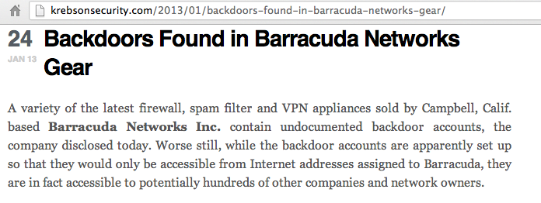
Vendors may connect via a VPN

May be malicious

Maintenance hooks

Secret accounts left in by manufacturer

Link Ch 7f

Traffic analysis and inference

Like phone call register

Knowledge of who has been contacted and when may be enough to compromise secrets

Antivirus Software

Signature files

Require frequent updates

Heuristics

Detect "virus-like" behavior

Has false positives

Other Defense Methods

Application whitelisting

Only approved code can run

Data leakage prevention

Network devices prevent sensitive data from leaving

Malware callback detection

Network forensics to detect infection

Spectacular failure at CCSF
Knowing your cyber-enemy

Perpetrators

Hackers

Skilled enough to do unexpected things

Script kiddies

Run programs without understanding them

Virus writers

Vary in quality, some are very skilled

Bot herders

Run botnets

Perpetrators

Phreakers

Break into phone networks to get free calls

Black Hats and White Hats

Good guys v. bad guys

Last modified 3-10-13

