Cryptography's Role

Cryptography provides

Confidentiality –only those who have the key can read data

Integrity through hash values

Authentication through digital signatures & certificates

Non-repudiation –you can't deny what you did later, through digital signatures

Cryptography doesn't contribute directly to availability

Encryption Defined

Encryption converts data from plaintext (readable) to ciphertext (scrambled)

Algorithm is the mathematical process to encrypt and decrypt the message

Key is a value needed to encrypt and decrypt the data, usually a long random series of bits, sometimes derived from a password or passphrase

Block and Stream Ciphers

Block ciphers operate on a block of input (often 64 bits) at a time

Advantages: Reusable keys are much easier to manage, widely supported

Usually implemented in software

Stream ciphers encrypt one bit at a time in a continuous stream

Key is commonly used only once and then discarded

Much faster than block ciphers

Usually implemented in hardware

One-Time Pad

A long stream of random bits

Used only once, then discarded

Considered unbreakable

BUT key distribution is impractical for many uses

Key must be longer than the message
Types of Ciphers

Substitution and Transposition

Substitution Cipher

Substitute one letter for another

“A” becomes “R”, “B” becomes “G”, etc.

Character rotation

Caesar rotated three to the right
(A > D, B > E, C > F, etc.)

ROT13 is a Caesar cipher

Subject to frequency analysis
attack

Caesar Cipher

Shift each letter forward one character

ABCDEFGHIJKLMNOPQRSTUVWXYZ

BCDEFGHIJKLMNOPQRSTUVWXYZA

CCSF --> DDTG

ROT13

Shift each letter forward 13 characters

ABCDEFGHIJKLMNOPQRSTUVWXYZ

NOPQRSTUVWXYZABCDEFGHIJKLM

CCSF --> PPFS --> CCSF

Encrypting with ROT13 twice returns you to plaintext

Decryption algorithm = Encryption algorithm

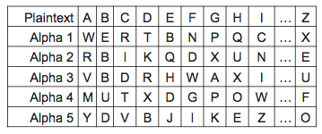
Very weak—obfuscation, not encryption

Polyalphabetic Cipher

CAGED becomes RRADB

Not subject to frequency attack

Transposition Cipher

Letters are rearranged without changing them

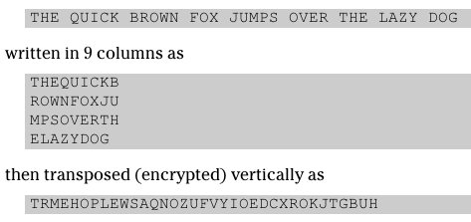

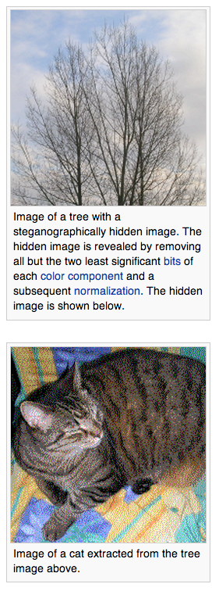

Steganography

Steganography

Hiding a payload file inside another carrier file

Digital watermarks are invisible marks in files to identify the owner

Image from Wikipedia

Printer Steganography

Color printers put tiny yellow dots on pages to identify the printer used

Serial # and timestamp

Intended to make it difficult to print forged money with them

Link Ch 8a

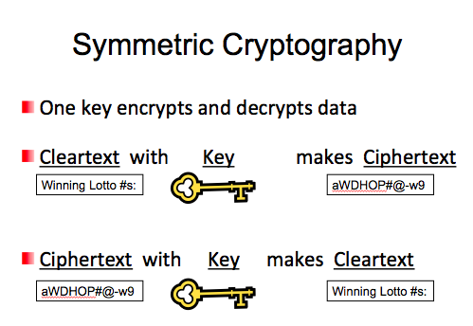
Symmetric Cryptography

Disadvantages

Key distribution requires out-of-band secure channel for "Shared Secret Key"

Doesn't scale: separate key needed for each pair of people

Doesn't provide authentication or non-repudiation

Because two people have the same key

Advantages

Speed: much faster than asymmetric systems

Strength: Can be very strong with a good algorithm like AES and a key 128 bits or longer

Availability: Many good algorithms are available
Block Cipher Modes of Operation

Electronic Code Book (ECB)

Cipher-block chaining (CBC)

Cipher feedback (CFB)

Output feedback (OFB)

Counter (CTR)

Initialization Vector (IV)

Starting block of information needed to encrypt the first block of data

IV must be random and should not be re-used

Block Cipher: Electronic Code Book

Simplest block cipher mode

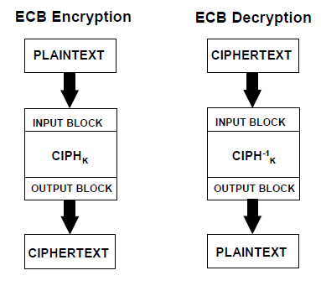
Each block encrypted separately

Like plaintext encrypts to like ciphertext

Vulnerable to a dictionary attack

WEP does this

Microsoft made this error in their password hashes

Microsoft also made this error in Microsoft Office document encryption

ECB Mode

Images from NIST (link Ch 8b)

Cipher-block Chaining (CBC)

Ciphertext output from each encrypted plaintext block is used in the encryption for the next block

First block encrypted with IV (initialization vector)
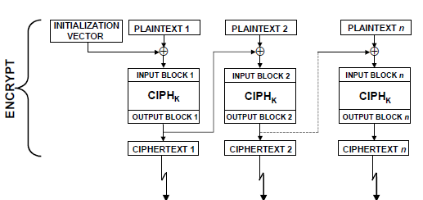

Cipher Feedback (CFB)

Plaintext for block N is XOR’d with the ciphertext from block N-1.

In the first block, the plaintext XOR’d with the encrypted IV

Output Feedback (OFB)

Plaintext is XOR’d with the encrypted material in the previous block to produce ciphertext

Counter (CTR)

Uses a “nonce” (a random number that is used once) that is concatenated with a counter or other simple function, to create a series of keys

Allows parallel computation
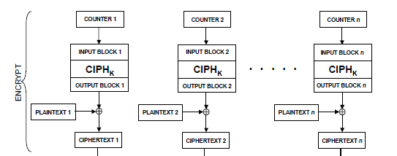
Symmetric Encryption Algorithms

DES (Data Encryption Standard)

3DES (Triple DES)

AES (Advanced Encryption Standard)

IDEA (International Data Encryption Algorithm)

RC5 (Rivest Cipher 5)

DES & 3DES

56-bit key makes it too insecure to be trusted

Broken by brute force in 1997

3DES is stronger

Three rounds of DES encryption, typically using two different keys

Effective strength is 112 bits (link Ch 8d)

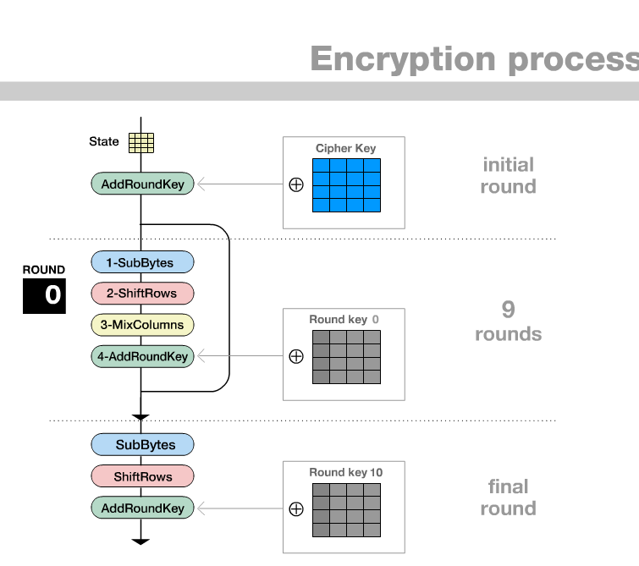
Slow to compute

AES

Currently recommended by NIST

Strong and fast

Link Ch 8e

Blowfish & Twofish

Block ciphers with variable key lengths

Strong if key is long enough

Designed by Bruce Schneier

Public domain

Rivest Ciphers

Symmetric algorithms with variable-length keys

RC2: Block cipher

RC4: Stream cipher

RC5: Block cipher

RC6: Block cipher

IDEA

Block cipher

Operates in distinct modes like DES

Stronger than RC4 and 3DES

Patented, not in common use

Used by PGP email

No known practical attacks
Asymmetric Cryptography Algorithms

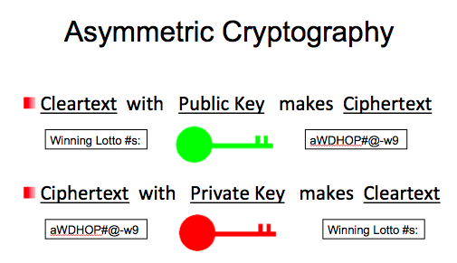
Use two keys that are mathematically related

Data encrypted with one key can be decrypted only with the other key

Another name for asymmetric key cryptography is public key cryptography

Public key: known by the public

Private key: known only by owner

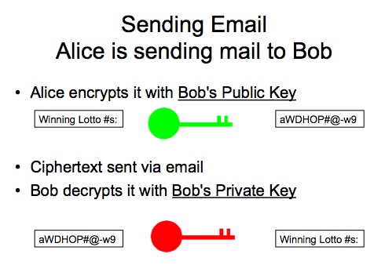

Asymmetric Cryptography

Disadvantage: slow to compute

Advantages:

Provides confidentiality, authentication, and
non-repudiation

Scalable: Each user needs only one key pair

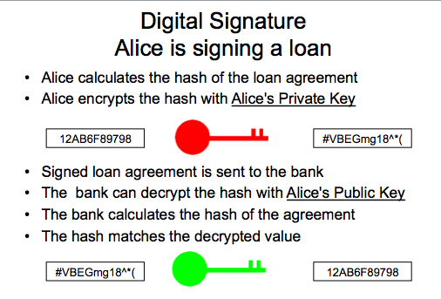
Hybrid system is common—use asymmetric crypto only to deliver a private key, and use private-key crypto after that

Popular Algorithms

Asymmetric Encryption

RSA, ECC, ElGamal

Asymmetric Key Exchange

Diffie-Hellman

Message Authentication

Message Authentication Guarantees

Message has not been altered

It's not a replay of a previous message

Was sent from the stated origin (not a forgery)

Is sent to the intended recipient

Basic systems: Checksum, CRC, Parity

Advanced systems: Digital signature, Message Digest

Message Digests

Short hash value computed from a message

Should have these properties

Original message can't be re-created from the message digest

Finding a message with a given digest should be impossible in practice

No two messages should produce the same digest (collisions)

Message digest should be calculated from the entire original message

MD5 (Message Digest 5)

Popular but broken

Has known collisions

128 bits long

SHA (Secure Hash Algorithm)

SHA-1

160 bits

No known collisions, but has some theoretical weaknesses

SHA-2

224, 256, 384, or 512 bits

No known collisions

SHA-3

New, no known weaknesses, but unnecessary: SHA-2 is probably good enough (link Ch 8f)

HMAC (Hashed Message Authentication Code)

Encrypts a hash with a shared secret key

Hash is typically MD5 or SHA-1

This protects the hash from man-in-the-middle attacks

Used in IPSec and TLS (link Ch 8g)
Public Key Infrastructure (PKI)

Public Key Infrastructure (PKI)

Electronic ID cards for the Internet

Certification Authority (CA)

Issues certificates, maintains and publishes status information and Certificate Revocation Lists (CRLs)

Registration Authority (RA)

Verifies certificate contents for the CA

Repository

Stores and distributes certificates and CRLs

Key Management

Key generation

Key distribution

Key installation

Key storage

Key change

Key control

Key disposal

Key Escrow and Key Recovery

Divide a key in two parts

Place them in two escrow accounts

With a court order, keys can be recovered
E-mail and Internet Encryption

Email Encryption

Secure Multipurpose Internet Mail Extensions (S/MIME)

Uses RSA, digital signatures, and X.509 digital certificates to provide confidentiality and authentication

PGP (Pretty Good Privacy)

Uses IDEA and RSA, but a Chain of Trust instead of CAs

MOSS and PEM are other systems, rarely used

Internet Security Applications

SSL/TLS

Used for HTTPS sessions

Uses RSA, IDEA, DES, and 3DES

Secure Electronic Transaction (SET)

Developed by Visa and Mastercard for e-commerce

Uses DES, RSA, and X.509 certificates

S-HTTP

Uses public and private-key encryption

Not widely used

IPSec (Internet Protocol Security)

Uses public and private-key encryption

Not widely used

Transport Mode encrypts only data

Tunnel Mode encrypts whole packet

Authentication Header (AH) provides integrity, authentication, and non-repudiation

Encapsulating Security Payload (ESP) provides confidentiality and limited authentication

Security Association (SA)

One-way communication between two hosts

Each SA supports only a single protocol (AH or ESP), so four SAs may be needed for 2 hosts

SA is identified by three numbers

Security Parameter Index (SPI)

A 32-bit string

Destination IP address

Security Protocol ID (AH or ESP)

Internet Key Exchange (IKE) uses three protocols

Internet Security Association and Key Management Protocol (ISAKMP)

Secure Key Exchange Mechanism (SKEME)

Oakley Key Determination Protocol

Three modes

Main, Aggressive, Quick

Multi-Protocol Label Switching (MPLS)

Extremely fast method of forwarding packets

Labels are inserted between OSI layers 2 and 3

Protocol independent

Highly scalable

Provides Quality of Service with multiple Classes of Service

Secure layer 3 VPN Tunneling

No encryption, but theoretically the traffic flow is restricted (link Ch 8h)

SSH (Secure Shell)

Used for command-line connections, replacing Telnet

Encrypted but doesn't use CAs, so vulnerable to man-in-the-middle attacks

SSH-1 is widely used but vulnerable

SSH-2 is better

Wireless Transport Layer Security (WTLS)

Secures Wireless Application Protocol (WAP)

Commonly used for Internet connections on mobile devices

Three classes

Class 1: Anonymous authentication

Class 2: Server authentication only

Class 3: Client-server authentication

WEP v. WPA

Wired Equivalent Privacy (WEP) is broken and cannot be trusted

WPA and WPA-2 are strong

WPA uses TKIP (Temporal Key Integrity Protocol)

WPA uses EAP (Extensible Authentication Protocol)

Pre-Shared Key mode

802.1x mode – uses a RADIUS server
Attacks

Methods

Analytic Attacks

Using mathematical analysis to reduce the complexity of the algorithm

Brute-force Attacks

Try every possible key

Implementation Attacks

Find a weak spot in a protocol or algorithm used

Statistical Attacks

Insufficiently random numbers, etc.

Rainbow Tables

Also called time-memory trade-off

A large precomputed table of hashes is stored in RAM

This makes brute force attacks faster

Used by Ophcrack and RainbowCrack

Less popular with modern hash-crackers, because GPUs are so fast

Birthday Attack

If 23 people are in the room, what is the chance that they all have different birthdays?

365 364 363 363 361 360 343

--- X --- X --- X --- X --- X --- … --- = 49%

365 365 365 365 365 365 . . . 365

So there’s a 51% chance that two of them have the same birthday

Birthday Attack (Continued)

If there are N possible hash values,

You’ll find collisions when you have calculated 1.2 x sqrt(N) values

SHA-1 uses a 160-bit key

Theoretically, it would require 2⁸⁰ computations to break

Other Attacks

Ciphertext Only Attack

Chosen Text Attack

Known Plaintext Attack

Man-in-the-Middle Attack

Intercept messages from client and server

Replay Attack

Record traffic and replay it

Last modified 3-17-13

