Computer Architecture

Hardware, Firmware, and Software

Computer Architecture

CPU (maybe more than one)

Memory

Peripherals

Buses to connect them together

Input devices

Output devices

Network communications

Operating system

Applications

Hardware: CPU (Central Processing Unit)

Performs arithmetic, logic, and computing

Main components

Arithmetic Logic Unit (ALU)

Numerical calculations and comparisons

Bus Interface Unit (BIU)

Supervises data transfer over bus between CPU and I/O devices

Control Unit

Coordinates other CPU components

Main components

Decode Unit

Converts instructions into individual CPU commands

Floating-Point Unit

Handles higher math operations

Memory Management Unit (MMU)

Addresses and catalogs data in memory; translates logical addresses to physical addresses

Main components

Pre-Fetch Unit

Preloads instructions into CPU registers

Protection Test Unit (PTU)

Monitors all CPU functions to ensure they are properly executed

Registers

Holds data, addresses, and instructions temporarily (Ex: EIP, ESP)

CPU Components

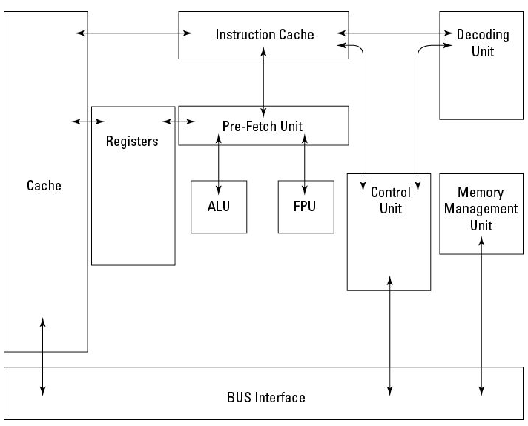
CISC and RISC

Complex Instruction Set Computing (CISC)

Many, complex, machine-language instructions

Used by Intel processors: x86, Pentium, etc.

Reduced Instruction Set Computing (RISC)

Fewer, simpler instructions

Used by Alpha, PowerPC, and SPARC

Processor Types

Multitasking

Allows multiple programs to run at once

Each program takes a turn using the processor

Multiprocessing

Multiple processors all working at once

Multiuser OS

Modern operating systems are multiuser

They differentiate between users

Users may have different

Shell environments

Profiles

Privilege levels

Process isolation

Bus

A set of electric connections that carry signals, addresses, and data from one component to another

Data bus moves data between CPU, memory, and peripherals

Address bus moves data and instructions between CPU and memory

Control bus transmits control information between CPU and other devices

Main Memory

Stores programs, instructions, and data

Physical memory

RAM or ROM

Secondary memory also called secondary storage

Hard disk, SSD, tape

RAM (Random Access Memory)

Volatile—data fades when power is off

Dynamic RAM (RDAM) must be refreshed every 3 milliseconds

Static RAM (SRAM) doesn’t need to be refreshed, faster

ROM (Read-Only Memory )

Nonvolatile—retains data without power

Programmable Read-Only Memory (PROM)

Can only be written once, and never erased, like a CD-ROM

Erasable PROM (EPROM)

Erased with ultraviolet light

Electrically Erasable PROM (EEPROM)

Can be erased without ultraviolet light

Flash memory

Used in USB and solid-state drives (SSDs)

Secondary Memory

Nonvolatile storage

Hard disk

SSD

Tape (sequential)

Virtual Memory is not RAM but a disk file or partition aka “Page file” or “Swap”

Protection Domain

Protection domain (or protected memory)

Memory assigned to one process, protected so other processes can’t read or alter it

Addressing

Absolute address specifies a memory location exactly

Indexed address is relative to an index register

Direct address is specified in a command

Indirect address is the location in RAM that contains another address (a pointer)

Firmware

Instructions in ROM

Rarely or never changed

BIOS in a computer

Also used in digital cameras, routers, MP3 players, etc.

Operating System

Controls the computer

Three main components

Kernel – core, must be in RAM

Device drivers – controls hardware

Tools – programs for maintenance, like filesystem repair or network testing

Functions of Operating System

Process management

Resource management

I/O device management

Memory management

File management

Communications management

Virtualization

Host machine runs a hypervisor that allocates resources for the guest operating systems

Cloud computing uses virtual machines hosted elsewhere, such as Amazon E2C

Cloud security is a hot topic now

Security Architecture

Trusted Computing Base (TCB)

Hardware, firmware, and software working together to enforce a security policy

Security perimeter separates the TCB from the rest of the system

Access control permits or denies the use of an object (e.g. system or file) by a subject (user or process)

Trusted Computing Base (TCB)

Reference monitor

A component that enforces access controls

Security kernel

Combination of elements in a TCB that implements the reference monitor concept

It must:

Mediate all access

Be protected from modification

Be verified as correct

Open and Closed Systems

Open systems

Vendor-independent

Complies with a published and accepted standard

Can be independently reviewed

Ex: Linux, Open Office, Apache

Closed system

Proprietary hardware and/or software

May not be compatible with other brands

Ex: Windows, Oracle, Apple iTunes

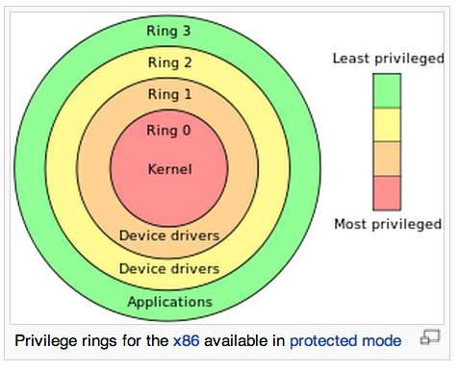
Protection Rings

Ring 0 is kernel mode

Rings 1 and 2 are not used by Windows

Ring 3 is user mode

Link Ch 9a

Security Modes

Used by US military and government systems

Dedicated

All users must have clearance >= highest level of information on the system and need-to-know

System high

All users must have clearance but not necessarily need-to-know

Multilevel

System has information at different classification levels and restricts access appropriately

Must be a trusted computer system (with a TCB)

Limited access

Users don’t need a security clearance

Highest level of information on the system is “Sensitive but Unclassified”

Recovery Procedures

Protect systems from hardware or software failure

Fault-tolerant

Redundancy enables the system to continue to operate after failure of a component

Fail-safe

When a failure is detected, the program stops

System is protected from compromise

Fail-soft (resilient)

When a failure is detected, certain noncritical processing stops

System continues to function in a degraded mode

Failover

When a failure is detected, system automatically transfers processing to another component

Example: failover cluster

Vulnerabilities in Security Architectures

Covert channels

Hidden communications

Rootkits

Subvert system architecture

Difficult or impossible to detect

Race conditions

Brief periods of vulnerability from the timing of events

Exploitation requires “winning the race”

State attacks

Web-based applications often have weaknesses in session management

Attacker steals or forges a session identifier and hijacks a session

Emanations

Electronic or acoustic waves leak out, exposing confidential data

Tempest project
Security Countermeasures

Defense in Depth

Two or more layers of protection

Screening router

Firewall

IDS

Hardened OS

OS-based network access filtering

System Hardening

Improving the security of a system beyond the default installation

Remove unnecessary components

Remove unnecessary accounts

Close unused ports

Change default passwords

Run programs at lowest privilege

Install patches

Heterogeneous Environment

Mix different systems

Such as Windows & Linux

Prevents compromise of all systems at once if a vulnerability is revealed

System Resilience

Ability to keep running in less-than-ideal conditions

Filter malicious input

Injections, buffer overflows, Denial of Service attacks

Redundant components

RAID, server cluster

Maintenance hooks

Hidden “backdoor” features in software that exposes it to compromise

Security Countermeasures

Reveal as little information about the system as possible

Change default banners and error messages

Limit access to persons who must use the system

Disable unneeded services

Use strong authentication
CIA

Confidentiality

Access and authorization

Vulnerability management

Sound system design

Sound data management practices

Integrity

Data should have:

Completeness

Timeliness

Accuracy

Validity

Measures to ensure integrity

Authorization

Input control

Access control

Output control

Availability

Systems must provide service to authorized users

Resilient hardware design

Resilient software

Resilient architecture

Avoiding single points of failure

Sound configuration management and change management procedures

Access Control Models

Bell-LaPadula

First formal confidentiality model of a mandatory access control system

Developed for the Department of Defense (DoD)

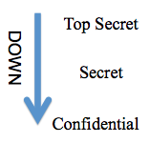
DoD uses three security classifications

Confidential, Secret, Top Secret

Information cannot flow downward

No Read Up

No Write Down

Provides confidentiality, but not integrity

Write-up is allowed, which compromises integrity

Ex: KGB

Biba

Integrity model

No Read Down

No Write Up

Provides integrity, but not confidentiality

Read-Up is allowed, so no confidentiality

Benefit: Stay on Target

Ex: Catholic Church

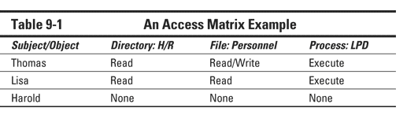
Access Matrix

Access control lists (columns)

Capability lists (rows)

Take-Grant

Specify rights a subject can transfer to or from another subject

Four basic operations

Create, Revoke, Take, Grant

Clark-Wilson

Security framework for commercial business like banking

Addresses all three CIA goals

Unconstrained Data Items (UDI)

Data outside controlled area, such as user input

Constrained Data Items (CDI)

Data inside control area—must have integrity

Integrity Verfication Procedures (IVP)

Checks validity of CDIs

Transformation Procedures (TP)

Changes a UDI to a CDI (Link Ch 9b)

Information Flow

Controls access based on flow of information

Security policy controls direction of flow from one application or system to another

Useful for analyzing covert channels

Non-Interference

Ensures that actions done by one user don’t affect actions of another

If high-privilege actions affect low-privilege actions, that is a side-channel leaking high-privilege data
Evaluation Criteria

Trusted Computer System Evaluation Criteria (TCSEC)

Orange Book

Part of the Rainbow Series developed for US DoD in 1983

Implements Bell-LaPadula model

Objectives

Measurement of trust levels

Guidance for vendors

Acquisition requirements for customers

Four Control Requirements in the Orange Book

Security policy

Assurance

Accountability

Documentation

Security policy

Discretionary Access Control (DAC)

Mandatory Access Control (MAC)

Object reuse (data remanance)

Labels

Required in MAC systems

Assurance

Guarantees that a security policy is correctly implemented

Security architecture

System integrity

Covert channel analysis

Covert storage channel alters stored data

Covert timing channel alters performance or timing

Trusted facility management

Assigns a specific person to administer security

Trusted recovery

Security testing

Design specification and verification

Configuration management

Trusted distribution

Accountability

Ability to associate users with actions

Identification and authentication

Trusted path

For communications between user and TCB

Audit

Documentation

Security Features User’s Guide

Trusted Facility Manual

Test dcumentation

Design documentation

Classes of Protection in the Orange Book

D: Minimal protection

C: Discretionary protection (C1 & C2)

B: Mandatory protection (B1, B2, & B3)

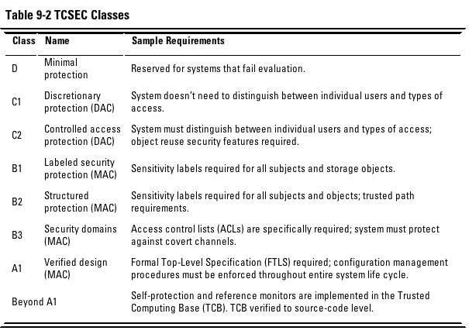
A: Verified protection (A1)

Limitations of the Orange Book

Addresses only confidentiality, not integrity and availability

Not applicable to most commercial systems

Emphasizes protection against outsiders, not insiders

Doesn’t address networking issues

Other Criteria

Trusted Network Intepretation (TNI)

Part of the Rainbow Series (Red book)

Addresses networking & transmission security

European Information Technology Security Evaluation Criteria (ITSEC)

Uses Function and Evaluation levels
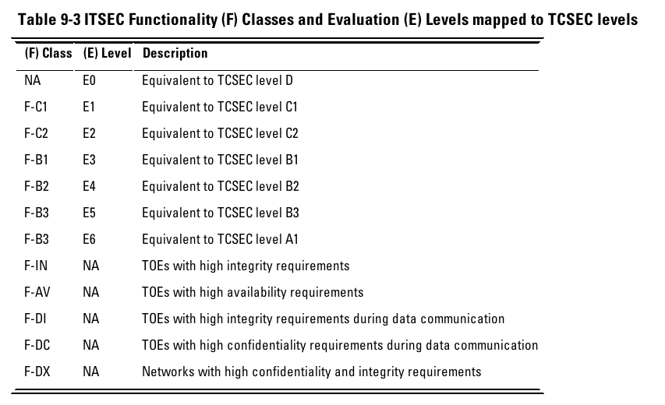

Common Criteria

International standard to supercede both US and European criteria
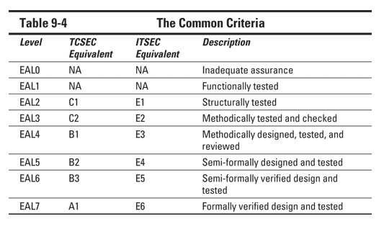

System Certification and Accreditation

Certification: system meets standard criteria

Accreditation: approval for a specific use

Formally implemented in US military and government as DITSCAP and NIACAP

DITSCAP

Defense Information Technology Security Certification and Accreditation Process

For US DoD systems

Definition: mission, environment, and architecture

Verification: system complies with baseline

Validation: confirms compliance

Post-Accreditation: ongoing activities to maintain compliance and address new threats

NIACAP

National Information Assurance Certification and Accreditation Process

For US government national security systems

Four phases same as DITSCAP and:

Site accreditation: Systems at a location

Type accreditation: Specific system at multiple locations

System accreditation: Specific application at a specific location

DCID 6/3

Director of Central Intelligence Directive 6/3

Protects information used by the US Central Intelligence Agency

Last modified 4-7-13

