Ch 1: Malware Analysis Primer

The Goals of Malware Analysis

Incident Response

Case history

A medical clinic with 10 offices found malware on one of their workstations

Hired a consultant to clean & re-image that machine

All done—case closed?

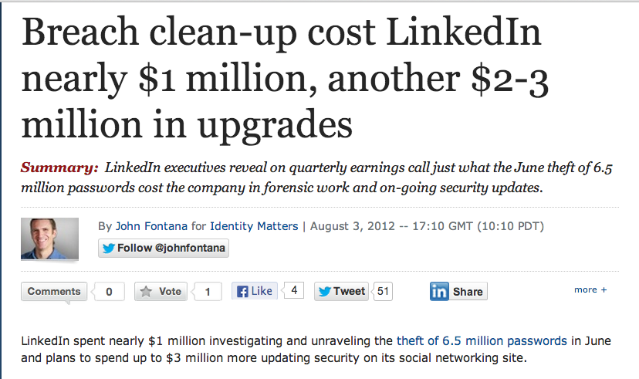
Incident Response

After malware is found, you need to know

Did an attacker implant a rootkit or trojan on your systems?

Is the attacker really gone?

What did the attacker steal or add?

How did the attack get in

Root-cause analysis

Link Ch 1a

Malware Analysis

Dissecting malware to understand

How it works

How to identify it

How to defeat or eliminate it

A critical part of incident response

The Goals of Malware Analysis

Information required to respond to a network intrusion

Exactly what happened

Ensure you’ve located all infected machines and files

How to measure and contain the damage

Find signatures for intrusion detection systems

Signatures

Host-based signatures

Identify files or registry keys on a victim computer that indicate an infection

Focus on what the malware did to the system, not the malware itself

Different from antivirus signature

Network signatures

Detect malware by analyzing network traffic

More effective when made using malware analysis

False Positives
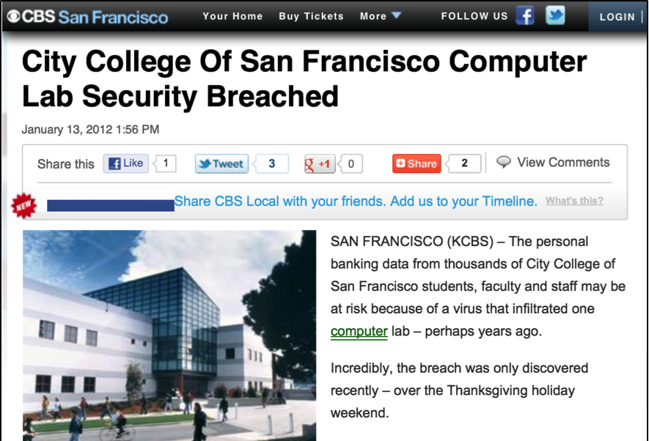
Malware Analysis Techniques

Static v. Dynamic Analysis

Static Analysis

Examines malware without running it

Tools: VirusTotal, strings, a disassembler like IDA Pro

Dynamic Analysis

Run the malware and monitor its effect

Use a virtual machine and take snapshots

Tools: RegShot, Process Monitor, Process Hacker, CaptureBAT

RAM Analysis: Mandant Redline and Volatility

Basic Analysis

Basic static analysis

View malware without looking at instructions

Tools: VirusTotal, strings

Quick and easy but fails for advanced malware and can miss important behavior

Basic dynamic analysis

Easy but requires a safe test environment

Not effective on all malware

Advanced Analysis

Advanced static analysis

Reverse-engineering with a disassembler

Complex, requires understanding of assembly code

Advanced Dynamic Analysis

Run code in a debugger

Examines internal state of a running malicious executable
Types of Malware

Backdoor

Allows attacker to control the system

Botnet

All infected computers receive instructions from the same Command-and-Control (C&C) server

Downloader

Malicious code that exists only to download other malicious code

Used when attacker first gains access

Information-stealing malware

Sniffers, keyloggers, password hash grabbers

Launcher

Malicious program used to launch other malicious programs

Often uses nontraditional techniques to ensure stealth or greater access to a system

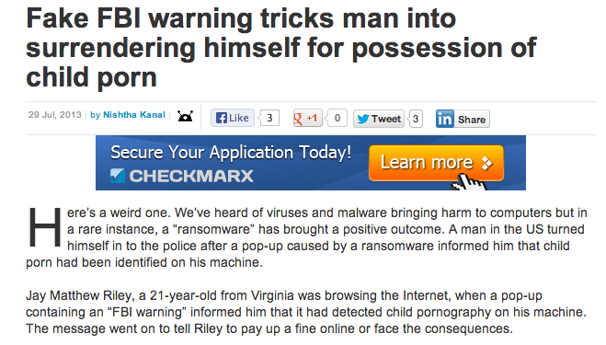
Rootkit

Malware that conceals the existence of other code

Usually paired with a backdoor

Scareware

Frightens user into buying something

Link Ch 1b

Spam-sending malware

Attacker rents machine to spammers

Worms or viruses

Malicious code that can copy itself and infect additional computers

Mass v. Targeted Malware

Mass malware

Intended to infect as many machines as possible

Most common type

Targeted malware

Tailored to a specific target

Very difficult to detect, prevent, and remove

Requires advanced analysis

Ex: Stuxnet
General Rules for Malware Analysis

General Rules for Malware Analysis

Don’t Get Caught in Details

You don’t need to understand 100% of the code

Focus on key features

Try Several Tools

If one tool fails, try another

Don’t get stuck on a hard issue, move along

Malware authors are constantly raising the bar

Ch 2: Basic Static Analysis Techniques

Antivirus scanning

Hashes

A file’s strings, functions, and headers
Antivirus Scanning

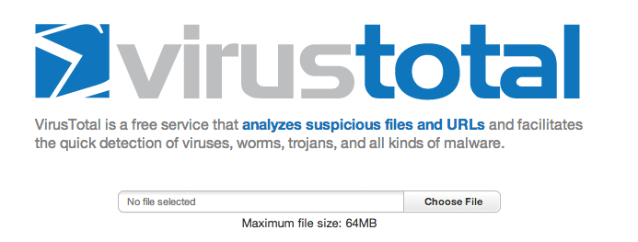
Only a First Step

Malware can easily change its signature and fool the antivirus

VirusTotal is convenient, but using it may alert attackers that they’ve been caught

Link Ch 2a

Hashing

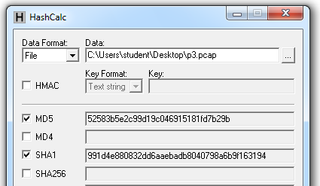
A fingerprint for malware

Hashes

MD5 or SHA-1

Condenses a file of any size down to a fixed-length fingerprint

Uniquely identifies a file well in practice

There are MD5 collisions but they are not common

Collision: two different files with the same hash

HashCalc

Hash Uses

Label a malware file

Share the hash with other analysts to identify malware

Search the hash online to see if someone else has already identified the file
Finding Strings

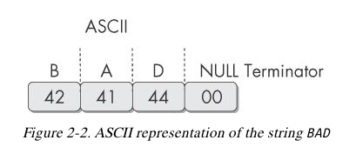
Strings

Any sequence of printable characters is a string

Strings are terminated by a null (0x00)

ASCII characters are 8 bits long

Now called ANSI

Unicode characters are 16 bits long

Microsoft calls them "wide characters"
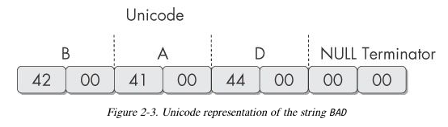

The strings Command

Native in Linux, also available for Windows

Finds all strings in a file 3 or more characters long

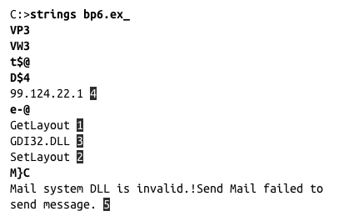
Bold items in this example can be ignored

GetLayout and SetLayout are Windows functions

GDI32.DLL is a Dynamic Link Library

Packed and Obfuscated Malware

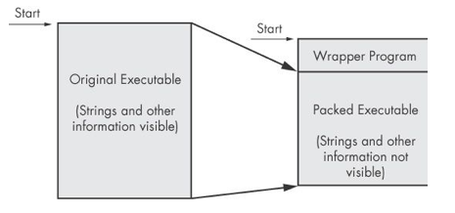
Packing Files

The code is compressed, like a Zip file

This makes the strings and instructions unreadable

All you'll see is the wrapper – small code that unpacks the file when it is run

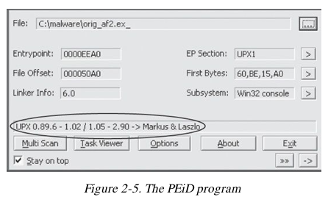

Detecting Packers with PEiD

Warning! PEiD may run the malware!

Demo: UPX

Packing Obfuscates Strings

Portable Executable File Format

EXE Files

PE Files

Used by Windows executable files, object code, and DLLs

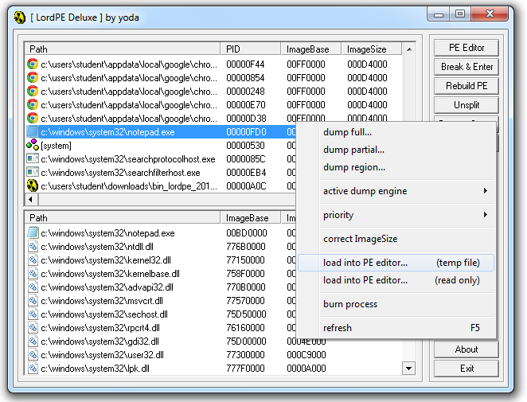
A data structure that contains the information necessary for Windows to load the file

Almost every file executed on Windows is in PE format

PE Header

Information about the code

Type of application

Required library functions

Space requirements

LordPE Demo

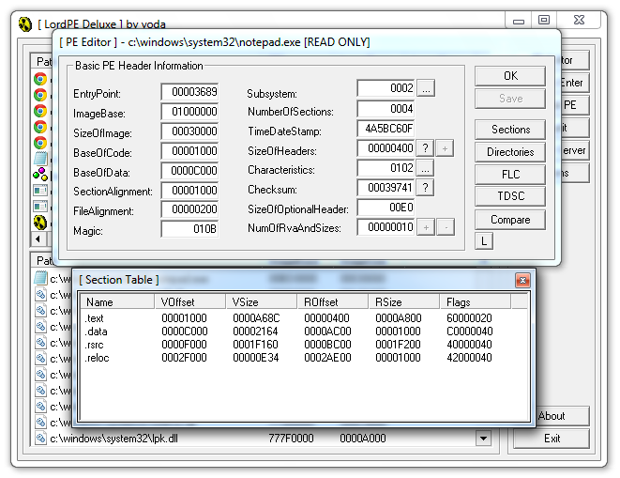

Main Sections

There are a lot more sections

But the main ones are enough for now

Link Ch 2c

Linked Libraries and Functions

Imports

Functions used by a program that are stored in a different program, such as library

Connected to the main EXE by Linking

Can be linked three ways

Statically

At Runtime

Dynamically

Static Linking

Rarely used for Windows executables

Common in Unix and Linux

All code from the library is copied into the executable

Makes executable large in size

Runtime Linking

Unpopular in friendly programs

Common in malware, especially packed or obfuscated malware

Connect to libraries only when needed, not when the program starts

Most commonly done with the LoadLibrary and GetProcAddress functions

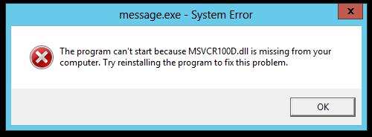
Dynamic Linking

Most common method

Host OS searches for necessary libraries when the program is loaded

Clues in Libraries

The PE header lists every library and function that will be loaded

Their names can reveal what the program does

URLDownloadToFile indicates that the program downloads something
Dependency Walker

Shows Dynamically Linked Functions

Normal programs have a lot of DLLs

Malware often has very few DLLs

Services.exe
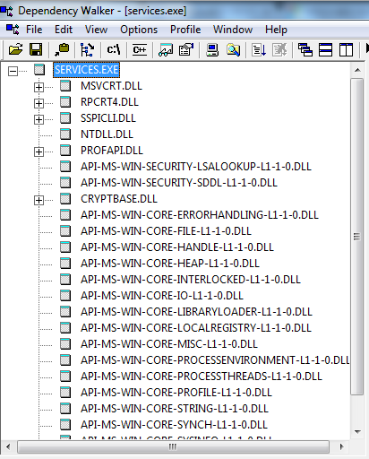

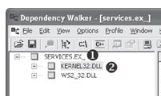

Services.ex_ (malware)

Imports & Exports in Dependency Walker
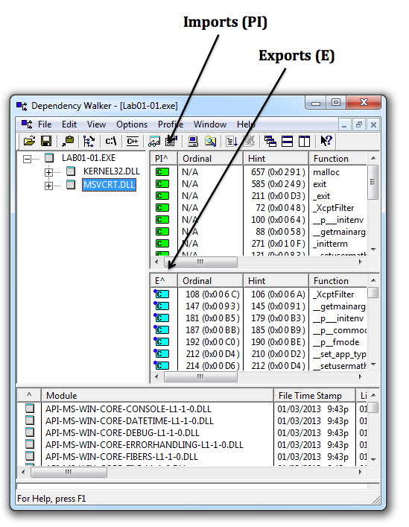

Exports

DLLs export functions

EXEs import functions

Both exports and imports are listed in the PE header

The book says exports are rare in EXEs, but I see a ton of exports in innocent EXEs

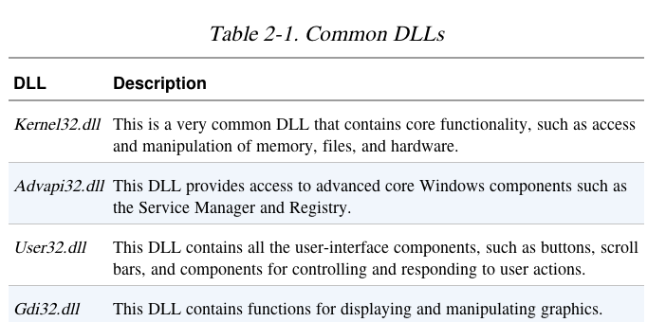

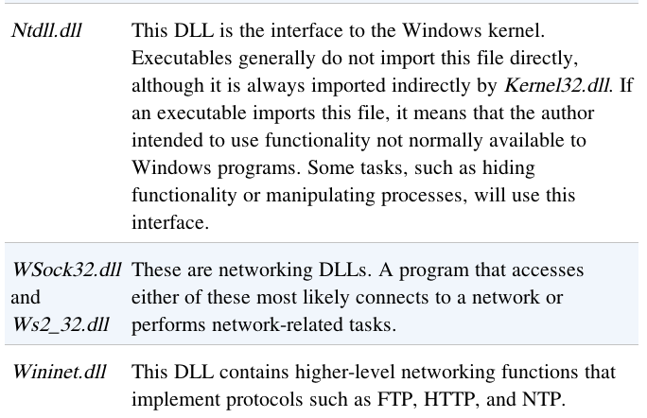

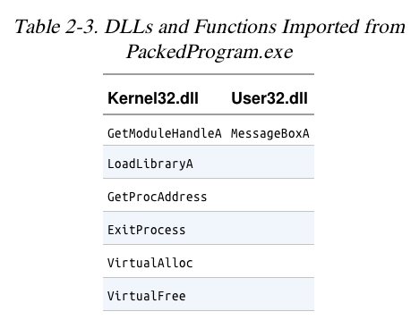
Example: Keylogger

Imports User32.dll and uses the function SetWindowsHookEx which is a popular way keyloggers receive keyboard inputs

It exports LowLevelKeyboardProc and LowLevelMouseProc to send the data elsewhere

It uses RegisterHotKey to define a special keystroke like Ctrl+Shift+P to harvest the collected data

Ex: A Packed Program

Very few functions

All you see is the unpacker
The PE File Headers and Sections

Important PE Sections

.text -- instructions for the CPU to execute

.rdata -- imports & exports

.data – global data

.rsrc – strings, icons, images, menus

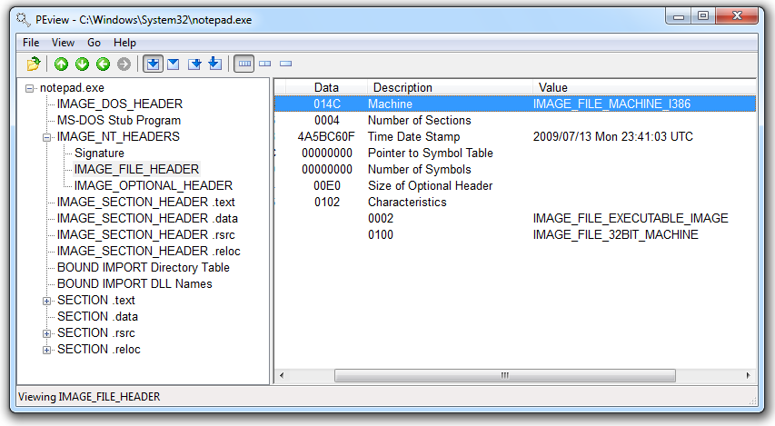
PEView (Link Ch 2e)

Time Date Stamp

Shows when this executable was compiled

Older programs are more likely to be known to antivirus software

But sometimes the date is wrong

All Delphi programs show June 19, 1992

Date can also be faked

IMAGE_SECTION_HEADER

Virtual Size – RAM

Size of Raw Data – DISK

For .text section, normally equal, or nearly equal

Packed executables show Virtual Size much larger than Size of Raw Data for .text section

Not Packed
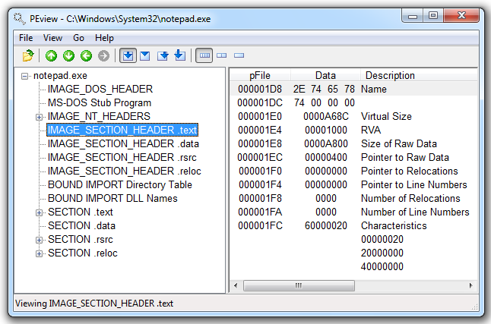

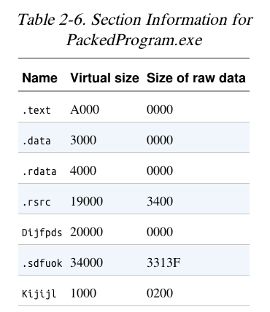

Resource Hacker

Lets you browse the .rsrc section

Strings, icons, and menus

Link Ch 2f

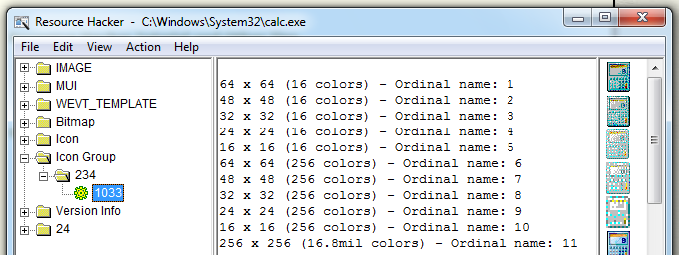
Resource Hacker in Windows XP seems more useful than Resource Hacker in Windows 7

Last modified 8-18-13

