WinDbg v. OllyDbg

OllyDbg is the most popular user-mode debugger for malware analysts

WinDbg can be used in either user-mode or kernel-mode

This chapter explores ways to use WinDbg for kernel debugging and rootkit analysis

Drivers and Kernel Code

Device Drivers

Windows device drivers allow third-party developers to run code in the Windows kernel

Drivers are difficult to analyze

They load into memory, stay resident, and respond to requests from applications

Applications don't directly access kernel drivers

They access device objects which send requests to particular devices

Devices

Devices are not physical hardware components

They are software representations of those components

Driver creates and destroys devices, which can be accessed from user space

USB Flash Drive

User plugs in flash drive

Windows creates the "F: drive" device object

Applications can now make requests to the F: drive

They will be sent to the driver for USB flash drives

Loading Drivers

Drivers must be loaded into the kernel

Just as DLLs are loaded into processes

When a driver is first loaded, its DriverEntry procedure is called

Just like DLLMail for DLLs

DriverEntry

DLLs expose functionality through the export table

Drivers must register the address for callback functions

They will be called when a user-space software component requests a service

DriverEntry performs this registration

Windows creates a driver object structure, passes it to DriverEntry which fills it with callback functions

DriverEntry then creates a device that can be accessed from user-land

Example: Normal Read

Normal read request

User-mode application obtains a file handle to device

Calls ReadFile on that handle

Kernel processes ReadFile request

Invokes the driver's callback function handling I/O

Malicious Request

Most common request from malware is DeviceIoControl

A generic request from a user-space module to a device managed by a driver

User-space program passes in an arbitrary-length buffer of input data

Received an arbitrary-length buffer of data as output

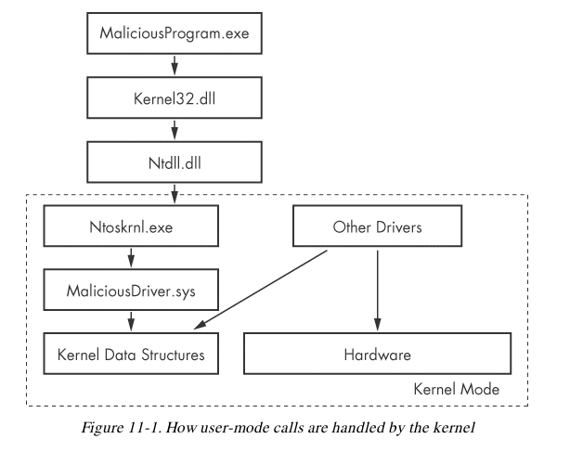
Ntoskrnl.dll & Hal.dll

Malicious drivers rarely control hardware

They interact with Ntoskrnl.dll & Hal.dll

Ntoskrnl.dll has code for core OS functions

Hal.dll has code for interacting with main hardware components

Malware will import functions from one or both of these files so it can manipulate the kernel
Setting Up Kernel Debugging

VMware

In the virtual machine, enable kernel debugging

Configure a virtual serial port between VM and host

Configure WinDbg on the host machine

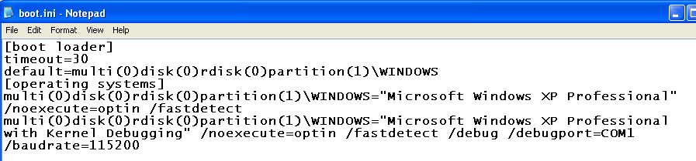
Edit C:\Boot.ini

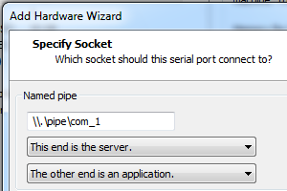
Second boot option enables debugging

This method won't work on Windows 7!

Add a Virtual Serial Port

Using WinDbg

Command-Line Commands

Reading from Memory

dx addressToRead

x can be

da Displays as ASCII text

du Displays as Unicode text

dd Displays as 32-bit double words

da 0x401020

Shows the ASCII text starting at 0x401020

Editing Memory

ex addressToWrite dataToWrite

x can be

ea Writes as ASCII text

eu Writes as Unicode text

ed Writes as 32-bit double words

Using Arithmetic Operators

Usual arithmetic operators + - / *

dwo reveals the value at a 32-bit location pointer

du dwo (esp+4)

Shows the first argument for a function, as a wide character string

Setting Breakpoints

bp sets breakpoints

You can specify an action to be performed when the breakpoint is hit

g tells it to resume running after the action

bp GetProcAddress "da dwo(esp+8); g"

Breaks when GetProcAddress is called, prints out the second argument, and then continues

The second argument is the function name

Listing Modules

lm

Lists all modules loaded into a process

Including EXEs and DLLs in user space

And the kernel drivers in kernel mode

As close as WinDbg gets to a memory map
Microsoft Symbols

Symbols are Labels

Including symbols lets you use

MmCreateProcessAddressSpace

instead of

0x8050f1a2

Searching for Symbols

moduleName!symbolName

Can be used anywhere an address is expected

moduleName

The EXE, DLL, or SYS filename (without extension)

symbolName

Name associated with the address

ntoskrnl.exe is an exception, and is named nt

Ex: u nt!NtCreateProcess

Unassembles that function (disassembly)

Deferred Breakpoints

bu newModule!exportedFunction

Will set a breakpoint on exportedFunction as soon as a module named newModule is loaded

$iment

Function that finds the entry point of a module

bu $iment(driverName)

Breaks on the entry point of the driver before any of the driver's code runs

Searching with x

You can search for functions or symbols using wildcards

x nt!*CreateProcess*

Displays exported functions & internal functions
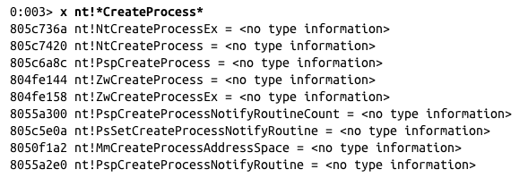

Listing Closest Symbol with ln

Helps in figuring out where a call goes

ln address

First lines show two closest matches

Last line shows exact match
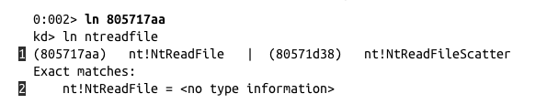

Viewing Structure Information with dt

Microsoft symbols include type information for many structures

Including undocumented internal types

They are often used by malware

dt moduleName!symbolName

dt moduleName!symbolName address

Shows structure with data from address

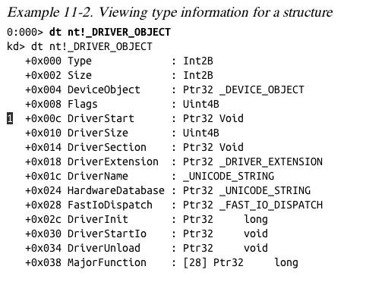

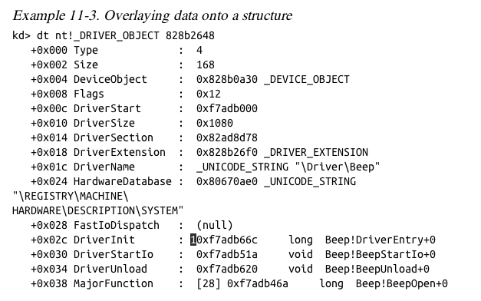

Initialization Function

The DriverInit function is called first when a driver is loaded

Malware will sometimes place its entire malicious payload in this function

Configuring Windows Symbols

If your debugging machine is connected to an always-on broadband link, you can configure WinDbg to automatically download symbols from Microsoft as needed

They are cached locally

File, Symbol File Path

SRC*c:\websymbols*http://msdl.microsoft.com/download/symbols

Manually Downloading Symbols

Link Ch 10a

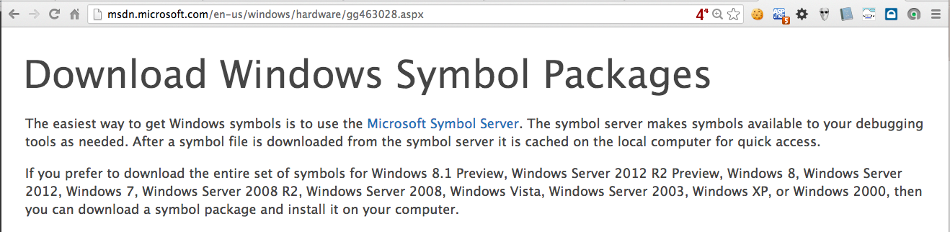

Kernel Debugging in Practice

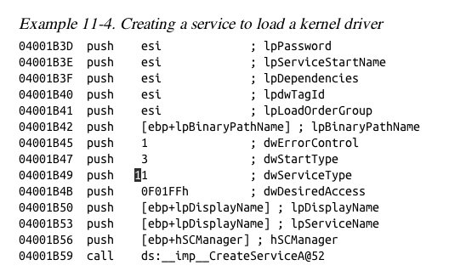
Kernel Mode and User Mode Functions

We'll examine a program that writes to files from kernel space

Kernel mode programs cannot call user-mode functions like CreateFile and WriteFile

Must use NtCreateFile and NtWriteFile

User-Space Code

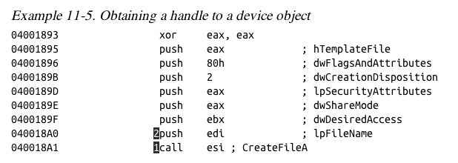
Creates a service with the CreateService function

dwServiceType is 0x01 (Kernel driver)

Not shown: edi being set to

\\.\FileWriter\Device

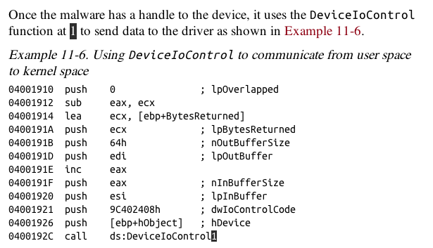

Kernel-Mode Code

Set kernel-mode debugger to Verbose mode

You'll see every kernel module that loads

Kernel modules are not loaded or unloaded often

Any loads are suspicious

Except Kmixer.sys in VMware machines
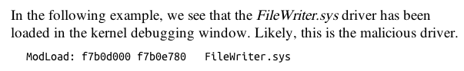

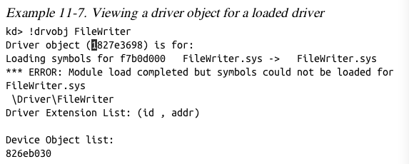

!drvobj command shows driver object

dt command shows structure
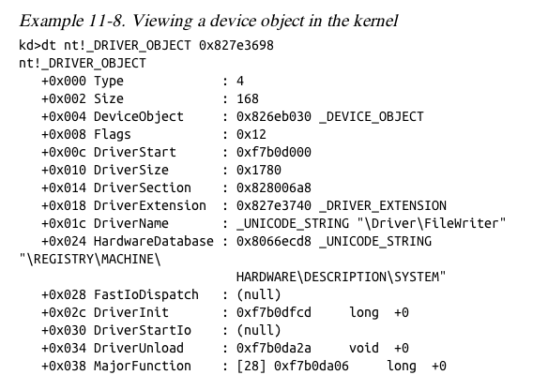

Kernel-Mode Filenames

Tracing this function, it eventually creates this file

\DosDevices\C:\secretfile.txt

This is a fully qualified object name

Identifies the root device, usually \DosDevices

Finding Driver Objects

Applications work with devices, not drivers

Look at user-space application to identify the interesting device object

Use device object in User Mode to find driver object in Kernel Mode

Use !devobj to find out more about the driver object

Use !devhandles to find application that use the driver
Rootkits

Rootkit Basics

Rootkits modify the internal functionality of the OS to conceal themselves

Hide processes, network connections, and other resources from running programs

Difficult for antivirus, administrators, and security analysts to discover their malicious activity

Most rootkits modify the kernel

Most popular method:

System Service Descriptor Table (SSDT) hooking

System Service Descriptor Table (SSDT)

Used internally by Microsoft

To look up function calls into the kernel

Not normally used by third-party applications or drivers

Only three ways for user space to access kernel code

SYSCALL

SYSENTER

INT 0x2E

SYSENTER

Used by modern versions of Windows

Function code stored in EAX register

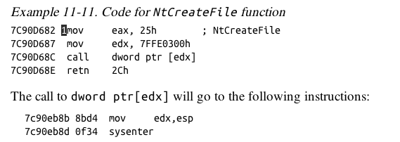
Example from ntdll.dll

EAX set to 0x25

Stack pointer saved in EDX

SYSENTER is called

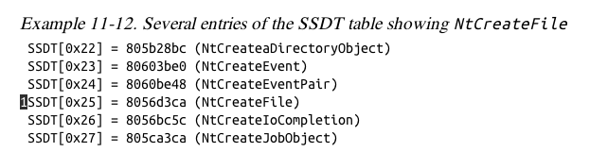

SSDT Table Entries

Rootkit changes the values in the SSDT so rootkit code is called instead of the intended function

0x25 would be changed to a malicious driver's function

Hooking NtCreateFile won't hide a file, however

Rootkit Analysis in Practice

Simplest way to detect SSDT hooking

Just look at the SSDT

Look for values that are unreasonable

In this case, ntoskrnl.exe starts at address 804d7000 and ends at 806cd580

ntoskrnl.exe is the Kernel!

lm m nt

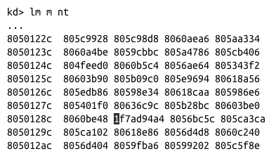
Lists modules matching "nt" (Kernel modules)

Shows the SSDT table

SSDT Table

Marked entry is hooked

To identify it, examine a clean system's SSDT

Finding the Malicious Driver

lm

Lists open modules

In the kernel, they are all drivers
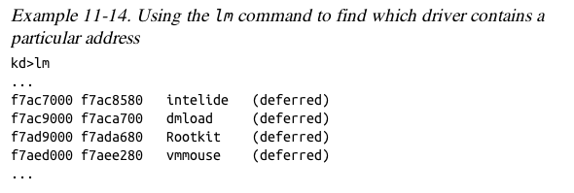

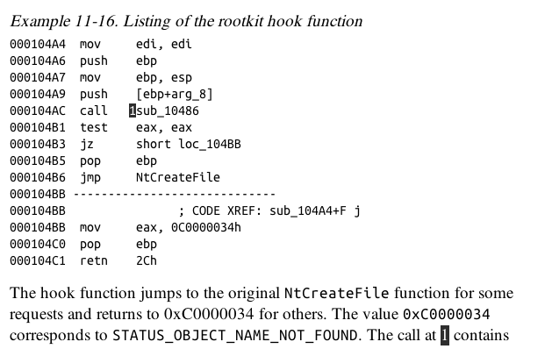

Interrupts

Interrupts allow hardware to trigger software events

Driver calls IoConnectInterrupt to register a handler for an interrupt code

Specifies an Interrupt Service Routine (ISR)

Will be called when the interrupt code is generated

Interrupt Descriptor Table (IDT)

Stores the ISR information

!idt command shows the IDT

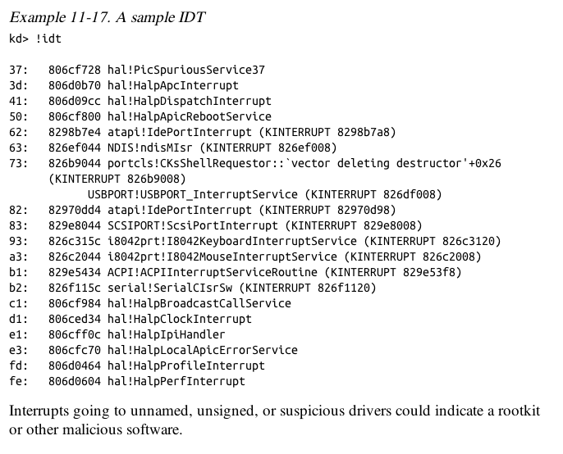

Loading Drivers

If you want to load a driver to test it, you can download the OSR Driver Loader tool

Kernel Issues for Windows Vista, Windows 7, and x64 Versions

Uses BCDedit instead of boot.ini

x64 versions starting with XP have PatchGuard

Prevents thirdparty code from modifying the kernel

Including kernel code itself, SSDT, IDT, etc.

Can interfere with debugging, because debugger patches code when inserting breakpoints

There are 64-bit kernel debugging tools

Link Ch 10c

Driver Signing

Enforced in all 64-bit versions of Windows starting with Vista

Only digitally signed drivers will load

Effective protection!

Kernel malware for x64 systems is practically nonexistent

You can disable driver signing enforcement by specifying nointegritychecks in BCDEdit

Last modified 10-21-13

