Downloaders and Launchers

Downloaders

Download another piece of malware

And execute it on the local system

Commonly use the Windows API URLDownloadtoFileA, followed by a call to WinExec

Launchers (aka Loaders)

Prepares another piece of malware for covert execution

Either immediately or later

Stores malware in unexpected places, such as the .rsrc section of a PE file
Backdoors

Backdoors

Provide remote access to victim machine

The most common type of malware

Often communicate over HTTP on Port 80

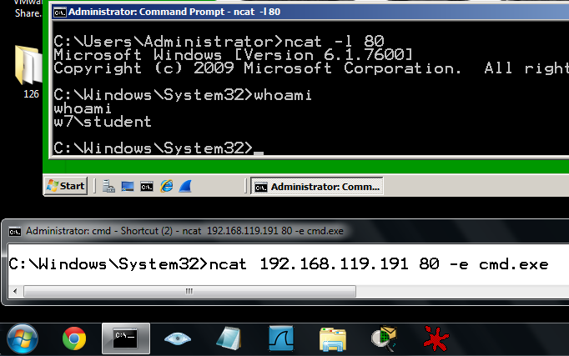
Network signatures are helpful for detection

Common capabilities

Manipulate Registry, enumerate display windows, create directories, search files, etc.

Reverse Shell

Infected machine calls out to attacker, asking for commands to execute

Windows Reverse Shells

Basic

Call CreateProcess and manipulate STARTUPINFO structure

Create a socket to remote machine

Then tie socket to standard input, output, and error for cmd.exe

CreateProcess runs cmd.exe with its window suppressed, to hide it

Windows Reverse Shells

Multithreaded

Create a socket, two pipes, and two threads

Look for API calls to CreateThread and CreatePipe

One thread for stdin, one for stdout

RATs (Remote Administration Tools)

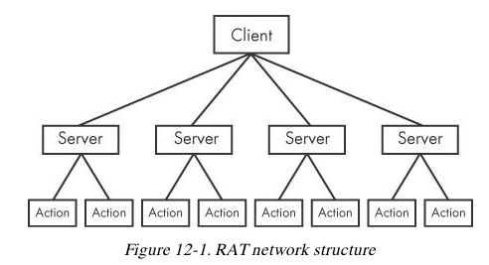
Ex: Poison Ivy

Botnets

A collection of compromised hosts

Called bots or zombies

Botnets v. RATs

Botnet contain many hosts; RATs control fewer hosts

All bots are controlled at once; RATs control victims one by one

RATs are for targeted attacks; botnets are used in mass attacks
Credential Stealers

Credential Stealers

Three types

Wait for user to log in and steal credentials

Dump stored data, such as password hashes

Log keystrokes

GINA Interception

Windows XP's Graphical Identification and Authentication (GINA)

Intended to allow third parties to customize logon process for RFID or smart cards

Intercepted by malware to steal credentials

GINA is implemented in msgina.dll

Loaded by WinLogon executable during logon

WinLogon also loads third-party customizations in DLLs loaded between WinLogon and GINA

GINA Registry Key

HKLM\SOFTWARE\Microsoft\Windows NT\CurrentVersion\Winlogon\GinaDLL

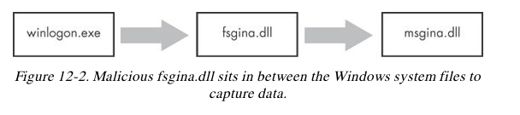
Contains third-party DLLs to be loaded by WinLogon

MITM Attack

Malicious DLL must export all functions the real msgina.dll does, to act as a MITM

More than 15 functions

Most start with Wlx

Good indicator

Malware DLL exporting a lot of Wlx functions is probably a GINA interceptor

WlxLoggedOutSAS

Most exports simply call through to the real functions in msgina.dll

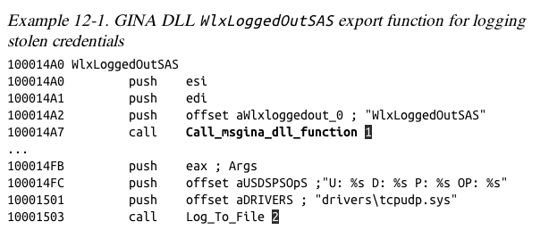
At 2, the malware logs the credentials to the file %SystemRoot%\system32\drivers\tcpudp.sys

Hash Dumping

Windows login passwords are stored as LM or NTLM hashes

Hashes can be used directly to authenticate (pass-the-hash attack)

Or cracked offline to find passwords

Pwdump and Pass-the-Hash Toolkit

Free hacking tools that provide hash dumping

Open-source

Code re-used in malware

Modified to bypass antivirus

Pwdump

Injects a DLL into LSASS (Local Security Authority Subsystem Service)

To get hashes from the SAM (Security Account Manager)

Injected DLL runs inside another process

Gets all the privileges of that process

LSASS is a common target

High privileges

Access to many useful API functions

Pwdump

Injects lsaext.dll into lsass.exe

Calls GetHash, an export of lsaext.dll

Hash extraction uses undocumented Windows function calls

Attackers may change the name of the GetHash function

Pwdump Variant

Uses these libraries

samsrv.dll to access the SAM

advapi32.dll to access functions not already imported into lsass.exe

Several Sam functions

Hashes extracted by SamIGetPrivateData

Decrypted with SystemFunction025 and SystemFunction027

All undocumented functions
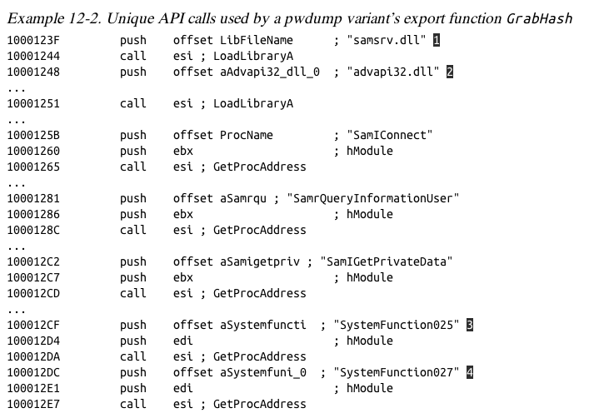

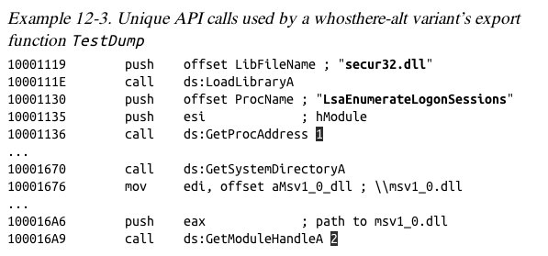
Pass-the-Hash Toolkit

Injects a DLL into lsass.exe to get hashes

Program named whosthere-alt

Uses different API functions than Pwdump

Keystroke Logging

Kernel-Based Keyloggers

Difficult to detect with user-mode applications

Frequently part of a rootkit

Act as keyboard drivers

Bypass user-space programs and protections

User-Space Keyloggers

Use Windows API

Implemented with hooking or polling

Hooking

Uses SetWindowsHookEx function to notify malware each time a key is pressed

Polling

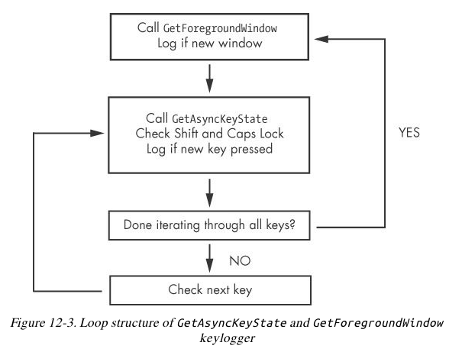
Uses GetAsyncKeyState & GetForegroundWindow to constantly poll the state of the keys

Polling Keyloggers

GetAsyncKeyState

Identifies whether a key is pressed or unpressed

GetForegroundWindow

Identifies the foreground window

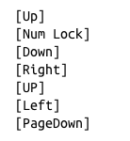
Identifying Keyloggers in Strings Listings

Persistence Mechanisms

Three Persistence Mechanisms

Registry modifications, such as Run key

Other important registry entries:

AppInit_DLLs

Winlogon Notify

ScvHost DLLs

Registry Modifications

Run key

HKEY_LOCAL_MACHINE\ SOFTWARE\ Microsoft\ Windows\ CurrentVersion\ Run

Many others, as revealed by Autoruns

ProcMon shows registry modifications

AppInit_DLLs

APPINIT DLLS

AppInit_DLLs are loaded into every process that loads User32.dll

This registry key contains a space-delimited list of DLLs

HKEY_LOCAL_MACHINE\ SOFTWARE\ Microsoft\ Windows NT\ CurrentVersion\ Windows

Many processes load them

Malware will call DLLMain to check which process it is in before launching payload

Winlogon Notify

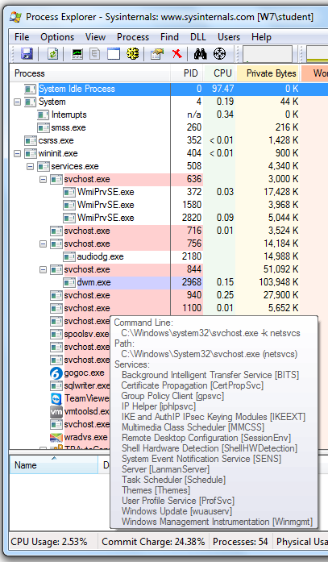
Notify value in

HKEY_LOCAL_MACHINE\ SOFTWARE\ Microsoft\ Windows

These DLLs handle winlogon.exe events

Malware tied to an event like logon, startup, lock screen, etc.

It can even launch in Safe Mode

ScvHost DLLs

Scvhost is a generic host process for services that run as DLLs

Many instances of Scvhost are running at once

Groups defined at

HKEY_LOCAL_MACHINE\ SOFTWARE\ Microsoft\ Windows NT\ CurrentVersion\ Svchost

Services defined at

HKEY_LOCAL_MACHINE\ System\ CurrentControlSet\ Services\ ServiceName

Process Explorer

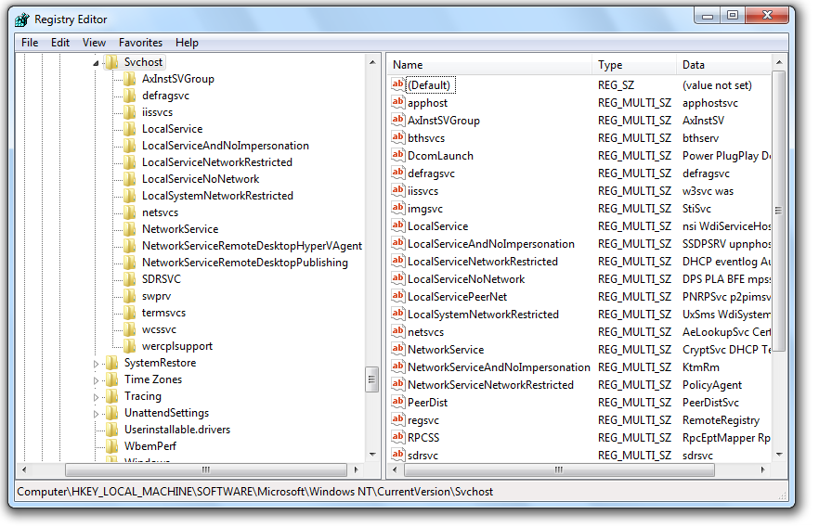

ServiceDLL

All svchost.exe DLL contain a Parameters kety with a ServiceDLL value

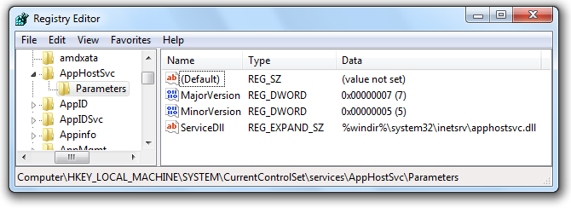
Malware sets ServiceDLL to location of malicious DLL

Groups

Malware usually adds itself to an existing group

Or overwrites a nonvital service

Often a rarelyused service from the netsvcs group

Detect this with dynamic analysis monitoring the registry

Or look for service functions like CreateServiceA in disassembly

Trojanized System Binaries

Malware patches bytes of a system binar

To force the system to execute the malware

The next time the infected binary is loaded

DLLs are popular targets

Typically the entry function is modified

Jumps to code inserted in an empty portion of the binary

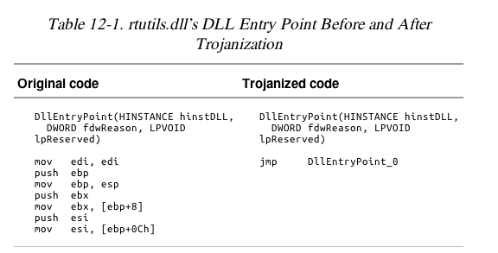
Then executes DLL normally

DLL Load-Order Hijacking
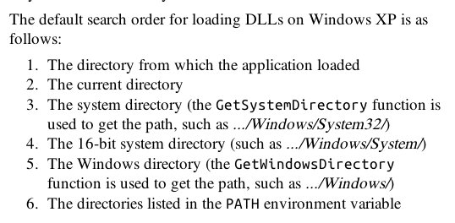

KnownDLLs Registry Key

Contains list of specific DLL locations

Overrides the search order for listed DLLs

DLL load-order hijacking can only be used

On binarues in directories other than System32

That load DLLs in System32

That are not protected by KnownDLLs

Example: explorer.exe

Lives in /Windows

Loads ntshrui.dll from System32

ntshrui.dll is not a known DLL

Default search is performed

A malicious ntshrui.dll in /Windows will be loaded instead

Many Vulnerable DLLs

Any startup binary not found in /System32 is vulnerable

explorer.exe has about 50 vulnerable DLLs

Known DLLs are not fully protected, because

Many DLLs load other DLLs

Recursive imports follow the default search order

Privilege Escalation

No User Account Control

Most users run Windows XP as Administrator all the time, so no privilege escalation is needed to become Administrator

Metasploit has many privilege escalation exploits

DLL load-order hijacking can be used to escalate privileges

Using SeDebugPrivilege

Processes run by the user can't do ev erything

Functions like TerminateProcess or CreateRemoteThread require System privileges

The SeDebugPrivilege privilege was intended for debugging

Allows local Administrator accounts to escalate to System privileges

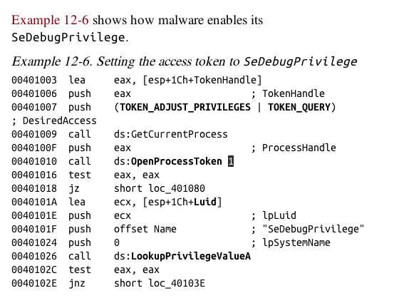

1 obtains an access token
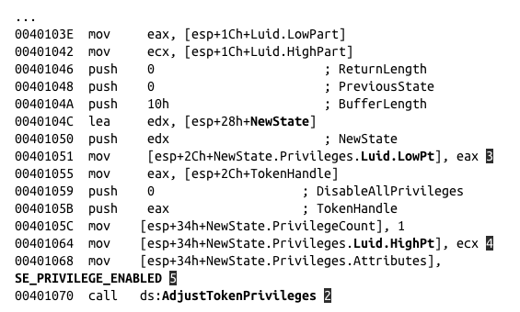

2 AdjustTokenPrivileges raises privileges to System

Covering Its Tracks—User-Mode Rootkits

User-Mode Rootkits

Modify internal functionality of the OS

Hide files, network connections, processes, etc.

Kernel-mode rootkits are more powerful

This section is about User-mode rootkits

IAT (Import Address Table) Hooking

May modify

IAT (Import Address Table) or

EAT (Export Address Table)

Parts of a PE file

Filled in by the loader

Link Ch 11a

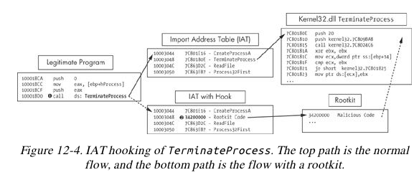
IAT Hooking

Inline Hooking

Overwrites the API function code

Contained in the imported DLLs

Changes actual function code, not pointers

Last modified 10-26-13

