Launchers

Purpose of a Launcher

Sets itself or another piece of malware

For immediate or future covert execution

Conceals malicious behavior from the user

Usually contain the malware they're loading

An executable or DLL in its own resource section

Normal items in the resource section

Icons, images, menus, strings

Encryption or Compression

The resource section may be encrypted or compressed

Resource extraction will use APIs like

FindResource

LoadResource

SizeofResource

Often contains privilege escalation code
Process Injection

Process Injection

The most popular covert launching process

Injects code into a running process

Conceals malicious behavior

May bypass firewalls and other process-specific security mechanisms

Common API calls:

VirtualAllocEx to allocate space

WriteProcessMemory to write to it

DLL Injection

The most commonly used covert launching technique

Inject code into a remote process that calls LoadLibrary

Forces the DLL to load in the context of that process

On load, the OS automatically calls DLLMain which contains the malicious code

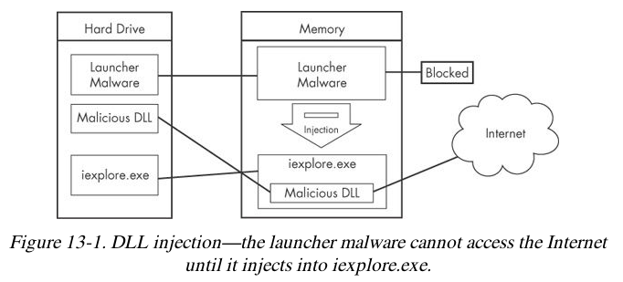
Gaining Privileges

Malware code has the same privileges as the code it is injected into

CreateRemoteThread uses 3 parameters

Process handle hProcess

Starting point lpStartAddress (LoadLibrary)

Argument lpParameter Malicious DLL name

Direct Injection

Injects code directly into the remote process

Without using a DLL

More flexible than DLL injection

Requires a lot of customized code

To run without negatively impacting the host process

Difficult to write
Process Replacement

Process Replacement

Overwrites the memory space of a running object with malicious code

Disguises malware as a legitimate process

Avoids risk of crashing a process with process injection

Malware gains the privileges of the process it replaces

Commonly replaces svchost.exe

Suspended State

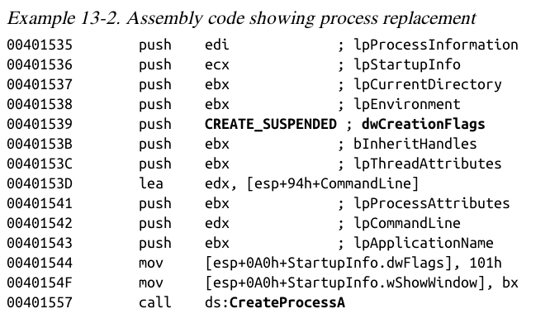
In a suspended state, the process is loaded into memory but the primary thread is suspended

This uses the CREATE_SUSPENDED value

in the dwCreationFlags parameter

In a call to the CreateProcess function

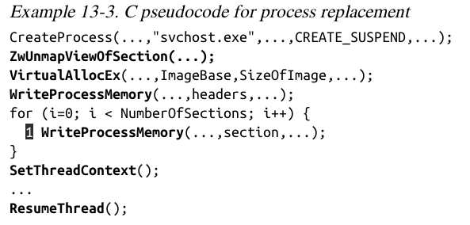
ZwUnmapViewOfSection releases all memory pointed to by a section

VirtualAllocEx allocates new memory

WriteProcessMemory puts malware in it

SetThreadContext restores the victim process's environment and sets the entry

VirtualAllocEx allocates new memory

WriteProcessMemory puts malware in it

Hook Injection

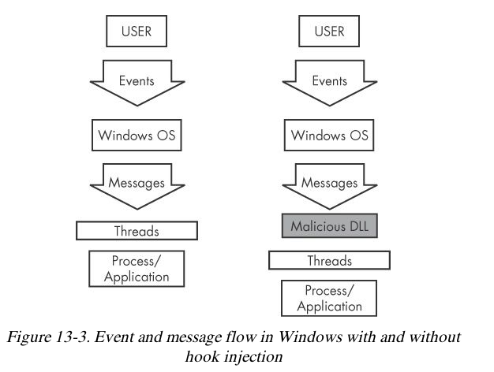
Hooks

Windows hooks intercept messages destined for applications

Malicious hooks

Ensure that malicious code will run whenever a particular message is intercepted

Ensure that a DLL will be loaded in a victim process's memory space

Local and Remote Hooks

Local hooks observe or manipulate messages destined for an internal process

Remote hooks observe or manipulate messages destined for a remote process (another process on the computer)

High-Level and Low-Level Remote Hooks

High-level remote hooks

Require that the hook procedure is an exported function contained in DLL

Mapped by the OS into the process space of a hooked thread or all threads

Low-level remote hooks

Require that the hook procedure be contained in the process that installed the hool

Keyloggers Using Hooks

Keystrokes can be captured by high-level or low-level hooks using these procedure types

WH_KEYBOARD or WH_KEYBOARD_LL

Using SetWindowsHookEx

Parameters

idHook – type of hook to install

lpfn – points to hook procedure

hMod – handle to DLL, or local module, in which the lpfn procedure is defined

dwThrearId– thread to associate the hook with. Zero = all threads

The hook procedure must call CallNextHookEx to pass execution to the next hook procedure so the system continues to run properly

Thread Targeting

Loading into all threads can degrade system performance

May also trigger an IPS

Keyloggers load into all threads, to get all the keystrokes

Other malware targets a single thread

Often targets a Windows message that is rarely used, such as WH_CBT (a computer-based training message)

Malicious DLL hook.dll is loaded

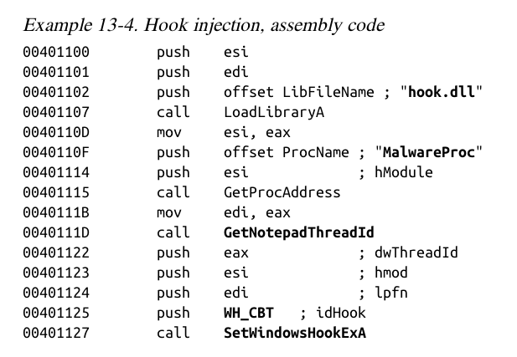
Malicious hook procedure address obtained

The hook procedure calls only CallNextHookEx

A WH_CBT message is sent to a Notepad thread

Forces hook.dll to be loaded by Notepad

It runs in the Notepad process space

Detours

A Microsoft Product

Detours makes it easy for application developers to modify applications and the OS

Used in malware to add new DLLs to existing binaries on disk

Modifies the PE structure to create a .detour section

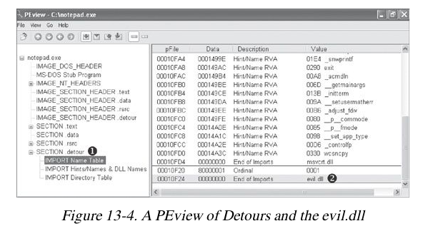
Containing original OE header with a new import address table

setdll is the Microsoft tool used to point the PE to the new import table

There are other ways to add a .detour section

APC Injection

Asynchronous Procedure Call
(APC)

Directs a thread to execute other code prior to executing its regular path

Every thread has a queue of APCs attached to it

These are processed when the thread is in an alterable state, such as when these functions are called

WaitForSingleObjectEx

WaitForMultipleObjectsEx

Sleep

Two Forms of APCs

Kernel-Mode APC

Generated for the system or a driver

User-Mode APC

Generated for an application

APC Injection is used in both cases

APC Injection from User Space

Uses API function QueueUserAPC

Thread must be in an alterable state

WaitForSingleObjectEx is the most common call in the Windows API

Many threads are usually in the alterable state

QueueUserAPC Parameters

hThread handle to

pfnAPC defines the function to run

dwData parameter for function
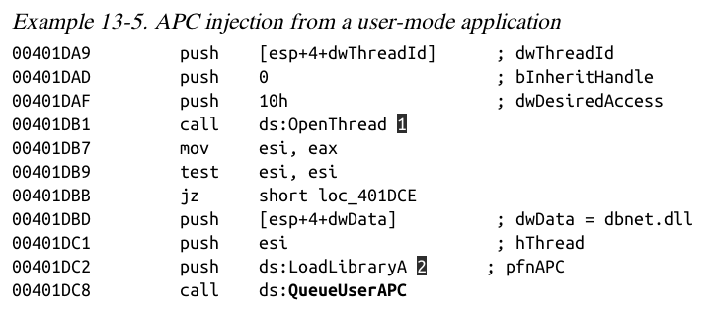

1: Opens a handle to the thread

2: QueueUserAPC is called with pfnAPC set to LoadLibraryA (loads a DLL)

dwData contains the DLL name (dbnet.dll)

Svchost.exe is often targeted for APC injection

APC Injection from Kernel Space

Malware drivers and rootkits often want to execute code in user space

This is difficult to do

One method is APC injection to get to user space

Most often to svchost.exe

Functions used:

KeInitializeApc

KeInsertQueueApc

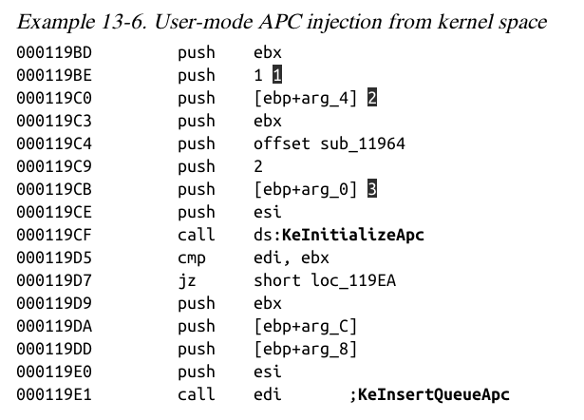

Last modified 11-3-13

