The Goal of Analyzing Encoding Algorithms

Reasons Malware Uses Encoding

Hide configuration information

Such as C&C domains

Save information to a staging file

Before stealing it

Store strings needed by malware

Decode them just before they are needed

Disguise malware as a legitimate tool

Hide suspicious strings
Simple Ciphers

Why Use Simple Ciphers?

They are easily broken, but

They are small, so they fit into space-constrained environments like exploit shellcode

Less obvious than more complex ciphers

Low overhead, little impact on performance

These are obfuscation, not encryption

They make it difficult to recognize the data, but can't stop a skilled analyst

Caesar Cipher

Move each letter forward 3 spaces in the alphabet

ABCDEFGHIJKLMNOPQRSTUVWXYZ

DEFGHIJKLMNOPQRSTUVWXYZABC

Example

ATTACK AT NOON

DWWDFN DW QRRQ

XOR
0 xor 0 = 0
0 xor 1 = 1
1 xor 0 = 1
1 xor 1 = 0

Uses a key to encrypt data

Uses one bit of data and one bit of the key at a time

Example: Encode HI with a key of 0x3c

HI = 0x48 0x49 (ASCII encoding)

Data: 0100 1000 0100 1001

Key: 0011 1100 0011 1100

Result: 0111 0100 0111 0101
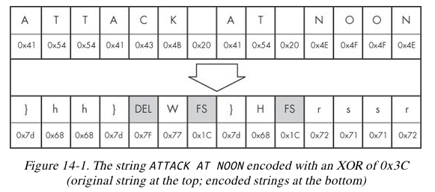

XOR Reverses Itself

Example: Encode HI with a key of 0x3c

HI = 0x48 0x49 (ASCII encoding)

Data: 0100 1000 0100 1001

Key: 0011 1100 0011 1100

Encode it again

Result: 0111 0100 0111 0101

Key: 0011 1100 0011 1100

Data: 0100 1000 0100 1001

Brute-Forcing XOR Encoding

If the key is a single byte, there are only 256 possible keys

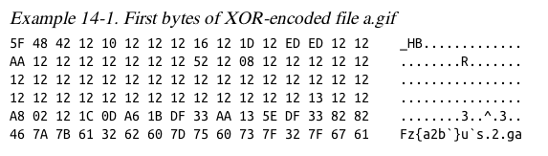
Error in book; this should be "a.exe"

PE files begin with MZ

MZ = 0x4d 0x5a

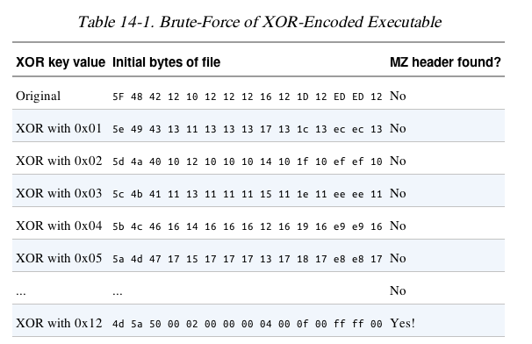

Tools for examining XOR obfuscation for Malware Analysis

Link Ch 13a
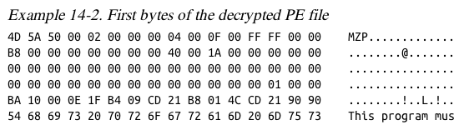

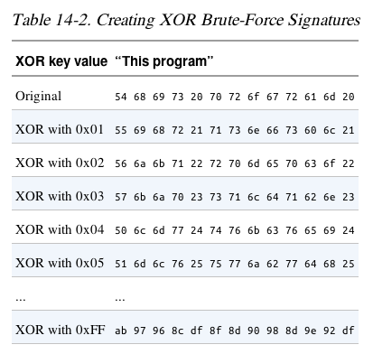
Brute-Forcing Many Files

Look for a common string, like "This Program"

XOR and Nulls

A null byte reveals the key, because

0x00 xor KEY = KEY

Obviously the key here is 0x12

NULL-Preserving Single-Byte XOR Encoding

Algorithm:

Use XOR encoding, EXCEPT

If the plaintext is NULL or the key itself, skip the byte
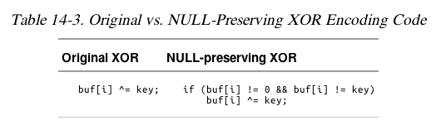

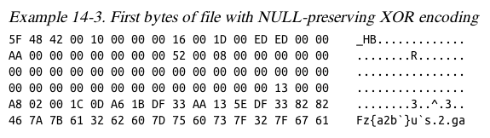

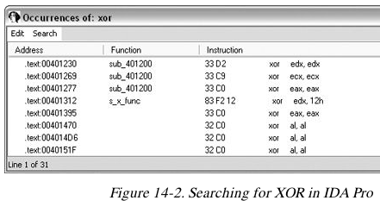

Identifying XOR Loops in IDA Pro

Small loops with an XOR instruction inside

Start in "IDA View" (seeing code)

Click Search, Text

Enter xor and Find all occurrences

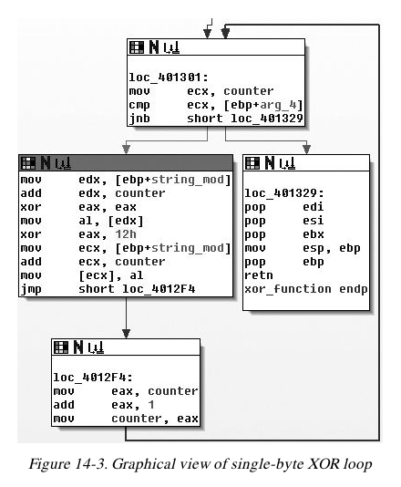
Three Forms of XOR

XOR a register with itself, like xor edx, edx

Innocent, a common way to zero a register

XOR a register or memory reference with a constant

May be an encoding loop, and key is the constant

XOR a register or memory reference with a different register or memory reference

May be an encoding loop, key less obvious

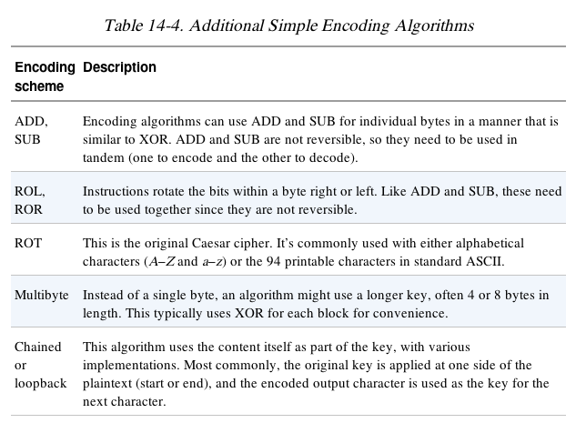

Base64

Converts 6 bits into one character in a 64-character alphabet

There are a few versions, but all use these 62 characters:

ABCDEFGHIJKLMNOPQRSTUVWXYZ

abcdefghijklmnopqrstuvwxyz

0123456789

MIME uses + and /

Also = to indicate padding

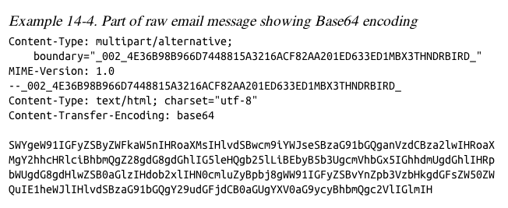

Transforming Data to Base64

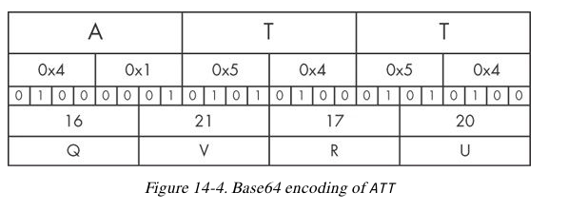
Use 3-byte chunks (24 bits)

Break into four 6-bit fields

Convert each to Base64

base64encode.org
base64decode.org

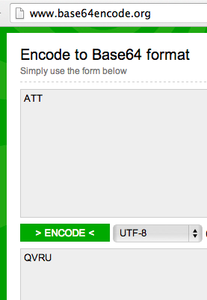

3 bytes encode to 4 Base64 characters

Padding

If input had only 2 characters, an = is appended

If input had only 1 character, == is appended

ATT -> QVRU

AT -> QVQ=

A -> QQ==

Example

URL and cookie are Base64-encoded

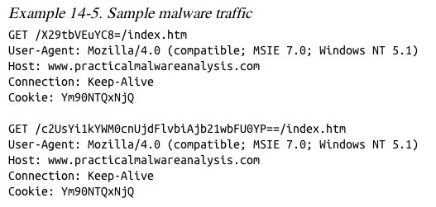

Cookie: Ym90NTQxNjQ

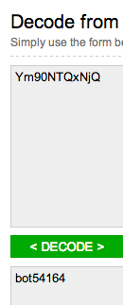
This has 11 characters—padding is omitted

Some Base64 decoders will fail, but this one just automatically adds the missing padding

Finding the Base64 Function

Look for this "indexing string"

ABCDEFGHIJKLMNOPQRSTUVWXYZabcdefghijklmnopqrstuvwxyz0123456789+/

Look for a lone padding character (typically =) hard-coded into the encoding function

Decoding the URLs

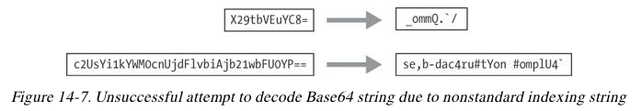

Custom indexing string

aABCDEFGHIJKLMNOPQRSTUVWXYZbcdefghijklmnopqrstuvwxyz0123456789+/

Look for a lone padding character (typically =) hard-coded into the encoding function
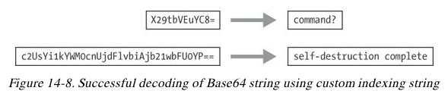

Common Cryptographic Algorithms

Strong Cryptography

Strong enough to resist brute-force attacks

Ex: SSL, AES, etc.

Disadvantages of strong encryption

Large cryptographic libraries required

May make code less portable

Standard cryptographic libraries are easily detected

Via function imports, function matching, or identification of cryptographic constants

Symmetric encryption requires a way to hide the key

Recognizing Strings and Imports

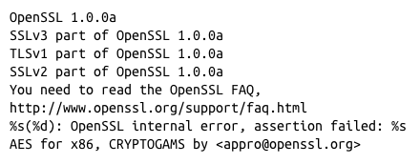
Strings found in malware encrypted with OpenSSL

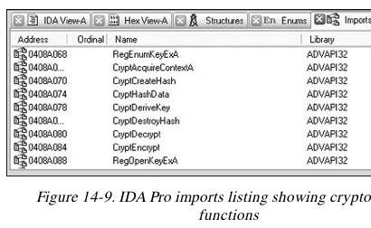

Microsoft crypto functions usually start with Crypt or CP or Cert

Searching for Cryptographic Constants

IDA Pro's FindCrypt2 Plug-in (Link Ch 13c)

Finds magic constants (binary signatures of crypto routines)

Cannot find RC4 or IDEA routines because they don't use a magic constant

RC4 is commonly used in malware because it's small and easy to implement

FindCrypt2

Runs automatically on any new analysis

Can be run manually from the Plug-In Menu
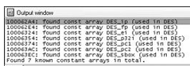

Krypto ANALyzer (PEiD Plug-in)

Download from link Ch 13d

Has wider range of constants than FindCrypt2

More false positives

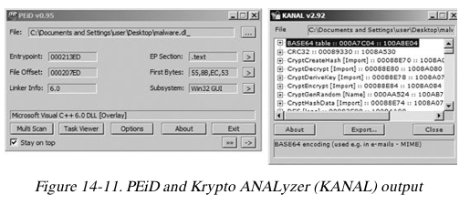
Also finds Base64 tables and crypto function imports

Entropy

Entropy measures disorder

To calculate it, just count the number of occurrences of each byte from 0 to 255

Calculate Pi = Probability of value i

Then sum Pi log( Pi) for I = 0 to 255 (Link 13e)

If all the bytes are equally likely, the entropy is 8 (maximum disorder)

If all the bytes are the same, the entropy is zero

Searching for High-Entropy Content

IDA Pro Entropy Plugin

Finds regions of high entropy, indicating encryption (or compression)
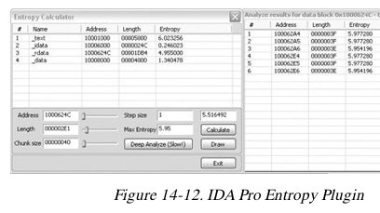

Recommended Parameters

Chunk size: 64 Max. Entropy: 5.95

Good for finding many constants,

Including Base64-encoding strings (entropy 6)

Chunk size: 256 Max. Entropy: 7.9

Finds very random regions

Entropy Graph

IDA Pro Entropy Plugin

Draw button

Lighter regions have high entropy

Hover over graph to see numerical value

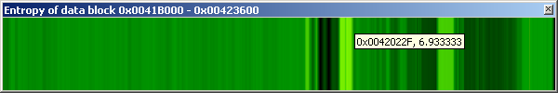

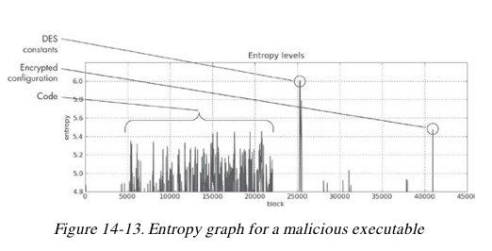

Custom Encoding

Homegrown Encoding Schemes

Examples

One round of XOR, then Base64

Custom algorithm, possibly similar to a published cryptographic algorithm
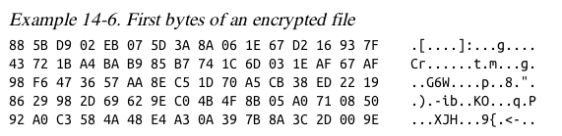

Identifying Custom Encoding

This sample makes a bunch of 700 KB files

Figure out the encoding from the code

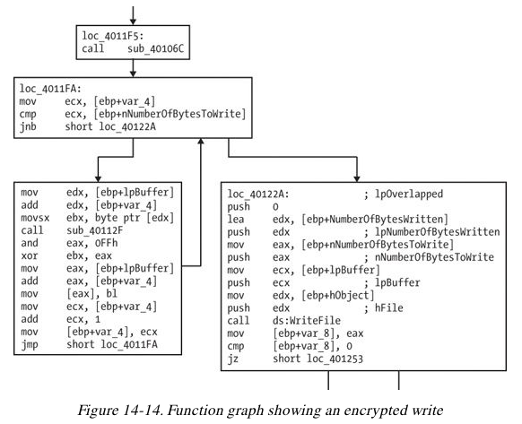
Find CreateFileA and WriteFileA

In function sub_4011A9

Uses XOR with a pseudorandom stream

Advantages of Custom Encoding to the Attacker

Can be small and nonopbious

Harder to reverse-engineer

Decoding

Two Methods

Reprogram the functions

Use the functions in the malware itself

Self-Decoding

Stop the malware in a debugger with data decoded

Isolate the decryption function and set a breakpoint directly after it

BUT sometimes you can't figure out how to stop it with the data you need decoded

Manual Programming of Decoding Functions

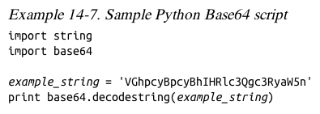
Standard functions may be available

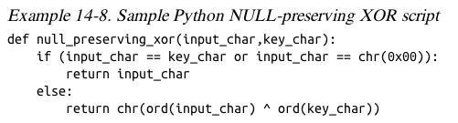

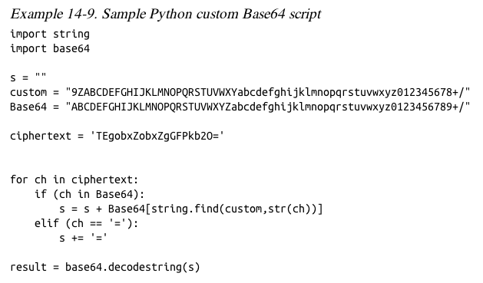

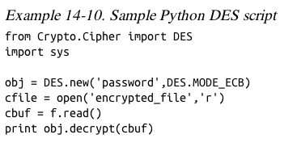

PyCrypto Library

Good for standard algorithms

How to Decrypt Using Malware

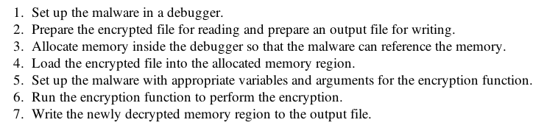

Last modified 11-16-13

