Network Countermeasures

Common Network Countermeasures

Filtering with firewalls and routers

By IP address, TCP and UDP ports

DNS Servers

Resolve malicious domain names to an internal host (a sinkhole )

Proxy servers

Can detect or prevent access to specific domains

Content-Based Countermeasures

These devices can look at layer 7 data (deep packet inspection)

IDS (Intrusion Detection System)

IPS (Intrusion Prevention System)

Email proxy

Web proxy

Observing the Malware in Its Natural Habitat

Before static or dynamic analysis

Mine logs, alerts, and packet captures generated by malware in its original location

Advantages of Real Networks

Live-captured data is the most accurate

Some malware detects lab environments

Real traffic contains information about both ends, infected host and C&C server

Passively monitoring traffic cannot be detected by the attacker

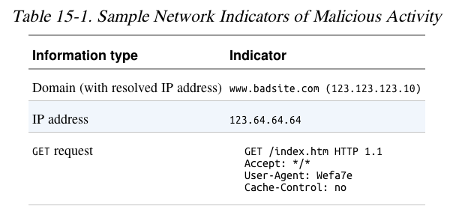
OPSEC (Operational Security)

Indications of Malicious Activity

OPSEC

Preventing adversaries from obtaining sensitive information

Running malware at home may alert attackers

Who expected it to be run in a company

Ways an Attacker Can Identify Investigative Activity

Send spear-phishing email with a link to a specific individual

Watch for access attempts outside the expected geographic area

Design an exploit that logs infections

In a blog comment, Twitter, Pastebin, etc.

Embed an unused domain in malware

Watch for attempts to resolve the domain
Safely Investigate an Attacker Online

Indirection Tactics

Proxy server, Tor, Web-based anonymizer

Not subtle—it's obvious that you are hiding

Use a dedicated VM for research

Hide its location with a cellular or VPN connection

Use an ephemeral cloud machine

Such as an Amazon E2C virtual machine

Search Engines

Usually safe

If the domain was previously unknown to the search engine, it may be crawled

Clicking results still activates secondary links on the site

Even opening cached resources
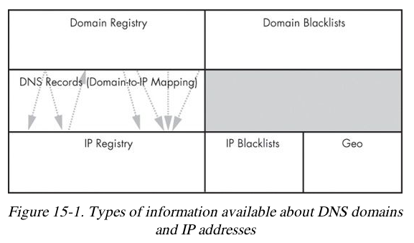

Getting IP Address and Domain Information

Command-Line v.Web-Based Lookups

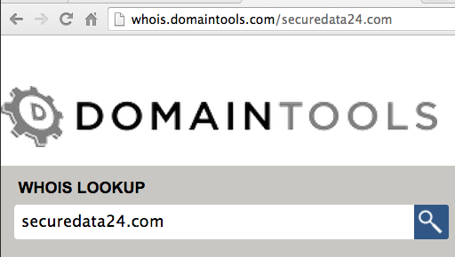
whois and dig can be used, but they will expose your IP address

Websites that do the query for you provide anonymity

May give more information

DomainTools

Historical DNS records

Reverse IP lookups

Reverse whois (lookup based on contact information metadata)

RobTex

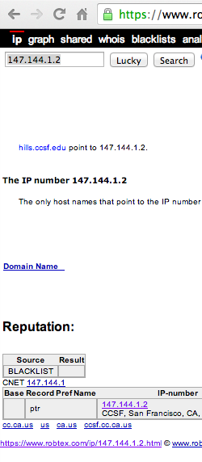
Finds multiple domain names that point to a single IP address

Checks blacklists

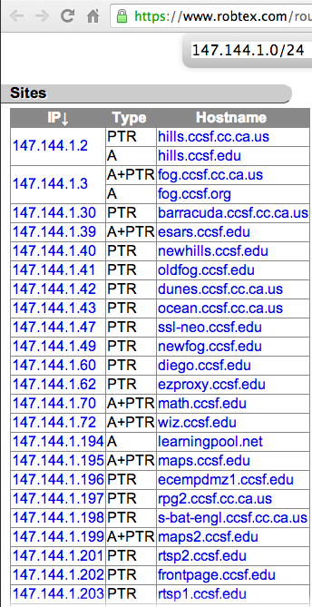

BFK DNS Logger

Gathers data with passive DNS monitoring

Stealthy

Content-Based Network Countermeasures

Intrusion Detection with Snort

Rule-based detection, can use:

TCP or IP headers

Size of payload

Connection state (such as ESTABLISHED)

Layer 7 payload data

Snort Rule to Block HTTP Traffic by User-Agent
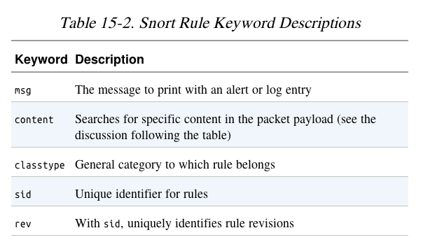

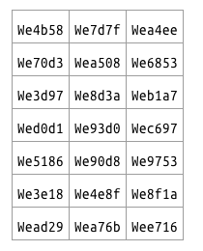

Taking a Deeper Look

Running the malware several times shows these User-Agent strings

Rules can be fine-tuned to capture the malware without false positives

Combining Dynamic and Static Analysis Techniques

Two Objectives of Deeper Analysis

Full coverage of functionality

Provide new inputs to drive the malware down unused paths

Using iNetSim or custom scripts

Understanding functionality, including inputs and outputs

Static analysis finds where and how content is generated

Dynamic analysis confirms the expected behavior

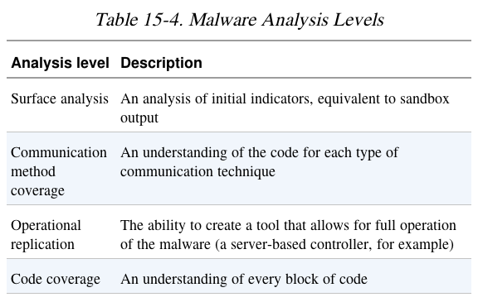
Danger of Overanalysis

Hiding in Plain Sight

Attackers mimic existing protocols

Often HTTP, HTTPS, and DNS

HTTP for beaconing (request for instructions)

HTTPS hides the nature and intent of communications

Information can be transmitted in DNS requests

For example, in long domain names

GETs

Used to send a command prompt followed by a directory listing

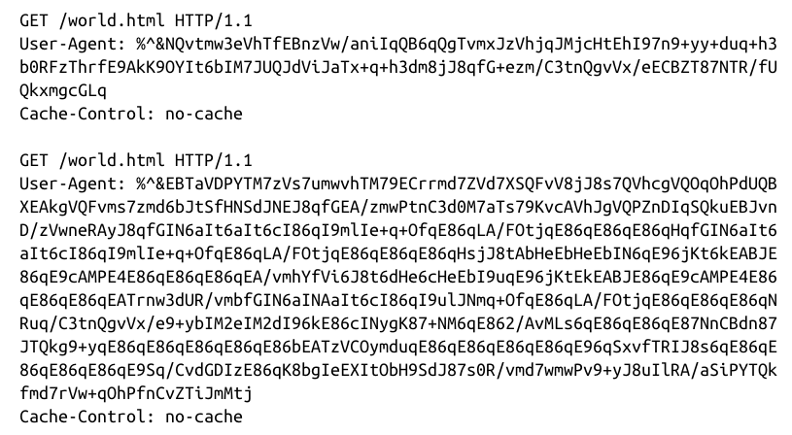

User Agents

Early malware used strange User-Agent strings

This made it easy to block

Valid user agent:

3 Possible User Agents

Malware alternates between these to defeat detection
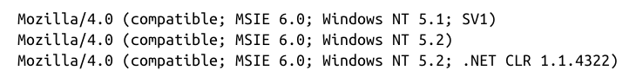

Attackers Use Existing Infrastructure

Botnet commands concealed in source code of a Web page

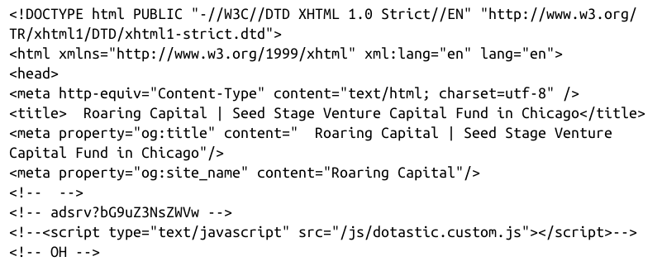

Leveraging Client-initiated Beaconing

Hosts behind NATs or proxy servers have a concealed IP address

Makes it difficult for attackers to know which bot is phoning home

Beacon identifies host with an unique identifier

Such as an encoded string with basic information about the host

Understanding Surrounding Code

Malware beacon

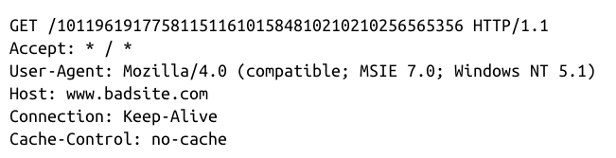

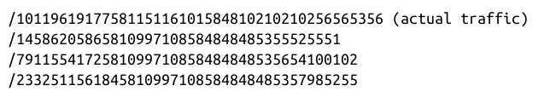

URIs

Example Malware

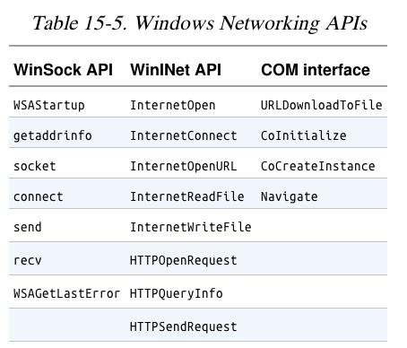
Uses InternetOpen and HTTPOpenRequest

URI is generated from calls to

GetTickCount, Random, gethostbyname

Sources of Network Content

Random data

Data from networking libraries

Such as the GET created from a call to HTTPSendRequest

Hard-coded data

Data about the host and its configuration

Hostname, current time, CPU speed

Data received from other sources

Remote server, file system, keystrokes

Hard-Coded vs. Ephemeral Data

Malware using lower-level networking APIs such as Winsock

Requires more manually-generated content to mimic common traffic

More hard-coded data

Likely the author makes a mistake that leaves a signature in the network traffic

May misspell a word like Mozilla

How URI is Generated

Identifying and Leveraging the Encoding Steps
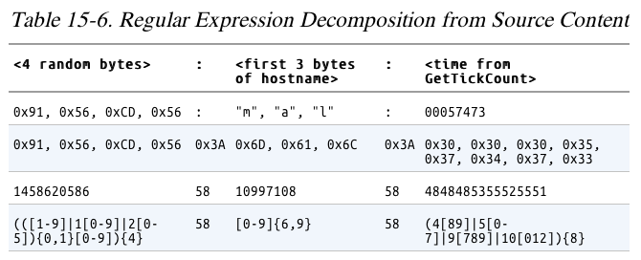

Creating a Signature

Avoid excessive complexity

Slows down the IDS

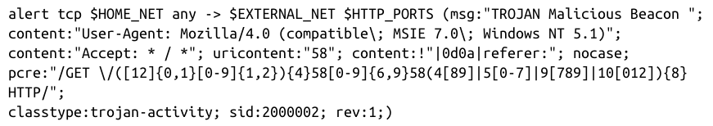
Include enough detail to eliminate false positives
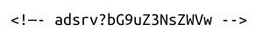
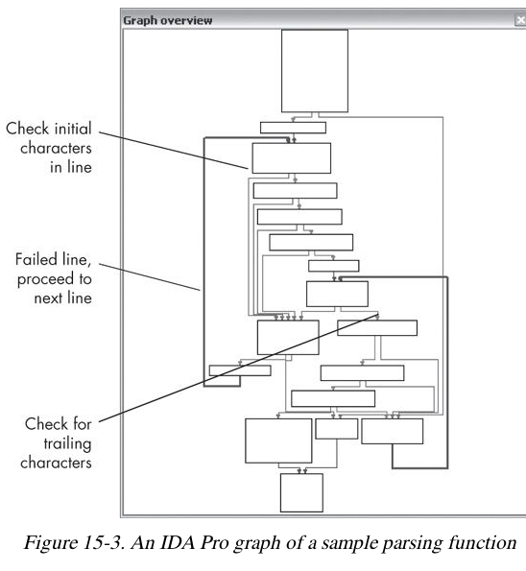

Analyzing the Parsing Routines

Malware strings and the Web page comments both include the string adsrv?

Parser looks for 3 elements

<!—

text

-->

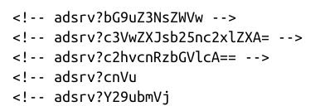
Possible Signatures

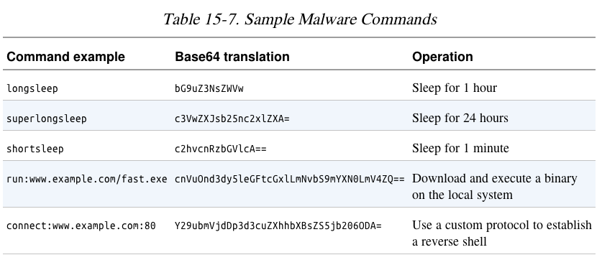
The five possible commands
These will work, but any change in the
malware will evade them

Targeting Multiple Elements

These are more general

The first one accepts any Base64 in a comment with the adsrv prefix
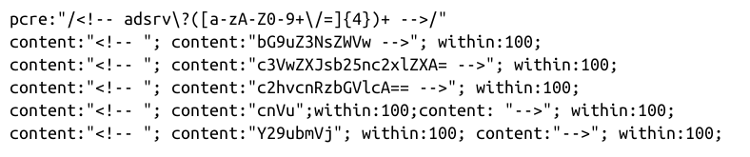

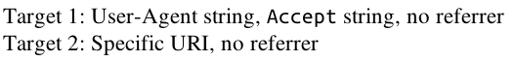
Making General Signatures

Understanding the Attacker's Perspective

Rules of Thumb

Focus on elements of the protocol that are part of both end points

Look for elements that use code on both the client and server

It will be hard for the attacker to change them both

Rules of Thumb

Focus on elements of the protocol known to be part of a key

Such as a User-Agent that identifies bot traffic

Again, it would require updating both ends to change

Identify elements of the protocol that are not immediately apparent in traffic

This will be less likely to be used by other, sloppy, defenders who leak info to the attacker

Last modified 11-24-13

