Ch 2: Malware Analysis in Virtual Machines

Dynamic Analysis

Running malware deliberately, while monitoring the results

Requires a safe environment

Must prevent malware from spreading to production machines

Real machines can be airgapped –no network connection to the Internet or to other machines

Real Machines

Disadvantages

No Internet connection, so parts of the malware may not work

Can be difficult to remove malware, so re-imaging the machine will be necessary

Advantage

Some malware detects virtual machines and won't run properly in one

Virtual Machines

The most common method

We'll do it that way

This protects the host machine from the malware

Except for a few very rare cases of malware that escape the virtual machine and infect the host

VMware Player

Free but limited

Cannot take snapshots

VMware Workstation or Fusion is a better choice, but they cost money

You could also use VirtualBox, Hyper-V, Parallels, or Xen.

Windows XP

The malware we are analyzing targets Windows XP, as most malware does

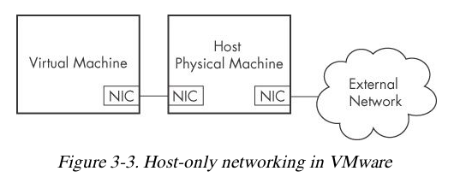
The DVD handed out in class contains a Win XP SP3 virtual machine for you to use

Configuring VMware

You can disable networking by disconnecting the virtual network adapter

Host-only networking allows network traffic to the host but not the Internet

Connecting Malware to the Internet

NAT mode lets VMs see each other and the Internet, but puts a virtual router between the VM and the LAN

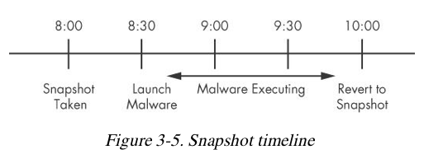
Bridged networking connects the VM directly to the LAN

Can allow malware to do some harm or spread – controversial

You could send spam or participate in a DDoS attack

Risks of Using VMware for Malware Analysis

Malware may detect that it is in a VM and run differently

VMware has bugs: malware may crash or exploit it

Malware may spread or affect the host – don't use a sensitive host machine

All the textbook samples are harmless
Ch 3: Basic Dynamic Analysis

Why Perform Dynamic Analysis?

Static analysis can reach a dead-end, due to

Obfuscation

Packing

Examiner has exhausted the available static analysis techniques

Dynamic analysis is efficient and will show you exactly what the malware does

Sandboxes: The Quick-and-Dirty Approach

Sandbox

All-in-one software for basic dynamic analysis

Virtualized environment that simulates network services

Examples: Norman Sandbox, GFI Sandbox, Anubis, Joe Sandbox, ThreatExpert, BitBlaze, Comodo Instant Malware Analysis

They are expensive but easy to use

They produce a nice PDF report of results

Running Malware

Launching DLLs

EXE files can be run directly, but DLLs can't

Use Rundll32.exe (included in Windows)

rundll32.exe DLLname, Export arguments

The Export value is one of the exported functions you found in Dependency Walker, PEview, or PE Explorer.

Launching DLLs

Example

rip.dll has these exports: Install and Uninstall

rundll32.exe rip.dll, Install

Some functions use ordinal values instead of names, like

rundll32.exe xyzzy.dll, #5

It's also possible to modify the PE header and convert a DLL into an EXE

Monitoring with Process Monitor

Process Monitor

Monitors registry, file system, network, process, and thread activity

All recorded events are kept, but you can filter the display to make it easier to find items of interest

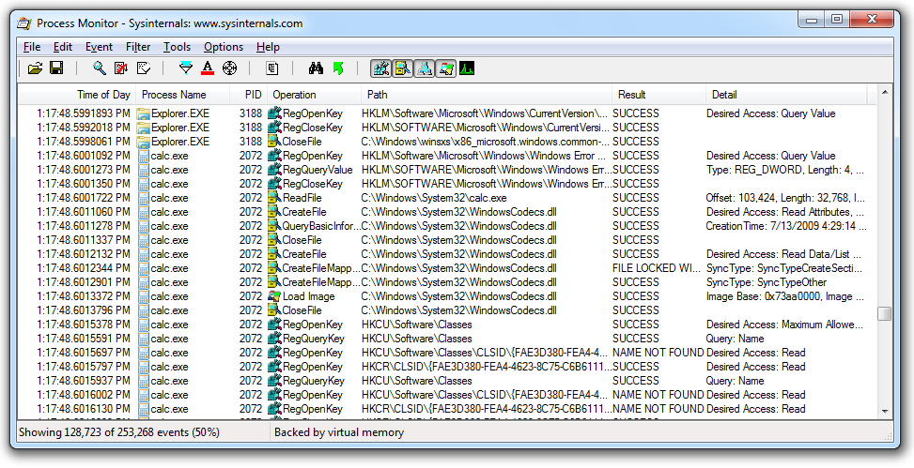
Don't run it too long or it will fill up all RAM and crash the machine

Launching Calc.exe

Process Monitor Toolbar
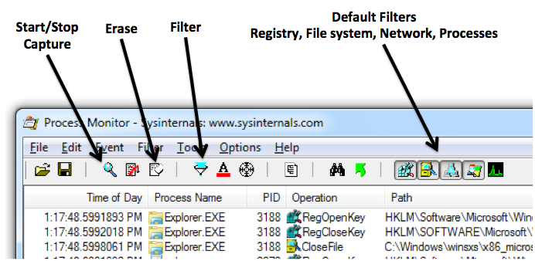

Filtering with Exclude

One technique: hide normal activity before launching malware

Right-click each Process Name and click Exclude

Doesn't seem to work well with these samples

Filtering with Include

Most useful filters: Process Name, Operation, and Detail

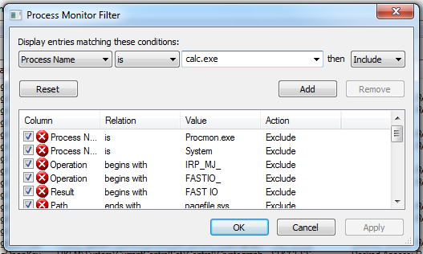

Viewing Processes with Process Explorer
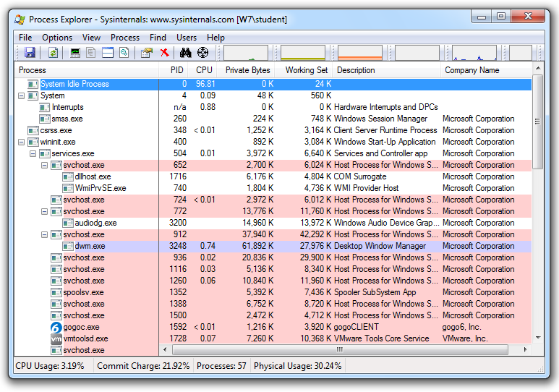

Coloring

Services are pink

Processes are blue

New processes are green briefly

Terminated processes are red

DLL Mode

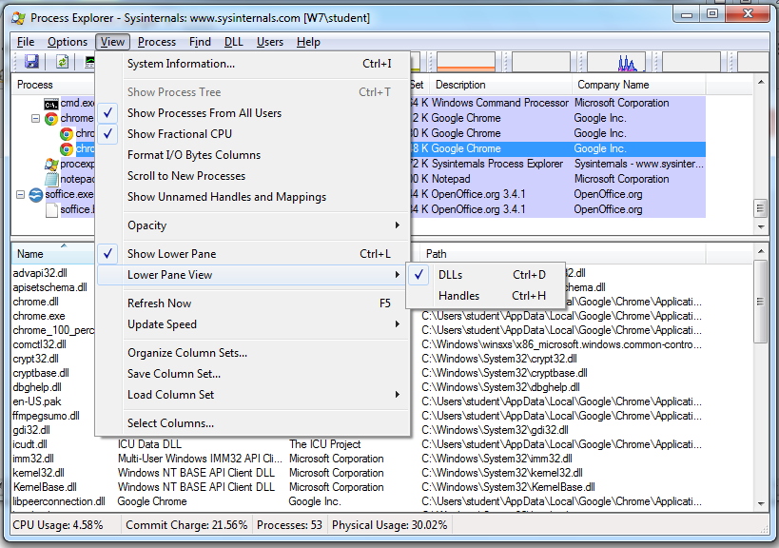

Properties

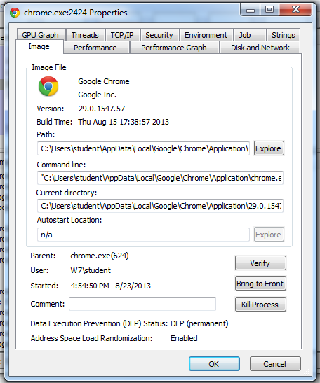
Shows DEP and ASLR status

Verify button checks the disk file's Windows signature

But not the RAM image, so it won't detect process replacement

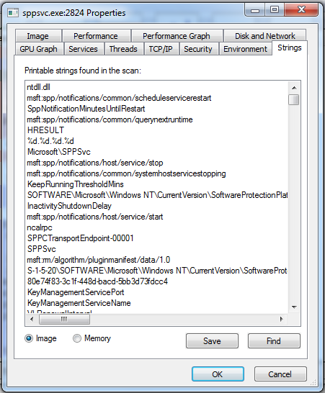

Strings

Compare Image to Memory strings, if they are very different, it can indicate process replacement

Detecting Malicious Documents

Open the document (e.g. PDF) on a system with a vulnerable application

Watch Process Explorer to see if it launches a process

The Image tab of that process's Properties sheet will show where the malware is

Comparing Registry Snapshots with Regshot
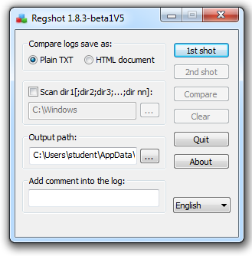

Faking a Network

Using ApateDNS to Redirect DNS Resolutions

ApateDNS Does Not Work

I couldn't get it to redirect any traffic in Win XP or 7

nslookup works, but you don't see anything in a browser or with ping

I decided to ignore it and use INetSim instead

Monitoring with Ncat (included with Nmap)
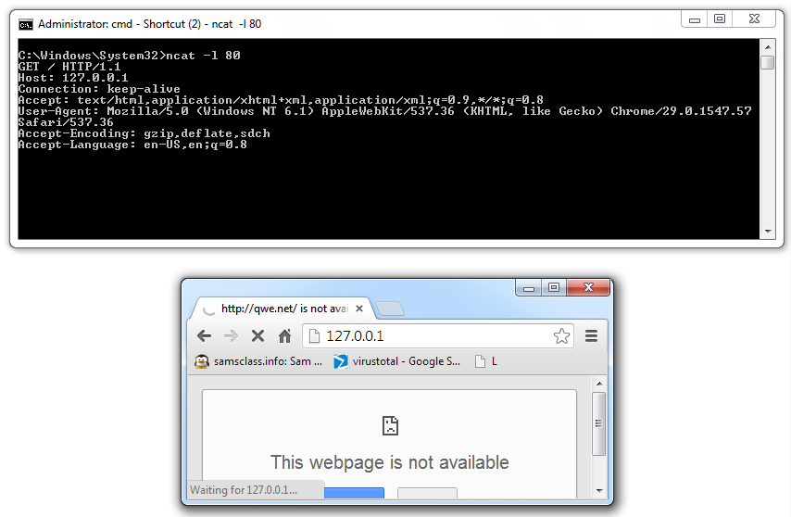

Packet Sniffing with Wireshark
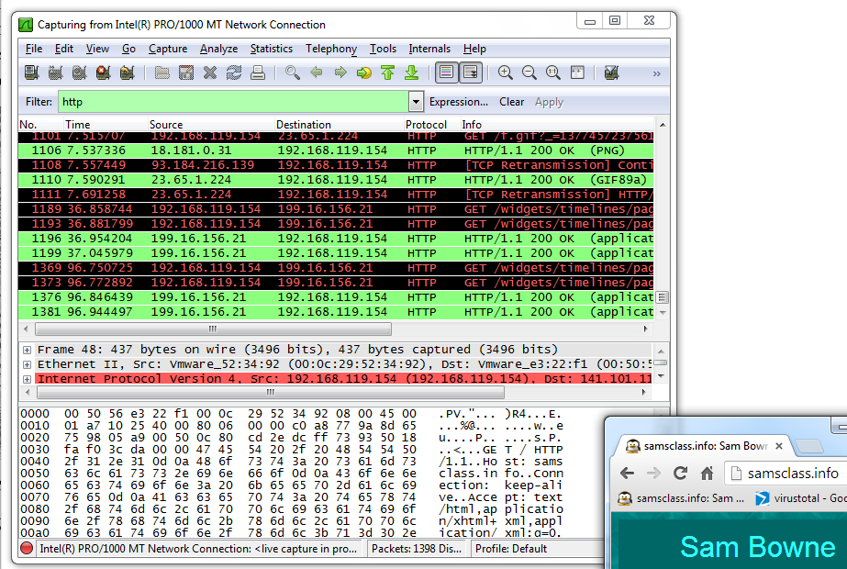

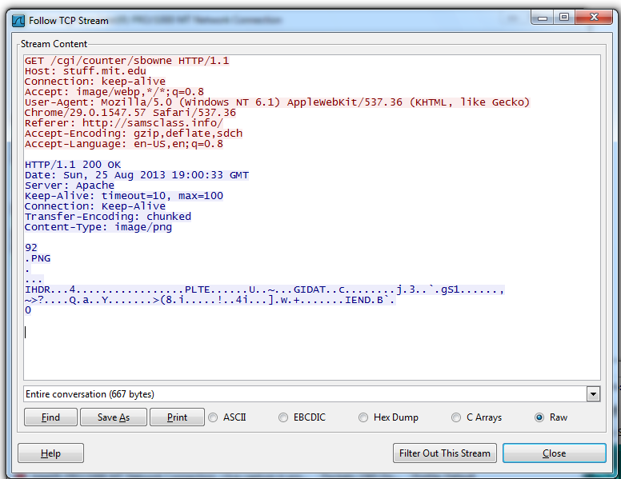

Follow TCP Stream

Can safe files from streams here too

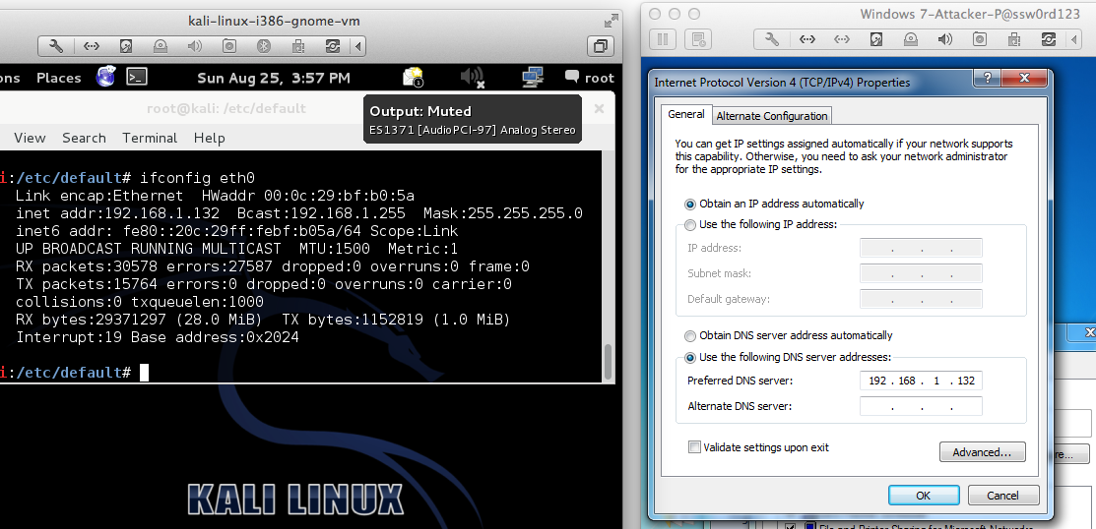
Using INetSim

INetSim Fools a Browser

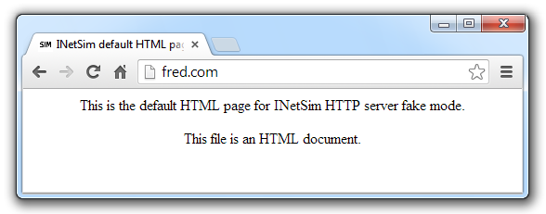

INetSim Fools Nmap
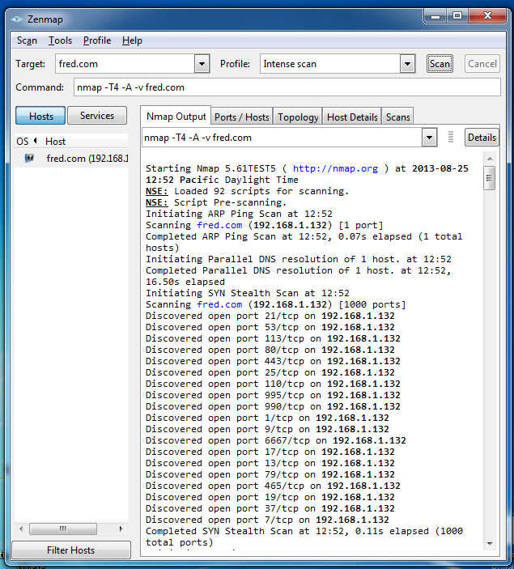

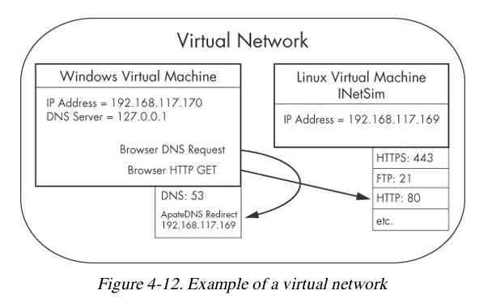
Basic Dynamic Tools in Practice

Using the Tools

Procmon

Filter on the malware executable name and clear all events just before running it

Process Explorer

Regshot

Virtual Network with INetSim

Wireshark

Last modified 8-26-13

