Basic Techniques

Basic static analysis

Looks at malware from the outside

Basic dynamic analysis

Only shows you how the malware operates in one case

Disassembly

View code of malware & figure out what it does
Levels of Abstraction

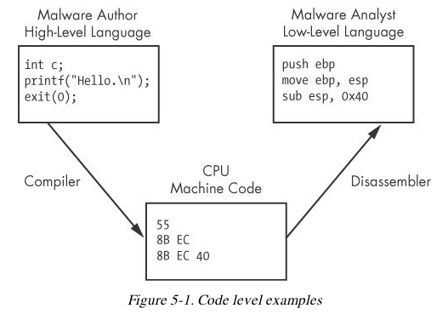
Six Levels of Abstraction

Hardware

Microcode

Machine code

Low-level languages

High-level languages

Interpreted languages

Hardware

Digital circuits

XOR, AND, OR, NOT gates

Cannot be easily manipulated by software

Microcode

Also called firmware

Only operates on specific hardware it was designed for

Not usually important for malware analysis

Machine code

Opcodes

Tell the processor to do something

Created when a program written in a high-level language is compiled

Low-level languages

Human-readable version of processor's instruction set

Assembly language

PUSH, POP, NOP, MOV, JMP ...

Disassembler generates assembly language

This is the highest level language that can be reliably recovered from malware when source code is unavailable

High-level languages

Most programmers use these

C, C++, etc.

Converted to machine code by a compiler

Interpreted languages

Highest level

Java, C#, Perl, .NET, Python

Code is not compiled into machine code

It is translated into bytecode

An intermediate representation

Independent of hardware and OS

Bytecode executes in an interpreter, which translates bytecode into machine language on the fly at runtime

Ex: Java Virtual Machine
Reverse Engineering

Disassembly

Malware on a disk is in binary form at the machine code level

Disassembly converts the binary form to assembly language

IDA Pro is the most popular disassembler

Assembly Language

Different versions for each type of processor

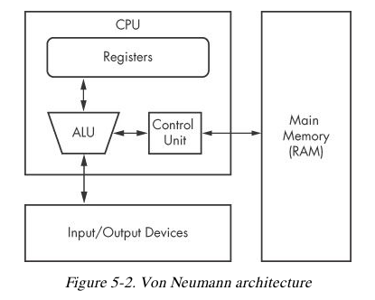
x86 – 32-bit Intel (most common)

x64 – 64-bit Intel

SPARC, PowerPC, MIPS, ARM – others

Windows runs on x86 or x64

x64 machines can run x86 programs

Most malware is designed for x86
The x86 Architecture

CPU (Central Processing Unit) executes code

RAM stores all data and code

I/O system interfaces with hard disk, keyboard, monitor, etc.

CPU Components

Control unit

Fetches instructions from RAM using a register named the instruction pointer

Registers

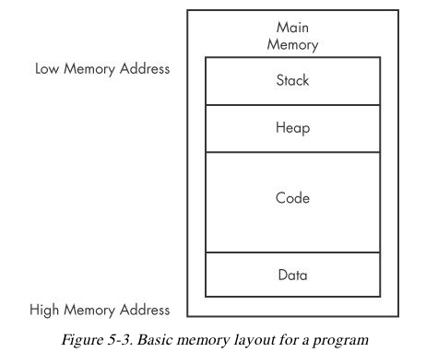
Data storage within the CPU

Faster than RAM

ALU (Arithmetic Logic Unit)

Executes an instruction and places results in registers or RAM

Main Memory (RAM)

Data

Values placed in RAM when a program loads

These values are static

They cannot change while the program is running

They are also global

Available to any part of the program

Code

Instructions for the CPU

Controls what the program does

Heap

Dynamic memory

Changes frequently during program execution

Program allocates new values, and frees them when they are no longer needed

Stack

Local variables and parameters for functions

Helps programs flow

Instructions

Mnemonic followed by operands

mov ecx 0x42

Move into Extended C register the value 42 (hex)

mov ecx is 0xB9 in hexadecimal

The value 42 is 0x4200000000

In binary this instruction is

0xB942000000

Endianness

Big-Endian

Most significant byte first

0x42 as a 64-bit value would be 0x00000042

Little-Endian

Least significant byte first

0x42 as a 64-bit value would be 0x42000000

Network data uses big-endian

x86 programs use little-endian

IP Addresses

127.0.0.1, or in hex, 7F 00 00 01

Sent over the network as 0x7F000001

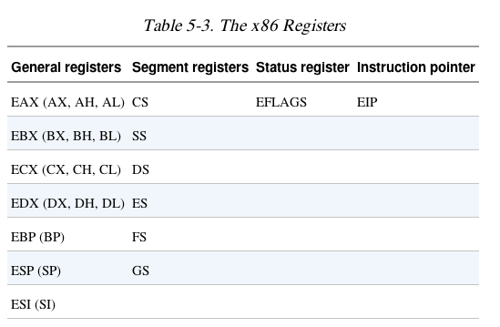
Stored in RAM as 0x0100007F

Operands

Immediate

Fixed values like –x42

Register

eax, ebx, ecx, and so on

Memory address

Denoted with brackets, like [eax]

Registers

General registers

Used by the CPU during execution

Segment registers

Used to track sections of memory

Status flags

Used to make decisions

Instruction pointer

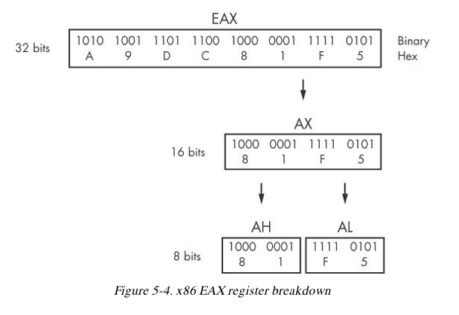
Address of next instruction to execute

Size of Registers

General registers are all 32 bits in size

Can be referenced as either 32bits (edx) or 16 bits (dx)

Four registers (eax, ebx, ecx, edx) can also be referenced as 8-bit values

AL is lowest 8 bits

AH is higher 8 bits

General Registers

Typically store data or memory addresses

Normally interchangeable

Some instructions reference specific registers

Multiplication and division use EAX and EDX

Conventions

Compilers use registers in consistent ways

EAX contains the return value for function calls

Flags

EFLAGS is a status register

32 bits in size

Each bit is a flag

SET (1) or Cleared (0)

Important Flags

ZF Zero flag

Set when the result of an operation is zero

CF Carry flag

Set when result is too large or small for destination

SF Sign Flag

Set when result is negative, or when most significant bit is set after arithmetic

TF Trap Flag

Used for debugging—if set, processor executes only one instruction at a time

EIP (Extended Instruction Pointer)

Contains the memory address of the next instruction to be executed

If EIP contains wrong data, the CPU will fetch non-legitimate instructions and crash

Buffer overflows target EIP
Simple Instructions

mov destination, source

Moves data from one location to another

We use Intel format throughout the book, with destination first

Remember indirect addressing

[ebx] means the memory location pointed to by EBX

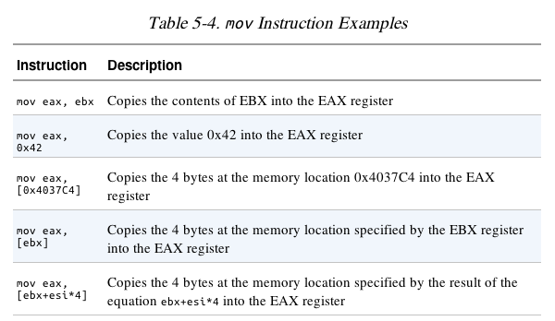
lea (Load Effective Address)

lea destination, source

lea eax, [ebx+8]

Puts ebx + 8 into eax

Compare

mov eax, [ebx+8]

Moves the data at location ebx+8 into eax

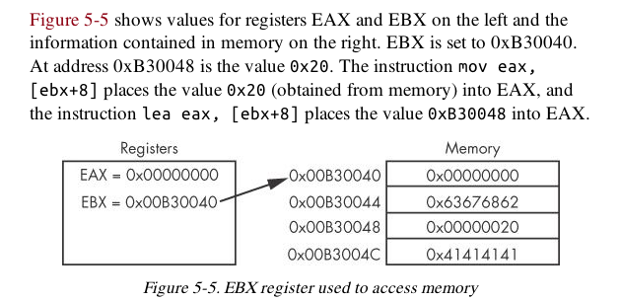
Arithmetic

sub Subtracts

add Adds

inc Increments

dec Decrements

mul Multiplies

div Divides

NOP

Does nothing

0x90

Commonly used as a NOP Sled

Allows attackers to run code even if they are imprecise about jumping to it

The Stack

Memory for functions, local variables, and flow control

Last in, First out

ESP (Extended Stack Pointer) – top of stack

EBP (Extended Base Pointer) – bottom of stack

PUSH puts data on the stack

POP takes data off the stack

Other Stack Instructions

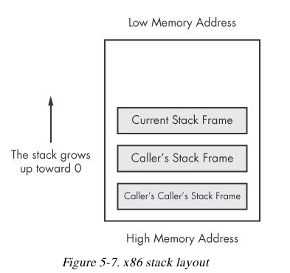
All used with functions

Call

Leave

Enter

Ret

Function Calls

Small programs that do one thing and return, like printf()

Prologue

Instructions at the start of a function that prepare stack and registers for the function to use

Epilogue

Instructions at the end of a end of a function that restore the stack and registers to their state before the function was called

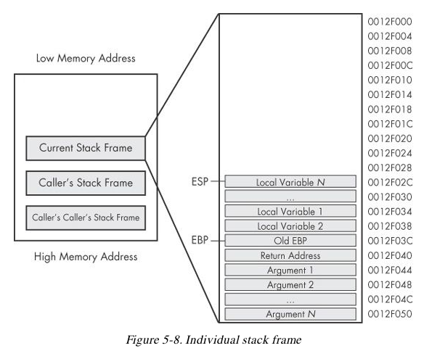

Conditionals

test

Compares two values the way AND does, but does not alter them

test eax, eax

Sets Zero Flag if eax is zero

cmp eax, ebx

Sets Zero Flag if the arguments are equal

Branching

jz loc

Jump to loc if the Zero Flag is set

jnz loc

Jump to loc if the Zero Flag is cleared

C Main Method

Every C program has a main() function

int main(int argc, char** argv)

argc contains the number of arguments on the command line

argv is a pointer to an array of names containing the arguments

Example

cp foo bar

argc = 3

argv[0] = cp

argv[1] = foo

argv[2] = bar

Last modified 9-2-13

