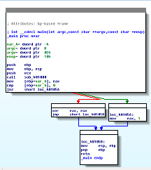
IDA Pro Versions

Full-featured pay version

Old free version

Both support x86

Pay version supports x64 and other processors, such as cell phone processors

Both have code signatures for common library code in FLIRT (Fast Library identification and Recognition Technology)

Graph and Text Mode

Spacebar
switches
mode

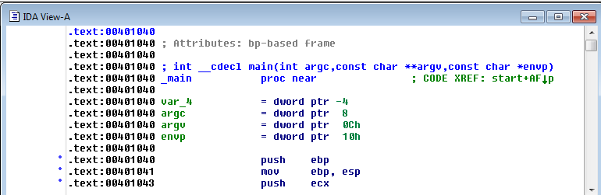

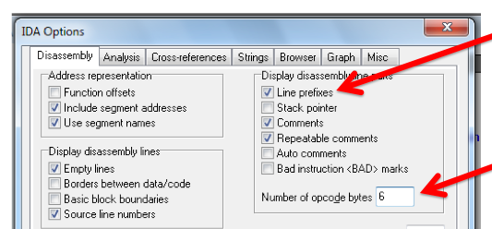
Display

Options, General

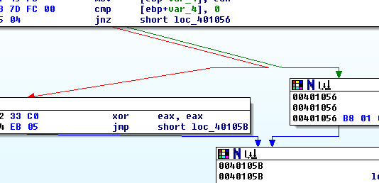
Arrows

Colors

Red Conditional jump not taken

Green Conditional jump taken

Blue Unconditional jump

Direction

Up Loop

Arrow Color Example

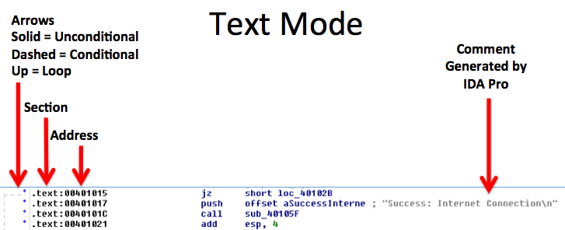
Highlighting

Highlighting text in graph mode highlights every instance of that text
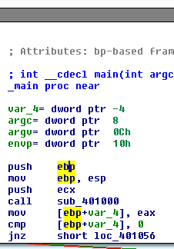

Options, General, Adds Comments to Each Instruction – seems silly
Useful Windows for Analysis

Functions

Shows each function, length, and flags

L = Library functions

Sortable

Large functions usually more important
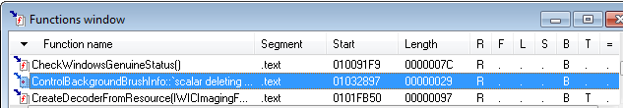

Names Window

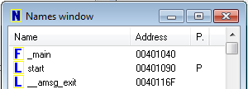
Every address with a name

Functions, named code, named data, strings

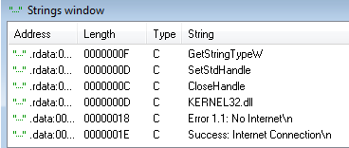

Strings

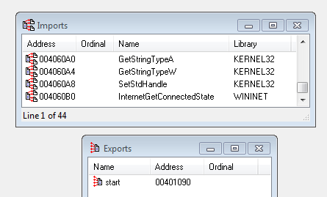

Imports & Exports

Structures

All active data structures

Hover to see yellow pop-up window

Cross-Reference

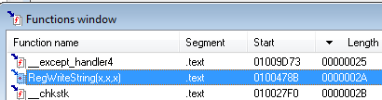
Double-click function

Jump to code in other views

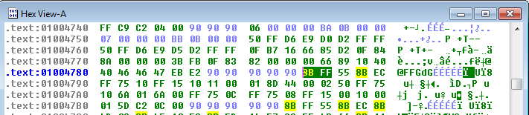

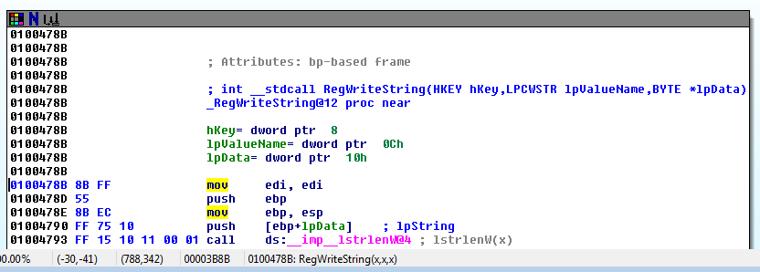

Function Call

Parameters pushed onto stack

CALL to start function

Returning to the Default View

Windows, Reset Desktop

Windows, Save Desktop

To save a new view
Navigating IDA Pro

Imports or Strings

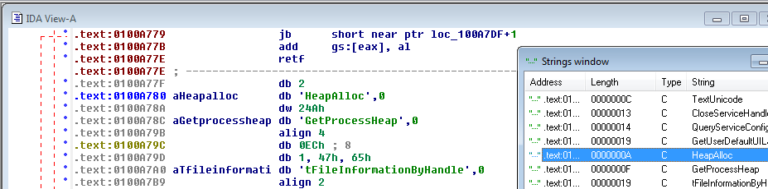
Double-click any entry to display it in the disassembly window

Using Links

Double-click any address in the disassembly window to display that location
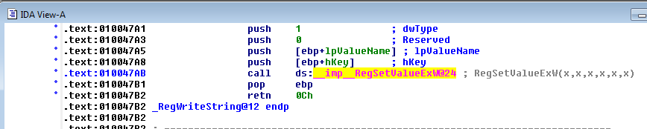
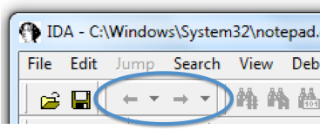

History

Forward and Back buttons work like a Web browser

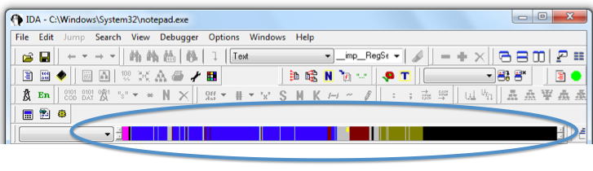

Navigation Band

Light blue: Library code

Red: Compiler-generated code

Dark blue: User-written code – Analyze this
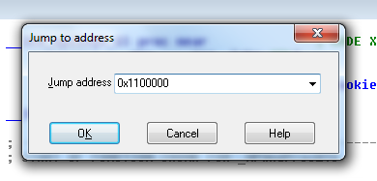

Jump to Location

Press G

Can jump to address or named location

Searching

Many options

Search, Text is handy

Using Cross-References

Code Cross-References

XREF comment shows where this function is called

But it only shows a couple of cross-references by default
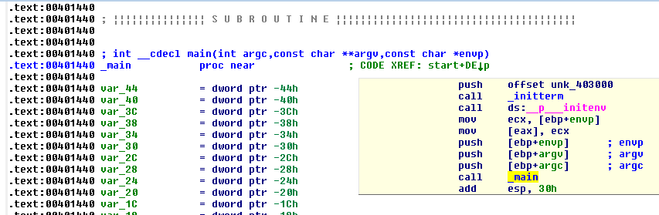

To See All Cross-References

Click function name and press X
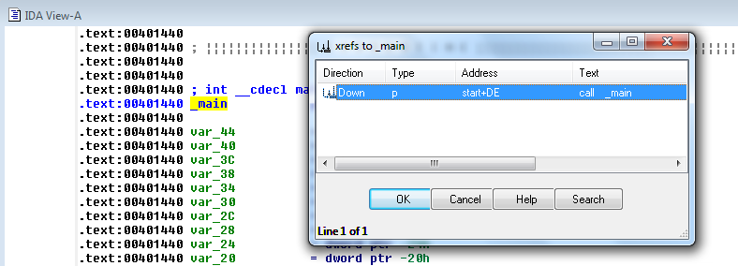

Data Cross-References

Demo:

Start with strings

Double-click an interesting string

Hover over DATA XREF to see where that string is used

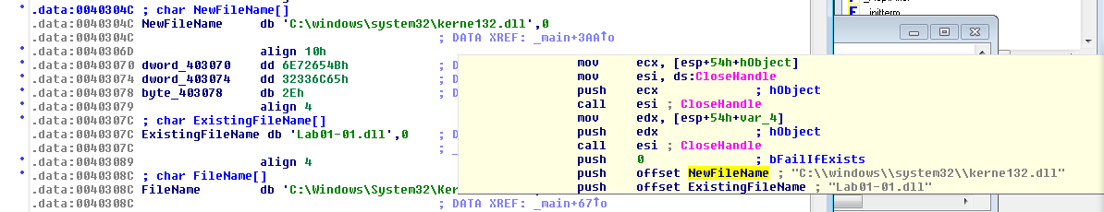
X shows all references

Analyzing Functions

Function and Argument Recognition

IDA Pro identifies a function, names it, and also names the local variables

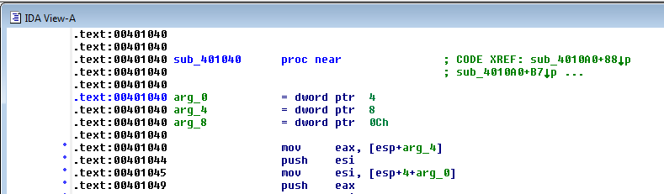
It's not always correct

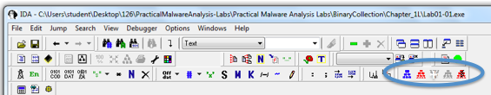
Using Graphing Options
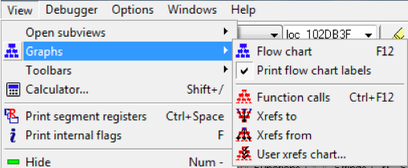

Graphing Options

These are "Legacy Graphs" and cannot be manipulated with IDA

The first two seem obsolete

Flow chart

Create flow chart of current function

Function calls

Graph function calls for entire program

Xrefs to

Graphs XREFs to get to selected XREF

Can show all the paths that get to a function

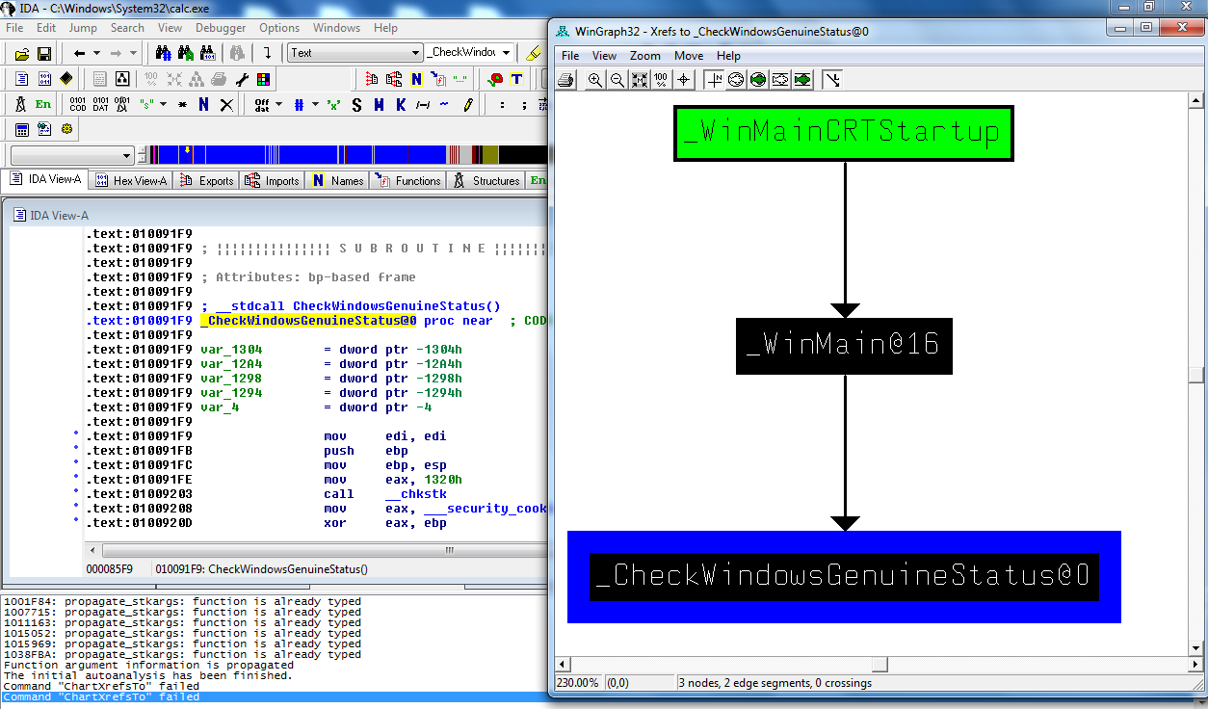
Windows Genuine Status in Calc.exe

Xrefs from

Graphs XREFs from selected XREF

Can show all the paths that exit from a function
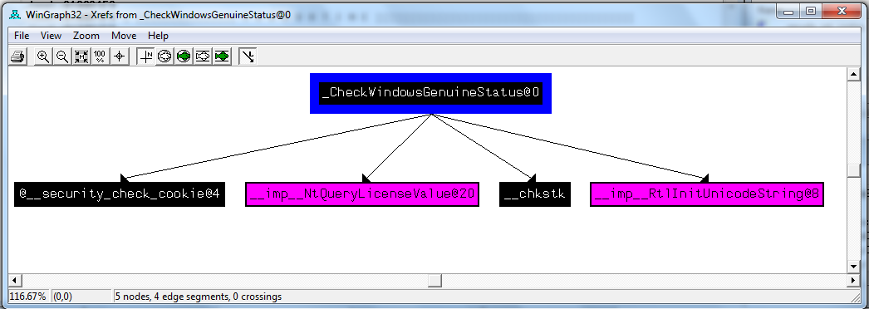

User xrefs chart...

Customize graph's recursive depth, symbols used, to or from symbol, etc.

The only way to modify legacy graphs

Enhancing Disassembly

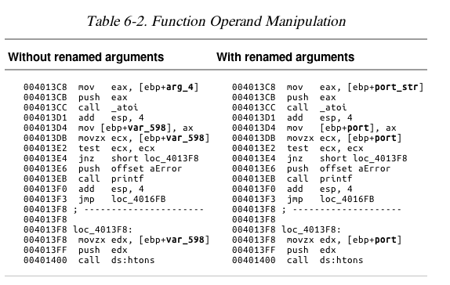
Warning

There's no Undo, so if you make changes and mess them up, you may be sorry

Renaming Locations

You can change a name like sub_401000 to ReverseBackdoorThread

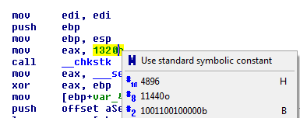
Change it in one place, IDA will change it everywhere else

Comments

Press colon (:) to add a single comment

Press semicolon (;) to echo this comment to all Xrefs

Formatting Operands

Hexadecimal by default

Right-click to use other formats

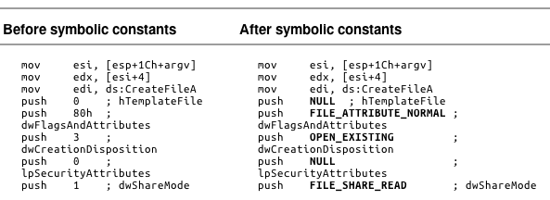
Using Named Constants

Makes Windows API arguments clearer

Extending IDA with Plug-ins

IDC (IDA's scripting language) and Python scripts available (link Ch 6a)

Last modified 9-16-13

