Function Call
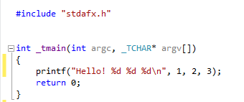

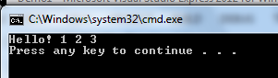

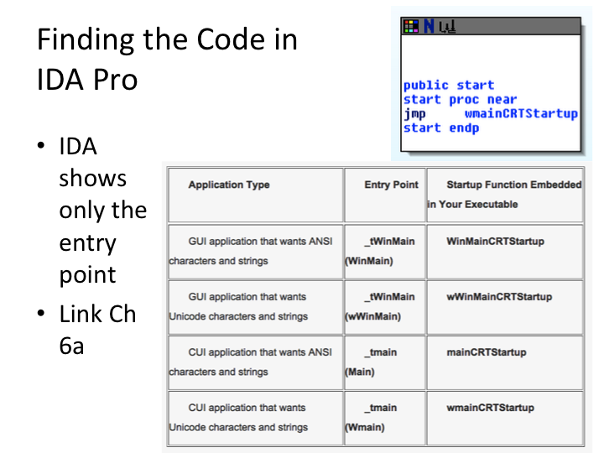

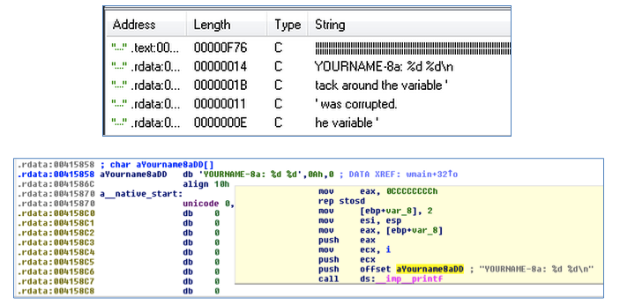
Trick: Use Strings, then XREF

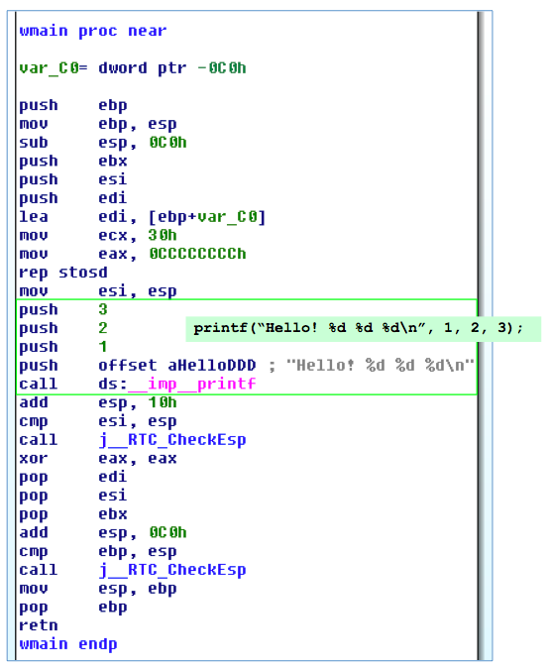

Disassembly in IDA Pro

4 arguments for printf() function

Pushed onto stack

Reverse order

call launches function

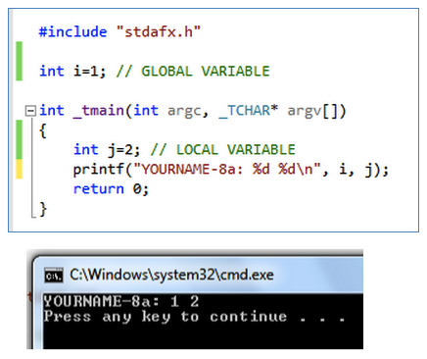
Global vs. Local Variables

Global variables

Available to any function in the program

Local variables

Defined in a function and only available to that function

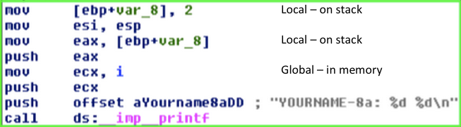

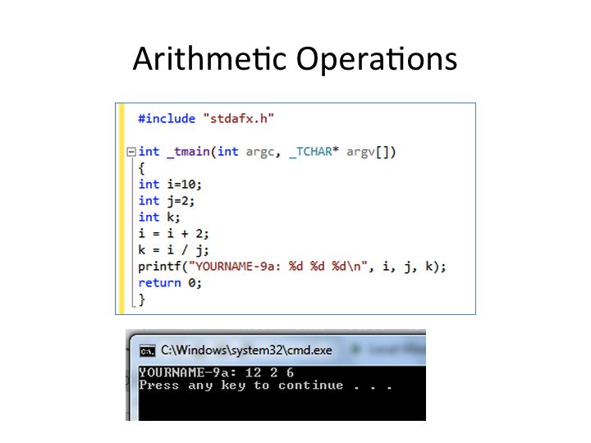
Arithmetic Operations

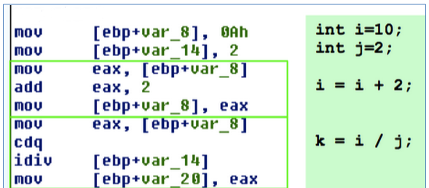

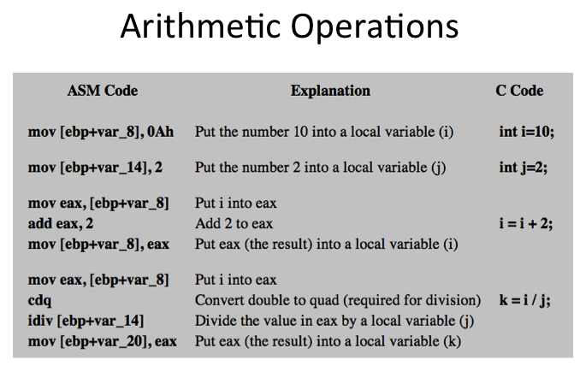

Branching (if)
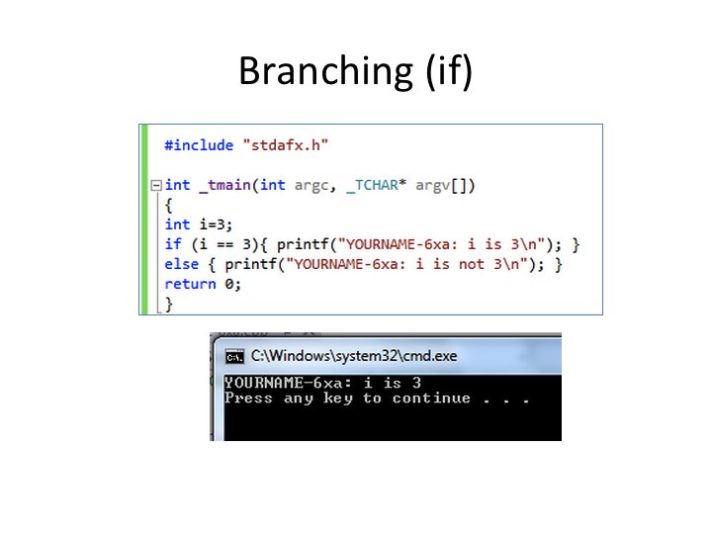

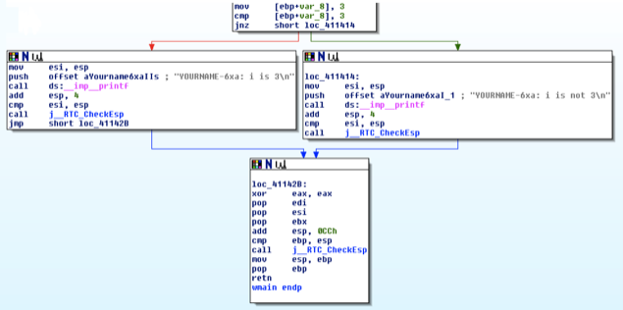

Summary

Finding the Code

Strings, then XREF

Function Call

Arguments pushed onto stack

Reverse order

call

Variables

Global: in memory, available to all functions

Local: on stack, only available to one function

Arithmetic

Move variables into registers

Perform arithmetic (add, sub, idiv, etc.)

Move results back into variables

Branching

Compare (cmp, test, etc.)

Conditional jump (jz, jnz, etc.)

Red arrow if false, green arrow if true

Last modified 9-23-13

