The Windows API (Application Programming Interface)

What is the API?

Governs how programs interact with Microsoft libraries

Concepts

Types and Hungarian Notation

Handles

File System Functions

Special Files

Types and Hungarian Notation

Windows API has its own names to represent C data types

Such as DWORD for 32-bit unsigned integers and WORD for 16-bit unsigned integers

Hungarian Notation

Variables that contain a 32-bit unsigned integer start with the prefix dw

Common API Types

Type (Prefix)

WORD (w) 16-bit unsigned value

DWORD (dw) 32-bit unsigned value

Handle (H) A reference to an object

Long Pointer (LP) Points to another type

Handles

Items opened or created in the OS, like

Window, process, menu, file, ...

Handles are like pointers to those objects

They not pointers, however

The only thing you can do with a handle is store it and use it in a later function call to refer to the same object

Handle Example

The CreateWindowEx function returns an HWND, a handle to the window

To do anything to that window (such as DestroyWindow) , use that handle

File System Functions

CreateFile, ReadFile, WriteFile

Normal file input/output

CreateFileMapping, MapViewOfFile

Used by malware, loads file into RAM

Can be used to execute a file without using the Windows loader

Special Files

Shared files like \\server\\share

Or \\?\server\share

Disables string parsing, allows longer filenames

Namespaces

Special folders in the Windows file system

\ Lowest namespace, contains everything

\\.\ Device namespace used for direct disk input/output

Witty worm wrote to \\.\PhysicalDisk1 to corrupt the disk

Link Ch 7a

Alternate Data Streams

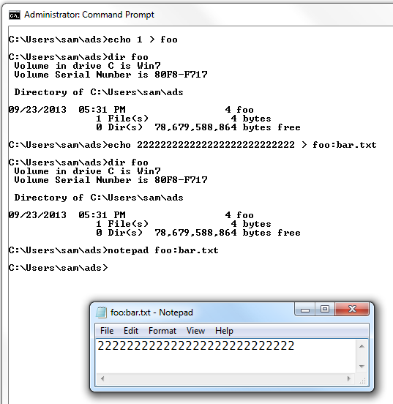
Second stream of data attached to a filename

File.txt:otherfile.txt

The Windows Registry

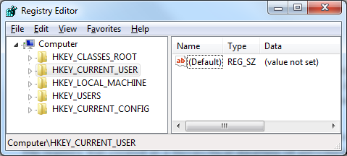
Registry Purpose

Store operating system and program configuration settings

Desktop background, mouse preferences, etc.

Malware uses the registry for Malware uses the registry for persistence

Making malware re-start when the system reboots

Registry Terms

Root keys The 5 shown above

Subkey A folder within a folder

Key A folder; can contain folders or values

Value entry Two parts: name and data

Value or Data The data stored in a registry entry

REGEDIT Tool to view/edit the Registry
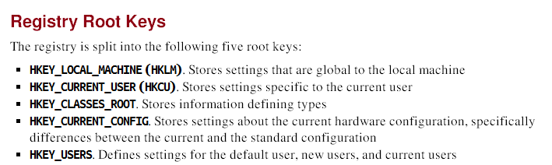

Run Key

HKLM\SOFTWARE\Microsoft\Windows\CurrentVersion\Run

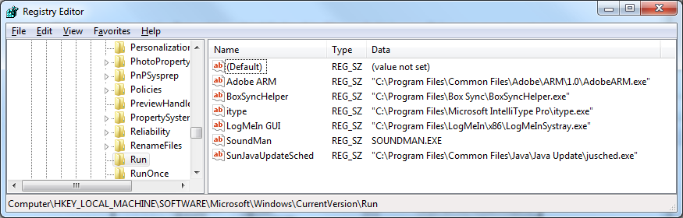
Executables that start when a user logs on

Autoruns

Sysinternals tool

Lists code that will run automatically when system starts

Executables

DLLs lodaded into IE and other programs

Drivers loaded into Kernel

It checks 25 to 30 registry locations

Won't necessarily find all automatically running code

Link Ch 7b

Autoruns
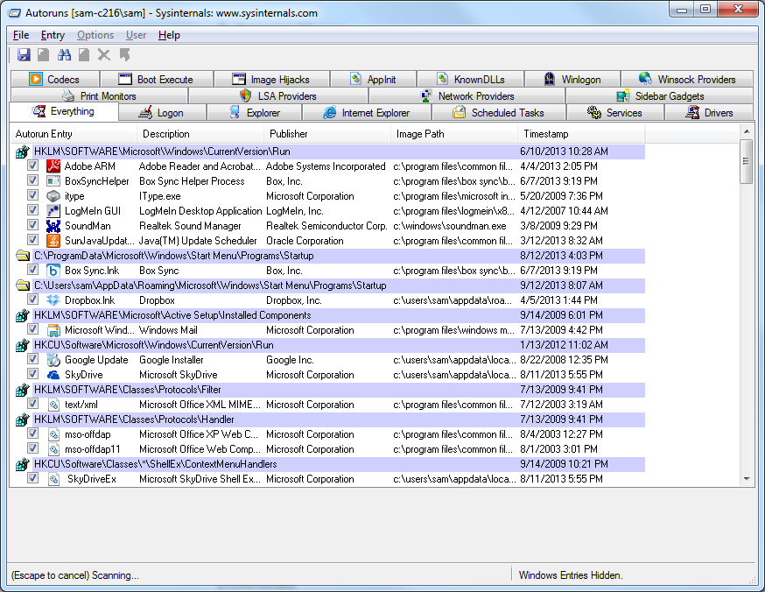

Common Registry Functions

RegOpenKeyEx

Opens a registry key for editing and querying

RegSetValueEx

Adds a new value to the registry & sets its data

RegGetValue

Returns the data for a value entry in the Registry

Note: Documentation will omit the trailing W or A character in a call like RegOpenKeyExW

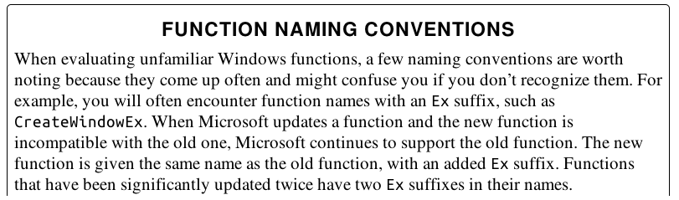

From Ch 2
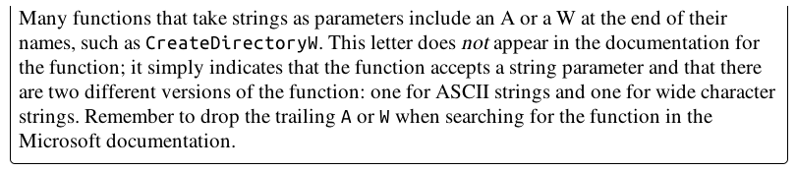

Registry Code
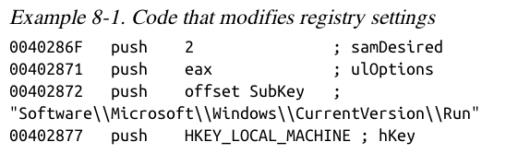

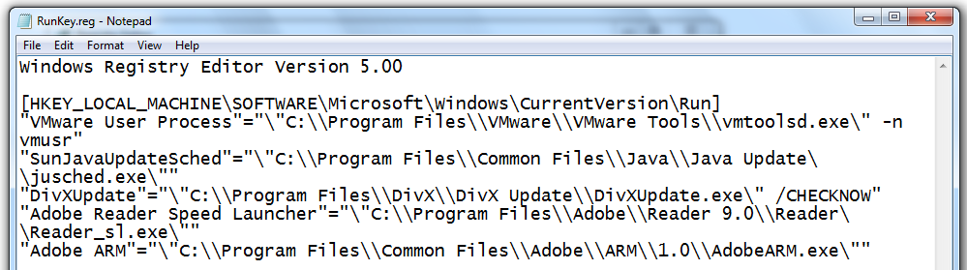

.REG Files

Networking APIs

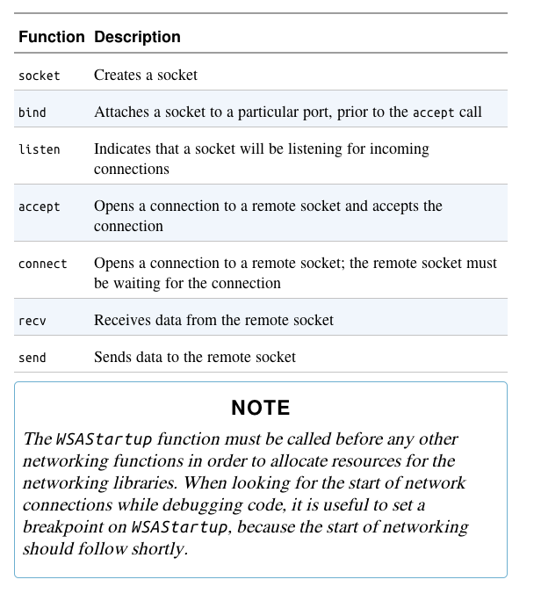
Berkeley Compatible Sockets

Winsock libraries, primarily in ws2_32.dll

Almost identical in Windows and Unix

Server and Client Sides

Server side

Maintains an open socket waiting for connections

Calls, in order, socket, bind, listen, accept

Then send and recv as necessary

Client side

Connects to a waiting socket

Calls, in order, socket, connect

Then send and recv as necessary

Simplified Server Program

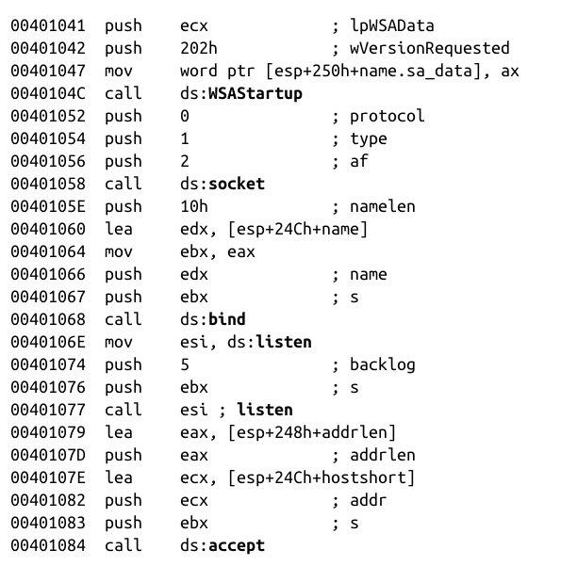
Realistic code would call WSAGetLastError many times

The WinINet API

Higher-level API than Winsock

Functions in Wininet.dll

Implements Application-layer protocols like HTTP and FTP

InternetOpen – connects to Internet

InternetOpenURL –connects to a URL

InternetReadFile –reads data from a dowloaded file

Following Running Malware

Transferring Execution

jmp and call transfer execution to another part of code, but there are other ways

DLLs

Processes

Threads

Mutexes

Services

Component Object Model (COM)

Exceptions

DLLs (Dynamic Link Libraries)

Share code among multiple applications

DLLs export code that can be used by other applications

Static libraries were used before DLLs

They still exist, but are much less common

They cannot share memory among running processes

Static libraries use more RAM than DLLs

DLL Advantages

Using DLLs already included in Windows makes code smaller

Software companies can also make custom DLLs

Distribute DLLs along with EXEs

How Malware Authors Use DLLs

Store malicious code in DLL

Sometimes load malicious DLL into another process

Using Windows DLLs

Nearly all malware uses basic Windows DLLS

Using third-party DLLs

Use Firefox DLL to connect to a server, instead of Windows API

Basic DLL Structure

DLLs are very similar to EXEs

PE file format

A single flag indicates that it's a DLL instead of an EXE

DLLs have more exports & fewer imports

DllMain is the main function, not exported, but specified as the entry point in the PE Header

Called when a function loads or unloads the library

Processes

Every program being executed by Windows is a process

Each process has its own resources

Handles, memory

Each process has one or more threads

Older malware ran as an independent process

Newer malware executes its code as part of another process

Many Processes Run at Once
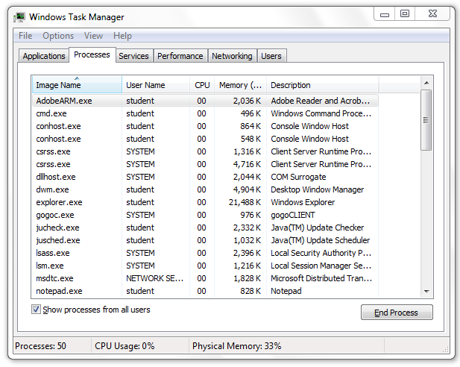

Memory Management

Each process uses resources, like CPU, file system, and memory

OS allocates memory to each process

Two processes accessing the same memory address actually access different locations in RAM

Virtual address space (link Ch 7c)

Creating a New Process

CreateProcess

Can create a simple remote shell with one function call

STARTUPINFO parameter contains handles for standard input, standard output, and standard error streams

Can be set to a socket, creating a remote shell

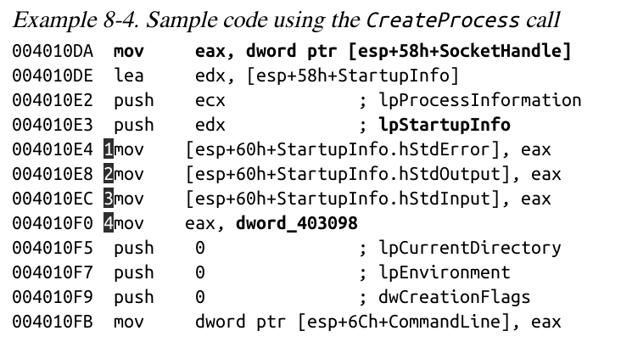
Code to Create a Shell

Loads socket handle, StdError, StdOutput and StdInput into lpProcessInformation

CommandLine contains the command line

It's executed when CreateProcess is called

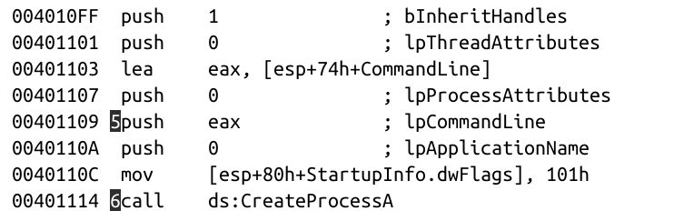

Threads

Processes are containers

Each process contains one or more threads

Threads are what Windows actually executes

Threads

Independent sequences of instructions

Executed by CPU without waiting for other threads

Threads within a process share the same memoru space

Each thread has its own registers and stack

Thread Context

When a thread is running, it has complete control of the CPU

Other threads cannot affect the state of the CPU

When a thread changes a register, it does not affect any other threads

When the OS switches to another thread, it saves all CPU values in a structure called the thread context

Creating a Thread

CreateThread

Caller specified a start address, also called a start function

How Malware Uses Threads

Use CreateThread to load a malicious DLL into a process

Create two threads, for input and output

Used to communicate with a running application

Interprocess Coordination with Mutexes

Mutexes are global objects that coordinate multiple processes and threads

In the kernel, they are called mutants

Mutexes often use hard-coded names which can be used to identify malware

Functions for Mutexes

WaitForSingleObject

Gives a thread access to the mutex

Any subsequent threads attempting to gain access to it must wait

ReleaseMutex

Called when a thread is done using the mutex

CreateMutex

OpenMutex

Gets a handle to another process's mutex

Making Sure Only One Copy of Malware is Running

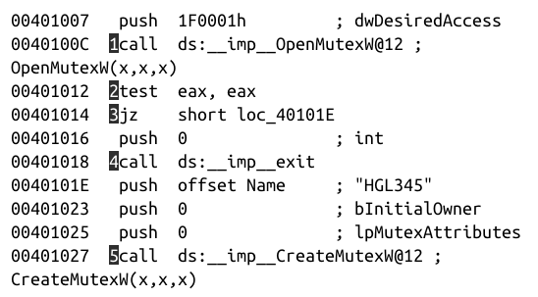
OpenMutex checks if HGL345 exists

If not, it is created with CreateMutex

Note
test eax, eax
Link Ch 7d

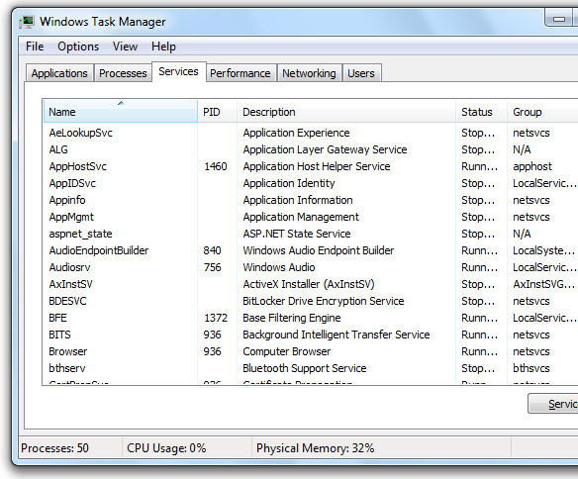

Services

Services run in the background without user input

SYSTEM Account

Services often run as SYSTEM which is even more powerful than the Administrator

Services can run automatically when Windows starts

An easy way for malware to maintain persistence

Persistent malware survives a restart

Service API Functions

OpenSCManager

Returns a handle to the Service Control Manager

CreateService

Adds a new service to the Service Control Manager

Can specify whether the service will start automatically at boot time

StartService

Only used if the service is set to start manually

Svchost.exe

WIN32_SHARE_PROCESS

Most common type of service used by malware

Stores code for service in a DLL

Combines several services into a single shared process named svchost.exe
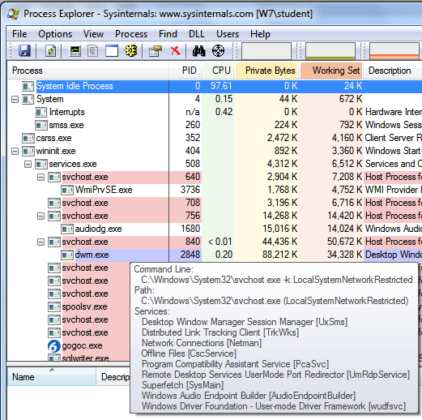

Svchost.exe in Process Explorer

Other Common Service Types

WIN32_OWN_PROCESS

Runs as an EXE in an independent process

KERNEL_DRIVER

Used to load code into the Kernel

Service Information in the Registry

HKLM\System\CurrentControlSet\Services

Start value = 0x03 for "Load on Demand"

Type = 0x20 for WIN32_SHARE_PROCESS

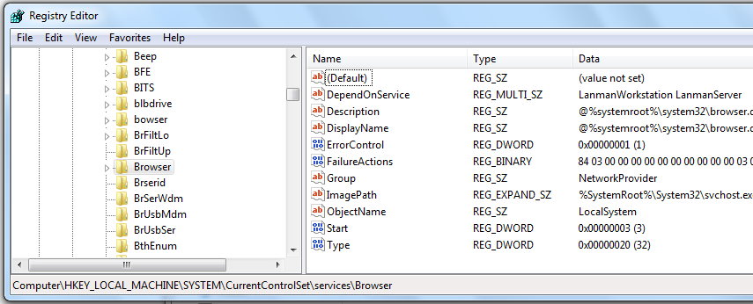
Link Ch 7e

SC Command

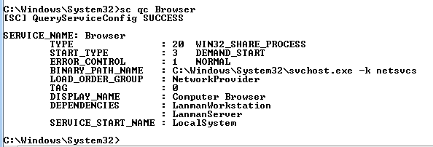
Included in Windows

Gives information about Services

Component Object Model (COM)

Allows different software components to share code

Every thread that uses COM must call OleInitialize or CoInitializeEx before calling other COM libraries

GUIDs, CLSIDs, IIDs

COM objects are accessed via Globally Unique Identifiers (GUIDs)

There are several types of GUIDs, including

Class Identifiers (CLSIDs)

in Registry at HKEY_CLASSES_ROOT\CLSID

Interface Identifiers (IIDs)

in Registry at HKEY_CLASSES_ROOT\Interface

Link Ch 7f

Exceptions

Exceptions are caused by errors, such as division by zero or invalid memory access

When an exception occurs, execution transfers to the Structured Exception Handler
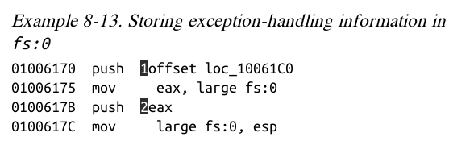

fs:0 Stores Exception Location

FS is one of six Segment Registers

Link Ch 7g-i

Kernel v. User Mode

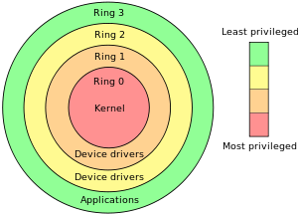
Two Privilege Levels

Ring 0: Kernel Mode

Ring 3: User mode

Rings 1 and 2 are not used by Windows

Link Ch 7j

User Mode

Nearly all code runs in user mode

Except OS and hardware drivers, which run in kernel mode

User mode cannot access hardware directly

Restricted to a subset of CPU instructions

Can only manipulate hardware through the Windows API

User Mode Processes

Each process has its own memory, security permissions, and resources

If a user-mode program executes an invalid instruction and crashes, Windows can reclaim the resources and terminate the program

Calling the Kernel

It's not possible to jump directly from user mode to the kernel

SYSENTER, SYSCALL, or INT 0x2E instructions use lookup tables to locate predefined functions

Kernel Processes

All kernel processes share resources and memory addresses

Fewer security checks

If kernel code executes an invalid instruction, the OS crashes with the Blue Screen of Death

Antivirus software and firewalls run in Kernel mode

Malware in Kernel Mode

More powerful than user-mode malware

Auditing doesn't apply to kernel

Almost all rootkits use kernel code

Most malware does not use kernel mode

The Native API

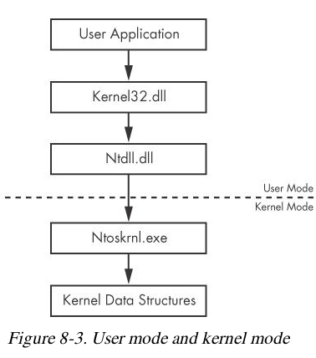
Lower-level interface for interacting with Windows

Rarely used by nonmalicious programs

Popular among malware writers

Ntdll.dll manages interactions between user space and the kernel

Ntdll functions make up the Native API

The Native API

Undocumented

Intended for internal Windows use

Can be used by programs

Native API calls can be more powerful and stealthier than Windows API calls

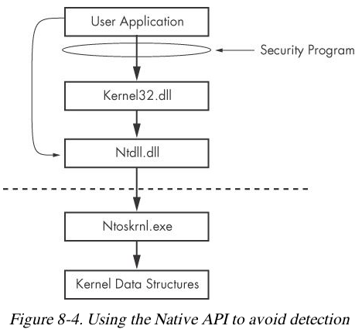

Popular Native API Calls in Malware

NTtQuerySystemInformation

NTtQueryInformationProcess

NTtQueryInformationThread

NTtQueryInformationFile

NTtQueryInformationKey

Provide much more information than any available Win32 calls

Popular Native API Calls in Malware

NtContinue

Returns from an exception

Can be used to transfer execution in complicated ways

Used to confuse analysists and make a program more difficult to debug

Last modified 9-30-13

