Disassemblers v. Debuggers

A disassembler like IDA Pro shows the state of the program just before execution begins

Debuggers show

Every memory location

Register

Argument to every function

At any point during processing

And let you change them

Two Debuggers

Ollydbg

Most popular for malware analysis

User-mode debugging only

IDA Pro has a built-in debugger, but it's not as easy to use or powerful as Ollydbg

Windbg

Supports kernel-mode debugging

Source-Level v. Assembly-Level Debuggers

Source-level debugger

Usually built into development platform

Can set breakpoints (which stop at lines of code)

Can step through program one line at a time

Assembly-level debuggers (low-level)

Operate on assembly code rather than source code

Malware analysts are usually forced to use them, because they don't have source code
Kernel v. User-Mode Debugging

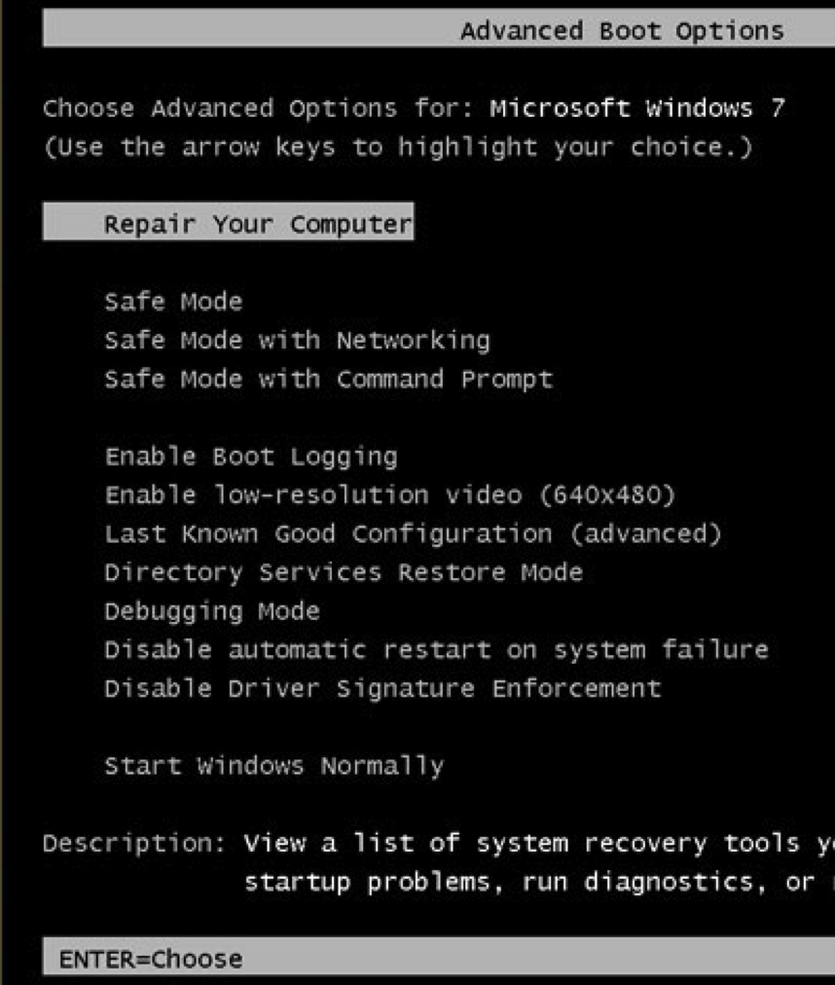
User Mode Debugging

Debugger runs on the same system as the code being analyzed

Debugging a single executable

Separated from other executables by the OS

Kernel Mode Debugging

Requires two computers, because there is only one kernel per computer

If the kernel is at a breakpoint, the system stops

One computer runs the code being debugged

Other computer runs the debugger

OS must be configured to allow kernel debugging

Two machines must be connected

Windows 7 Advanced Boot Options

Press F8 during startup

"Debugging Mode"

Good Intro to OllyDbg

Link Ch 8a

Using a Debugger

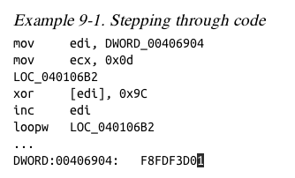
Two Ways

Start the program with the debugger

It stops running immediately prior to the execution of its entry point

Attach a debugger to a program that is already running

All its threads are paused

Useful to debug a process that is affected by malware

Single-Stepping

Simple, but slow

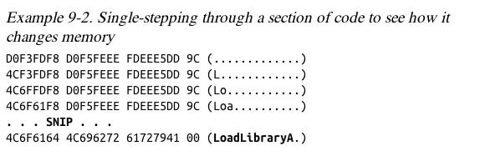
Don't get bogged down in details

Example

This code decodes the string with XOR

Stepping-over v. Stepping-Into

Single step executes one instruction

Step-over call instructions

Bypasses the call

Decreases the amount of code you need to analyze

Might miss important functionality, especially if the function never returns

Step-into a call

Moves into the function and stops at its first command

Pausing Execution with Breakpoints

A program that is paused at a breakpoint is called broken

Example

You can't tell where this call is going

Set a breakpoint at the call and see what's in eax
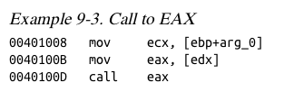

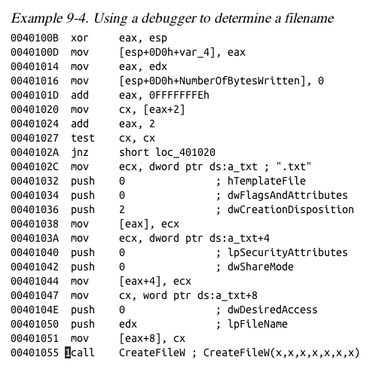
This code calculates a filename and then creates the file

Set a breakpoint at CreateFileW and look at the stack to see the filename

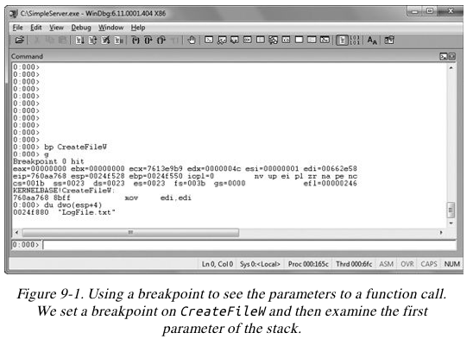

WinDbg

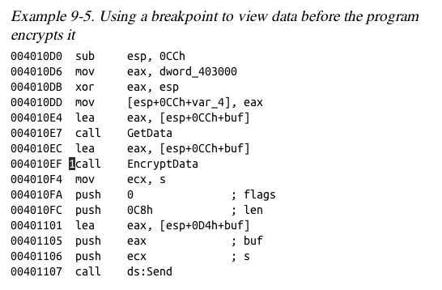
Encrypted Data

Suppose malware sends encrypted network data

Set a breakpoint before the data is encrypted and view it

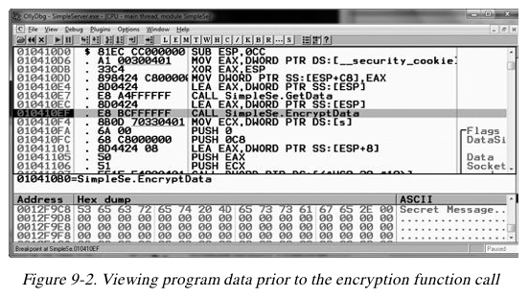

OllyDbg

Types of Breakpoints

Software execution

Hardware execution

Conditional

Software Execution Breakpoints

The default option for most debuggers

Debugger overwrites the first byte of the instruction with 0xCC

The instruction for INT 3

An interrupt designed for use with debuggers

When the breakpoint is executed, the OS generates an exception and transfers control to the debuggersx

Memory Contents at a Breakpoint

There's a breakpoint at the push instruction

Debugger says it's 0x55, but it's really 0xCC
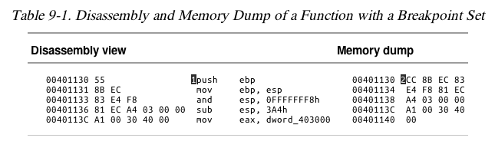

When Software Execution Breakpoints Fail

If the 0xCC byte is changed during code execution, the breakpoint won't occur

If other code reads the memory containing the breakpoint, it will read 0xCC instead of the original byte

Code that verifies integrity will notice the discrepancy

Hardware Execution Breakpoints

Uses four hardware Debug Registers

DR0 through DR3 – addresses of breakpoints

DR7 stores control information

The address to stop at is in a register

Can break on access or execution

Can set to break on read, write, or both

No change in code bytes

Running code can change the DR registers, to interfere with debuggers

General Detect flag in DR7

Causes a breakpoint prior to any mov instruction that would change the contents of a Debug Register

Does not detect other instructions, however

Conditional Breakpoints

Breaks only if a condition is true

Ex: Set a breakpoint on the GetProcAddress function

Only if parameter being passed in is RegSetValue

Implemented as software breakpoints

The debugger always receives the break

If the condition is not met, it resumes execution without alerting the user

Conditional breakpoints take much longer than ordinary instructions

A conditional breakpoint on a frequently-accessed instruction can slow a program down

Sometimes so much that it never finishes

Exceptions

Used by debuggers to gain control of a running program

Breakpoints generate exceptions

Exceptions are also caused by

Invalid memory access

Division by zero

Other conditions

First- and Second-Chance Exceptions

When a exception occurs while a debugger is attached

The program stops executing

The debugger is given first chance at control

Debugger can either handle the exception, or pass it on to the program

If it's passed on, the program's exception handler takes it

Second Chance

If the application doesn't handle the exception

The debugger is given a second chance to handle it

This means the program would have crashed if the debugger were not attached

In malware analysis, first-chance exceptions can usually be ignored

Second-chance exceptions cannot be ignored

They usually mean that the malware doesn't like the environment in which it is running

Common Exceptions

INT 3 (Software breakpoint)

Single-stepping in a debugger is implemented as an exception

If the trap flag in the flags register is set,

The processor executes one instruction and then generates an exception

Memory-access violation exception

Code tries to access a location that it cannot access, either because the address is invalid or because of access-control protections

Violating Privilege Rules

Attempt to execute privileged instruction with outside privileged mode

In other words, attempt to execute a kernel mode instruction in user mode

Or, attempt to execute Ring 0 instruction from Ring 3

List of Exceptions

Link Ch 8b
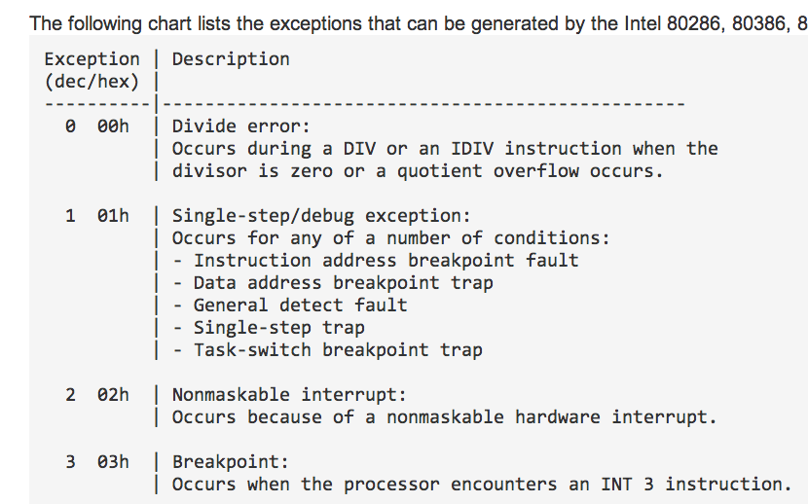

Modifying Execution with a Debugger

Skipping a Function

You can change control flags, the instruction pointer, or the code itself

You could avoid a function call by setting a breakpoint where at the call, and then changing the instruction pointer to the instruction after it

This may cause the program to crash or malfunction, or course

Testing a Function

You could run a function directly, without waiting for the main code to use it

You will have to set the parameters

This destroys a program's stack

The program won't run properly when the function completes
Modifying Program Execution in Practice

Real Virus

Operation depends on language setting of a computer

Simplified Chinese

Uninstalls itself & does no harm

English

Display pop-up "Your luck's no good"

Japanese or Indonesian

Overwrite the hard drive with random data

Break at 1; Change Return Value

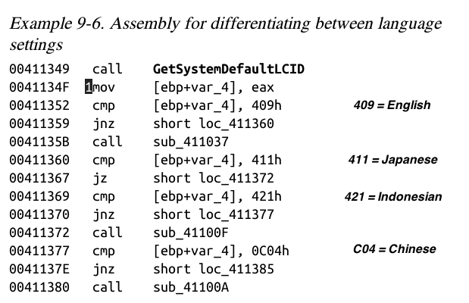

Last modified 10-4-13

