History

OllyDbg was developed more than a decade ago

First used to crack software and to develop exploits

The OllyDbg 1.1 source code was purchased by Immunity and rebranded as Immunity Debugger

The two products are very similar
Loading Malware

Ways to Debug Malware

You can load EXEs or DLLs directly into OllyDbg

If the malware is already running, you can attach OllyDbg to the running process

Opening an EXE

File, Open

Add command-line arguments if needed

OllyDbg will stop at the entry point, WinMain, if it can be determined

Otherwise it will break at the entry point defined in the PE Header

Configurable in Options, Debugging Options

Attaching to a Running Process

File, Attach

OllyDbg breaks in and pauses the program and all threads

If you catch it in DLL, set a breakpoint on access to the entire code section to get to the interesting code
The OllyDbg Interface
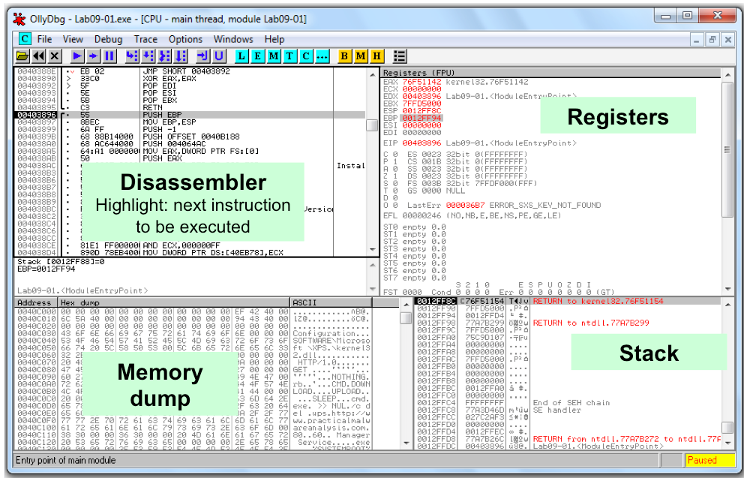

Modifying Data

Disassembler window

Press spacebar

Registers or Stack

Right-click, modify

Memory dump

Right-click, Binary, Edit

Ctrl+G to go to a memory location

Right-click a memory address in another pane and click "Follow in dump"

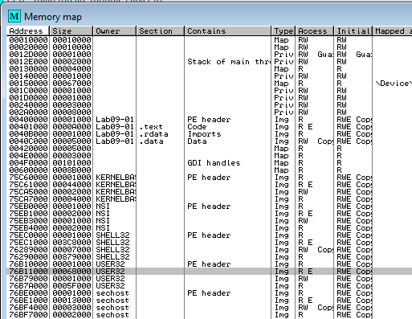
Memory Map

View, Memory Map

EXE and DLLs are identified

Double-click any row to show a memory dump

Right-click, View in Disassembler

Rebasing

Rebasing occurs when a module is not loaded at its preferred base address

PE files have a preferred base address

The image base in the PE header

Usually the file is loaded at that address

Most EXEs are designed to be loaded at 0x00400000

EXEs that support Address Space Layout Randomization (ASLR) will often be relocated

DLL Rebasing

DLLs are more commonly relocated

Because a single application may import many DLLs

Windows DLLs have different base addresses to avoid this

Third-party DLLs often have the same preferred base address

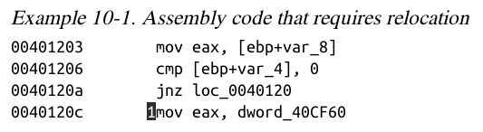
Absolute v. Relative Addresses

The first 3 instructions will work fine if relocated because they use relative addresses

The last one has an absolute address that will be wrong if the code is relocated

Fix-up Locations

Most DLLS have a list of fix-up locations in the .reloc section of the PE header

These are instructions that must be changed when code is relocated

DLLs are loaded after the EXE and in any order

You cannot predict where DLLs will be located in memory if they are rebased

.reloc Section in PEiD
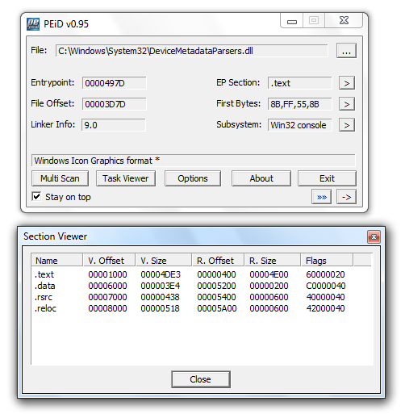

DLL Rebasing

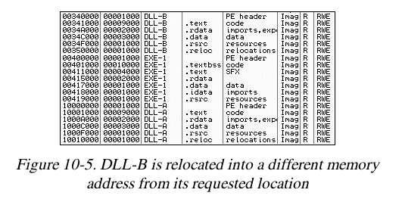
DLLS can have their .reloc removed

Such a DLL cannot be relocated

Must load at its preferred base address

Relocating DLLs is bad for performance

Adds to load time

So good programmers specify non-default base addresses when compiling DLLs

IDA Pro

IDA Pro is not attached to a real running process

It doesn't know about rebasing

If you use OllyDbg and IDA Pro at the same time, you may get different results

To avoid this, use the "Manual Load" option in IDA Pro

Specify the virtual base address manually

Viewing Threads and Stacks

View, Threads

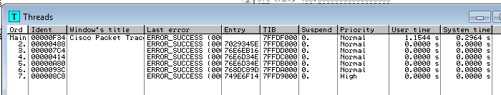
Right-click a thread to "Open in CPU", kill it, etc.

Each Thread Has its Own Stack

Visible in Memory Map

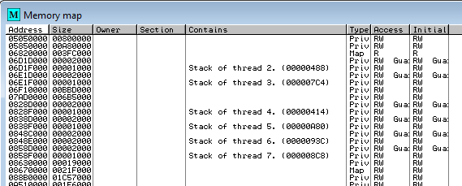

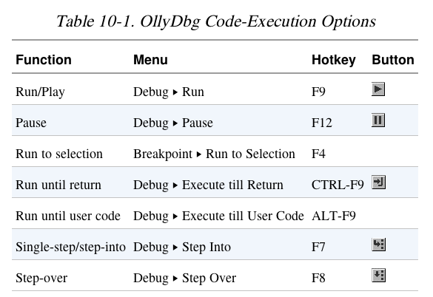
Executing Code

Run and Pause

You could Run a program and click Pause when it's where you want it to be

But that's sloppy and might leave you somewhere uninteresting, such as inside library code

Setting breakpoints is much better

Run and Run to Selection

Run is useful to resume execution after hitting a breakpoint

Run to Selection will execute until just before the selected instruction is executed

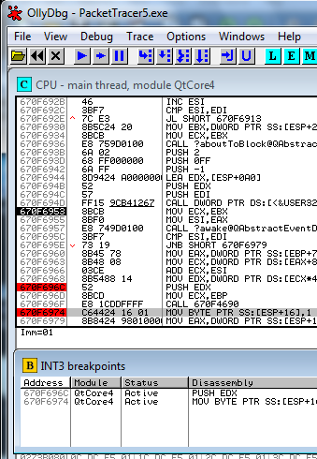
If the selection is never executed, it will run indefinitely

Execute till Return

Pauses execution until just before the current function is set to return

Can be useful if you want to finish the current function and stop

But if the function never ends, the program will continue to run indefinitely

Execute till User Code

Useful if you get lost in library code during debugging

Program will continue to run until it hit compiled malware code

Typically the .text section

Stepping Through Code

F7 -- Single-step (also called step-into)

F8 -- Step-over

Stepping-over means you skip some code

Some malware is designed to fool you, by calling routines and never returning, so stepping over will miss the most important part
Breakpoints

Types of Breakpoints

Software breakpoints

Hardware breakpoints

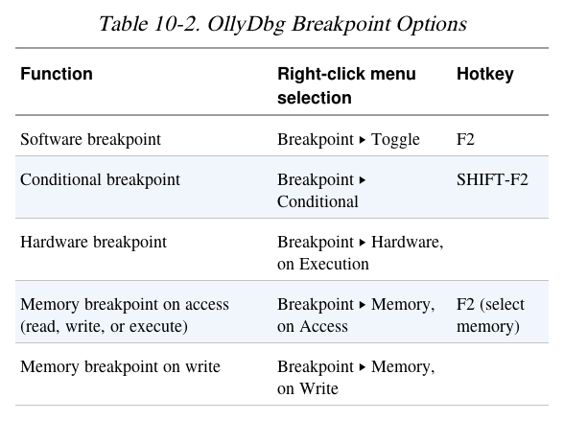
Conditional breakpoints

Breakpoints on memory

F2 – Add or remove a breakpoint

Viewing Active Breakpoints

View, Breakpoints, or click B icon on toolbar

Saving Breakpoints

When you close OllyDbg, it saves your breakpoints

If you open the same file again, the breakpoints are still available

Software Breakpoints

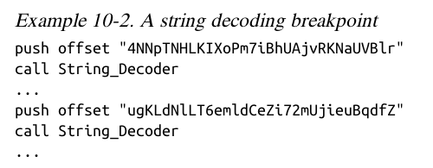
Useful for string decoders

Malware authors often obfuscate strings

With a string decoder that is called before each string is used

String Decoders

Put a breakpoint at the end of the decoder routine

The string becomes readable on the stack
Each time you press Play in OllyDbg, the program will execute and will break when a string is decoded for use

This method will only reveal strings as they are used

Conditional Breakpoints

Breaks only when a condition is true

Ex: Poison Ivy backdoor

Poison Ivy allocates memory to house the shellcode it receives from Command and Control (C&C) servers

Most memory allocations are for other purposes and uninteresting

Set a conditional breakpoint at the VirtualAlloc function in Kernel32.dll

Normal Breakpoint

Put a standard breakpoint at the start of the VirtualAlloc function

Here's the stack when it hits, showing five items:

Return address

4 parameters (Address, Size, AllocationType, Protect)
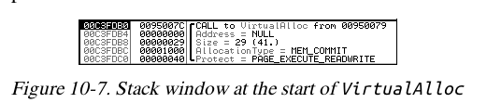

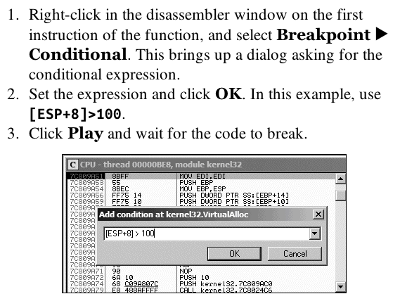

Conditional Breakpoint

Hardware Breakpints

Don't alter code, stack, or any target resource

Don't slow down execution

But you can only set 4 at a time

Click Breakpoint, "Hardware, on Execution"

You can set OllyDbg to use hardware breakpoints by default in Debugging Options

Useful if malware uses anti-debugging techniques

Memory Breakpoints

Code breaks on access to specified memory location

OllyDbg supports software and hardware memory breakpoints

Can break on read, write, execute, or any access

Right-click memory location, click Breakpoint, "Memory, on Access"

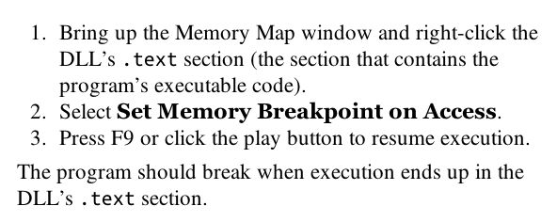
You can only set one memory breakpoint at a time

OllyDbg implements memory breakpoints by changing the attributes of memory blocks

This technique is not reliable and has considerable overhead

Use memory breakpoints sparingly

When is a DLL Used?
Loading DLLs

loaddll.exe

DLLs cannot be executed directly

OllyDbg uses a dummy loaddll.exe program to load them

Breaks at the DLL entry point DLLMain once the DLL is loaded

Press Play to run DLLMain and initialize the DLL for use

Demo

Get OllyDbg 1.10, NOT 2.00 or 2.01

Link Ch 9a

Use Win XP or Win 7

In OllyDbg, open c:\windows\system32\ws2_32.dll

Click Run button once

Debug, Call DLL Export

ntohl

Converts a 32-bit number from network to host byte order

Click argument 1, type in 7f000001

127.0.0.1 in "network" byte order

Click "Follow in Disassembler" to see the code

Click "Call" to run the function

Answer in EAX

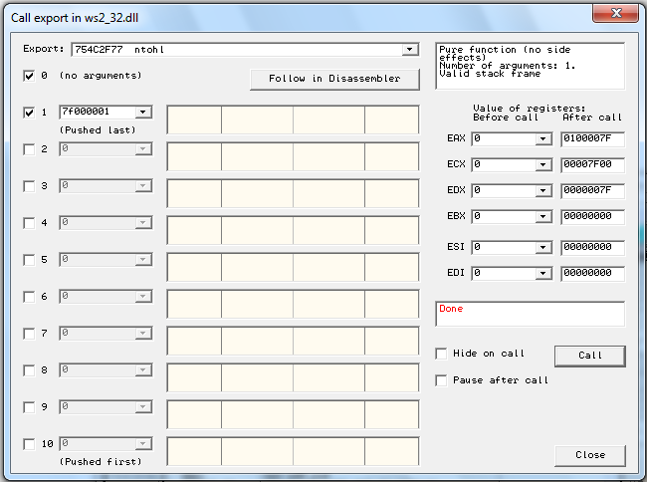

Don't Use OllyDbg 2!
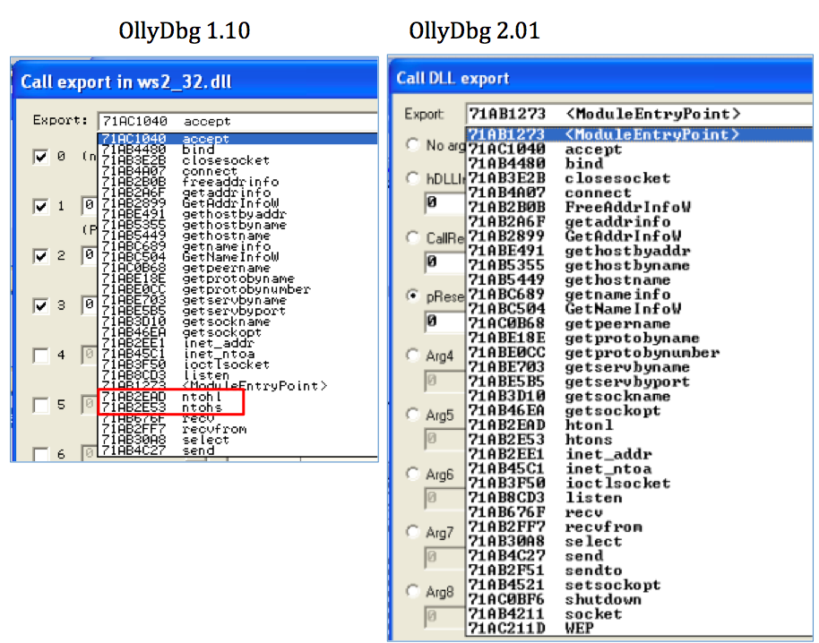

Tracing

Tracing

Powerful debugging technique

Records detailed execution information

Types of Tracing

Standard Back Trace

Call Stack Trace

Run Trace

Standard Back Trace

You move through the disassembler with the Step Into and Step Over buttond

OllyDbg is recording your movement

Use minus key on keyboard to move back in time

Plus key takes you forward

If you used Step Over, you cannot go back and decide to step into

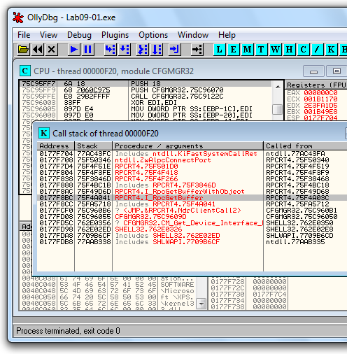
Call Stack Trace

Views the execution path to a given function

Click View, Call Stack

Displays the sequence of calls to reach your current location

Run Trace

Code runs, and OllyDbg saves every executed instruction and all changes to registers and flags

Highlight code, Run Trace, Add Selection

After code executes, View, Run Trace

To see instructions that were executed

+ and - keys to step forward and backwards

Trace Into and Trace Over

Buttons below "Options"

Easier to use than Add Selection

If you don't set breakpoints, OllyDbg will attempt to trace the entire program, which could take a long time and a lot of memory

Debug, Set Condition

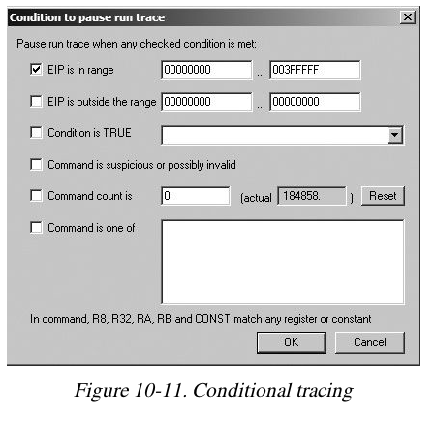
Traces until a condition hits

This condition catches Poison Ivy shellcode, which places code in dynamically allocated memory below 0x400000

Exception Handling

When an Exception Occurs

OllyDbg will stop the program

You have these options to pass the exception into the program:

Shift+F7 Step into exception

Shift+F8: Step over exception

Shift+F9: Run exception handler

Often you just ignore all exceptions in malware analysis

We aren't trying to fix problems in code

Patching

Binary Edit

Fill

Fill with 00

Fill with NOP (0x90)

Used to skip instructions

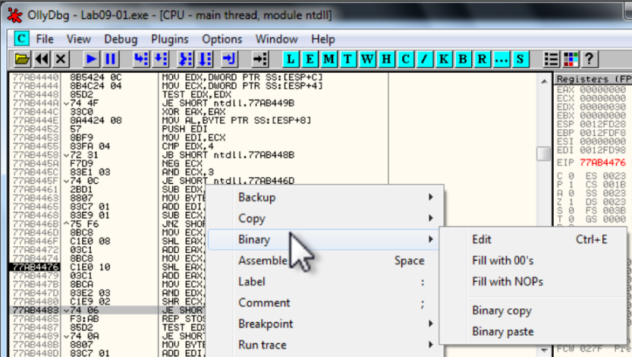
e.g. to force a branch

Saving Patched Code

Right-click disassembler window after patching

Copy To Executable, All Modifications, Save File

Copy All

Right-click in new window

Save File
Analyzing Shellcode

Undocumented technique

Shellcode

Copy shellcode from a hex editor to clipboard

Within memory map, select a region of type "Priv" (Private memory)

Double-click rows in memory map to show a hex dump

Find a region of hundreds of consecutive zeroes

Right-click chosen region in Memory Map, Set Access, Full Access (to clear NX bit)

Analyzing Shelcode

Highlight a region of zeroes, Binary, Binary Paste

Set EIP to location of shellcode

Right-click first instruction, New Origin Here

Assistance Features

Log

View, Log

Shows steps to reach here
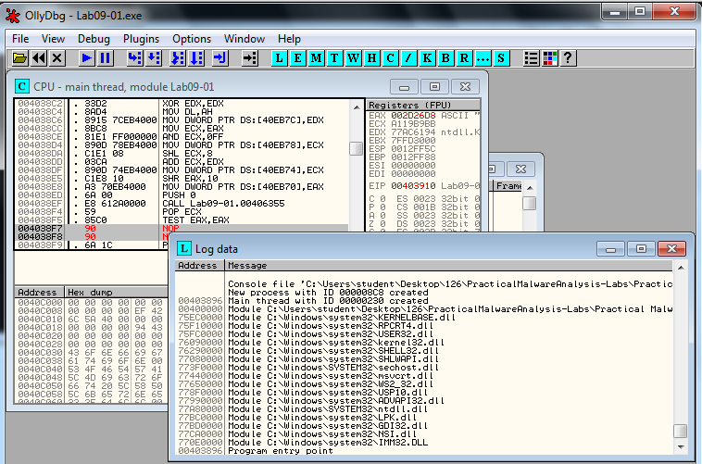

Watches Window

View, Watches

Watch the value of an expression

Press SPACEBAR to set expression

OllyDbg Help, Contents

Instructions for Evaluation of Expressions
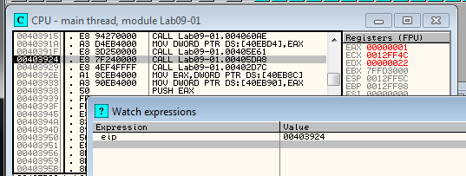

Labeling

Label subroutines and loops

Right-click an address, Label

Plug-ins

Recommended Plugins

OllyDump

Dumps debugged process to a PE file

Used for unpacking

Hide Debugger

Hides OllyDbg from debugger detection

Command Line

Control OllyDbg from the command line

Simpler to just use WinDbg

Bookmarks

Included by default in OllyDbg

Bookmarks memory locations
Scriptable Debugging

Immunity Debugger (ImmDbg)

Unlike OllyDbg, ImmDbg employs python scripts and pas an easy-to-use API

Scripts are located in the PyCommands subdirectory under the install directory of ImmDbg

Easy to create custom scripts for ImmDbg

Last modified 10-14-13

