This is a lengthy process, even if you have DSL or some other broadband connection, so do it when you can leave your machine dedicated to this task for a few hours.

Start SSH Secure File Transfer Client and connect to hills.ccsf.edu with your user ID and password.

On the upper right part of the window there is a white box showing the working directory on the HP-UNIX system. Click in that box, enter /usr/local/antivirus, and then press the Enter key. Your screen should look like the picture below (your local directory, on the left side, may be different).

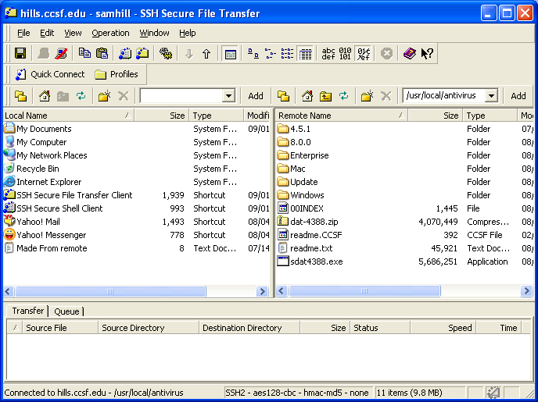

If you are using a Windows system, double-click the Windows folder. (There is a Mac folder for a Macintosh version, but I don’t know how to use the files inside it.) You will find a text file, several PDF files with documentation, and a large ZIP file (VSE80iLEN.zip) containing the software.

Drag the ZIP file to your desktop. The download will take a long time over a modem: you are moving 12 Megabytes, so it may take an hour or longer.

When the download is complete, double-click the VSE80iLEN.zip file to open the archive. Create a folder on your desktop and drag the files into it. Open that folder and double-click the Setup file. The installer will start, with a window titled FEAD® 2.3 Optimizer©. When that window closes, a McAfee VirusScan Enterprise Setup window will open. Click Next, accept the agreement, click OK, click Next, and click Install. When the installation is done, click Finish. Leave both the Update Now and Run On-Demand Scan boxes checked.

The update and on-demand scan are both lengthy processes, but important. They could take hours.

Wait for the installation to complete.

--Sam Bowne, Revised 9-1-04

