Use NVU, Dreamweaver, Frontpage, Netscape Composer or any other WYSIWYG editor to make a Web page. Do not use a word processor such as Microsoft Word.
Your webpage must have the following Required Elements
- Your webpage should consist of two files: hw10.html and an image file with any appropriate name, ending in .gif or .jpg
- Your name at the top of the Web page body section in any readable style you choose.
- At least two different font sizes and colors used
- A background color for the whole Web page
- A Table with at least two cells, and these items in the table:
  - An image in a cell
  - A hyperlink in a cell
  - An ordered or unordered list in a cell
  - A background color in a cell (just double-click a cell to do this)
- A citation to the source of your image, such as "picture from www.rollingstone.com". If you use a picture that is your own property, your page must say that "picture my own property".

HW 10 Example:
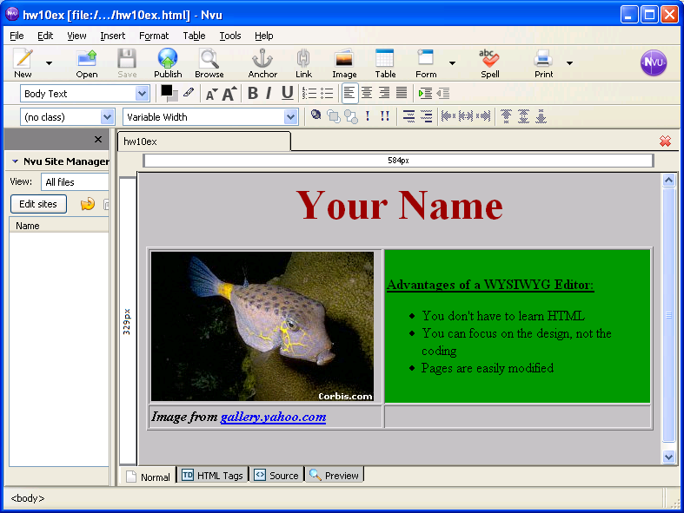

Put your Web page on the hills server using SSH Secure File Transfer

View your web page in a browser
Open Internet Explorer or another browser and type the URL of your Web page into the Address bar. The URL of your web page is:
http://hills.ccsf.edu/~flast01/hw10.html
with your HP-UNIX User ID instead of flast01.
Make sure the image is visible, and all the required elements are present.

E-mail the URL of your web page to me
Use any e-mail service of your choice, and compose a message to me at
cnit.131@gmail.com
with the subject
HW 10 from your name
with your name replaced by your own first and last name. Copy the URL of the webpage from the Address bar of the browser window and paste it into the body of the e-mail message. I recommend that you send a CC to yourself. Send the message.
Last modified: 10-25-05

