Overview
You need two images to work with -- a JPEG image and a GIF. The effects here work best if the JPEG is a detailed painting or photograph, and the GIF is a cartoon or line drawing.
You can use images you created, or find new images on the Web. Save both images in a floppy disk or anywhere else you can find them. Make a note of the names of both images, their file sizes, and the URLs you got them from (if they are not your own property).
In my examples below, I will use the filenames ship.jpg and bird.gif for the original images. Your images may have any name you like. In this homework, you will make seven images by modifying those two images, and make a web page with all seven images on it.
This technique uses a free online graphics editing program which is funded by advertising. Some of that advertising is annoying, so expect to see some pop-up ads as you proceed. If you see any Security Warning windows asking you to install toolbars, click No.
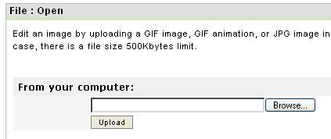

JPEG Compression
- Open a browser and go to http://www.myimager.com/ .
- In the drop-down list titled File at the upper left of the My Imager window, select Open.
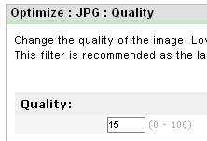
- A File: Open screen opens as shown above on this page. Enter the URL of your original JPEG image, or use the Browse button to upload it from your computer. Click the appropriate Upload button.
- In the drop-down list titled Optimize at the top of the window, in the JPG, JPEG: section, select Quality....
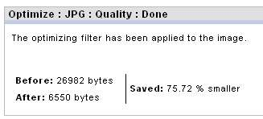
- An Optimize: JPG: Quality screen opens as shown to the right on this page. Enter a quality of 15 and click the Set Quality button.
- A Optimize: JPG: Quality: Done screen opens as shown to the right on this page. Note the original and reduced file sizes. If the file did not shrink to half its original size, or smaller, repeat the steps above and enter a lower quality value. Once you have a properly compressed image, point to it, right-click, and select Save Image As... to save it. Use a file name ending in _comp to indicate that this is a compressed file.

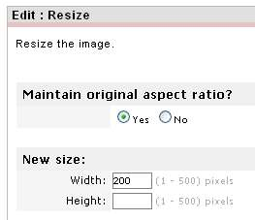
Shrinking an Image
- If necessary, open a browser and go to http://www.myimager.com/ .
- In the drop-down list titled File at the upper left of the My Imager window, select Open.
- In the File: Open window, enter the URL of your original JPEG image, or use the Browse button to upload it from your computer. Click the appropriate Upload button.
- In the drop-down list titled Edit at the top of the window, select Resize.
- An Edit: Resize screen opens as shown above on this page. To avoid image distortion, click Yes below the question Maintain original aspect ratio? Enter a new size in pixels into the Width box. Click the Submit button.
- A reduced image should appear on the screen. Point to it, right-click, and select Save Image As... to save it. Use a file name ending in _half to indicate that this is a shrunken file.
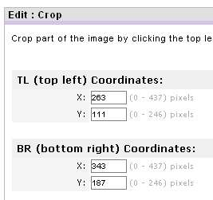

Cropping an Image
- If necessary, open a browser and go to http://www.myimager.com/ .
- In the drop-down list titled File at the upper left of the My Imager window, select Open.
- In the File: Open window, enter the URL of your original JPEG image, or use the Browse button to upload it from your computer. Click the appropriate Upload button.
- In the drop-down list titled Edit at the top of the window, select Crop....
- An Edit: Crop screen opens. Click the upper-left corner of the region you want to keep in the image, and then click the lower-right corner of the desired region. When you see the Edit: Crop with coordinate boxes, as shown to the right on this page, click the Crop it button.
- An Edit: Crop: Done screen opens, with the cropped image. Point to the cropped image, right-click, and select Save Image As... to save it. Use a file name ending in _detail to indicate that this is a cropped image.

Transparent GIF
- If necessary, open a browser and go to http://www.myimager.com/ .
- In the drop-down list titled File at the upper left of the My Imager window, select Open.
- In the File: Open window, enter the URL of your original GIF image, or use the Browse button to upload it from your computer. Click the appropriate Upload button.
- In the drop-down list titled Adjust at the top of the window, select Set Transparent....
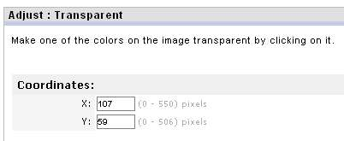
- An Adjust: Transparent screen opens. Click on the image, on a portion of it with the color you want to make transparent. When you see the Effects: Set Transparent with coordinate boxes, as shown to the right on this page, click the Submitbutton.
- An Adjust: Set Transparent: Done screen opens, with the transparent image. Point to the transparent image, right-click, and select Save Image As... to save it. Use a file name ending in _tr to indicate that this is a transparent image.
NOTE: Some GIFs on the Internet are already transparent. If you want to remove transparency information from an image, in the drop-down list titled Edit at the top of the window, select Convert to change it to a JPEG. Then select Edit, Convert again to change it back to a GIF. Now the image has lost its transparency.

Use NotePad to make a Web page in HTML named hw11.html. Your web page must have the following

Required Elements
- Your Name and hw11 in the title bar of the browser window
- Your statement must include a background color, or a background image, or both, so that the transparency of the Transparent GIF is easy to see. To use a background color, use the bgcolor attribute in the BODY statement like this (you can use any of many colors, not just blue):
<body bgcolor="blue">
To use a background image, use the background attribute in the BODY statement like this (you will have to get a background image and upload it to the server along with your page):
<body background="image.gif">
- These 6 images, labelled as shown below, including the file size in bytes or KB:
  - Original JPEG (file size)
  - Compressed JPEG (file size)
  - Shrunken JPEG (file size)
  - Detail of JPEG (file size)
  - Original GIF (file size)
  - Transparent GIF (file size)

- You must cite the sources of both of your images. If they are your own creations, say that.
- Put your Web page on the hills server, using Fugu or any other File Transfer Client.
- Send the URL of your Web page to me at
cnit.131@gmail.com
with the subject
HW 11 from YOUR NAME.

