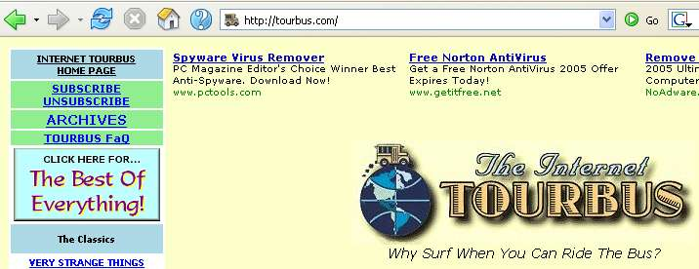
- Start at the Tourbus home page http://www.tourbus.com/

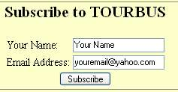

- Click on SUBSCRIBE at the top left. Fill in your e-mail address and name and click Submit.

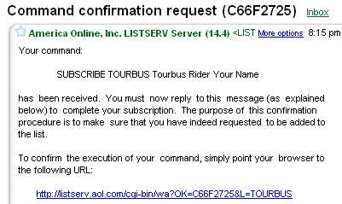
- Check your e-mail. You should have a confirmation message like the one shown to the right. Follow the instructions in the confirmation message and confirm your subscription.

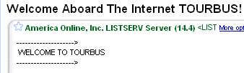
- You will receive a Welcome message in your inbox, as shown to the right on this page. Forward that message to me at cnit.131@ccsf.edu with the subject HW 12a from Your Name

Last Updated: 11-16-05

