Requirements:

- Access Usenet Newsgroups, using any one of these techniques:

Configure Netscape using the sand server (works on campus with no user name and password; if you want to do it from off-campus, the CCSF News Server needs Username: ccsf and Password: its)

Configure Outlook Express using the sand server (same notes as above)

Configure Outlook Express using your ISP's news service (you are on your own for this one; see your ISP's help web pages)

Use the Google Groups Website
- Subscribe to one or more newsgroups of your choice (please don't use an extremely rude or offensive one)
- Save a screen image of the message as a JPEG file.

Email the image to me at cnit.131@gmail.com with a subject line of HW 12b from YOUR NAME.

Netscape (only works on CCSF campus)

Configure Netscape to receive Usenet News. The steps are:

Click Start, Programs, Netscape 7.0, Mail & Newsgroups.

If the Account Wizard does not open automatically, click File, New, Account to start it.

When the Account Wizard opens the New Account Setup panel, select Newsgroup Account and click Next.

When the Account Wizard opens the Identity panel, enter your name and email address and click Next.

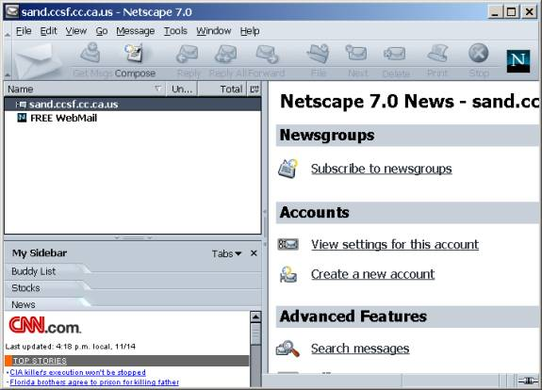
When the Account Wizard opens the Server Information panel, enter sand.ccsf.cc.ca.us and click Next.

When the Account Wizard opens the Account name panel, leave the name sand.ccsf.cc.ca.us unchanged and click Next.

When the Account Wizard opens the Congratulations! panel, click Finish.

If a box opens asking whether you want Netscape to be the default mail application, click No.

A window should open as shown to the right on this page. Click on sand.cccsf.cc.ca.us in the left pane and click on Subscribe to Newsgroups in the right pane.

Netscape asks for a User Name and Password. Enter a User Name of ccsf and a password of its.

When the Subscribe window opens, wait for the newsgroups to download and find a group that interests you. To find a group, enter a word in the Show items that contain box and highlight a group name that you like.

Click the Subscribe button, and the OK button.

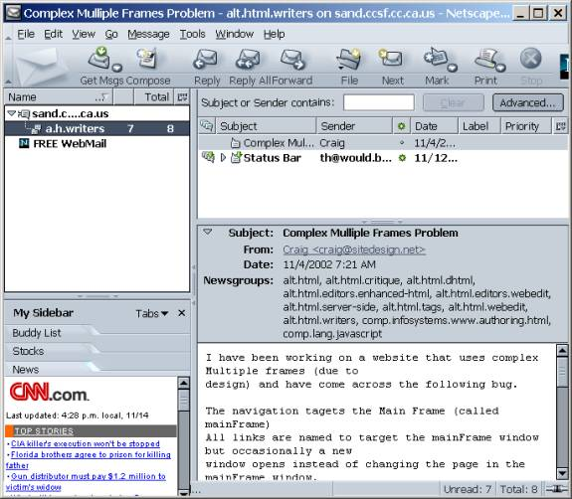
The newsgroup you subscribed to should appear in the left pane. Click its name and click a posting in the right pane.

Save a screen image of the message as a JPEG file.

Email the image to me at cnit.131@gmail.com with a subject line of HW 12b from YOUR NAME.

Outlook Express (only works on CCSF campus)

Configure Outlook Express to receive Usenet News. The steps are:

Select Tools, Accounts, News Tab

Select Add, News

Enter your name and e-mail address

The server is sand.ccsf.cc.ca.us

When a dialog box opens asking if you want to download newsgroup names, click Yes

Select a newsgroup with an interesting name and click Subscribe

Navigate to a message using the left pane of the main window (the one with your Inbox in it).

Save a screen image of the message as a JPEG file.

Email the image to me at cnit.131@gmail.com with a subject line of HW 12b from YOUR NAME.

Using Google Groups

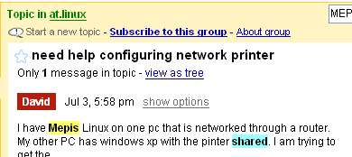
Start at the Google Groups page http://groups.google.com

Enter a keyword or two about your topic and click Search

Click on a message to see its full text

Press Alt+PrntScrn to copy the screen to the clipboard.

Open Paint and press Ctrl+V to paste it. Save it as a JPEG file.

Email the image to me at cnit.131@gmail.com with a subject line of HW 12b from YOUR NAME.

Revised 11-8-05

