
- Start at the Blogger home page www.blogger.com/

- Click on CREATE YOUR BLOG NOW at the lower right. Make up a user name and password, and fill in the other requested information. Click the CONTINUE button.

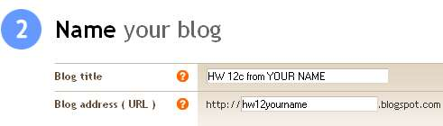
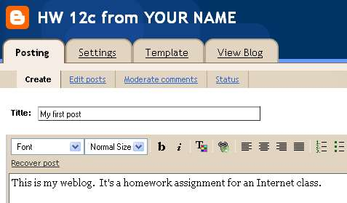
- On the Name your blog page, enter a Blog title of HW 12c from YOUR NAME and a Blog address of hw12yourname as shown to the right on this page. Type in the Word Verification word and click the CONTINUE button.

- On the Choose a template page, choose any template and click the CONTINUE button.

- On the HW 12c from YOUR NAME page, Enter a title for your first post, and some text below, as shown to the right on this page. Click the Publish Post button at the lower right of the screen.

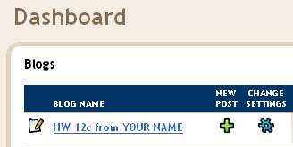
- On the Your blog published successfully. page, click the View Blog link to see your weblog.

- At the top left, click the Blogger logo to go back to the blogger.com page. In the Dashboard section, click on the plus sign under the words New Post, as shown to the right on this page.

- Make sure you have an image ready to put on your blog. Save it on the desktop or some other location you can access from the computer you are using. Make sure you know the source of your image.
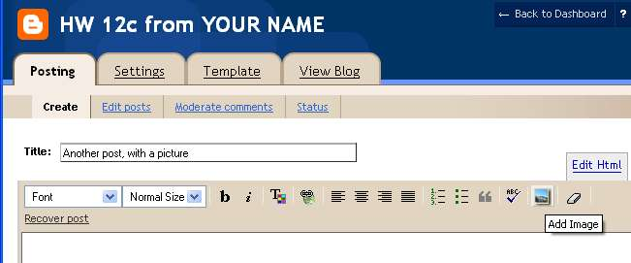
- Enter a title for the post. Click the Add Image button, indicated by the arrow to the right on this page.

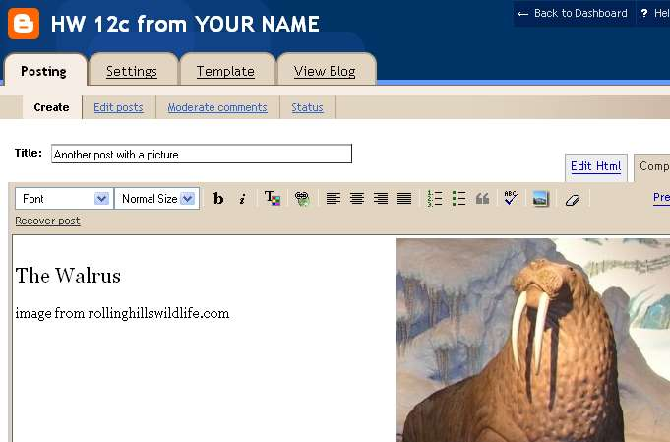
- A window opens with the heading Add an image from your computer on the left. Click the Browse button. Find your image, select a Layout option, and .click Upload image. When the upload finishes, click Done.

- Your image should appear in the HW12c from YOUR NAME window, as shown to the right on this page. When your image looks the way you want it to, click the Publish Post button.

- On the Your blog published successfully. page, click the View Blog link to see your weblog.

- Make sure your weblog has these required elements:

Your name at the top of the page

At least two posts

At least one image

Credit for the source of your image

- Email the URL of your blog to me at cnit.131@ccsf.edu with the subject HW 12cfrom Your Name

Last Updated: 11-16-05

