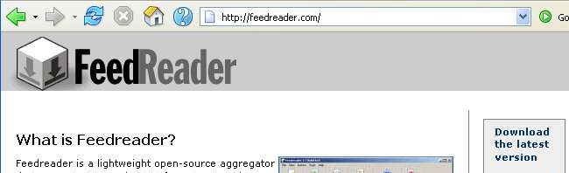
Installing Feedreader
- Start at www.feedreader.com. Click the Download the latest version link in the upper right of the screen, as shown in the figure to the right on this page.
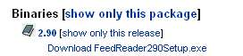
- In the next screen, under the Binaries heading, click the first Download Feedreader link as shown to the right on this page. This is the latest version.

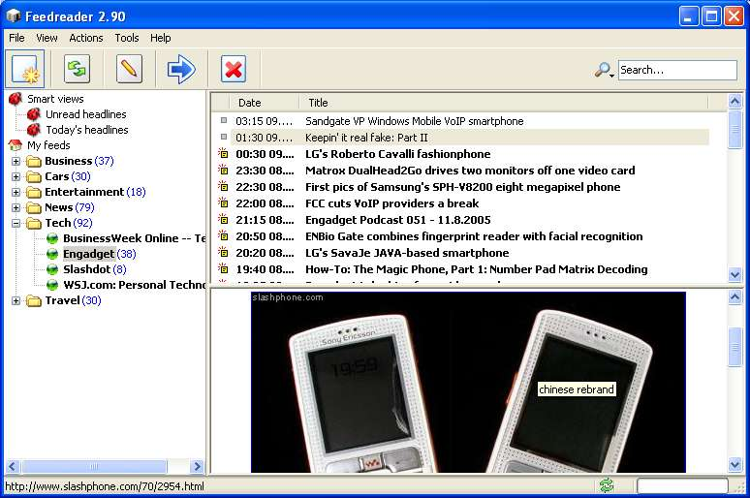
- The next page asks you to Please select a mirror. Try to find one in the USA near California, as shown to the right on this page. Click on the sponge-shaped icon at the right labeled 1500 kb. The download should start automatically. Save it on your desktop or some other location where you can find it.

- Find the FeedReader290Setup.exe file and double-click it. Go through the installation process as usual, accepting the default settings. When you are done, Feedreader should launch, as shown to the right on this page.

- The left pane shows the newsfeeds that Feedreader installs by default in several categories, like Business, Cars, and Tech. Expand a section and click on a feed to see how it works. You see the subject of each article in the top right-pane, and when you click on an article subject, it opens in the lower pane. It's a lot like reading your email in Outlook Express.

- The next thing to do is to add a custom feed to the list, of a topic that interests you.

Finding a Newsfeed
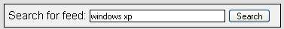
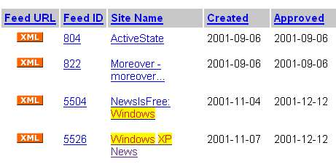
- Start at www.syndic8.com. Scroll down and find the Search for feed box shown to the right on this page. Enter a topic that interests you and click the Search button.

- A list of feed names appears, with orange XML buttons at the left, as shown to the right on this page.

Saving the Screen Image
- Press Alt+ PrintScrn to copy the window showing the list of feeds to the clipboard.
- Click Start, Programs, Accessories, Paint. In the untitled - Paint window, select Edit, Paste from the menu bar to paste the image into Paint.
- In the untitled - Paint window, click File, Save. Save the document in the My Pictures folder (or any other place you wish, such as a floppy disk) with the filename Your Name hw12d1. Select a Save as type of JPEG.

Adding the Newsfeed to Feedreader
- Find a feed that looks interesting, and point the mouse cursor to the orange XML link. Right-click and select Copy Shortcut (In Firefox, click Copy Link Location).
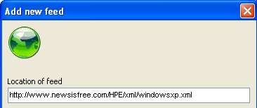
- In the Feedreader window, click File, Add Feed. In the Add new feed box, right-click and select Paste to paste in the URL of the new feed, as shown to the right on this page. Click the Next button.

- A progress indicator moves as the articles are downloaded from the feed. A Create feed in folder section appears. Select an appropriate section for your feed to appear in and click the Finish button.

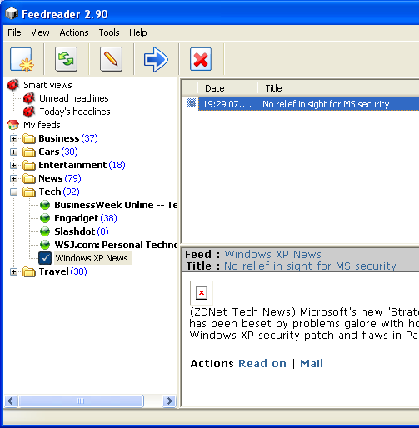
- Select the newsfeed you added in the left pane. An article or more should appear in the upper right pane. Select that article so that it appears in the lower right pane, as shown to the right on this page. If the new feed you added has no articles right now, make sure that it appears in the left pane, so I can tell you added a new feed.

Saving the Screen Image
- Press Alt+ PrintScrn to copy the Feedreader window to the clipboard.
- Click Start, Programs, Accessories, Paint. In the untitled - Paint window, select Edit, Paste from the menu bar to paste the image into Paint.
- In the untitled - Paint window, click File, Save. Save the document in the My Pictures folder (or any other place you wish, such as a floppy disk) with the filename Your Name hw12d2. Select a Save as type of JPEG.

- Send both images to me at cnit.131@ccsf.edu as email attachments. Use the subject HW 12dc from Your Name. Put the name of the new feed you added in the body of the e-mail message, so I can tell which one it is.

Last Updated: 11-16-05

