Decide What Kind of Job You are Looking For
- First write a sentence or two describing the kind of job you are looking for. Here are some examples:

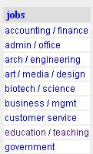
Designing Web sites as a freelancer, working from my home on a contract basis.

A full-time position at a company setting up, maintaining, and repairing computers and software, and perhaps training workers to use them.

A part-time job with flexible hours doing office work.
Finding Two Job Offers
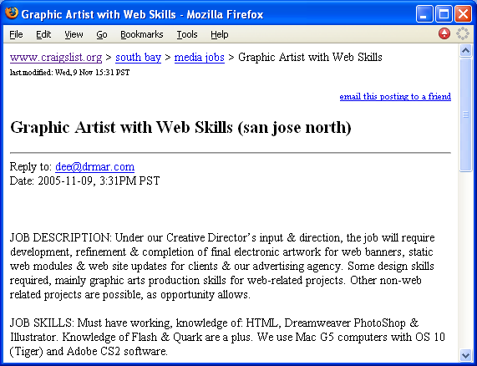
- Open a browser and go to craigslist.org. Find the jobs section on the main page, as shown to the right on this page, and click a category that seems to match your desired job type. You will see a list of jobs posted today, and if you scroll down you will see jobs from the past few days. Items posted on craigslist move rapidly, so it's best to pay the most attention to items posted recently.
- Find a job that looks reasonably close to your desired job. You may find it helpful to search by keyword or try other categories. You may want to use the ETC or part time links at the bottom of the jobs section.
- When you have a window open showing a job offer that meets your requirements, as shown to the right on this page, hold down the Alt key and press the PrntScrn key in the upper-right portion of your keyboard to copy the window to the clipboard.
- Click Start, Programs, Accessories, Paint.
- Type Ctrl+V to paste the screen image into Paint. Click File, Save. A Save As box opens. In the Save as type box, choose JPEG. Then give the file a name of YourNameHW 13a, replacing YourName with your own name, and save it on a floppy disk or in any other folder you can easily find.
- Close Paint.
- REPEAT STEPS 3-7 to find a second job offer that meets your requirements, and save a second screen image with a filename of YourNameHW 13b.
Find Two Comparable Resumes
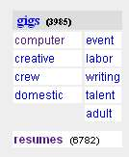
- Return to the craigslist.org page. Click the resumes link near the bottom of the page, as shown to the right on this page.
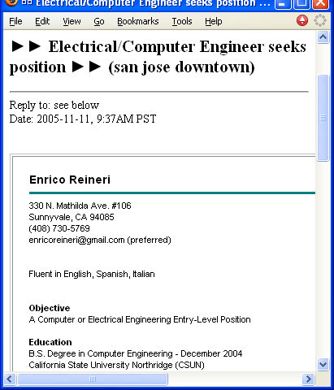
- Find a resume from a person who is looking for a job similar to yours to serve as an example, as shown to the right on this page. Read through it and think about what is good about it, and what is bad about it. Would you hire this person?
- Hold down the Alt key and press the PrntScrn key in the upper-right portion of your keyboard to copy the window to the clipboard.
- Click Start, Programs, Accessories, Paint.
- Type Ctrl+V to paste the screen image into Paint. Click File, Save. A Save As box opens. In the Save as type box, choose JPEG. Then give the file a name of YourNameHW 13c, replacing YourName with your own name, and save it on a floppy disk or in any other folder you can easily find.
- Close Paint.
- REPEAT STEPS 10-14 to find a second resume that meets your requirements, and save a second screen image with a filename of YourNameHW 13d.
Write Your Resume
- Write a resume in Notepad, Word, or any other test editor or word processing program you like. Make sure your resume has these required items:

Your name, address, phone number, and email address

Your objectives – what kind of job you want

Your education to date

Your job experience to date

Correct spelling and grammar

Neat appearance
- Save your resume with a file name of yournameresume.
- Email the four JPEG images and the resume to me as five e-mail attachments. Send them to cnit.131@gmail.com with the subject HW 13 from Your Name.

Revised 11-11-05

