Requirements
- You will need a headset with a microphone. They are available in the ICL-1 at the front desk, just ask for them. Plug them in to the computer in the color-coded ports, which are on the front of the computer for newer computers, and on the back for older computers.

Installing Skype
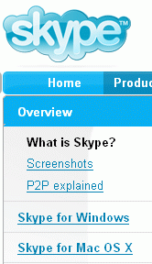
- Open a browser and go to skype.com
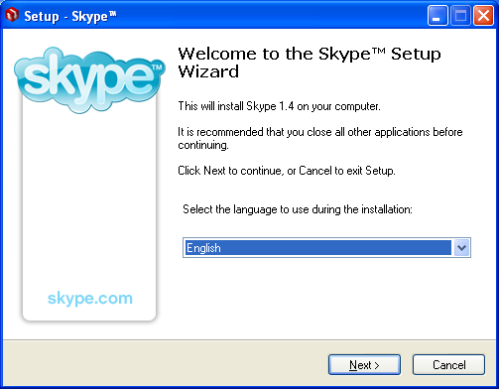
- Look on the left side of the screen, under the Overview section, as shown to the left on this page. If you are using a PC, click Skype for Windows. If you are using a Mac or some some other platform, click the appropriate link.
- In the next window, click the Download Skype button. Run the file, or save the file on your desktop and double-click it.
- You will see a box with a header saying Welcome to the Skype Setup Wizard, as shown to the right on this page. Click Next.

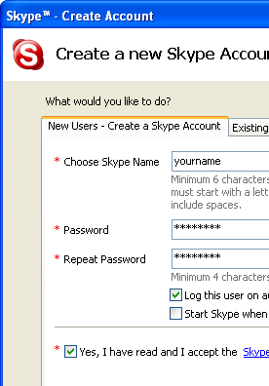
- Accept the agreement and click Next.
- Accept the default installation agreement and click Next.
- In the Select additional tasks window, I recommend unchecking the Start Skype when the computer starts box. Click Next.
- In the Completing the Skype Setup Wizard window, click Finish.

Creating a Skype Account
- A Create a new Skype Account box opens, as shown to the right on this page. Make up a Skype Name and password and type it in as specified, and click the Yes, I have read and I accept the Skype end user license agreement box. Click Next.
- In the Help your friends find you window, enter your name, city, and e-mail address and click Next.
- A Skype window opens showing Skype Contacts (1/1), and a blue Skype Getting Started Wizard box opens.
- In the Skype Getting Started Wizard box, click Start.

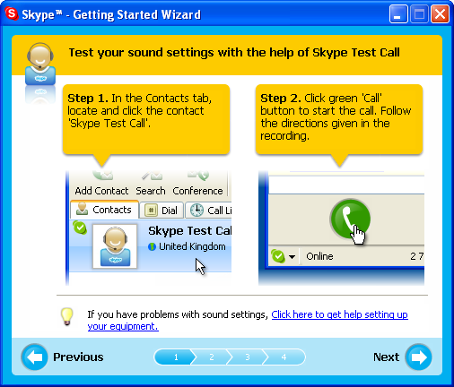
Testing Your Sound Settings
- A box appears with the heading Test your sound settings with the help of Skype Test Call as shown to the right on this page. Do the two steps to verify that you can both talk and hear through the headset.
- If you cannot hear or record, check to make sure you have plugged in the headset correctly. If you are in the ICL-1, the faculty monitor may be able to help you.
- After you have passed the sound test, click Next in the Skype Getting Started Wizard box.

Adding CNIT 131 as a Contact
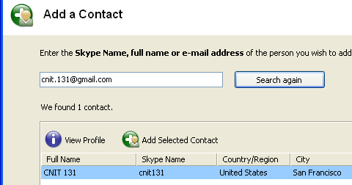
- The Add friends to your Contact List box appears. In the Skype window, c lick the Add Contact icon, as indicated.
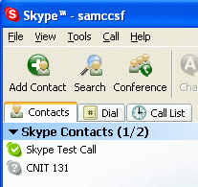
- In the Add a Contact box, enter cnit.131@gmail.com as shown to the right on this page. Click the Search button. When you see CNIT 131 appear in the lower part of the window, in San Francisco, as shown to the right on this page, click the Stop Search button.
- Click the Add Selected Contact button.
- In the Request Authoriozation from CNIT 131 (cnit131) box, click OK.

Calling CNIT 131 and Leaving a Voicemail
- In the Skype window, on the Contacts tab, there is now a CNIT 131 entry, as shown to the right on this page. Double-click CNIT 131.
- You should hear a telephonic beeping sound, and then my voice asking you to leave a message. Leave a short message, including your name. Please speak your name clearly. When you are done leaving the message, click the red telephone button in the lower right corner of the Skype window to hang up.

Revised 11-15-05 8 pm

