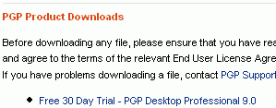
Downloading PGP
- Start a browser and go to www.pgp.com.
- At the top of the window, click on Downloads.
- Under the PGP Product Downloads section, click on the Free 30-Day Trial – PGP Desktop Professional 9.0 link, as shown to the right on this page.
- In the next screen, scroll to the bottom and check the box to indicate that you agree to the EULA. Click the Accept button.
- The next screen asks for your name, address, and other information. Fill it in any way you choose – feel free to lie about your personal information, but use an email address that works. When I tried a mailinator address, it didn't work, so I used a Yahoo one instead. At the bottom of the screen, click the button for the appropriate version (there is a PC version and a Mac version).
- Confirm your email address in the next screen.
- Check your email. You should receive a message with a Subject line beginning PGP Order Confirmation. Open it and click on the download link.
- Follow the instructions to download the file.
- Save the file on your desktop.
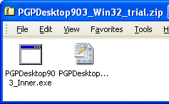
- The remaining instructions are for Windows 2000 or XP users. Windows 95 or 98 users will need Winzip. I'm not sure what Mac users will need.
- Minimize all the windows and find the downloaded file on your desktop and double-click it. That opens a zip archive containing two files as shown to the right on this page. Resize the window so it does not cover the whole desktop, and then drag those two files to the desktop. That will unzip them so you can use them.
Installing PGP
- Double-click the PGPDesktop903_inner.exe file on your desktop. When it asks you what language to use, select English.
- An installer runs. Accept the license agreement and click Next twice.
- Restart your machine when prompted to.
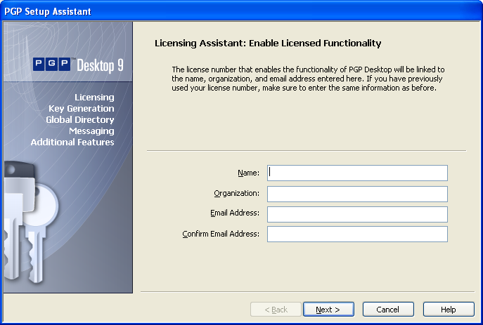
PGP Setup
- The PGP Setup Assistant opens as shown to the right on this page. If you see an Enabling PGP screen, accept the default selection of Yes and click Next.
- At the Licensing Assistant: Enable Licensed Functionality screen, click Next.
- At the Licensing Assistant: Enter License screen, select Use without a license and disable most functionality and click Next.
- At the Licensing screen, click Next.
Generating Your Keys
- At the User Type screen, accept the default selection of I am a new user and click Next.
- At the PGP Key Generation Assistant screen, click Next.
- At the Name and Email Assignment screen, enter your name and a working email address and click Next.
- At the Passphrase Assignment screen, enter a word or phrase you can remember into both boxes and click Next.
- At the Key Generation Progress screen, wait till the animation stops and click Next.
- At the PGP Messaging: Introduction screen, clear both boxes and click Next.
- At the Congratulations! screen, click Finish.
- You should now see a padlock-and-keys icon in the notification area (the lower-right corner of the screen), as shown to the right on this page. That icon indicates that PGP is running, and it’s the easiest way to use the PGP program.
Exporting Your Key to a Floppy Disk
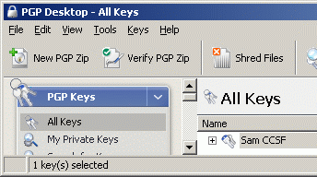
- It is important to export your key to a floppy disk, so that you will still be able to read your encrypted e-mail even if the computer you are using loses the information. This is especially important if you work in a public lab, because the files on the machine will vanish at each restart because of the Deep Freeze software. If you are working at home on your own machine, this step is not really necessary.
- Click the padlock icon in the notification area and select Open PGP Desktop.
- In the PGP Desktop – All Keys window, you will see your name listed in the All Keys column, as shown to the right on this page. You will see your name instead of Sam CCSF.

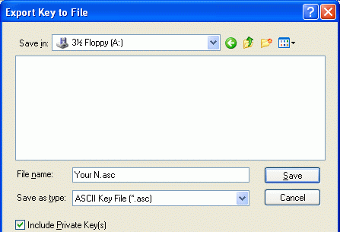
- Right-click your name and select Export. In the Export Key to File window, in the Save in: drop-down list box, select 3 ½ Floppy (A:). Check the Include Private Key(s) box, as shown to the right on this page. Accept the default file name and click Save to save the file.
- Click Start, My Computer and double-click 3 ½ Floppy (A:). You should see the file on the diskette as shown below.
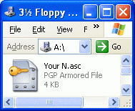

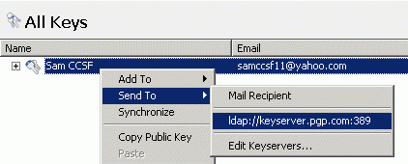
Exporting a Public Key to keyserver.pgp.com
- No one can send you encrypted email unless they have your public key. The best way to make that key available is to upload it to a public server.
- In the PGP Desktop – All Keys window, right-click your name and select Send To, ldap://keyserver.pgp.com:389, as shown to the right on this page.
- A PGP Global Directory Assistant window opens. Click Next.
- A progress indicator moves. When it stops, you should see a message saying Successfully uploaded key(s) to keyserver.pgp.com. Click Next.
- At the completing the PGP Global Directory Assistant screen, click Finish.
Verifying Your Key
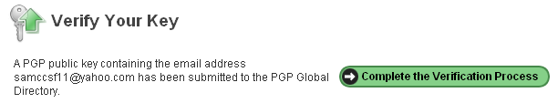
- Check your email at the address you used in step 21. You should see a message with the subject [PGP Global Directory] Verify Your Key.
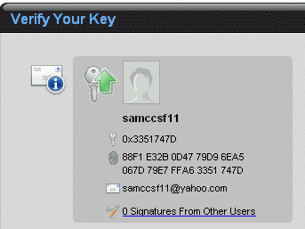
- Open that message and click the Complete the Verification Process button, as shown to the right on this page.
- A Web page opens with the title Verify Your Key as shown to the right on this page. Click the Accept button.
- The next window is titled Email Address Confirmed and it gives you a chance to download a verification key. You can just ignore that and close the browser – the verification key is not required for this assignment.
Importing a Public Key from keyserver.pgp.com
- In the PGP Desktop – All Keys window, in the left pane, click Search for Keys.
- A Search for Keys pane opens at the top of the PGP Desktop – All Keys window. Leave the first two boxes set at the defaults, which create the phrase Search everywhere for keys that meet all of the following conditions:
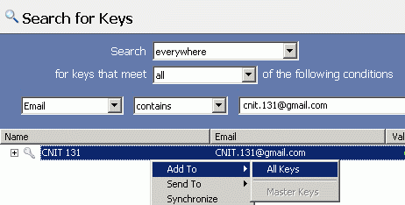
- In the third line, there are three boxes. In the first box, select Email. Leave the second box set to Contains and in the third box, enter cnit.131@gmail.com. Your Search for Keys pane should look like the figure to the right on this page.
- Click the Search button. CNIT 131 should appear in the lower portion of the window.
- Right-click CNIT 131 and select Add To, All Keys.
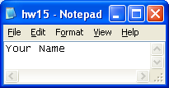
Encrypting a Text File
- Click Start, All Programs, Accessories, Notepad. Type in your name, as shown to the right on this page, and save the file as hw15 on your floppy disk, or in any other folder you can find, such as the My Documents folder.
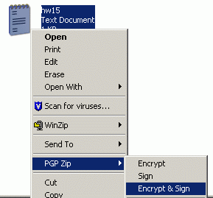
- Open the folder containing the hw15 file. Right-click the hw15 file and select PGP, PGP Zip, Encrypt & Sign as shown to the right on this page.

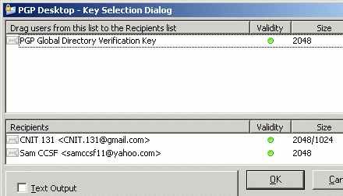
- In the PGP Desktop – Key Selection Dialog box, drag CNIT 131 from the upper pane to the lower Recipients list, as shown to the right on this page. This means the file will be encrypted using my public key that you just imported, so I can read it. Your name will also appear in the Recipients list—that way you can read your copy of the email. Click the OK button.
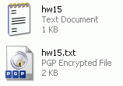
- A PGP Desktop – Enter Passphrase box opens, but you won’t have to enter it because it was cached earlier. Click the OK button.
- A hw15.txt file will appear on your diskette, with an icon showing a lock, and the file type PGP Encrypted File, as shown to the right on this page.
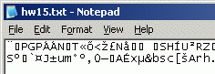
- To see what the encryption has accomplished, right-click this file and select Open With …, NotePad. (You may have to select Choose Program and select NotePad from a list.)
- You can see that the file is utterly unreadable, as shown to the right on this page. Close Notepad.
Emailing the Encrypted Text File to Me
- Use any email client of your choice to mail the hw15.txt.pgp file to me as an attachment. My address is CNIT.131@gmail.com. Use a subject line of HW15 from Your Name.
Receiving an Encrypted Text File From Me
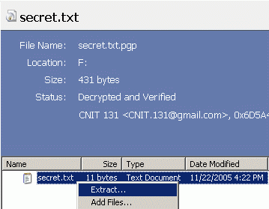
- Read your email. Within a few days, I will reply to your email, and I will include an attachment with the secret instructions you need to use to complete this assignment. Save the attachment on a floppy disk, or any other folder of your choice.
- Right-click the padlock icon in the notification area at the lower-right corner of your desktop and select Open PGP Desktop. Verify that your key is shown in the list. If it is not, select File, Import and import the key from the floppy disk you saved it on.
- Open the floppy disk (or the other folder you saved my attachment in). Double-click the encrypted file. PGP Desktop should open showing that the secret.txt file was Decrypted and Verified, as shown to the right on this page.
- In the lower pane of the PGP Desktop window, right-click the secret.txt file and select Extract. Enter your passphrase if you are prompted to.
- In the Browse for Folder box, select the desktop or any other location of your choice for the decrypted file, and click OK.
- Open the decrypted file and send the secret word inside it back to me to complete the assignment.
Modified 11-23-05

