This assignment is worth 25 points.

WARNING TO STUDENTS USING PUBLIC MACHINES IN THE ICL-1 LAB OR OTHER COMPUTER LABS: If you have important mail in your pine Inbox it will be lost when you do this homework. Move important mail to a folder other than Inbox before starting this homework assignment. If you do not know how to make a folder in pine, see me during an office hour or after class so I can show you how.

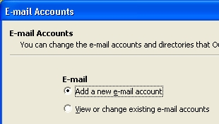
Configuring an E-Mail Client
You need to configure an e-mail client for this assignment. The instructions below are for Microsoft Outlook, the most popular client, but you can use Netscape, Outlook Express, Eudora, or any other e-mail client if you prefer.

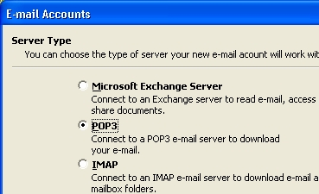
1. Start Microsoft Outlook with Start, Programs, Microsoft Outlook. Select Tools, E-mail Accounts from the menu bar. When the E-mail Accounts window opens as shown to the right on this page, click Add a new e-mail account and then click Next.

2. In the next window, select POP3 and then click Next.

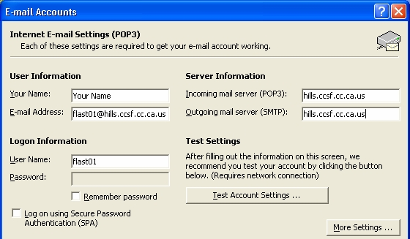
3. In the next window, fill in your name, e-mail address, and hills user ID on the left side. If you are using a public machine, leave the password blank and uncheck the Remember Password box. On the right side, enter hills.ccsf.cc.ca.us for both the Incoming and Outgoing server names. Click Next. In the next window, click Finish.
4. In the main Outlook window, click Send/Receive. When a box pops up asking for your password, type it in. Locate a message sent to your hills account and click on it so that the hills address is visible in the preview pane (the lower part of the window). If your inbox is empty, send yourself a test message like the one you see in the figure to the right on this page.
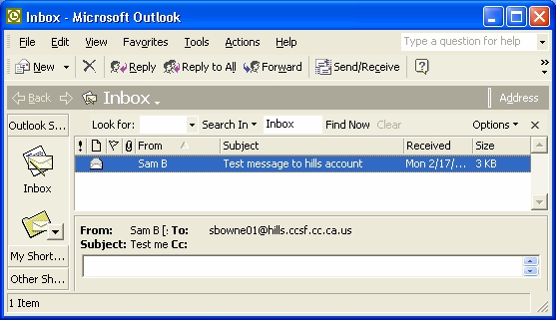
5. Save a screen image of your Outlook screen
- Hold down the Alt key and press the PrntScrn key.
- Click Start Programs, Accessories, Paint to open a Paint window.
- Type Ctrl+V to paste the screen image into Paint. Click File, Save. In the Save as type box at the bottom choose JPEG. Then give the file a name of HW5, and save it on a floppy disk or in any other folder you can easily find.
- Close Paint.

Creating a Password-Protected Document
6. Start Microsoft Word (NOT WordPad or NotePad) and make a document containing your name. You may use any readable font face and size.
7. Select File, Save As... from the menu bar to open the Save As... dialog box as shown to the right on this page.
8. Select Tools, then Security Options inside the Save As dialog box as shown below.
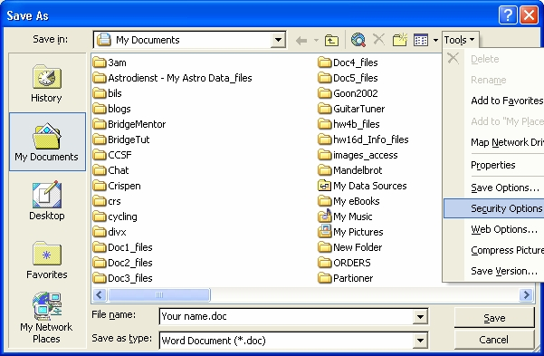

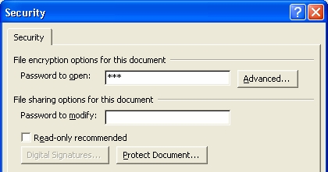
9. The Security dialog box opens as shown to the right on this page. Type in the password sam into the Password to open box. Click OK. Enter the password again, and then click OK. Use lowercase letters for the password. Enter the filename hw5 and save the document on your floppy disk. Word will add the extension .doc. Close Word.

Emailing The Screen Image and the Password-Protected Document
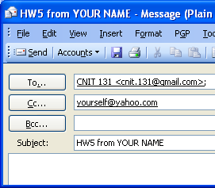
10. Open Outlook and click the New button to create a new e-mail message. Address it to cnit.131@gmail.com, send a CC to yourself, and enter a subject of hw5 from YOUR NAME, as shown on the figure to the right on this page. Do not use the exact address "yourself@yahoo.com" – use your own email address. Do not use the literal words "YOUR NAME" in the subject – use your own name.

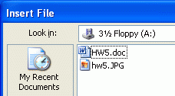
11. Click the Attachment button (it looks like a paper clip).
12. In the Insert File box, navigate to the hw5.doc file you just saved, as shown in the figure to the right on this page, and double-click it.
13. Click the Attachment button again.
14. In the Insert File box, navigate to the hw5.JPG file you saved earlier, and double-click it.
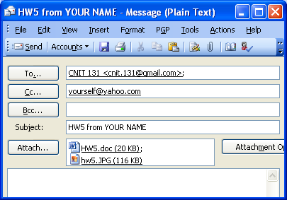
15. Your message should show two attached files, as shown to the right on this page.
15. Send the message. When you get your copy, double-click on the HW5.doc attachment and verify that it is password-protected with the password sam, and that it contains your name.

Revised 9-13-05

