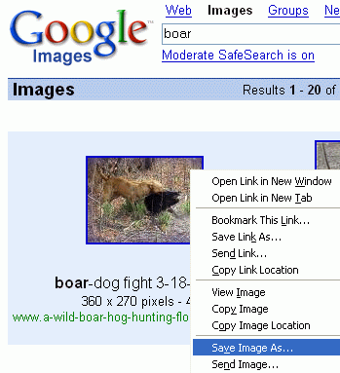
Saving two Images
- Start a browser and go to google.com
- Click the Images link.
- Enter a keyword to specify what you want an image of (something you will pretend to sell on your E-Commerce site) and press the Enter key.
- Find an image you like and point to it. Right-click and select Save Image As…. Save the image on a floppy disk, or in the My Pictures folder, or any other folder you can find. Remember that campus lab machines usually lose all the files you saved when you log off.
Apple Macintosh users have no right mouse button, so just drag the image to the desktop.
- Click on the image. In the next screen, click See full-size image. Save this image on the same way you saved the small image in the previous step.
- Look at the Address bar of your browser and find the URL of the site you copied this image from. It is important to give credit to the real source of your image. Saying the image came from Google is NOT proper credit, because Google is not the actual source of the image. Write down the URL (usually the domain name is enough) in the box to the right.

My images came from: ______________________________________________________________

Making an EasyStoreCreator Site
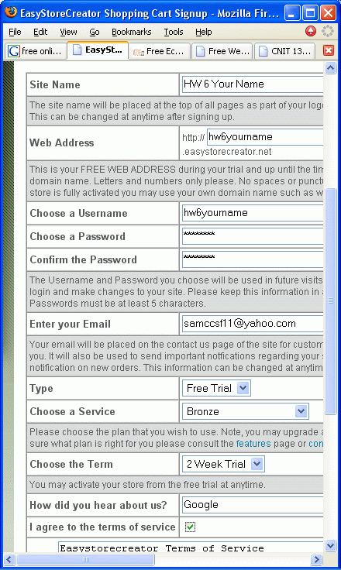
- Start a browser and go to easystorecreator.com
- Under the FREE TRIAL heading, click Click here to signup now.
- Fill in the form as shown in the figure to the right. Do not use the literal phrase "Your Name" – use your own name instead. Make up any password you can remember, and use your actual email address instead of samccsf11@yahoo.com.
- Make sure you have written down your Web Address, Username, and Password before proceeding.
- When the form is filled out, click the Create Site Now button at the bottom.
- In the next screen, click Click here to login now.
- In the next screen, enter the username and password you selected in step 9 and click Login.
- The next screen shows the New Site Owners Basic To Do List as shown at the bottom of this page. There are twelve steps to make a site, but for this homework, you only have to do these steps, as explained on the following pages:

Add contact info

Add homepage info

Add departments

Add items
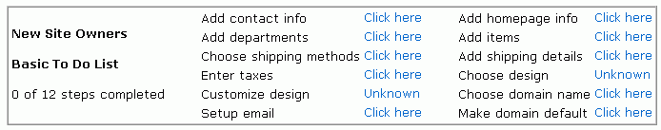

Add Contact Info
- Click the Click here link to the right of Add contact info.
- On the next page, click the Search Engines tab and fill in the form as shown below. Choose at least two keywords appropriate for your store, and enter this Description:
- This is a homework assignment for an Internet class, not a real store. Do not try to buy anything here. If you have any questions, contact sbowme@ccsf.edu.
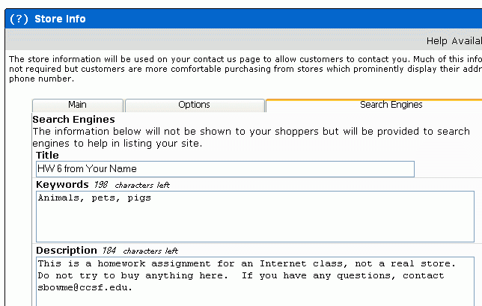
- When you nave completed the form, click the Save button at the bottom of the page.
- The next page has the New Site Owners Basic To Do List at the top.

Add Homepage Info
- Click the Click here link to the right of Add homepage info.
- On the next page, enter this text into the Page Content Top box:
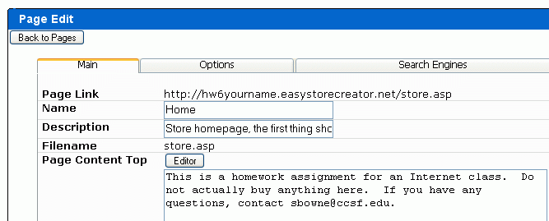
- This is a homework assignment for an Internet class, not a real store. Do not try to buy anything here. If you have any questions, contact sbowme@ccsf.edu.

- Click the Save button at the bottom of the page. The next page has the New Site Owners Basic To Do List at the top.

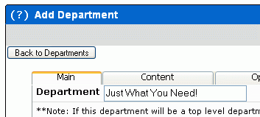
Add Departments
- Click the Click here link to the right of Add departments.
- On the next page, enter any name for your department in the Department box and click the Save button at the bottom of the page.
- The next page has the New Site Owners Basic To Do List at the top.
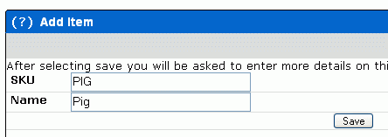

Add Items
- Click the Click here link to the right of Add items.
- In the first screen, make up any product name and type it into both the SKU and Name boxes. Click the Save button.
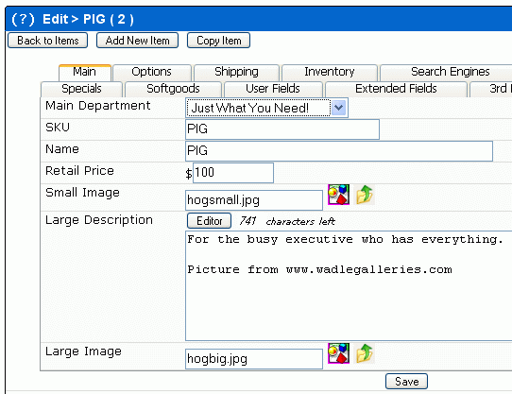
- In the next screen, click the drop-down arrow in the Main Department line and select the department you created in the Add Departments page.
- Enter a Retail Price of any amount.
- In the Small Image line, click the icon on the right side that shows a yellow folder and a green upward-pointing arrow.
- A small box pops up so you can upload your image. Click the Browse button. Find your small image and double-click it. Then click the Upload button to send it to the server.
- Repeat the same steps on the Large Image line to upload your Large Image.
- In the Large Description box, type in any description you want of your product. Be sure you give credit to the source of your image. If it is your own property, say that.
- When you nave completed the form, click the Save button at the bottom of the page.

Examining Your E-Commerce Site
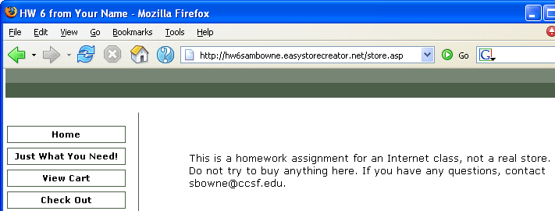
- Click the yellow Preview box in the upper left of the screen. Your site should open, as shown below.

- Examine your site and make sure it has these required items:
- A title of HW 6 from Your Name in the title bar of the browser window, with your own name instead of the literal text Your Name.
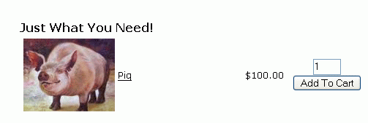
- A warning on the main page that this is a homework assignment, with my e-mail address: sbowne@ccsf.edu.
- The second link on the left should be a Department Name you created
- Clicking the Department Name should show a page like that showing to the right, with a Small Image, a Name, and a Price for your item.
- Clicking the Small Image should show a Large Image, a Description, and Credit for the source of your image.
- Click the Home link to get to the home page of your site. Click View, Source to view the HTML source code of your home page. Near the top of the source code, it should have a <meta name="keywords" tag, and a <meta name="description" tag, as shown below. There will be a few lines of code before these tags, and more code after them.
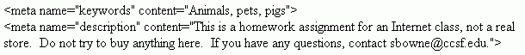
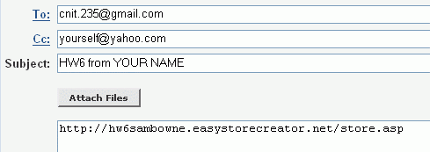
- If your site is correct, click the Home link to get to the home page of your site and email that URL to me at cnit.131@gmail.com. Send a CC to yourself, and enter a subject of hw6 from YOUR NAME, as shown below.

Revised 9-24-05

