Use NotePad or any other text editor to make a Web page in HTML
Your webpage must have the following Required Elements
- Your webpage should consist of two files: hw7.html and an image file with any appropriate name, ending in .gif or .jpg
- Opening and Closing <HTML> and </HTML> tags, properly enclosing the entire HTML document.
- Opening and Closing <HEAD> and </HEAD> tags, properly enclosing the entire head section.
- Opening and Closing <BODY> and </BODY> tags, properly enclosing the entire body of the webpage.
- Opening and Closing <TITLE> and </TITLE> tags, properly enclosing an appropriate title for your page, and placed in the HEAD section of the HTML document.
- Your name at the top of the Web page body section in any readable style you choose.
- At least one Header tag types used such as <H1> or <H2>, with the appropriate closing </H1> or </H2> tag, and any readable text you choose within the tags.
- At least one Paragraph tag used <P> with the appropriate closing </P> tag, and any readable text you choose within the tags.
- At least one Break tag used <BR>.
- At least one formatting tag <B>, <U>, or <I> used with the appropriate closing tag, and any readable text you choose within the tags.
- At least one Image tag such as <img src="picture.jpg">, with the corresponding image file so that the image is viewable on your Web page. You may use the same image you used in homework 6 if you want to.
- A citation to the source of your image, such as "picture from www.rollingstone.com". If you use a picture that is your own property, your page must say that "picture my own property".
---------------------------------------------------------------------------------------------------------------
HW 6 Example:
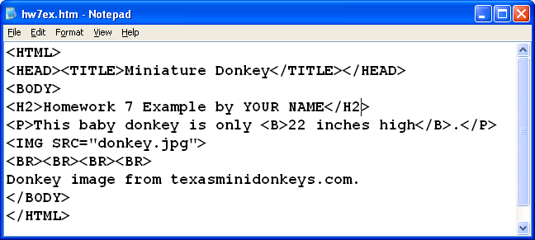

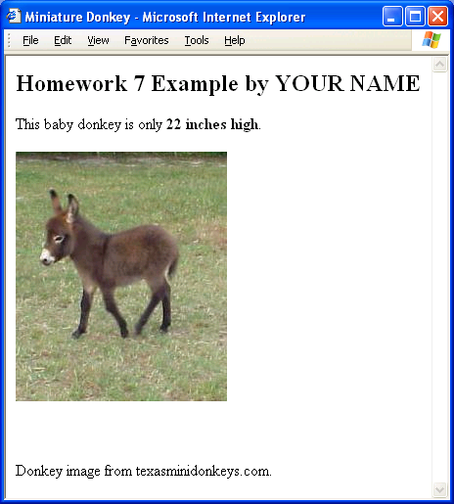
HW 6 Example in Display Form:

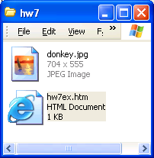

Put your Web page on the hills server using SSH Secure File Transfer
Your webpage should consist of two files, an HTML file and an image file. Open the floppy disk or folder your files are in and display it on your desktop as shown in the figure to the right on this page.

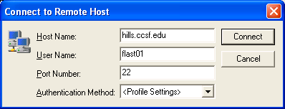
Click Start, Programs, SSH Secure Shell, Secure File Transfer Client to open a Secure File Transfer window. Press the Enter key and log in to the hills server as shown to the right on this page. Enter your password when prompted to.

A file transfer window opens as shown below, with two panes. The left pane is your computer, and the right pane is the hills server.

Your computer
Hills Server

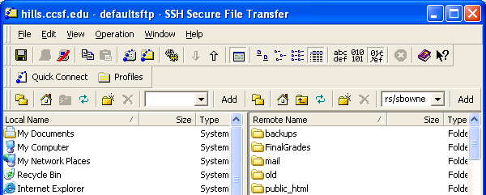

In the left pane, open the folder or device containing your hw7 files. If you put them on a floppy disk, double-click My Computer and then double-click 3 ½ Floppy (A:).

In the right pane, double-click the public_html folder to open it. Your window should now look like the example below.

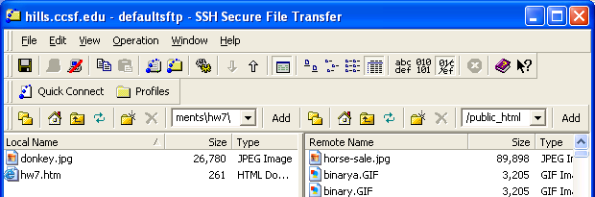
Drag the tw

Drag the two files from your computer (the left pane) and drop them in any white portion of the right pane (the hills server).

After the transfer, your Secure Shell Client window should show the files in the right pane, as shown in the figure below.
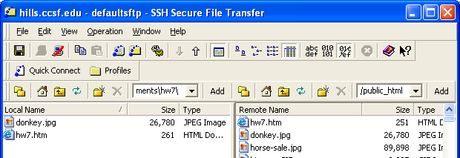

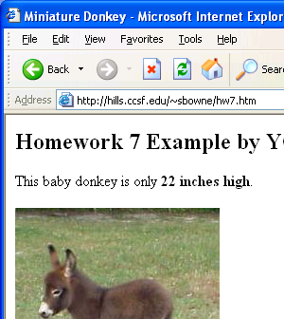

View your web page in a browser
Open Internet Explorer or another browser and type the URL of your Web page into the Address bar. The URL of your web page is:
http://hills.ccsf.edu/~flast01/hw7.html
with your HP-UNIX User ID instead of flast01.
Make sure the image is visible, and all the required elements are present.

E-mail the URL of your web page to me
Use any e-mail service of your choice, and compose a message to me at
cnit.131@gmail.com
with the subject
Hw 7 from your name
with your name replaced by your own first and last name. Copy the URL of the webpage from the Address bar of the browser window and paste it into the body of the e-mail message. I recommend that you send a CC to yourself. Send the message.
Last modified: 9-27-05

