Use NotePad or any other text editor to make a Web page in HTML
Your webpage must have the following Required Elements
- Your webpage should consist of two files: hw8.html and an image file with any appropriate name, ending in .gif or .jpg
- Opening and Closing <HTML> and </HTML> tags, properly enclosing the entire HTML document.
- Opening and Closing <HEAD> and </HEAD> tags, properly enclosing the entire head section.
- Opening and Closing <BODY> and </BODY> tags, properly enclosing the entire body of the webpage.
- Opening and Closing <TITLE> and </TITLE> tags, properly enclosing an appropriate title for your page, and placed in the HEAD section of the HTML document.
- Your name at the top of the Web page body section in any readable style you choose.
- A FONT tag used, with a specified color, face, and size, such as <FONT color="red" face="Arial" size="+2">, with the closing </FONT> tag, and any readable text you choose within the tags.
- At least one align attribute used in either a paragraph or header tag, such as <H1 align="center"> , with the appropriate closing tag, and any readable text you choose within the tags.
- At least one anchor tag used to create a hyperlink, such as <A href="http://www.ccsf.edu">Click for CCSF</A>.
- At least two of these BODY tag attributes: text, bgcolor, link , vlink , alink, for example, <BODY bgcolor="aqua" link="red">
- At least one Image tag such as <img src="picture.jpg">, with the corresponding image file so that the image is viewable on your Web page.
- A citation to the source of your image, such as "picture from www.rollingstone.com". If you use a picture that is your own property, your page must say that "picture my own property".
HW 8 Example:
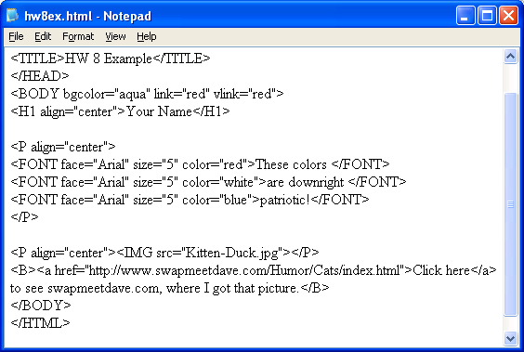

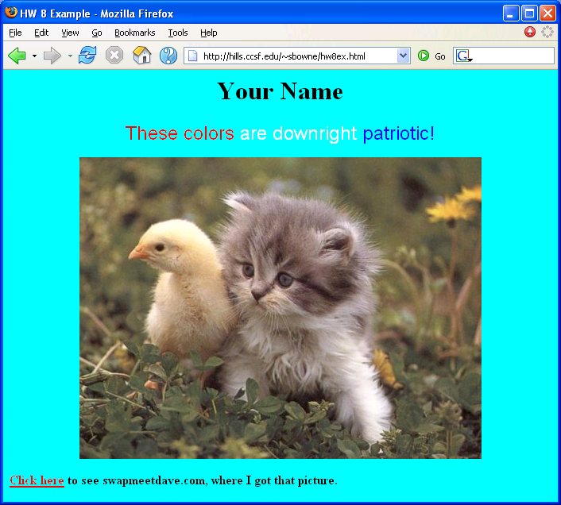
HW 8 Example in Display Form:

Put your Web page on the hills server using SSH Secure File Transfer

View your web page in a browser
Open Internet Explorer or another browser and type the URL of your Web page into the Address bar. The URL of your web page is:
http://hills.ccsf.edu/~flast01/hw8.html
with your HP-UNIX User ID instead of flast01.
Make sure the image is visible, and all the required elements are present.

E-mail the URL of your web page to me
Use any e-mail service of your choice, and compose a message to me at
cnit.131@gmail.com
with the subject
HW 8 from your name
with your name replaced by your own first and last name. Copy the URL of the webpage from the Address bar of the browser window and paste it into the body of the e-mail message. I recommend that you send a CC to yourself. Send the message.
Last modified: 10-4-05

