Use NotePad or any other text editor to make a Web page in HTML
Your webpage must have the following Required Elements
- Your webpage should consist of one HTML file named hw9.html and one or more image files with any appropriate names, ending in .gif or .jpg
- Opening and Closing <HTML> and </HTML> tags, properly enclosing the entire HTML document.
- Opening and Closing <HEAD> and </HEAD> tags, properly enclosing the entire head section.
- Opening and Closing <BODY> and </BODY> tags, properly enclosing the entire body of the webpage.
- Opening and Closing <TITLE> and </TITLE> tags, properly enclosing an appropriate title for your page, and placed in the HEAD section of the HTML document.
- Your name at the top of the Web page body section in any readable style you choose.
- An <IMG SRC> tag displaying an image file that is in a subdirectory – the easiest way to create one is to make a folder named images on your computer, put an image inside it, and drag the whole folder to the server in SSH Secure File Transfer. Then put the folder name in the <IMG SRC> tag like this: <IMG SRC="images/fish.gif">
- Text that wraps around an image, using the align attribute of the IMG tag
- A specified amount of white space around an image, using the hspace attribute of the IMG tag
- An image used as a hyperlink
- A list (ordered or unordered) with at least three items
- A comment
- A citation to the source(s) of your image(s), such as "picture from www.rollingstone.com". If you use a picture that is your own property, your page must say that "picture my own property". Citing a search engine like "image from google" is NOT acceptable.
HW 9 Example:

<html>
<head>
<title>HW 9 Example</title>
</head>
<body>
<H3 align="right">Your Name</H3>
<H1>Here are several image effects:</H2>

<H2>
<IMG SRC="images/redlizard_small.jpg" align="left">
This<BR>
Lizard<BR>
Is In A<BR>
Subdirectory<BR>
With<BR>
Text<BR>
Wrapped<BR>
Around it
</H2>

<H2>This peacock has 50 pixels of hspace around

it</H2>
<IMG SRC="peacock_small.jpg" hspace="50">

<H2>Click the donkey to go to Yahoo</H2>
<A href="http://www.yahoo.com">
<IMG SRC="donkey.jpg"></A>

<h2>Sources</h2>
<UL>
<LI>Peacock from www.gorzow.mm.pl/~bebelebe</LI>
<LI>Donkey from texasminidonkeys.com</LI>
<LI>Red lizard from adirondackphotos.info</LI>
</UL>

</body>
</html>

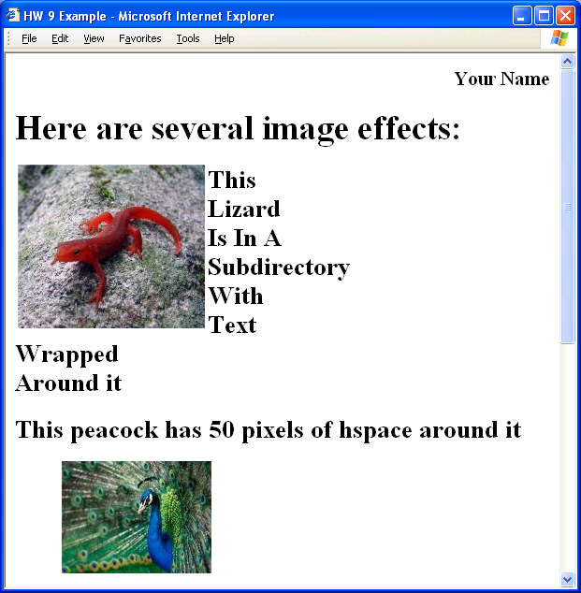
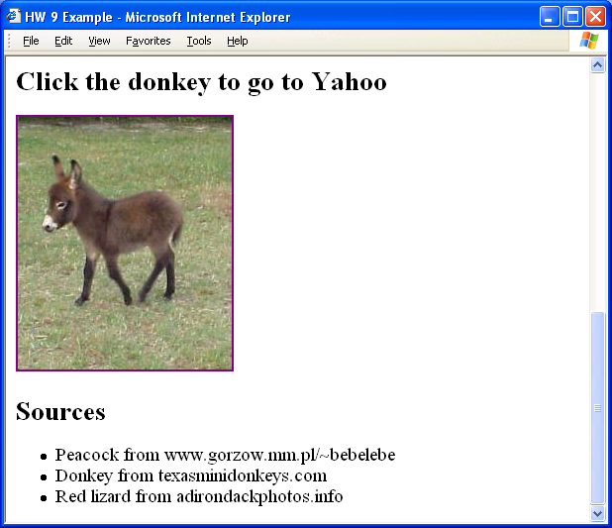
HW 9 Example in Display Form:

Put your Web page on the hills server using SSH Secure File Transfer

View your web page in a browser
Open Internet Explorer or another browser and type the URL of your Web page into the Address bar. The URL of your web page is:
http://hills.ccsf.edu/~flast01/hw9.html
with your HP-UNIX User ID instead of flast01.
Make sure the images are visible, and all the required elements are present.

E-mail the URL of your web page to me
Use any e-mail service of your choice, and compose a message to me at
cnit.131@gmail.com
with the subject
HW 9 from your name
with your name replaced by your own first and last name. Copy the URL of the webpage from the Address bar of the browser window and paste it into the body of the e-mail message. I recommend that you send a CC to yourself. Send the message.
Last modified: 10-18-05

