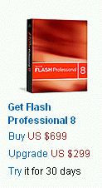
Downloading Flash 8
- You need to have broadband Internet access to download this 100 MB file. If you have only dial-up Internet access, ask your instructor for a CD to use. Copy the Flash folder from the CD to your desktop and skip to the Installing Flash 8 section below.
- Start a browser and go to www.macromedia.com.
- In the Products section, click on Flash 8.
- A page opens with the header Flash Professional 8. Find the section with the photo of a red box and the words Get Flash Professional 8. Click the word Try in the sentence Try it for 30 days, as shown to the right on this page.
- In the right-hand column, click on Evaluation Guide.
- In the Download Now box, click on Flash 8 Free 30-day trial.
- At the Macromedia Trial Downloads page, enter your e-mail address, click the No, I will create one now radio button, and click the Continue button.
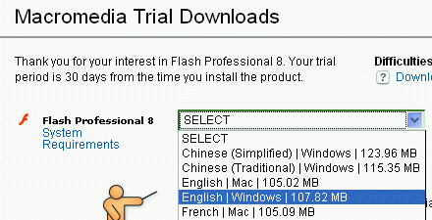
- At the Macromedia Trial Downloads page, fill out the long form and click the Continue button at the bottom of the page.
- A Macromedia Trial Downloads page opens. Next to Flash Professional 8, select English | Windows (or English | Mac if you are using a Macintosh), as shown to the right on this page. Click the Download button. It is a 107 MB download, so if you don't have broadband, forget it.
- Save the Flash8-en.exe file on your desktop, or some other folder you can find.
Installing Flash 8
- Double-click the Flash8-en.exe file.
- A Macromedia Flash 8 – InstallShield Wizard box opens. A progress indicator moves across the box twice, it closes, and a Macromedia Flash 8—Installation Wizard box appears. Click Next.
- In the License Agreement box, click I accept… and click Next.
- In the Destination Folder box, click Next.
- In the Install Macromedia Flash Player box, click Next.
- In the Ready to Install the Program box, click Install. Wait while a progress indicator moves across the box several times.
- In the InstallShield Wizard Complete box, click Finish.

- Note: This software is only active for 30 days unless you buy it. The best deal I found online was here http://www.directdeals.com/category_flash.aspx -- you can get Flash MX 2004 (the older version) for $160. You can also buy Flash Professional 8 at the CCSF bookstore for $249. To get current prices, enter macromedia flash academic into a search engine.
Selecting Your Images
- You will make a simple Flash movie, with a background image and a moving image. In your movie, the moving image will be animated to move on top of the background image. Use Google Images or any other source of images and find the two images. Save them on a floppy disk or some other folder you can easily find. Make sure you know the source of your images, so you can give them credit. If they are your own property, you must say that in your movie.
Starting Flash and Creating a New Flash Document
- Click Start, All Programs, Macromedia, Macromedia Flash 8.
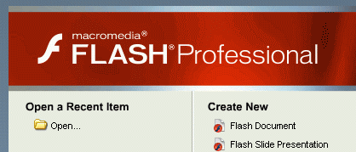
- In the Welcome to Macromedia Flash box, select I want to try Macromedia Flash and click the Continue button.
- In the Select Flash 8 Trial Edition box, click Flash Professional 8 and click the OK button.
- The Macromedia Flash Professional 8 window opens as shown to the right on this page. Under the Create New header, click Flash Document.
The Flash Window
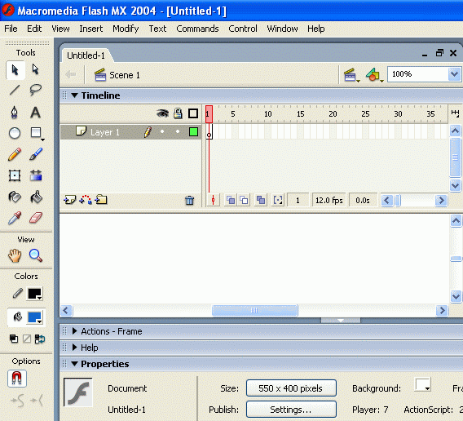
- Notice the main features of the Flash window as shown in the figure below:
Menu bar
Selection tool
Text Tool
Timeline Pane
Stage
Properties Pane

- The Stage area in the center is where you place images and build your movie. Each movie is a series of frames, and you control the animation with the Timeline pane. Right now there is only one layer in the movie, named Layer 1, and although there is room for 65 frames or more on the window, only the first frame has any content so far. The basic idea is that you add objects to the Stage, and then control the motion using the Timeline.
- The tools on the left are used to place objects on the Stage, and to manipulate them. You can draw directly on the stage with the tools in the toolbar shown to the left, or add text with the Text Tool.
Importing Your Images
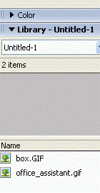
- Before you can use images in Flash, you have to import them. From the menu bar, select File,.Import, Import to Library. Navigate to your background image, select it, and click the Open button. Repeat the process to import your moving image.
- On the right side of the screen, you should see the Library with your images in it, as shown to the right on this page.
Making the Background Layer
- Drag your background image icon from the Library into the blank white Stage area in the center of the Macromedia Flash Professional 8 – Untitled window.
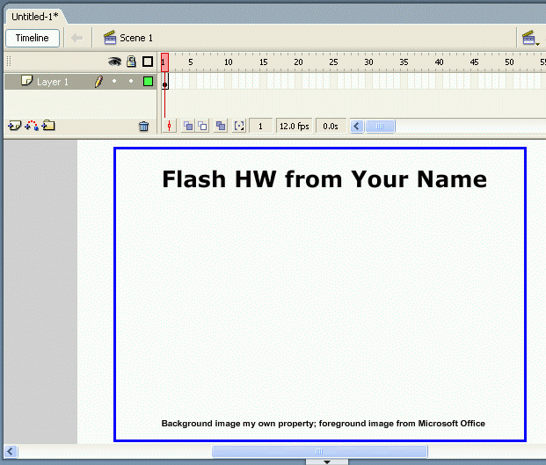
- Click the Text Tool on the left side of the Macromedia Flash 8 – Untitled window and drag across the top of the Stage area to make a label at the top. Type in a label of Flash HW from Your Name as shown to the right on this page. You can adjust the font using the Properties area at the bottom, and you can drag the text area around with the mouse.
- Add a second text area to your movie giving credit to your foreground and background image sources, as shown to the right on this page.

- This completes the static background of the movie. We will put the moving image on a different layer, so the layer named Layer 1 in the Timeline section should be renamed.
- In the Timeline section, double-click the Layer 1 label and type in Background. Press the Enter key.
Saving Your Movie
- From the menu bar, click File, Save. Save your file on a floppy disk, or in a folder you can find. Give it a name you can remember, like hwf. Notice that it saves as a .fla file – this is a working Flash document. This document can be used to design flash movies, but cannot be viewed in a browser.
Inserting the Foreground Layer
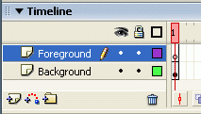
- In the Timeline section, right-click the Background label and select Insert Layer. A new layer named Layer 2 appears above the Background layer.
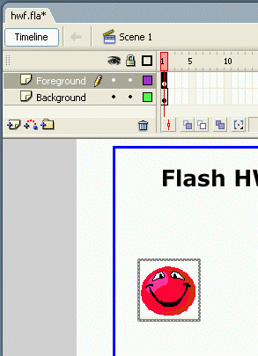
- In the Timeline section, double-click the Layer 2 label and type in Foreground. Press the Enter key. You should now have two layers in the Timeline section as shown to the upper right on this page.
Inserting the Foreground Image into the Foreground Layer
- In the Timeline section, in the Foreground layer, click the white cell in column 1. That cell shows a black background with a white dot, as shown to the right on this page.
- Drag your foreground image from the Library window onto the stage. Position it at the starting point for its motion.
HW15
Animating the Foreground Image
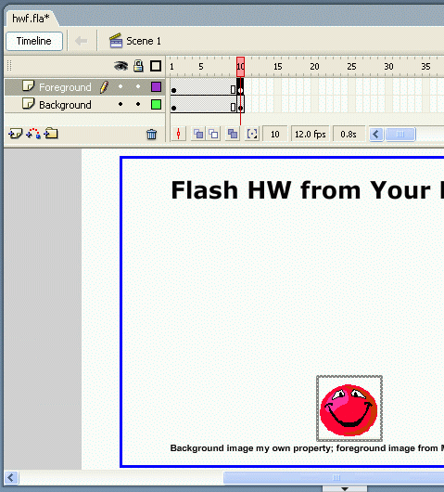
- In the Timeline section, in the Foreground layer, click the cell in column 10. At the top of your keyboard, press the F6 key. This makes frame 10 a Key Frame, and cell 10 shows a black background with a white dot. As you will see below, motion happens by filling in frames between Key Frames.
- In the Timeline section, in the Background layer, click the cell in column 10. At the top of your keyboard, press the F6 key. This copies the background into the first ten frames.
HW15
- In the Timeline section, in the Foreground layer, click the cell in column 10. In the Stage area, drag your foreground image to the ending point for its motion. Your timeline should now look like the example to the right on this page.
Setting the Tween Motion
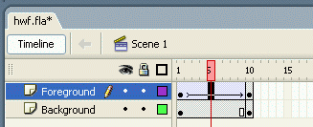
- In the Timeline section, in the Foreground layer, click the cell in column 5. In the Properties area at the bottom of the screen, set the Tween value to Motion. This will fill in the frames between the Key Frames (Frame 1 and Frame 10) to create smooth motion. Your foreground image moves to a point between the starting and ending position, and an arrow appears in the Foreground layer in the Timeline section, as shown to the right on this page.
Saving Your Movie
- From the menu bar, click File, Save. This saves your movie as a .fla file.
Previewing Your Movie
- From the menu bar, click Control, Test Movie. This converts your movie to a shockwave file (.swf) that can be seen in a browser, and plays it in the browser. Look at it and see if it looks the way you want it to.
- When you are done viewing the preview, close the preview window by clicking the small X on the gray background in the upper right-hand corner.
- Adjust your movie as desired. When you are happy with it, save it again.
Exporting Your Movie
- From the menu bar, click File, Export, Export Movie. In the Export Movie box, select your floppy disk, or another folder you can find. Name your file hwf. Flash will add the extension .swf creating a Shockwave file that can be viewed in a browser.
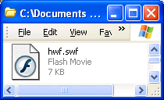
- An Export Flash Player box opens, giving you a chance to adjust the quality settings for your movie. Accept the default settings and click OK.
- Click Start, My Computer and open your floppy disk, or the other folder you used. You should see your hwf.swf file, as shown to the right on this page.
- Upload the file to the hills server using SSH Secure Shell as usual. Open it in a browser and make sure it works.
- Email the URL of your movie to me at cnit.131@gmail.com with the subject Flash HW from Your Name.

Revised 11-2-05

