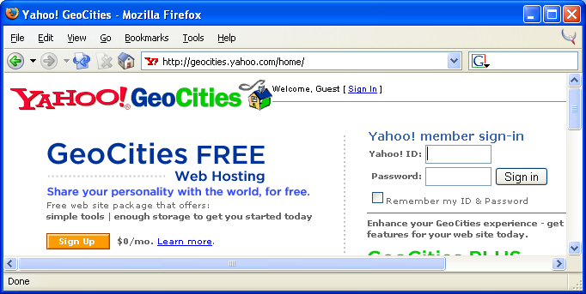
- Opening Yahoo: Open Internet Explorer or another browser and go to www.yahoo.com. The Yahoo main page opens. Click on GeoCities in the Connect line. The GeoCities page opens as shown to the right on this page. If you have a Yahoo account, sign in with your Yahoo! ID and password. If you do not have a Yahoo account, find the FREE Web Hosting section and click the Sign Up button. Follow the instructions to create a new account and then start this process over at the start of step 1.
- Starting File Manager: The Yahoo! Geocities page opens. Click on File Manager. When the next window opens, click Open File Manager.
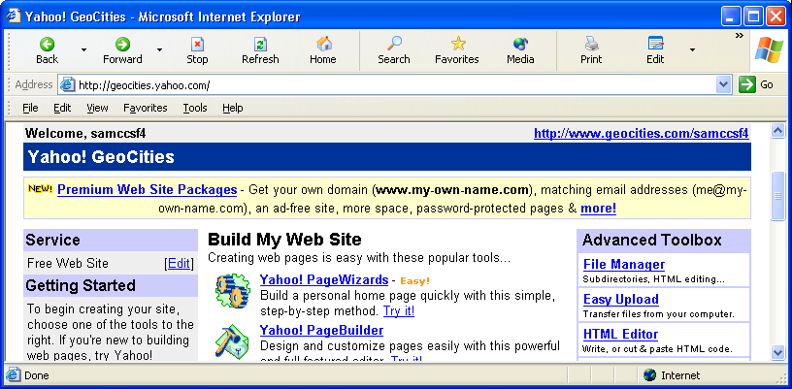
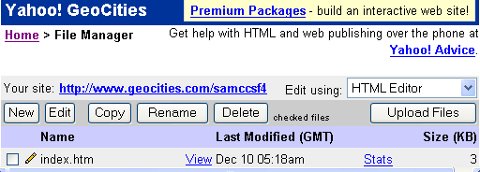
- File Manager: The File Manager window opens. Find the Upload Files button on the right and click it.

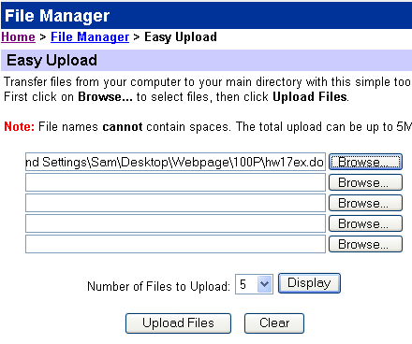
- Uploading : Click one of the Browse buttons. A Choose File window opens. Navigate to your file and double-click it. Then click the Upload Files button.

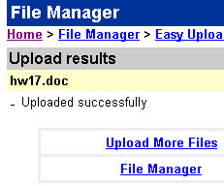
- The Upload Results page opens, showing that the file was Uploaded successfully. Click the blue File Manager link. window.

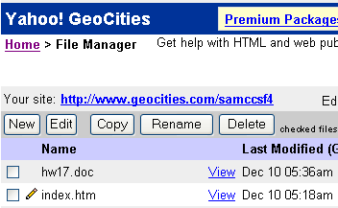
- In the File Manager window, find your HTML file and click the blue View link to the right of its name. This will open your file in a browser.
14

