5 points Extra Credit for HW 4, 6, 7, 8a, and 9

Total Possible Points = 25 if you make all 5 pages validate

To earn 5 extra points on any or all of the Web pages you created for the homework assignments listed above, run your existing page through the W3.org HTML validator, and post the self-validating link on your page. E-mail me the link when the validation works.

How to Validate HTML Pages

Add the following DOCTYPE statement to your HTML document if it is not already there (HTML-KIT adds it automatically):

<!DOCTYPE HTML PUBLIC "-//W3C//DTD HTML 4.01 Transitional//EN">

The DOCTYPE statement must be the first line in your source file, before the <HTML> tag. The DOCTYPE statement defines what language your page is using, by referring to the official specifications of HTML 4.01 Transitional on the W3 website. Your document cannot be validated without this statement.

Add the following META tag to your HTML document if it is not already there:

<meta http-equiv="Content-Type" content="text/html; charset=ISO-8859-1">

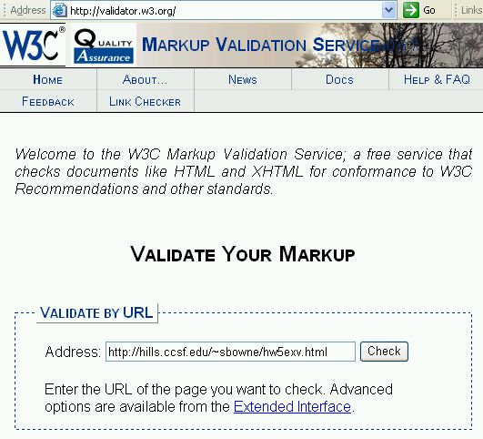
This META tag must be in the HEAD section of your html document, between the <HEAD> and </HEAD> tags. This META tag states the character set your page is using. ISO-8859-1 is the standard for Western European languages. Other languages such as Arabic and Chinese use different encoding schemes. Your document cannot be validated without this statement (unless you configure the Web server to provide the necessary information using techniques beyond the scope of this course).

Open a browser and go to http://validator.w3.org/
Enter the URL of your page in the Validate by URL box and click the Check button. The URL of your page will be something like

http://hills.ccsf.edu/~flast01/hw5.html

where flast01 is replaced by your HP-UNIX ID)

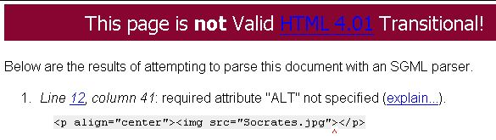
If there are any errors in your page, they will be listed as shown in the example shown to the right on this page.

In this example, the error is in the line: <img src="Socrates.jpg">
The corrected line is: <img src="Socrates.jpg" alt="Socrates">
Fix the errors on your page, re-publish it, and re-validate it until it validates.

Multiple Validation Errors

If you have a line like this:

<h3>Annoyances</h1>

that opens one header size and closes a different one, the validator will flag that error, and then complain about many lines afterwards because that error causes good HTML code to be mis-interpreted. If you get a lot of errors, just fix the first one, re-publish, and re-validate your page. The other errors may just vanish.


When your page validates, you will get the This page is valid message shown to the right on this page.

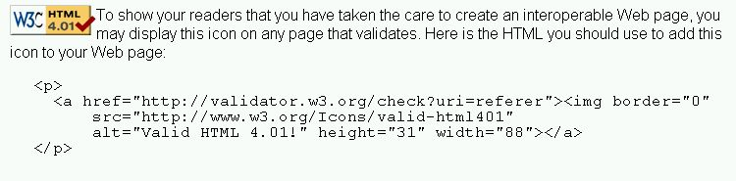
Scroll down in the validator page until you see the instructions showing how to add the Validator icon to your page, as shown in the figure below on this page. Copy and paste the HTML code into your source code and re-publish your page.
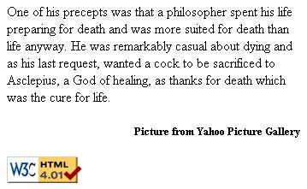

The Validator icon should appear on your page as shown in the image to the right on this page. Click it and verify that your page validates.

E-mail the URL of your Web page to me at

Cnit.131@gmail.com

with the subject

CNIT 131 Extra Credit for HW 4 (or HW 6, HW 7, HW 8a, or HW 9) from YOUR NAME.

Last modified 3-9-05

