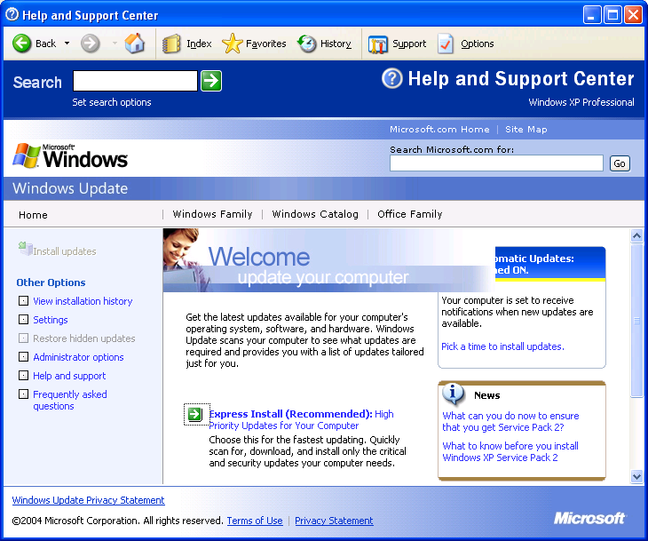
Updating Windows XP
- Log in to your machine with an account that has local Administrator privileges.
- Click Start, Help and Support. In the Pick a task section, click on Keep your computer up-to-date with Windows Update.
- If a Security Warning box opens asking if you want to install and run software, click Yes.
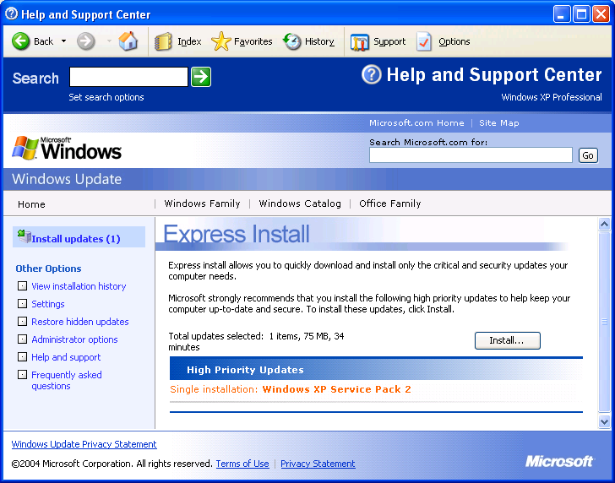
- Your Help and Support Center window should now look like the figure to the right on this page. In the lower-center, find the blue Express Install (Recommended) link and click it. Wait while Windows Update scans your system.
- If Windows Update finds any critical updates you need, it will show them in a screen like the one to the right on this page. Click the gray Install button. You may have to click an I Agree button to agree to a license agreement.
- Wait while the updates download and install. If you have a dial-up Internet connection, it may take many hours to download Service Pack 2. You can continue using your computer for other things while the update proceeds, but it may respond more slowly.
- After the updates have installed, you will usually be prompted to restart your computer. Close all windows and restart.
- After your machine restarts, start over at step 1 and repeat the process. You may have to repeat it as many as four or five times before Windows Update tells you there are no more updates to install. When Windows Update cannot find any more updates to install, you are done.

Last Modified: 9-2-04

