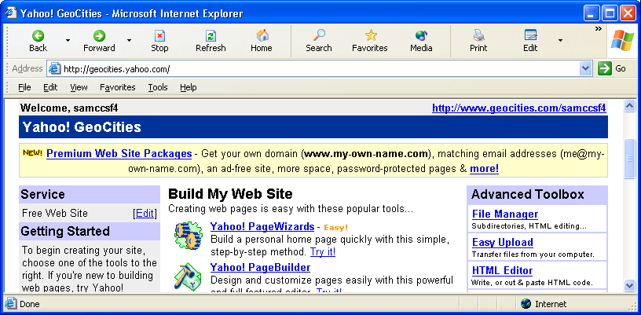
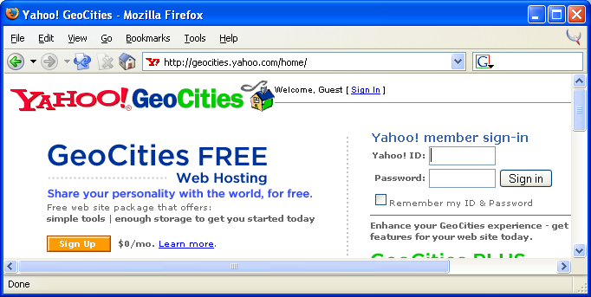
- Opening Yahoo: Open Internet Explorer or another browser and go to www.yahoo.com. The Yahoo main page opens. Click on GeoCities in the Connect line. The GeoCities page opens as shown to the right on this page. If you have a Yahoo account, sign in with your Yahoo! ID and password. (If you do not have a Yahoo account, find the FREE Web Hosting section and click the Sign Up button. Follow the instructions to create a new account and then start this process over at the start of step 1.)
- Starting HTML Editor: The Yahoo! Geocities page opens. Find the Advanced Toolbox section on the right of the page. In the Advanced Toolbox section, click on HTML Editor.
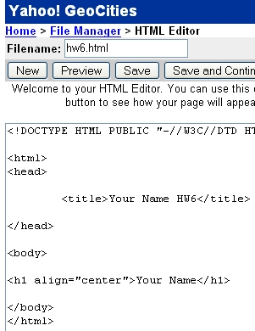

- HTML Editor: The HTML Editor window opens, as shown to the right on this page. Type in your desired source code. Put the desired file name in the Filename box in the upper left and click the Save button.

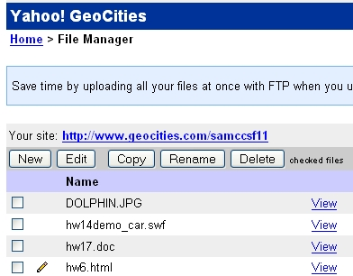
- File Manager: The File Manager window opens as shown to the right on this page. Find your file name in the list. You can use your file two ways from File Manager:
  - Click on the blue View link to see how your file looks in a browser
  - Click in the pencil icon to the left of the file name to open it in HTML Editor so you can revise it
- View your page, then edit it with HTML Editor until you are content with it.

How to Upload an Imageto Yahoo Geocities


- Open a browser and go to google.com. Click Images, type in the topic of your image, and press the Enter key.
- Look through the image results and find an image you like.
- If you are on a Mac, drag the image right out of the browser and drop it on the desktop. If you are on a PC, save the picture by right-clicking on it and selecting Save Image.
- Write down the name of the website you got the image from so you can give them credit.
- Repeat step 1 above to open Yahoo Geocities in a browser.
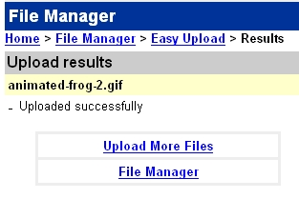
- Find the Advanced Toolbox section on the right of the page. In the Advanced Toolbox section, click on Easy Upload.
- In the Easy Upload screen, click one of the Browse buttons.
- In the File Upload box, find your saved image and double-click it.
- In the Easy Upload screen, click the Upload Files button.
- You should see an Upload Results screen with the message Uploaded successfully, as shown to the right on this page. If you see an error message, make sure there are no spaces or + signs in the file name.

