Installing the Free Zone Alarm Firewall

Selecting a Machine to Use:
- This homework assignment requires you to install firewall software, which is forbidden in many public labs. Do not attempt this homework in the ICL-1, your classroom, or any other public lab, unless your instructor is there to supervise you.
- If you have your own computer, you can do this assignment there.
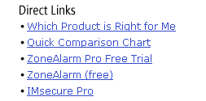
- If you have a PC with Windows XP, there is no need to install Zone Alarm. Just install Service Pack 2 instead.

Downloading the Zone Alarm Free Firewall
- Start Internet Explorer and enter this Address:
www.zonelabs.com
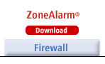
- Press Enter to open the Zone Labs page. Look in the lower-right portion of the screen and find the Direct Links section, as shown in the figure to the right on this page. Click the blue ZoneAlarm (free) link.
- The next screen prominently advertises Zone Alarm Pro and Zone Alarm Plus because they cost money. Find the free version, called Zone Alarm as shown in the figure to the right on this page, and click the red Download button.
- In the next screen, click the blue Download FREE ZoneAlarm link.
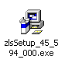
- A box pops up asking you to where to save the file. Save it on the desktop with its default file name, which is zlsSetup_45_594_000.exe. This is the installer file. Wait until the download finishes: it is a 4.9 MB file, so it could take as long as 15 to 30 minutes if you are using a modem.

Installing Zone Alarm
- Minimize all windows. Find the zlsSetup_45_594_000.exe icon, as shown in the figure to the right on this page. Double-click the zlsSetup_45_594_000.exe icon.
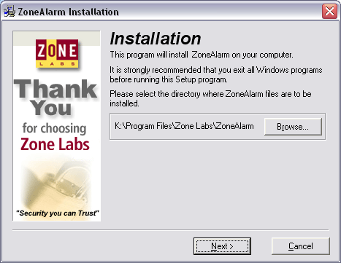
- An Installation screen opens, as shown in the figure to the right on this page.. Click the Next button.
- In the next screen, enter a fake name and email address and uncheck the boxes, unless you want to receive email about Zone Alarm products. In that case put in your real e-mail address. Click the Next button.
- In the next screen, check the box to accept the license agreement and click Install.
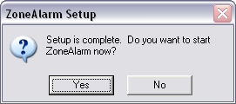
- After the installation finishes, there is a survey. Answer the questions to the best of your ability and click the Finish button.
- A ZoneAlarm Setup box asks “Do you want to start ZoneAlarm now?” Click Yes.

Configuring Zone Alarm
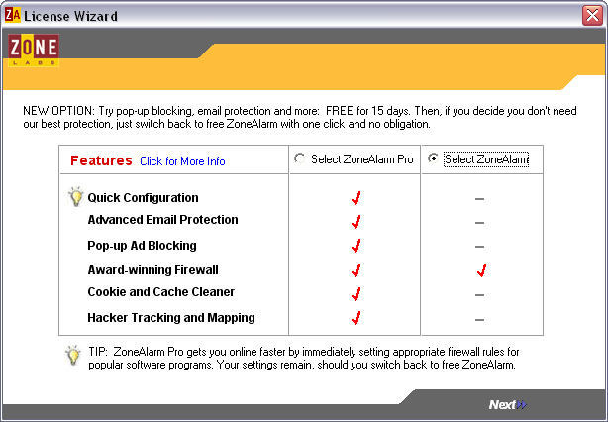
- A License Wizard window opens, as shown in the figure to the right on this page. They are trying to get you to use the versions that cost money. Click the Select ZoneAlarm radio button and then click Next in the lower right corner.
- The next window again tries to get you to use the Pro version. Click the Finish button.
- In the Welcome to Zone Alarm window, click Next.
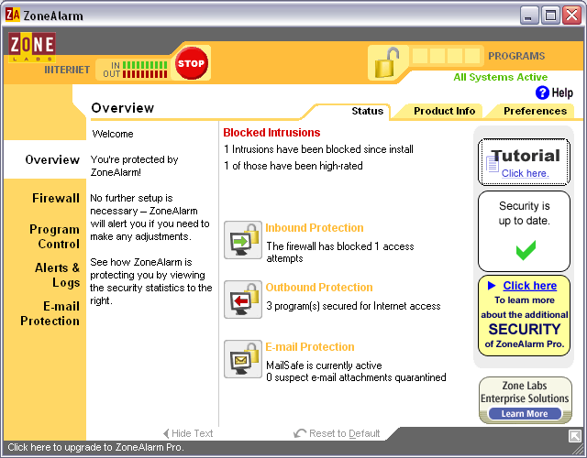
- In the FIREWALL ALERTS window, click Alert me whenever ZoneAlarm stops traffic and click Finish.
- In the Secure Programs window, you can give certain programs permission to use the Internet. Accept the default settings and click Finish.
- In the eBay FRAUD PREVENTION window, accept the default settings and click Next.
- In the Congratulations! window, accept the default settings and click Next.
- A Tutorial starts. Read all the screens, proceeding with the Next button.
- When the Tutorial is done, you will see the Zone Alarm main screen, as shown in the figure to the right on this page.

Opening the Firewall
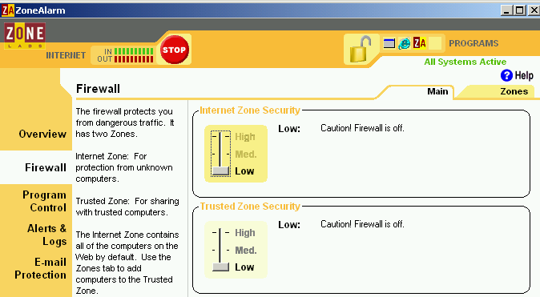
- When you have a firewall, sometimes it stops Internet traffic you want, like games, music, or chat rooms. When that happens, one way to fix the problem is to open the firewall.
- Restore the ZoneAlarm window, as shown in the figure to the right on this page. If you can’t find the window, right-click the little ZA Icon in the taskbar tray in the lower-right corner of your window and select Restore ZoneAlarm Control Center.
- On the left side of the ZoneAlarm window, click Firewall. You should see two sliding controls as shown in the figure to the right on this page. Drag the top slider down to Low. You should see two messages saying Caution: Firewall is off, as shown in the figure to the right on this page.
- If you have something you use often that the firewall stops, you should tell it to allow just that traffic. Check the Zone Alarm help menus to learn how to do that. I had no problem doing it with the more complex Sygate free firewall, but I was unable to open specific ports in Zone Alarm the last time I tried. If you figure it out, please e-mail it to me.

Updated 9-2-04

