Requirements:

- Access Usenet Newsgroups, using any one of these techniques:

Configure Netscape using the sand server (only works on campus)

Configure Outlook Express using the sand server (only works on campus, but not in C218)

Configure Outlook Express using your ISP's news service (you are on your own for this one; see your ISP's help web pages)

Use the Google Groups Website
- Subscribe to one or more newsgroups of your choice (please don't use an extremely rude or offensive one)
- Print out a message from a newsgroup, write your name on the printout and turn it in, or save a screen image and e-mail it to me at sbowne@ccsf.edu.

Netscape (only works on CCSF campus)

Configure Netscape to receive Usenet News. The steps are:

Click Start, Programs, Netscape 7.0, Mail & Newsgroups.

If the Account Wizard does not open automatically, click File, New, Account to start it.

When the Account Wizard opens the New Account Setup panel, select Newsgroup Account and click Next.

When the Account Wizard opens the Identity panel, enter your name and email address and click Next.

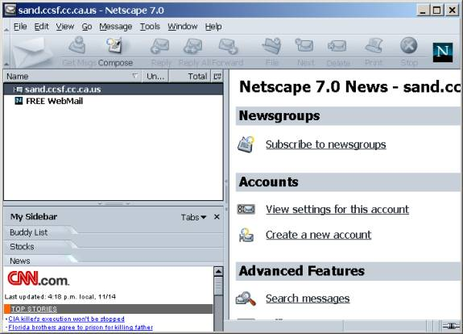
When the Account Wizard opens the Server Information panel, enter sand.ccsf.cc.ca.us and click Next.

When the Account Wizard opens the Account name panel, leave the name sand.ccsf.cc.ca.us unchanged and click Next.

When the Account Wizard opens the Congratulations! panel, click Finish.

If a box opens asking whether you want Netscape to be the default mail application, click No.

A window should open as shown to the right on this page. Click on sand.cccsf.cc.ca.us in the left pane and click on Subscribe to Newsgroups in the right pane.

Netscape asks for a User Name and Password. Enter a User Name of ccsf and a password of its.

When the Subscribe window opens, wait for the newsgroups to download and find a group that interests you. To find a group, enter a word in the Show items that contain box and highlight a group name that you like.

Click the Subscribe button, and the OK button.

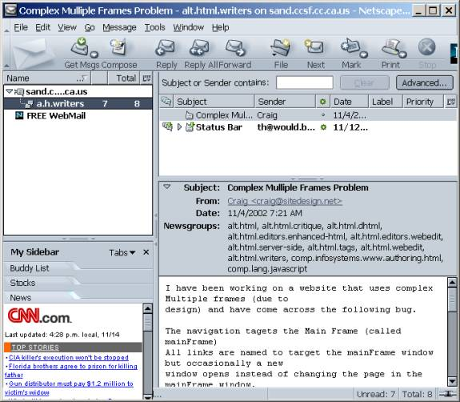
The newsgroup you subscribed to should appear in the left pane. Click its name and click a posting in the right pane.

Print out a posting with File, Print. Write your name and HW9b on the printout and turn it in.

Outlook Express (only works on CCSF campus)

Configure Outlook Express to receive Usenet News. The steps are:

Select Tools, Accounts, News Tab

Select Add, News

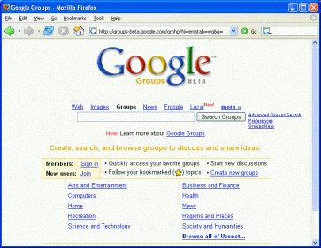
Enter your name and e-mail address

The server is sand.ccsf.cc.ca.us

When a dialog box opens asking if you want to download newsgroup names, click Yes

Select a newsgroup with an interesting name and click Subscribe

Navigate to a message using the left pane of the main window (the one with your Inbox in it) and print out a message from the newsgroup.

Using Google Groups

Start at the Google Groups page http://groups.google.com

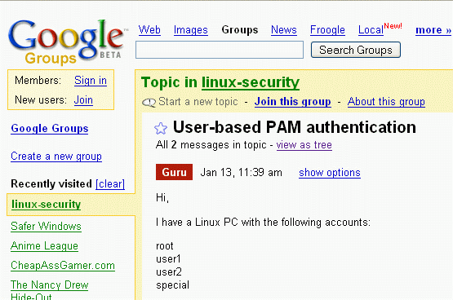
Click on one of the topic categories Arts and Entertainment, Computers, etc.

Click on a subtopic to see a Google header followed by a list of Threads, as shown below.

Click on a message to see a thread of related messages

Select File, Print and print out ONLY ONE PAGE of messages thread, write your name on it, and turn it in.

Revised 3-9-05

