Preparing Your E-Commerce Pages
- You need to make two Web pages: a Catalog page and a Thanks page. They are both HTML pages, as specified below.
Catalog Page
- The catalog page should have these things:

Your name and HW 13 in the title bar of the page

Your name at the top of the page, in the body section

At least two products

Each product must have a name, a picture, a description, and a price

You must give credit to the sources of the images you used. If they are your own property, say that.
- Give the catalog page a filename of hw13c.html:
Thanks Page
- The thanks page should have these things:

Your name and HW 13 in the title bar of the page

"Thanks for shopping with Your Name" or some other appropriate message in large font.

A link back to your main shopping page
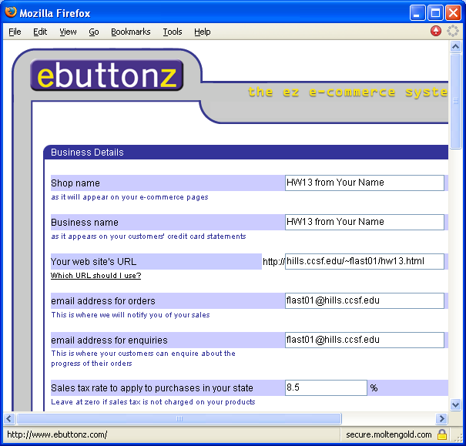
- Give the thanks page a filename of hw13.html:
Ebuttonz Free E-Commerce System
- Open a browser and go to http://www.ebuttonz.com/.
- Click the Start here link near to top of the page.
- Click the CLICK HERE TO GET STARTED link.
- The next page asks what country you are in. Accept the default selection of the USA flag, scroll down, and click the Continue button.
- A long form appears, as shown to the right. Use the values on the next page to fill in the top section.

Shop name: HW13 from Your Name. (Replace Your Name with your own name)
Business name: HW13 from Your Name.
Your web site's URL: hills.ccsf.edu/~flast01/hw13.html (Replace flast01 with your HP-UNIX ID)
Email address for orders: flast01@hills.ccsf.edu
Email address for enquiries: flast01@hills.ccsf.edu

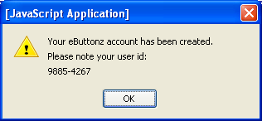
- Scroll down to complete the form. Make up a fake address and phone number – there is no reason to tell these guys the truth for this homework assignment. Remember to maintain your privacy: always lie on Internet forms unless you have a real reason to tell people the truth.

User ID: ____________________

Password: ____________________
- Near the bottom of the form you have to enter a password. Use something simple that you can remember, and write it down here so you don't forget it.
- Click the Continue button at the bottom of the form. Notice the pop-up box that opens – this has your user id. Write down your user id!! Don't forget it or you may have trouble modifying your e-commerce options later. After you have written the number down, click OK to close the [Javascript Application] box.
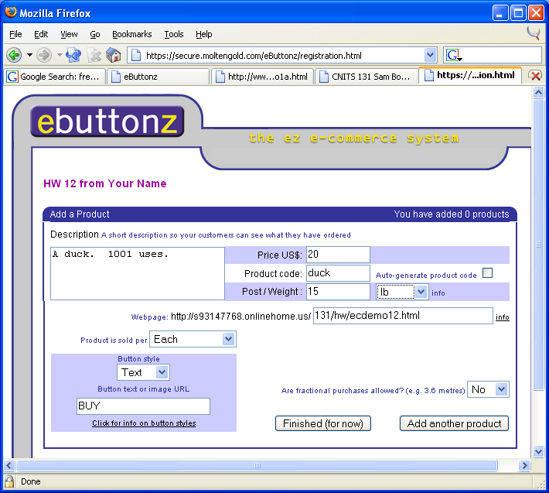
- The next page lets you add a product for customers to buy. Fill in the description and other fields with information about your first product. Then click the Add another product button and fill in the information about your second product, and click the Finished (for now) button.

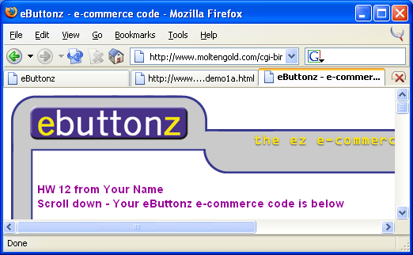
- You will see a screen with a Scroll down – Your eButtonz e-commerce code is below message, as shown to the right on this page. This page contains HTML codes you have to add to your hw13c.html page.

- Open your hw13c.html page in Notepad or an HTML editor so you can copy and paste code in to it.

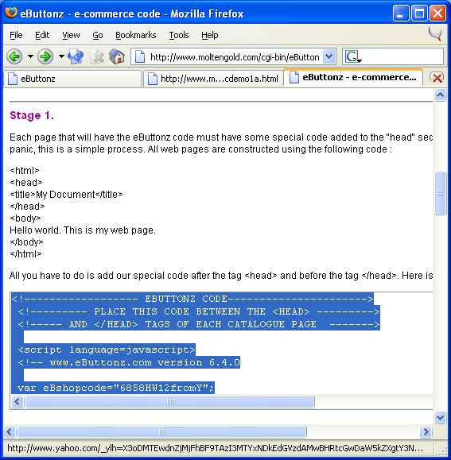
- Scroll down to the Stage 1 section, as shown to the right on this page. Find the box with HTML code in it and click in it. Press Ctrl+A on the keyboard to select all the HTML code in the box, as shown to the right on this page. Then press Ctrl+C to copy it to the clipboard.

- Make the hw13c.html page in Notepad active, and click in it just before the </HEAD> tag. Press Ctrl+V to paste in the code from eButtonz. This stuff is JavaScript, and it's pretty complicated, but you don't have to know how to write it to use it.

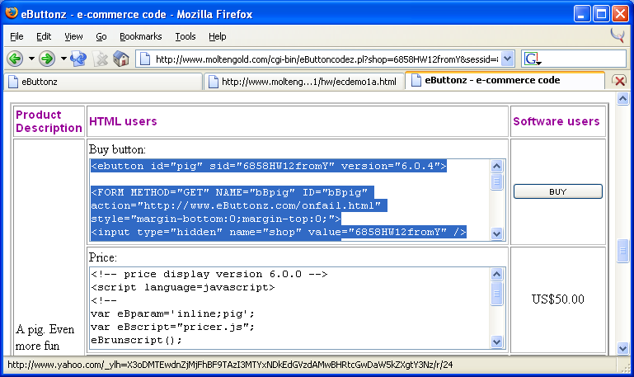
- Make the eButtonz browser window active again, and scroll down to Stage 2. There is a little window with some code in it starting with .eBbuyclass { -- ignore that. It's Cascading Style Sheet stuff used to control the appearance of the buttons, and we don't need it. Scroll down further and find the table with the HTML Users title, as shown to the right on this page.

- Find the Buy button code for your first product, click in it, and press Ctrl+A on the keyboard to select all the HTML code in the box, as shown in the figure above on this page. Then press Ctrl+C to copy it to the clipboard.
- Make the hw13c.html page in Notepad active. Click just below the picture of your product, or wherever you want the BUY button to appear. Press Ctrl+V to paste in the code. View your page in a browser and see how it looks. Adjust it as necessary. Make sure it looks good, but don’t worry if the BUY buttons don't work yet – they will only work after you post the page onto the server.
- Find the code in the eButtonz page for your other product's Buy button and add it to your hw13c.html page.
- After both buttons are on your page, post it onto the hills server. There should be four items to post:

The catalog page hw13c.html

Two image files used in the catalog page

The thanks page hw13.html
- Open a browser and type in the URL of your store. Your URL will be like this:
http://hills.ccsf.edu/~flast01/hw13c/html
- Test your hw13.html page by clicking on one of the BUY buttons. You should see a banner ad at the bottom of the window, and you should be able to complete a purchase online. This free demonstration only lets you pay by check, which is not much fun, but you can use this technique to make a real site and accept credit card payments too, if you apply for that option. I don't know if it's free then, however. It only works in Internet Explorer, not in Firefox.
- When your page is working correctly, send me an email message containing a link to your hw13c.html page. My e-mail address is sbowne@ccsf.edu. Use a subject of CNIT 131 MW 9:30 am HW 13 from Your Name.

Last modified 12-12-04

