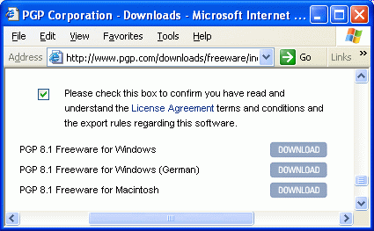
Downloading and Installing PGP
- Start a browser and go to www.pgp.com.
- At the top of the window, click on Downloads.
- Scroll down to bottom of the page and click on the word Freeware.
- Scroll to the bottom and check the box to indicate that you agree to the terms of service, as shown to the right on this page. Click on the gray DOWNLOAD button for the appropriate version (there is a PC version and a Mac version).
- Save the file on your desktop.
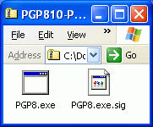
- The remaining instructions are for Windows XP users. I suppose the process is similar on other Windows versions and on Macs, but I am not sure. If you can't install and use PGP, use hushmail instead:
- Minimize all the windows and find the downloaded file on your desktop and double-click it. That opens a zip archive containing two files as shown to the right on this page. Resize the window so it does not cover the whole desktop, and then drag those two files to the desktop. That will unzip them so you can use them.
- Double-click the PGP8.exe file on your desktop. An installer runs. Click Next, Yes, Next.
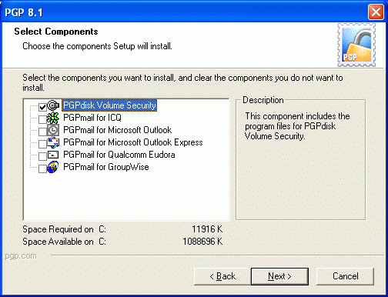
- At the User Type screen, click No, I'm a New User and click Next.
- At the Install Directory screen, click Next.
- At the Select Components screen, check only the first item PGPdisk Volume Security, as shown to the right on this page, and click Next. The other things are nice, but they don't work in the free version.

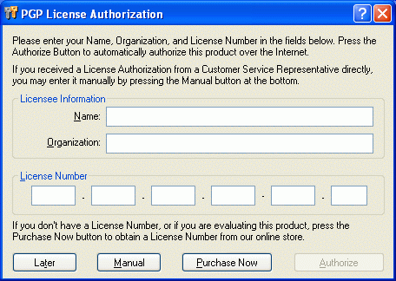
- At the Start Copying Files screen, click Next.
- When the installation is complete, the installer says that it needs to restart your computer. If you are using your own home computer, click Finish and let it restart. If you are using the campus labs, the machines may have Deep Freeze on them. You can't restart the machines with Deep Freeze, because they will erase the newly installed software. Instead, just log off and log on again.
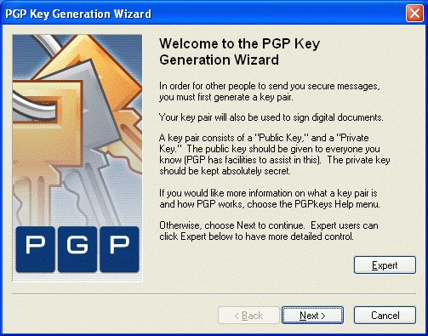
- After you restart, you will see the PGP License Authorization screen shown to the right on this page. Click the Later button.
Generating Your Keys
- The PGP Key Generation Wizard should open automatically, as shown to the right on this page. Click Next. If it does not automatically open, click the padlock icon in the notification area at the lower-right corner of your desktop and select PGPkeys. In the PGPkeys window, click Keys, New Key.

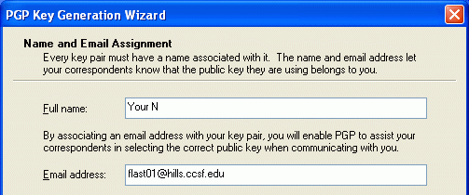
- When the Name and Email Assignment screen opens, as shown to the right on this page, enter your first name and last initial, and your e-mail address, as shown. Use an e-mail address you really use – not necessarily your hills address.
- At the Passphrase Assignment screen, you will need to enter a secret phrase that you can remember. Write down your passphrase, because if you lose it, you will not be able to read your encrypted e-mail. Click Next.
- At the Key Generation Progress screen, wait for the process to finish. Click Next.
- At the Completing the PGP Key Generation Wizard screen, click Finish .

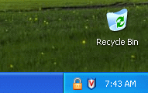
- You should now see a padlock icon in the notification area (the lower-right corner of the screen), as shown in the figure to the right on this page. That icon indicates that PGP is running, and it’s the easiest way to use the PGP program.
Exporting Your Key to a Floppy Disk
- It is important to export your key to a floppy disk, so that you will still be able to read your encrypted e-mail even if the computer you are using loses the information. This is especially important if you work in a public lab, because the files on the machine will vanish at each restart because of the Deep Freeze software. If you are working at home on your own machine, this step is not really necessary.
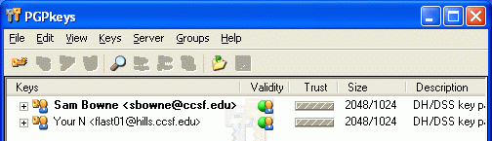
- Click the padlock icon in the notification area and select PGPkeys.
- In the PGPkeys window, you will see your name listed in the Keys column, as shown to the right on this page.
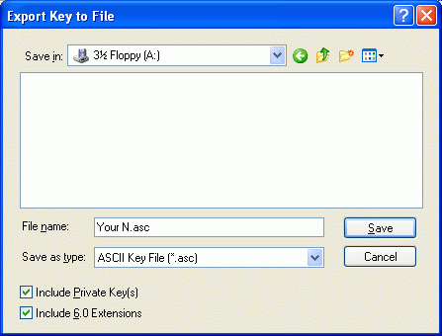
- Click on the icon to the left of your name to select your key. Then click Keys, Export. In the Export Key to File window, in the Save in: drop-down list box, select 3 ½ Floppy (A:). Check the Include Private Key(s) box, as shown to the right on this page, Accept the default file name and click Save to save the file.

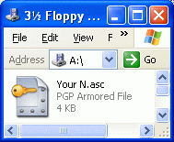
- Click Start, My Computer and double-click 3 ½ Floppy (A:). You should see the file on the diskette as shown to the right on this page.
Exporting a Public Key to keyserver.pgp.com
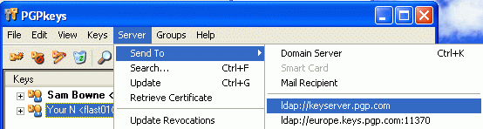
- No one can send you encrypted email unless they have your public key. The best way to make that key available is to upload it to a public server.
- In the PGPkeys window, click your key to select it. From the menu bar, click Server, Send To, ldap://keyserver.pgp.com as shown below on this page.
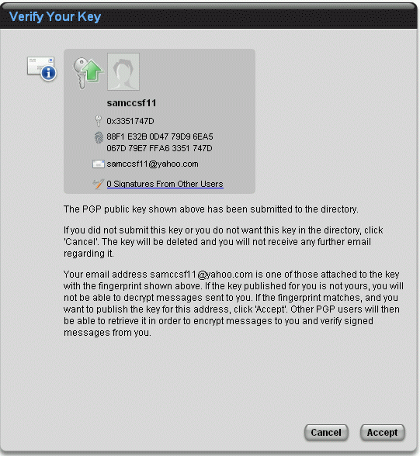
- You should see a PGP Information box saying Key(s) successfully uploaded to the server.
Verifying Your Key
- Check your email at the address you used in step 16. You should see a message with the subject [PGP Global Directory] Verify Your Key.
- Open that message and find this text in it: If the fingerprint matches, and you want to publish the key for this address, click here. Click the words click here.
- A Web page opens with the title Verify Your Key as shown to the right on this page. Click the Accept button.
- The next window is titled Email Address Confirmed and it gives you a chance to download a verification key. You can just ignore that and close the browser – the verification key is not required for this assignment.

Importing a Public Key from keyserver.pgp.com
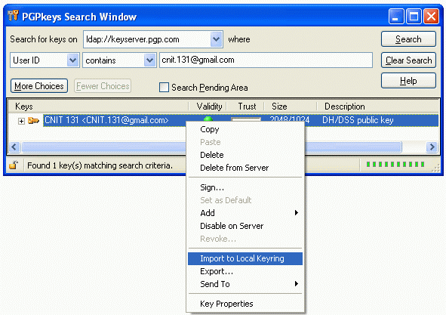
- In the PGPkeys window, from the menu bar, click Servers, Search.
- In the PGPkeys Search Window, accept the default entry in the Search for keys on box. In the second line, accept the default selections of User ID and contains. In the third box, enter cnit.131@gmail.com. Click the Search button. CNIT 131 should appear in the lower portion of the window, as shown to the right on this page.
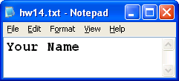
- Right-click CNIT 131 and select Import to Local Keyring. Close the PGPkeys Search Window.
Encrypting a Text File
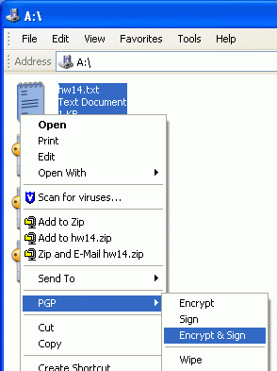
- Click Start, All Programs, Accessories, Notepad. Type in your name, as shown to the right on this page, and save the file as hw14 on your floppy disk, or in any other folder you can find, such as the My Documents folder.
- Click Start, My Computer and double-click 3 ½ Floppy (A:). (If you saved the file in some other folder, open that folder instead.) Right-click the hw14 file and select PGP, Encrypt & Sign as shown to the right on this page.

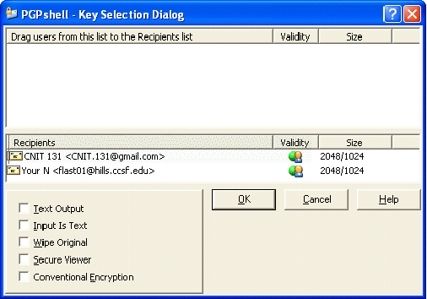
- In the PGPshell – Key Selection Dialog box, drag CNIT 131 from the upper pane to the lower Recipients list, as shown to the right on this page. This means the file will be encrypted using my public key that you just imported, so I can read it. Your name will also appear in the Recipients list—that way you can read your copy of the email. Click the OK button.
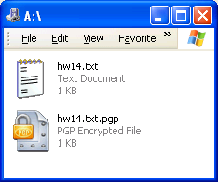
- In the PGPshell – Enter Passphrase box, enter your passphrase and click the OK button.

- You will now see a hw14.txt.pgp file on your diskette, as shown to the right on this page. To see what the encryption has accomplished, right-click this file and select Open With …, NotePad. (You may have to select Choose Program and select NotePad from a list.)
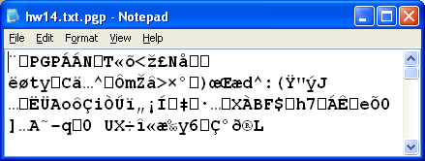

- You can see that the file is utterly unreadable, as shown to the right on this page. Close Notepad.

Emailing the Encrypted Text File to Me
- Use any email client of your choice to mail the hw4.txt.pgp file to me as an attachment. My address is CNIT.131@gmail.com. Use a subject line of CNIT 131 HW14 from Your Name.
Receiving an Encrypted Text File From Me
- Read your email. Within a few days, I will reply to your email, and I will include an attachment with the secret instructions you need to use to complete this assignment. Save the attachment on a floppy disk, or any other folder of your choice.
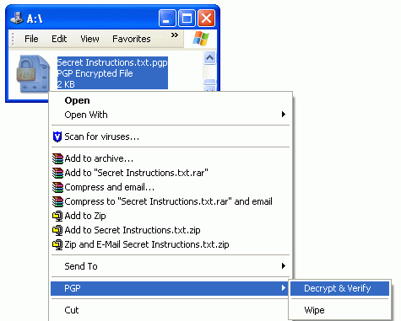
- Click the padlock icon in the notification area at the lower-right corner of your desktop and select PGPkeys. Verify that your key is shown in the list. If it is not, select Keys, Import and import the key from the floppy disk you saved it on.
- Open the floppy disk (or the other folder you saved my attachment in). Right-click it and select PGP, Decrypt & Verify as shown to the right on this page. Enter your passphrase when prompted to, and save the decrypted file with any name in a location you can find.
- Open the decrypted file and follow the instructions in it to complete the assignment.
Modified 5-5-05

