This assignment is worth 25 points.
You need to use both Internet Explorer and Netscape Navigator to do this assignment. If you don't have both browsers at home, you will need to use either Cloud 218 or the ICL-1 lab where both browsers are installed on the machines.

1. Creating a Folder for Internet Explorer Favorites
- Start Internet Explorer.
- Select Favorites, then Organize Favorites from the menu bar. The Organize Favorites dialog box opens as shown to the right on this page. Click the Create Folder button. A new folder appears with a highlighted name of New Folder. Type in your name for the folder name, and then click the Close button.

2. Adding the CCSF Home Page to Your Folder of Internet Explorer Favorites
- Click in the Address window and type in this URL:
www.ccsf.edu
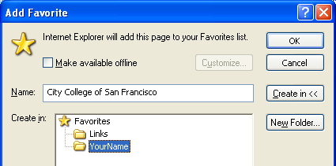
Then press Enter. The CCSF home page opens as shown to the right on this page.
- Select Favorites, then Add to Favorites from the menu bar. The Add Favorite dialog box opens as shown in the figure to the right on this page. Click the Create In>> button to display a list of available folders. Click on the folder with your name on it, and notice that the little yellow folder icon changes to an open folder. Then click OK to add the CCSF home page to your folder of Favorites.

3. Adding Sam Bowne's Home Page to Your Folder of Internet Explorer Favorites
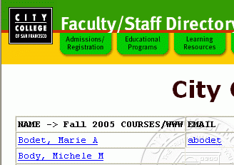
- In the center at the bottom of the CCSF home page, click the Faculty/Staff Directory link that appears in tiny red letters.
- Under the CCSF Faculty and Staff Directory Index header, click the blue letter B.
- On the next screen, click the blue Bo.
- A screen with faculty names appears, as shown in the picture to the right on this page. Scroll to the bottom of the next screen, and Click the blue Samuel F. Bowne on the left side.

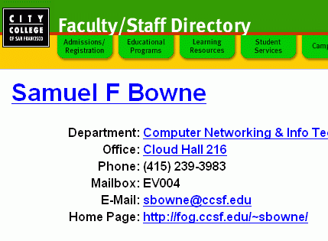
- A page with Samuel F Bowne in large blue letters at the top appears, as shown to the right on this page. Find the Home Page: link and click it.

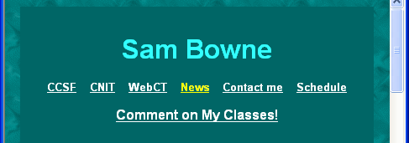
- A green page opens, as shown to the right on this page, Save this page in your folder of Favorites using the same procedure described above: Favorites, Add to Favorites, Create In>>.

4. Adding Slashdot to Your Folder of Internet Explorer Favorites
- Click in the Address window and type in this URL: www.slashdot.org
Then press Enter. The Slashdot page opens.
- Save the Slashdot page in your folder of Favorites using the same procedure described above.

5. Save a screen image of your Internet Explorer Favorites
- In Internet Explorer, click View, Explorer Bar, Favorites from the menu bar. This shows your Favorites at the left edge of your explorer window. Click the folder with your name on it to open it and show the saved Favorites, as shown to the right on this page.
- Hold down the Alt key and press the PrntScrn key in the upper-right portion of your keyboard to copy the screen image of the active window to the clipboard. Nothing visible changes on the screen, but a copy of the window is placed in the computer's RAM.
- Click the Start button at the lower left of the desktop, and select Programs, then Accessories, then Paint to open a Paint window.
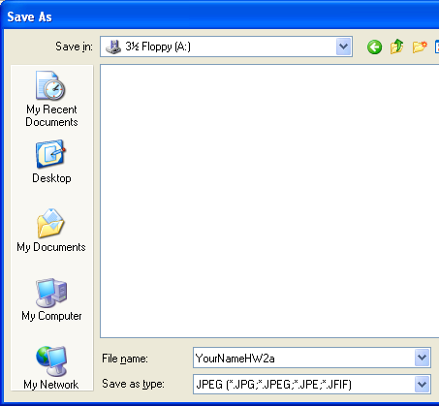
- Type Ctrl+V to paste the screen image into Paint. Click File, Save. A Save As window opens as shown to the right on this page. In the Save as type box at the bottom choose JPEG. Then give the file a name of YourNameHW2a, replacing YourName with your own name, and save it on a floppy disk or in any other folder you can easily find.

- Close Paint.

6. View the CCSF Home Page in SOURCE form with Internet Explorer
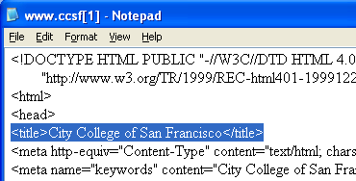
- Make sure you are viewing the CCSF home page in Internet Explorer.
- Select View, then Source from the menu bar. The HTML code appears in NotePad, as shown to the right on this page. Make sure the <title> line is visible, as highlighted in the image to the right.

7. Save a screen image of the SOURCE
- Hold down the Alt key and press the PrntScrn key in the upper-right portion of your keyboard to copy the screen image of the active window to the clipboard.
- Click Start Programs, Accessories, Paint to open a Paint window.
- Type Ctrl+V to paste the screen image into Paint. Click File, Save. In the Save as type box at the bottom choose JPEG. Then give the file a name of YourNameHW2b, replacing YourName with your own name, and save it on a floppy disk or in any other folder you can easily find.
- Close Paint.

8. Make a Folder for Netscape Navigator Bookmarks
- Start Netscape Navigator. You may use any version of Netscape or Mozilla. These instructions were written for Mozilla Firefox, version 0.8.
- Select Bookmarks, Manage Bookmarks from the menu bar. In the Bookmarks window, select File, New Folder. The Properties for "New Folder" dialog box opens. Type in your name in the Name: box, and then click the OK button. A new folder should appear in the Bookmarks window as shown in the figure to the right on this page. Don't close the Bookmarks window, but drag it to the right side of the screen.

9. Saving the Three Pages in your Folder of Netscape Bookmarks
- Click in the address box at the top of the Netscape window and type in this URL:
www.ccsf.edu
- Then press Enter. The CCSF home page should open, as shown in the figure to the right on this page. Make your Netscape window small enough to fit in the left half of the screen.
- In the Netscape window, find the little icon to the left of the www.ccsf.edu in the address bar, drag it to the right, and drop it into the folder with your name on it in the Bookmarks window.
- Navigate to Sam Bowne's home page as you did in step 3, and save that page in your folder of Bookmarks using the same procedure.
- Go to http://www.slashdot.org and save it in your folder of Bookmarks.

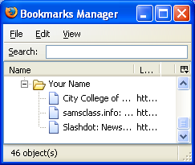
10. Save a screen image of your Netscape Navigator Bookmarks
- Make Bookmarks Manager the active window. It should look like the image to the right on this page.
- Hold down the Alt key and press the PrntScrn key in the upper-right portion of your keyboard to copy the screen image of the active window to the clipboard.
- Click Start Programs, Accessories, Paint to open a Paint window.
- Type Ctrl+V to paste the screen image into Paint. Click File, Save. In the Save as type box at the bottom choose JPEG. Then give the file a name of YourNameHW2c, replacing YourName with your own name, and save it on a floppy disk or in any other folder you can easily find.
- Close Paint.

11. View the CCSF Home Page in SOURCE form from Netscape Navigator
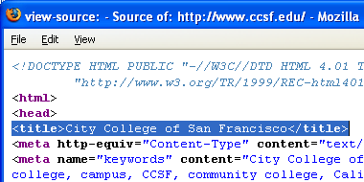
- Make sure you are viewing the CCSF home page in Netscape Navigator.
- Select View, then Page Source from the menu bar. The HTML code appears in a view source window as shown to the right on this page. Make sure the <title> line is visible, as highlighted in the image to the right.

12. Save a screen image of the SOURCE
- Hold down the Alt key and press the PrntScrn key in the upper-right portion of your keyboard to copy the screen image of the active window to the clipboard.
- Click Start Programs, Accessories, Paint to open a Paint window.
- Type Ctrl+V to paste the screen image into Paint. Click File, Save. In the Save as type box at the bottom choose JPEG. Then give the file a name of YourNameHW2d, replacing YourName with your own name, and save it on a floppy disk or in any other folder you can easily find.
- Close Paint.

13. Sending the Four Images to Me Using Email
- You have now created four image files. Email them to cnit.131@gmail.com as attachments to a single message with a subject line of HW2 From Your Name (replacing Your Name with your own name). You will receive your grade as a reply to your email. You can use any email service you want – Hotmail, Yahoo, AOL, or whatever you have. However, if you want to use CCSF's hills email, you will not find it easy to attach files with pine, so follow the instructions below.

14. How to Send Attachments With CCSF's WebIMAP System
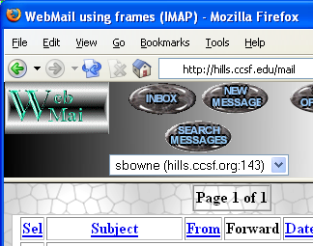
- Open Internet Explorer (or any other browser) and go to hills.ccsf.edu/mail
- Enter your HP-UNIX ID and password. The first time you use it you will see a configuration page – just accept the defaults and go on to the main MAIL page shown to the right on this page.

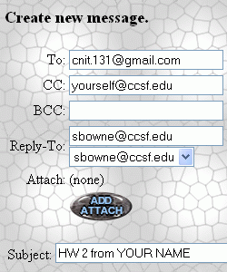
- In the To: line, enter cnit.131@gmail.com

- In the Cc: line, enter your own email address
(do not type in "yourself@ccsf.edu" literally)

- In the Subject: line, enter HW2 from Your Name
(replacing Your Name with your own name)

- Click the ADD ATTACH button.

- Under the Attachments to EMail Message header, click the Browse button.
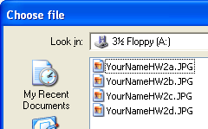
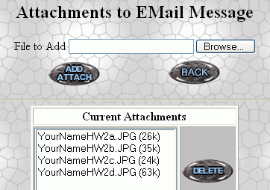
- In the Choose file window, click in the Look in: box and select 3½ Floppy (A:) (or wherever you stored your images in), as shown to the right on this page. Find the YourNameHW2a.JPG file and double-click it.

- Click the ADD ATTACH button.

- Repeat the same process: Browse, double-click filename, ADD ATTACH, for each of the other three images.

- When you see four items in the Current Attachments list, as shown to the right on this page, click the gray oval BACK button.

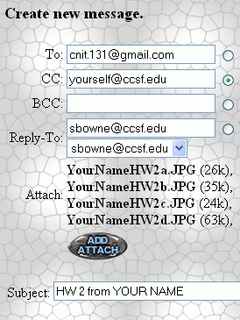
- The Create new message screen should now look like the image to the right on this page. Find the gray oval SEND MESSAGE button in the lower-right portion of the window and click it.

Revised 8-28-05

