Your Name HW2 Mon & Wed 11 am

IE Favorites

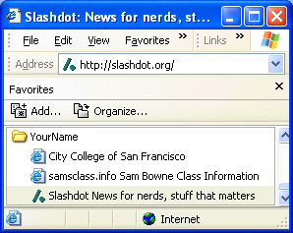

Source in IE

<!DOCTYPE HTML PUBLIC "-//W3C//DTD HTML 4.01 Transitional//EN"
"http://www.w3.org/TR/1999/REC-html401-19991224/loose.dtd">
<html>
<head>
<title>City College of San Francisco</title>
<meta http-equiv="Content-Type" content="text/html; charset=iso-8859-1">
<meta name="keywords" content="City College of San Francisco, City College, college, campus, CCSF, community college, California, downtown, fully accredited, courses, classes, schedule, academic, credit courses, non-credit courses">
<meta name="content" content="City College of San Francisco (CCSF) offers courses in more than 50 academic programs and over 100 occupational disciplines. There is a full range of credit courses leading to the Associate of Arts and Science degrees, most of which meet the general education requirements of four-year colleges and universities. Occupational courses and programs prepare students for immediate employment. Free noncredit courses such as English as a Second Language and Citizenship, as well as classes designed for Older Adults, are also available. Competitively priced, short-term community service courses are available to meet the training needs of business, industry and government, as well as personal enrichment of community members.">
<link rel="stylesheet" href="ccsf_style3.css" type="text/css">
<!-- Preload Script -->
<script type="text/javascript">
<!--
/*
* See if the browser is Netscape 4.x
* if so display the old version.
*/

Netscape Bookmarks

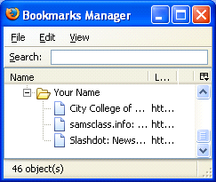

Source in Netscape

<!DOCTYPE HTML PUBLIC "-//W3C//DTD HTML 4.01 Transitional//EN"
"http://www.w3.org/TR/1999/REC-html401-19991224/loose.dtd">
<html>
<head>
<title>City College of San Francisco</title>
<meta http-equiv="Content-Type" content="text/html; charset=iso-8859-1">
<meta name="keywords" content="City College of San Francisco, City College, college, campus, CCSF, community college, California, downtown, fully accredited, courses, classes, schedule, academic, credit courses, non-credit courses">
<meta name="content" content="City College of San Francisco (CCSF) offers courses in more than 50 academic programs and over 100 occupational disciplines. There is a full range of credit courses leading to the Associate of Arts and Science degrees, most of which meet the general education requirements of four-year colleges and universities. Occupational courses and programs prepare students for immediate employment. Free noncredit courses such as English as a Second Language and Citizenship, as well as classes designed for Older Adults, are also available. Competitively priced, short-term community service courses are available to meet the training needs of business, industry and government, as well as personal enrichment of community members.">
<link rel="stylesheet" href="ccsf_style3.css" type="text/css">
<!-- Preload Script -->
<script type="text/javascript">
<!--
/*
* See if the browser is Netscape 4.x
* if so display the old version.
*/
NS4 = (document.layers) ? true : false;

