This assignment is worth 25 points.

WARNING TO STUDENTS USING PUBLIC MACHINES IN THE ICL-1 LAB OR OTHER COMPUTER LABS: If you have important mail in your pine Inbox it will be lost when you do this homework. Move important mail to a folder other than Inbox before starting this homework assignment. If you do not know how to make a folder in pine, see me during an office hour or after class so I can show you how.
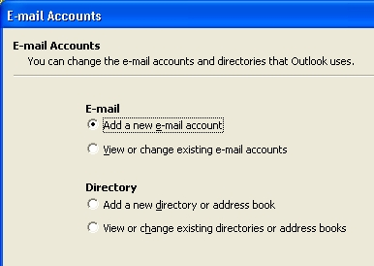

Configuring an E-Mail Client
You need to configure an e-mail client for this assignment. The instructions below are for Microsoft Outlook, the most popular client, but you can use Netscape, Outlook Express, Eudora, or any other e-mail client if you prefer.
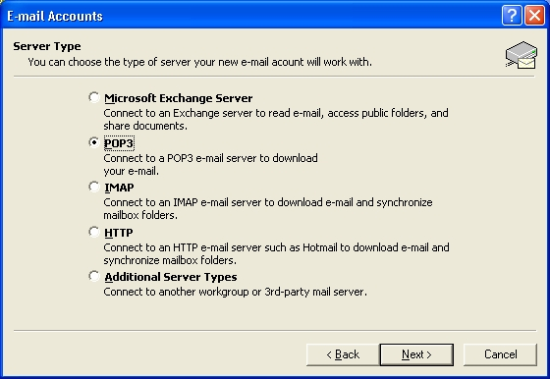
1. Start Microsoft Outlook with Start, Programs, Microsoft Outlook. Select Tools, E-mail Accounts from the menu bar. When the E-mail Accounts window opens as shown to the right on this page, click Add a new e-mail account and then click Next.

2. In the next window, select POP3 and then click Next.

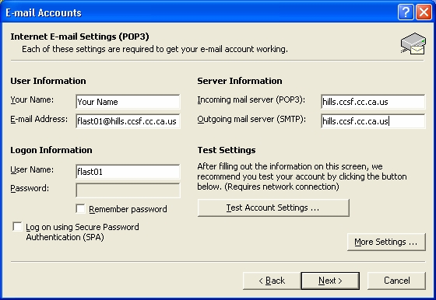
3. In the next window, fill in your name, e-mail address, and hills user ID on the left side. If you are using a public machine, leave the password blank and uncheck the Remember Password box. On the right side, enter hills.ccsf.cc.ca.us for both the Incoming and Outgoing server names. Click Next. In the next window, click Finish.
4. In the main Outlook window, click Send/Receive. When a box pops up asking for your password, type it in. Locate a message sent to your hills account and click on it so that the hills address is visible in the preview pane (the lower part of the window). If your inbox is empty, send yourself a test message like the one you see in the figure to the right on this page.
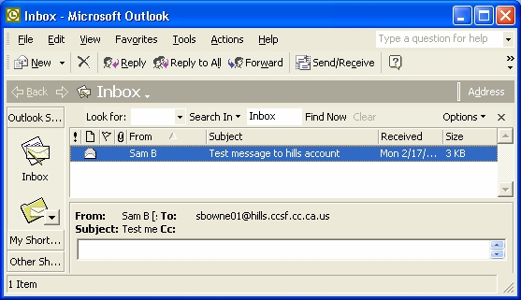
5. Print a screen image of your Outlook screen Hold down the ALT key and press the PrntScrn key on your keyboard to copy the active window to the clipboard. Then click the Start, Programs, Accessories, WordPad to open a WordPad window. Type Ctrl+V to paste the screen image into WordPad, and then select File, then Print from the WordPad menu bar to print it. Check the printout to make sure your hills address is visible. Close WordPad.

6. Write Your Name and hw5 on the printout and turn it in in class.

Creating a Password-Protected Document
6. Start Microsoft Word (NOT WordPad or NotePad) and make a document containing your name. You may use any readable font face and size.
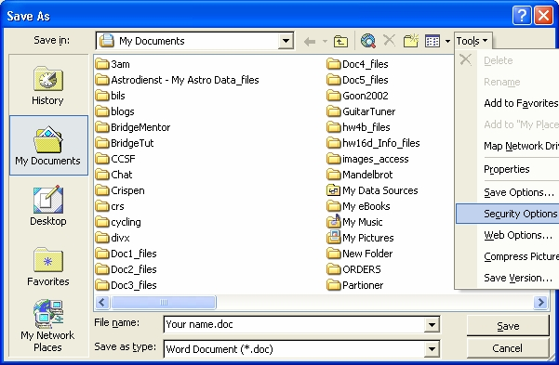
7. Select File, Save As... from the menu bar to open the Save As... dialog box as shown to the right on this page.
8.Select Tools, then Security Options inside the Save As dialog box as shown to the right on this page.
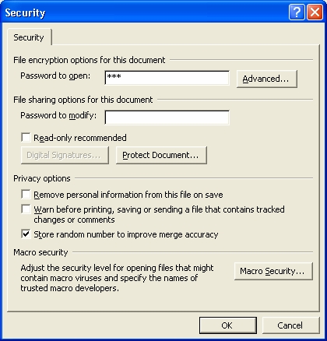
9. The Security dialog box opens as shown to the right on this page. Type in the password sam into the Password to open box. Click OK. Enter the password again, and then click OK. Use lowercase letters for the password. Enter the filename hw5 and save the document on your floppy disk. Word will add the extension .doc. Close Word.

Sending a Password-Protected Document
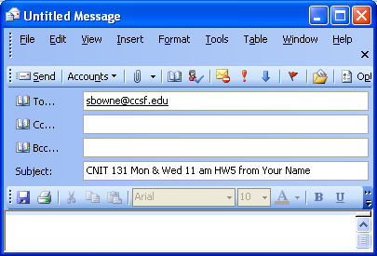
10. Open Outlook and click the New button to create a new e-mail message. Address it to me at sbowne@ccsf.edu and enter a subject of CNIT 131 Mon & Wed 11 am hw5 from Your Name, as shown on the figure to the right on this page, using the correct class meeting time and your name. Click the Attachment button (it looks like a paper clip).

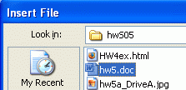
11. In the Insert File box, navigate to the hw5.doc file you just saved, as shown in the figure to the right on this page. Click on hw5.doc, and then click the Insert button.

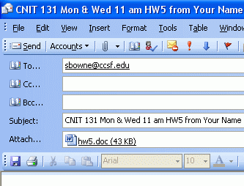
12. Your message should show an attached file, as shown to the right on this page. Add your own e-mail address to the Cc: field and send the message. When you get your copy, double-click on the attachment and verify that it is password-protected with the password sam and that it contains your name.

Grading
For grading, hw5 is broken into two parts: hw5a is the printout of a properly configured e-mail client, and is worth 15 points. Hw5b is the e-mail message containing a password-protected file, and it worth 10 points.
Revised 5-8-05

