Use NotePad or any other text editor of your choice to make a Web page in HTML
Your webpage must have the following Required Elements
  - Your webpage should consist of two files: hw5.html and an image file with any appropriate name, ending in .gif or .jpg
  - Opening and Closing <HTML> and </HTML> tags, properly enclosing the entire HTML document.
  - Opening and Closing <HEAD> and </HEAD> tags, properly enclosing the entire head section.
  - Opening and Closing <BODY> and </BODY> tags, properly enclosing the entire body of the webpage.
  - An appropriate TITLE that appears in the title bar of the browser, properly placed in the HEAD section of the HTML document.
  - Your name at the top of the Web page in any readable style you choose.
  - At least two different Header tag types used <H1>, <H2>, etc., with the appropriate closing </H1>, </H2> tags, and any readable text you choose within the tags.
  - At least one Header tag with ALIGN=CENTER or ALIGN=RIGHT used, such as
<H1 ALIGN=CENTER>This is Centered</H1>
and any readable text you choose within the tags.
  - At least one Paragraph tag used <P> with the appropriate closing </P> tag, and any readable text you choose within the tags.
  - At least one Image tag such as <img src="picture.jpg">, with the corresponding image file so that the image is viewable on your Web page. To get an image, open a browser and go to gallery.yahoo.com or any other site with images, point to an image, and right-click on it. Select Save Picture As... or Save Image As... and save the image on a floppy disk.
  - A citation to the source of your image, such as "picture from www.rollingstone.com". If you use a picture that is your own property, your page must say that "picture my own property". If you use a Yahoo picture with Corbis written on it, you do not need to cite the source.

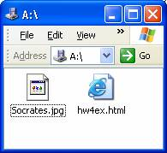
Put your Web page on the hills server using SSH Secure File Transfer
Your webpage should consist of two files, an HTML file and an image file. Open the floppy disk or folder your files are in and display it on your desktop as shown in the figure to the right on this page.
Open a Secure File Transfer window, connect to the hills server, and click Window, New File Transfer to open a SSH Secure File Transfer window.
Double-click the public_html folder in the right pane to open it, and navigate to the 3 1/2 Floppy drive (or wherever your HTML page is on your machine) in the left pane, so that your window looks like the figure below.
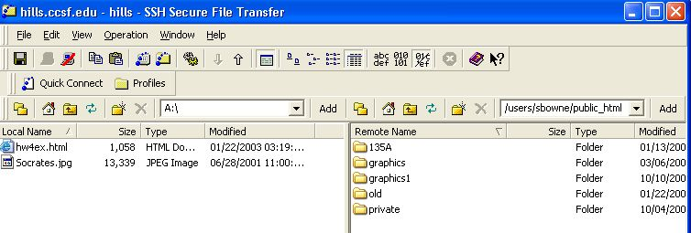
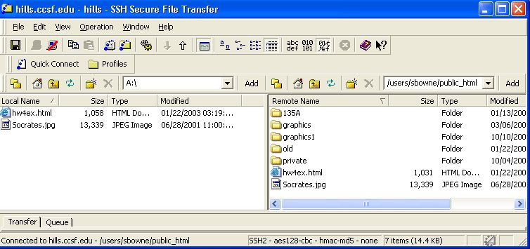
Drag the two files from your computer (the left pane) and drop them in the right pane of the Secure Shell Client window.
After the transfer, your Secure Shell Client window should show the files in the right pane, as shown in the figure below.

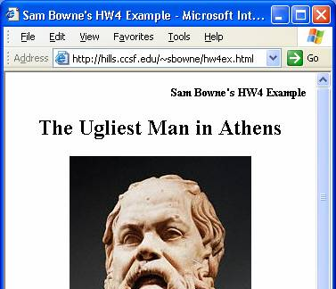
View your web page in a browser
Open Internet Explorer or another browser and type the URL of your Web page into the Address bar. The URL of your web page is:
http://hills.ccsf.edu/~flast01/hw5.html
with your HP-UNIX User ID instead of flast01.
Make sure the image is visible, and all the required elements are present.

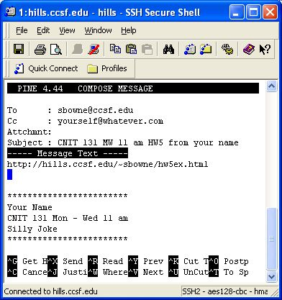
E-mail the URL of your web page to me
Use pine or any other e-mail service of your choice, and compose a message to me at
sbowne@ccsf.edu
with the subject
CNIT 131 hw6 from your name
with meeting times replaced by your class meeting times, and your name replaced by your own first and last name.
Copy the URL of the webpage from the Address bar of the browser window and paste it into the body of the e-mail message. I recommend that you send a CC to yourself. Send the message.

Read your E-mail
I will grade your homework and reply to your e-mail message with your grade and any suggestions for improvement.
 | Grading (partial)
-25 | URL does not work
-1 to -2 each | Required element missing or incorrect
-5 | No image visible
-2 | No citation to source of image (not required for Corbis Images)
-1 | Subject line of e-mail incorrect
-3 | Late
Last modified: 3-9-05

