Installing Windows XP Service Pack 2

Checking to See if you Already Have Service Pack 2
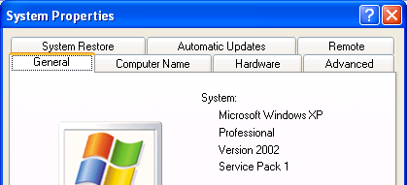
- Click Start, and point to My Computer. Right-click and select Properties. A System Properties window opens as shown to the right on this page. It should tell you at the top what version of Windows you have.
- You must have Microsoft Windows XP Home Edition or Microsoft Windows XP Professional to install Service Pack 2. If you have a different version of Windows, such as Windows 2000, ME, 98, or 95, you cannot install Service Pack 2. If you have one of those earlier versions of Windows, install the Zone Alarm free firewall instead.
- If you have Windows XP, look at the 4th line after the word System: to see what Service Pack you have. If it shows Service Pack 1, as in the example above, or no service pack at all, you should install Service Pack 2. If you already have Service Pack 2, you don’t need to do anything further to get it.

Using Windows Update to Get Service Pack 2
- The easiest way to get Service Pack 2 is over the Internet. The Updating Windows handout explains how to do that.

Using the Service Pack 2 CD
- But if you have no access to the Internet, or a dial-up connection, you may prefer to use a Service Pack 2 CD. You can get them from your instructor in class, or at any Comp USA, or order them direct from Microsoft.
- Insert the CD. If it does not automatically run, open My Computer and open the CD. Double-click the Autorun.exe file.
- A Microsoft Windows XP Service Pack 2 window opens. Click Continue.
- In the next screen, click Install Now.
- Wait while an Extracting Files window shows progress.
- A Windows XP Service Pack 2 Setup Wizard window opens. Click Next.
- In the next screen, click I Agree and click Next.
- In the next screen, click Next.
- Wait while the wizard installs. It may take half an hour or longer.

Updated 9-2-04

