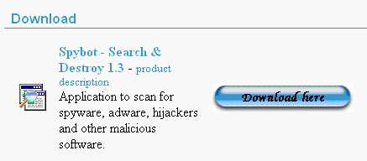
1. Download
Open a browser and go to www.safer-networking.org.
Click the Download link at the upper left.
Scroll down and find the Download header. Click the fires Download here button to get Spybot – Search & Destroy 1.3.
At the Mirror Selection screen, click one of the the Download here buttons. Follow the directions on your screen to download the file. These download mirrors are pretty confusing, but if you try a couple of them you should find one that works.
Save the spybotsd13.exe file on your desktop.

2. Installation
The file you have downloaded will be named spybotsd13.exe or similar. To install Spybot-S&D, all you have to do is run the file, and the installation program will start. Accept all the default settings and just click your way through the installer by using the Next button.
After the installation has finished, you will see a Spybot - Search & Destroy button on your desktop and in your start menu. Click on it to start Spybot-S&D the first time.
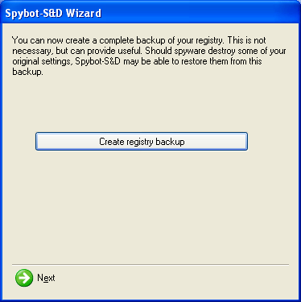
3. Backup and Updates
The first time you start Spybot-S&D, you see a Legal Stuff box. Check the Don't show this message again box and click OK.
A Spybot – S&D Wizard box opens. Click the Create registry backup button. When it finishes, click the Next button.
In the Spybot – S&D Wizard box, click the Search for updates button.
In the Spybot – S&D Wizard box, click the Download all available updates button.
4. Doing a scan
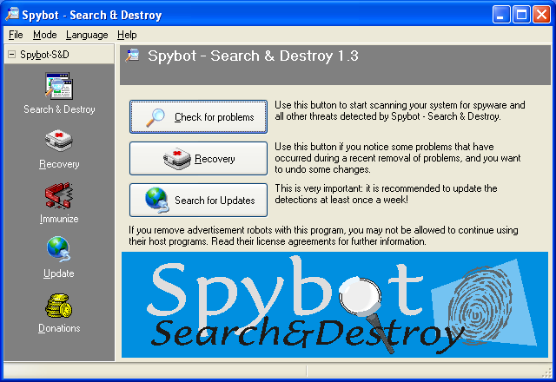
After the updates install, Spybot restarts and you will see the Spybot window as shown to the right on this page.
Click the Check for problems button.

5. Interpreting the results
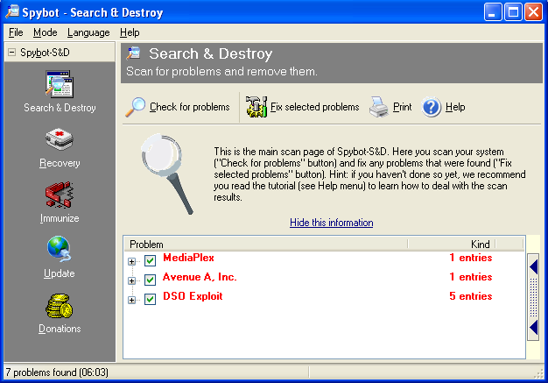
When the scan finishes, you will see a list of red things found on your computer, as shown in the second figure to the right on this page. These are spyware -- software that is reporting information about you back to some Internet server.
In Advanced Mode, Spybot will also find usage tracks and display them in green, but we are using Default Mode and they do not appear. That's OK because most usage tracks are harmless – they record things like your recently opened Word documents.
6. Removing the threats found
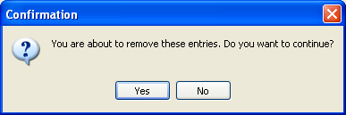
Click the Fix selected problems button. Spybot creates a System Restore Point first, which is very nice – that means if you discover that it has broken some program you want to use, you can undo the changes it makes with Start, Help, System Restore (on Windows XP systems).
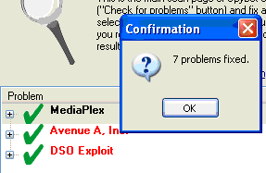
In a minute or two, you should see the Confirmation box shown to the right. Click Yes. Note: the first time I ran Spybot on my computers, this box did not appear until I pressed Alt+Tab.
7. Saving a screen image
When Spybot is done, you should see a Confirmatino box showing how many problems were fixed, as shown to the right on this page. Press the PrntScn key to copy the screen to the clipboard. Click Start, Programs, Accessories, Paint to open Paint. Then select Edit, Paste from the menu bar. An image of the window should appear in Paint. Click File, Save. Select My Documents or some other folder you can easily find to save the file in. Give the file a name of Spybot and select a File type of GIF. Click the Save button. If a window opens warning you that you will lose some color information, click Yes.
Last modified 4-25-05

