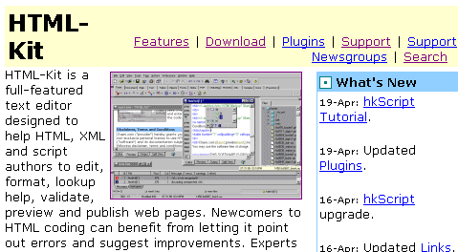
HTML-KIT:an HTML Editor

Download from http://www.chami.com/html-kit/

HTML-KIT User’s Guide

http://www.chami.com/html-kit/help/
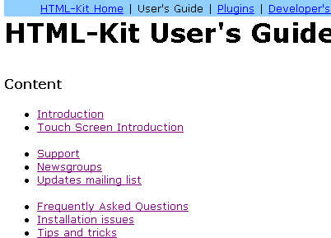

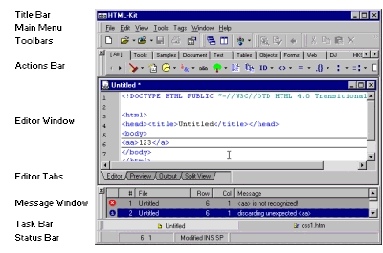

HTML-KIT Screen

Main Menu, Toolbars, and Action Bar all give you access to many, many HTML tools

Editor window shows the HTML code you are writing

Editor tabs give 4 views

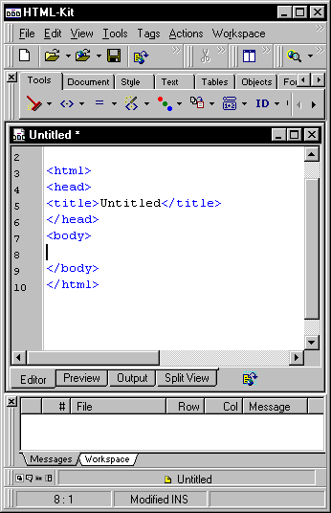
Task bar lets you choose among open HTML documents

Creating a New HTML Document

Click the blank page to start a new HTML document

HTML-KIT fills in the basic shell: <html>, <head>, <title>, <body> tags

Preview tab shows browser view

HTML-Tidy

Click the broom icon to check and correct your HTML code

Tidied Code Appears in Output Window

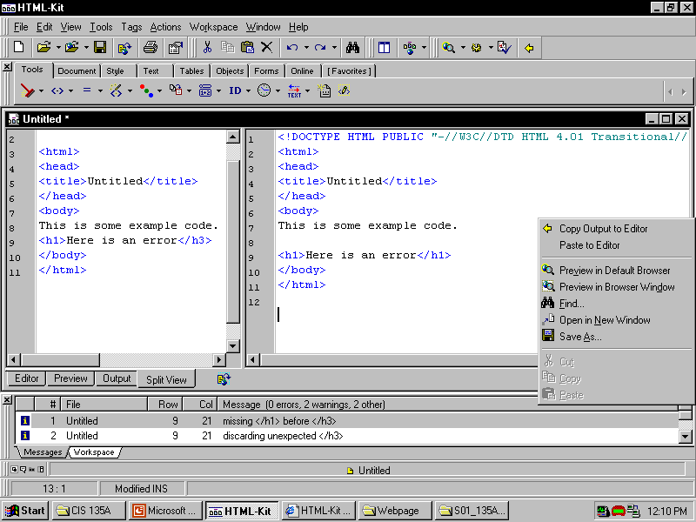
To accept corrections, right-click in Output window and select Copy Output to Editor

Repeat the Tidy process to make sure all errors are gone

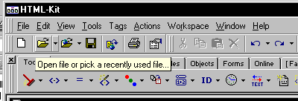
Saving and Opening Documents

Save document with File, Save

Open previously saved documents with File, Open

The open folder icon in the Toolbar has an extensive recently-used file list

Entering Tags

3 Methods

1. Just type them in as you do in NotePad

2.

Choose tags with mouse from HTML Tags tool

Then choose attributes from Attributes tool

3. Use Tags Wizard

Tags Wizard

Icon looks like a magic wand with < > brackets

Select a tag type

Select attributes in the Wizard window
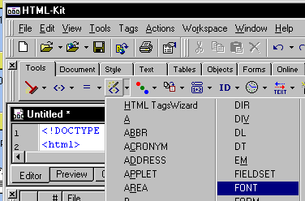
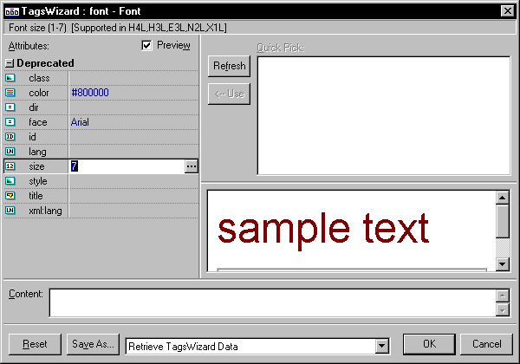

Using the Color Tool

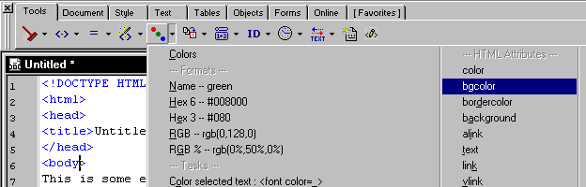
To add a background color:

Position the insertion point inside the Body tag

Click the Color tool

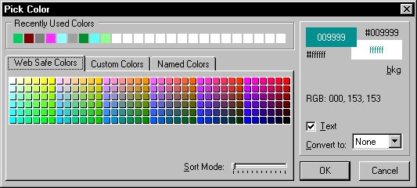
Select bgcolor

Choose color from onscreen palette

Inserting File Names

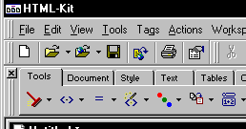
Position insertion point where filename tag is needed

Click Insert File Name tool

Browse for desired file

Click Open

Select tag type

Usually check Renove Path box

Click OK to insert file

Spelling Checker

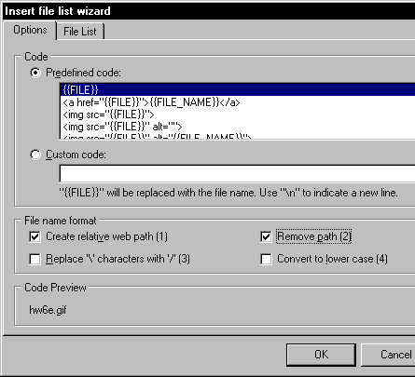
In HTML-KIT, select Tools, Spelling or press F7 to start the Spell Check

From now on, I will deduct points for spelling errors on web pages done for homework

