Learning Objectives.

Understand the purpose of your computer’s CPU, RAM, and hard drive

Learn about bits, bytes, kilobytes, megabytes, and gigabytes

Find out how the Internet is structured and how computers become part of the Internet

Discover how IP and DNS addresses are used

Master the basic navigational features of your Web browser
Taking Charge

The Internet (or Net) is used by students and others for many purposes

In 2001, college seniors used the Internet an average of 11 hours per week

People use the Internet to become informed on issues, to communicate with other who share their interests, and to pursue goals

Much time can be wasted online, but better understanding of the Internet can allow you to use your time more effectively

Some understanding of general computing concepts will establish a foundation that you will build upon as you learn about the Internet
Computer Basics

The Operating System

The Central Processing Unit

Memory and Storage

The Operating System

The heart of the computer

A large program that starts when the computer is turned on

The OS is needed to run other programs called application programs (e.g. Microsoft Word)

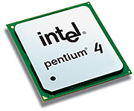
Examples:

Microsoft Windows 2000

Apple Macintosh OS 9

Linux

The Central Processing Unit

The CPU has three characteristics:

Clock speed

The number of instructions the CPU can execute in an amount of time

Measured in Megahertz (MHz) or
Gigahertz (GHz)
CPU

Image from intel.com

Instruction set

The collection of operations that the CPU can execute

Some instructions are general, like adding 2 integers

Other instructions are specific to the type of CPU

So software that runs on the PC will not run on the Macintosh (and vice-versa), without emulation.

Word size (a.k.a. data width)

The more data that the CPU can potentially manipulate at one time, the faster the CPU.

Early microprocessors used 8-bit or 16-bit word sizes

Most processors now use 32-bit word sizes

64-bit word size processors are available but not yet common

The instruction set must accommodate large word sizes in order to increase the CPU speed.

Memory and Storage

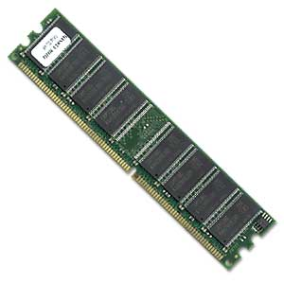
Random Access Memory (RAM)
RAM

Image from gearxs.com

Also called Main Memory

The memory that the CPU uses when it executes instructions

The CPU reads and writes to RAM very quickly

RAM is volatile - the information goes away when the computer is turned off or restarted (short-term)



Each program that you run requires some amount of RAM

Long-term storage

Hardware that stores:

Files that you create

Software and its data files

The information remains when the computer is turned off
Floppy Disk

Examples:
CD-ROM

Hard drive

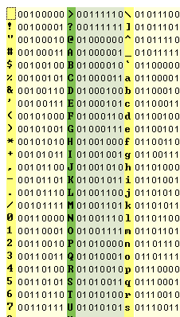
CD-ROM / CD-RW
Units of Memory

A file is a collection of data

Each file has a name

The online experience of what we see and hear is comprised of files

The software that we use needs files to run

The larger the file, the more time is needed to download the file to your computer.

The size of files is measurable

The smallest unit of data is the bit.

A bit is either a 1 or a 0

All data (and files) are a pattern of bits

A byte is 8 bits

Each byte can represent a letter, number or symbol.

The set of upper and lowercase letters, numbers, and other symbols is called the ASCII character set.

Kilobytes (K): 1024 bytes

Megabytes (MB): 1024 kilobytes

Gigabytes (GB): 1024 megabytes

Besides the size, there are two types of files:
ASCII

ASCII text files contain ASCII characters

Binary files contain characters that cannot be typed on the keyboard, generated by software
The Internet

The Internet is a network of networks that are spread all over the world

Networks that are geographically close are called Local Area Networks (LANs)

Often in the same building

The university’s network is a prime example

The Internet is a largely heterarchical network containing many individual LANs

A heterarchical network

Contains many nodes that are interconnected randomly, with no node more important than the others.

A hierarchical network

Contains a tree-like structure where some nodes are superior to others.

Root node is at the top of the hierarchy

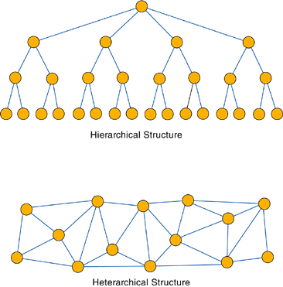
A characteristic of a heterarchical network is that it is a robust network.

If some nodes are removed, data can still be sent between nodes

Hierarchical networks are less robust, because failure near the root affects many nodes

The Internet also has dynamic routing, where the route of the data is determined at the time of transmission based on current network conditions.
Host Machines and Host Names

Each computer on the Internet is a host machine.

Each computer has a unique Internet Protocol (IP) address, such as 124.110.24.1

Some computers have a permanent IP address

Some computers lease an IP address while they are connected to the Internet

An IP address is not human-friendly

The IP address for most host machines are mapped to a Domain Name Service (DNS) address in order to be more people-friendly

The DNS address consists of a host name followed by a domain name

Example DNS Address: mail.yahoo.com

Host Name is: mail

Domain Name is: yahoo.com

Each domain name consists of:

Institutional site name

Top Level Domain name (TLD)

Example: hills.ccsf.edu

Hills.ccsf is the hills server at CCSF

edu refers to an educational site

Examples of TLDs include:

.com a commercial organization

.edu a US educational site

.net a network site

.au Australia

.fr France

.hk Hong Kong

.es Spain

New TLDs have been added as the original set became overloaded

While each machine has a unique IP address, it can have multiple DNS addresses (called aliases)

Anyone can register a DNS address

When you type in a DNS address, a domain name server translates it into an IP address.
Speed and Bottlenecks

When you go online, your computer exchanges data with other computers.

The transfer of data is measured in bits per second (bps); bandwidth

Your data transfer rate is determined by:

The type of connection (e.g. dial-up)

The traffic over the network

The bottleneck is the part of your connection that slows the data rate during transfer

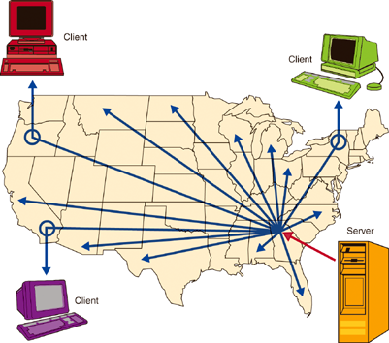
The Client/Server Software Model

Clients and servers are host machines

A client is the host machine that requests information from the server

The server is a resource that provides a service for (many) clients

The client/server interaction is the foundation for all Internet communication

Some companies use servers to supply commercial software to clients, without having to install the software onto the clients

Application Service Providers (ASPs) provide software through subscriptions

The software is “rented” with this arrangement
The World Wide Web and Web Browsers

The World Wide Web has become a popular means of accessing information and services.

The Web and the Internet are not the same.

The Internet is a network of computers and cables

The Web is a set of pages viewable in a Web browser, and it is only one of many services on the Internet

A Web browser is the software necessary to view information.

Some browsers are integrated into other software, such as an email client

Navigating the Web only takes a few commands.

The information in the Web is organized as hypertext, graphics, video, and sound

The text in a Web page may contain hyperlinks that, if clicked, allow you to view related information on other Web pages.

You control where you go and what information you see via these hyperlinks

A Web page is a document on the Web that you view through your Web browser

The act of reading Web pages and clicking on hyperlinks is called browsing

Browsing can be seen as a way of exploring

Each Web page has a unique address called a Uniform Resource Locator (URL) that you can use to jump directly to it
How to Get Online

Before you can use Internet resources, you need to get access to the Internet.

Many students use their accounts on university computers

Others use the computers at the library, their workplace, or even that of a friend.

Others will need to get an account and software through a commercial Internet Service Provider (ISP)

An ISP provides technical support for the provided software

Your account gives you a userid and password
Browser Tips and Tricks

Select your own default home page

When you start your browser, a default Web page is displayed

You can change the default page to another URL

Use the Find command

Find allows you to find text in a page

You enter the text that you want to find

If that text is in the page, then you view the first instance of the text in the page

Use your History list

The History list is a list of the URLs that you have visited recently

You can click on a URL from the list to revisit the page

Use Bookmarks (Favorites)

A bookmark is a pointer to a Web page that you expect to revisit

You can select a bookmark from a list, and quickly jump to that Web page.

Add Bookmarks with care

Bookmarking every page of interest is tempting

Large bookmark lists are difficult to use

Abort a download if you get stuck

If the browser appears to be stuck while loading page, select the option to stop the page loading

The page may display, but if not try clicking on the link again

Turn off graphics

Graphics files can be large and take a long time to download

If you are in a hurry or have a slow Internet connection, then you may spend time waiting for pages to load.

You can set your browser to not download graphics

Don’t let a “404 Not Found” message stop you dead

The error means that the specified URL was not found

Check that the URL was correct

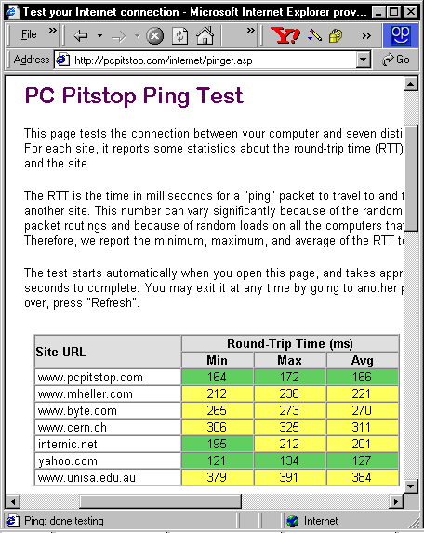
The page may have been removed or moved

You can always backtrack through the URL to see if a related part of the site is available

Avoid peak hours

The Internet has times of high traffic where response times are slower than off-peak times

In the US, the peak times of usage during the week are:

The middle of the day

Early evenings
Above and Beyond

PC Pitstop

Allows a ping test to see how fast your Internet connection is

www.pcpitstop.com

Test my PC, Internet connection, Ping Test

Types of Internet Connections
Type | Speed or Bandwidth
POTS (Plain Old Telephone Service) | 56 Kbps
ISDN (Integrated Services Digital Network) | 64-128 Kbps
DSL (Digital Subscriber Line) | 512 Kbps to 8 Mbps
Cable modem | 512 Kbps to 52 Mbps
T1 leased line | 1.544 Mbps
T3 leased line | 44.736 Mbps
TCP/IP (Transmission Control Protocol / Internet Protocol)

IP is a universal addressing system for all computers on the Internet.

TCP prepares the data for transmission by breaking the data into packets

Packet Switching
- Packets are sent towards their destinations by computers called routers
- Packets that are lost or damaged in transmission are resent
Ping
K:\Documents and Settings\Sam>ping yahoo.com

Pinging yahoo.com [66.94.231.99] with 32 bytes of data:

Reply from 66.94.231.99: bytes=32 time=55ms TTL=57
Reply from 66.94.231.99: bytes=32 time=11ms TTL=56
Reply from 66.94.231.99: bytes=32 time=28ms TTL=56
Reply from 66.94.231.99: bytes=32 time=13ms TTL=56

Ping statistics for 66.94.231.99:
Packets: Sent = 4, Received = 4, Lost = 0 (0% loss),
Approximate round trip times in milli-seconds:
Minimum = 11ms, Maximum = 55ms, Average = 26ms

PING sends a few packets to a single host just to see if it is answering

Tracert

Tracert sends a series of pings to show the whole route from your computer to a remote host
K:\Documents and Settings\Sam>tracert yahoo.com

Tracing route to yahoo.com [66.94.231.99]
over a maximum of 30 hops:

1 20 ms 6 ms 6 ms 192.168.2.1
2 27 ms 19 ms 20 ms 10.21.64.1
3 21 ms 19 ms 19 ms vl4.aggr1.sfrn.ca.rcn.net [208.59.216.194]
4 22 ms 20 ms 19 ms fe0-0-0.border2.sfrn.ca.rcn.net [208.59.255.11]
5 22 ms 26 ms 19 ms 208.59.94.250
6 31 ms 31 ms 31 ms vlan27.bas2.scd.yahoo.com [216.115.101.46]
7 24 ms 26 ms 21 ms UNKNOWN-66-218-82-234.yahoo.com [66.218.82.234]
8 36 ms 17 ms 15 ms p2.rc.scd.yahoo.com [66.94.231.99]

Trace complete.

